**DAILY ONLINE ACTIVITIES SUMMARY**

|  |  |  |  |  |  |  |  |
| --- | --- | --- | --- | --- | --- | --- | --- |
| **Date:** | **26/06/20** | | | | **Name:** | **Deena Muthappa** | |
| **Sem & Sec** | **8th sem, A sec** | | | | **USN:** | **4AL16CS028** | |
| **Online Test Summary** | | | | | | | |
| **Subject** | | **Not conducted** | | | | | |
| **Max. Marks** | |  | | **Score** | |  | |
| **Certification Course Summary** | | | | | | | |
| **Course** | **SQL Masterclass :SQL for Data Analytics** | | | | | | |
| **Certificate Provider** | | | **Udemy** | **Duration** | | | **7hrs** |
| **Coding Challenges** | | | | | | | |
| **Problem Statement: program to convert given binary number into decimal** | | | | | | | |
| **Status: Completed** | | | | | | | |
| **Uploaded the report in Github** | | | | **Yes** | | | |
| **If yes Repository name** | | | | **deenamuthaappa/Coding-Challenges** | | | |
| **Uploaded the report in slack** | | | | **Yes** | | | |

Online Test Details:

Not conducted

Certification Course Details:

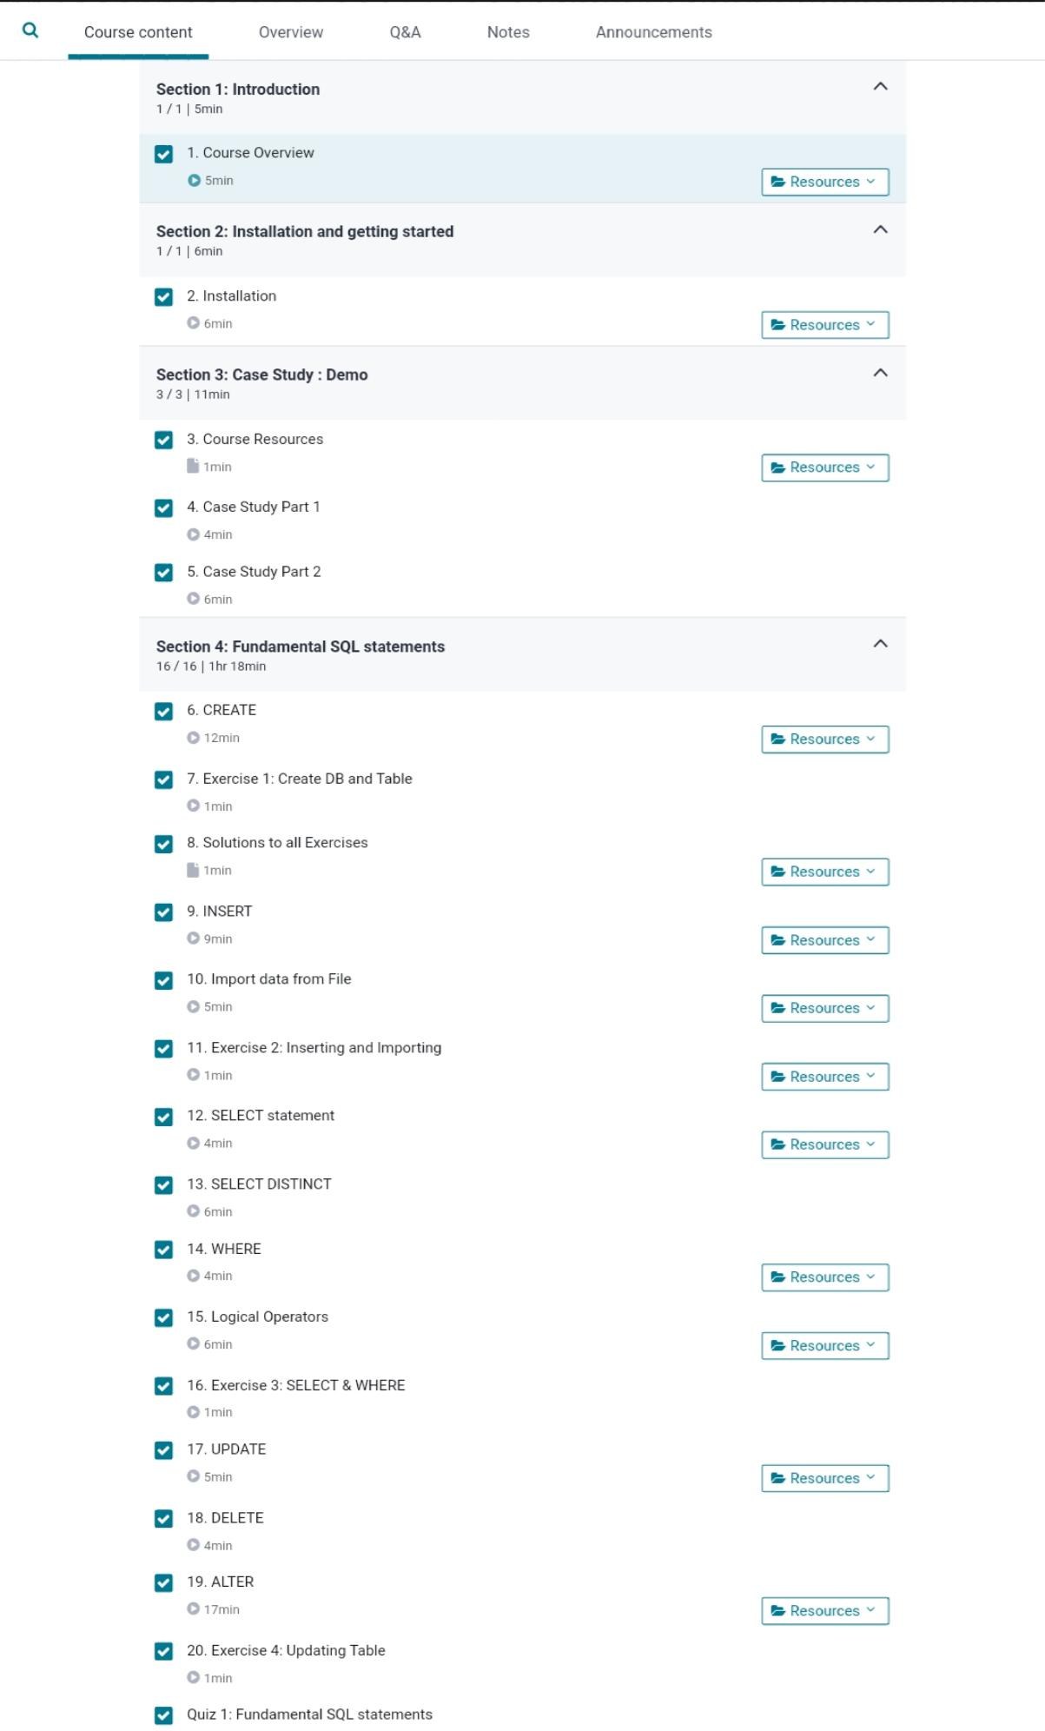

Coding Challenges Details:

/C program to convert a binary number into decimal number

#include

#include

int binary_to_decimal(long int n)

{

int decimal = 0, i = 0, remainder;

while (n!=0)

{

remainder = n%10;

n /= 10;

decimal += remainder*pow(2,i);

++i;

}

return decimal;

}

int main()

{

long int n;

printf(“Enter a binary number: “);

scanf(“%ld”, &n);

printf(“\nDecimal number : %d\n “, binary_to_decimal(n));

return 0;

}