**DAILY ONLINE ACTIVITIES SUMMARY**

|  |  |  |  |  |  |  |  |
| --- | --- | --- | --- | --- | --- | --- | --- |
| **Date:** | **26/07/20** | | | | **Name:** | **Deena Muthappa** | |
| **Sem & Sec** | **8th sem, A sec** | | | | **USN:** | **4AL16CS028** | |
| **Online Test Summary** | | | | | | | |
| **Subject** | | **Not conducted** | | | | | |
| **Max. Marks** | |  | | **Score** | |  | |
| **Certification Course Summary** | | | | | | | |
| **Course** | **NodeJs React Rest Summer 2020** | | | | | | |
| **Certificate Provider** | | | **Udemy** | **Duration** | | | **26hrs** |
| **Coding Challenges** | | | | | | | |
| **Problem Statement: Write a C program to insert elements into an array.** | | | | | | | |
| **Status: Completed** | | | | | | | |
| **Uploaded the report in Github** | | | | **Yes** | | | |
| **If yes Repository name** | | | | **deenamuthaappa/Coding-Challenges** | | | |
| **Uploaded the report in slack** | | | | **Yes** | | | |

Online Test Details:

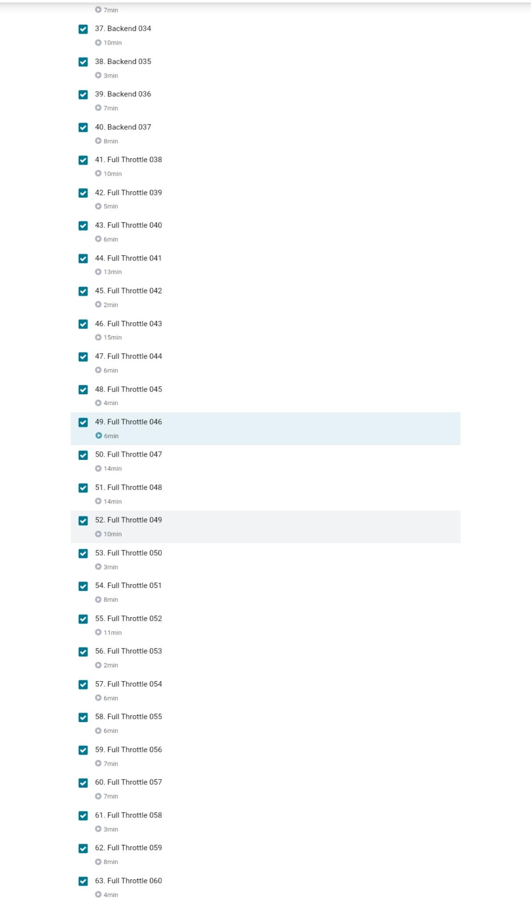Certification Course Details:

Coding Challenges

#include <stdio.h>

int main()

{

int n;

printf("Enter the number of elements: ");

scanf("%d",&n);

int arr[n];

int i;

printf("Enter the elements:\n");

for(i = 0; i < n; i++)

{

scanf("%d",&arr[i]);

}

int pos;

printf("Enter the position to insert an element: ");

scanf("%d",&pos);

int ele;

printf("Enter the element: ");

scanf("%d",&ele);

if(pos > n)

printf("Invalid Input");

else

{

for (i = n - 1; i >= pos - 1; i--)

arr[i+1] = arr[i];

arr[pos-1] = ele;

printf("Array after insertion is:\n");

for (i = 0; i <= n; i++)

printf("%d ", arr[i]);

}