**DAILY ONLINE ACTIVITIES SUMMARY**

|  |  |  |  |  |  |  |  |
| --- | --- | --- | --- | --- | --- | --- | --- |
| **Date:** | **27/06/20** | | | | **Name:** | **Deena Muthappa** | |
| **Sem & Sec** | **8th sem, A sec** | | | | **USN:** | **4AL16CS028** | |
| **Online Test Summary** | | | | | | | |
| **Subject** | | **Not conducted** | | | | | |
| **Max. Marks** | |  | | **Score** | |  | |
| **Certification Course Summary** | | | | | | | |
| **Course** | **SQL Masterclass :SQL for Data Analytics** | | | | | | |
| **Certificate Provider** | | | **Udemy** | **Duration** | | | **7.5hrs** |
| **Coding Challenges** | | | | | | | |
| **Problem Statement: Java program to find duplicate characters in a string** | | | | | | | |
| **Status: Completed** | | | | | | | |
| **Uploaded the report in Github** | | | | **Yes** | | | |
| **If yes Repository name** | | | | **deenamuthaappa/Coding-Challenges** | | | |
| **Uploaded the report in slack** | | | | **Yes** | | | |

Online Test Details: Not conducted

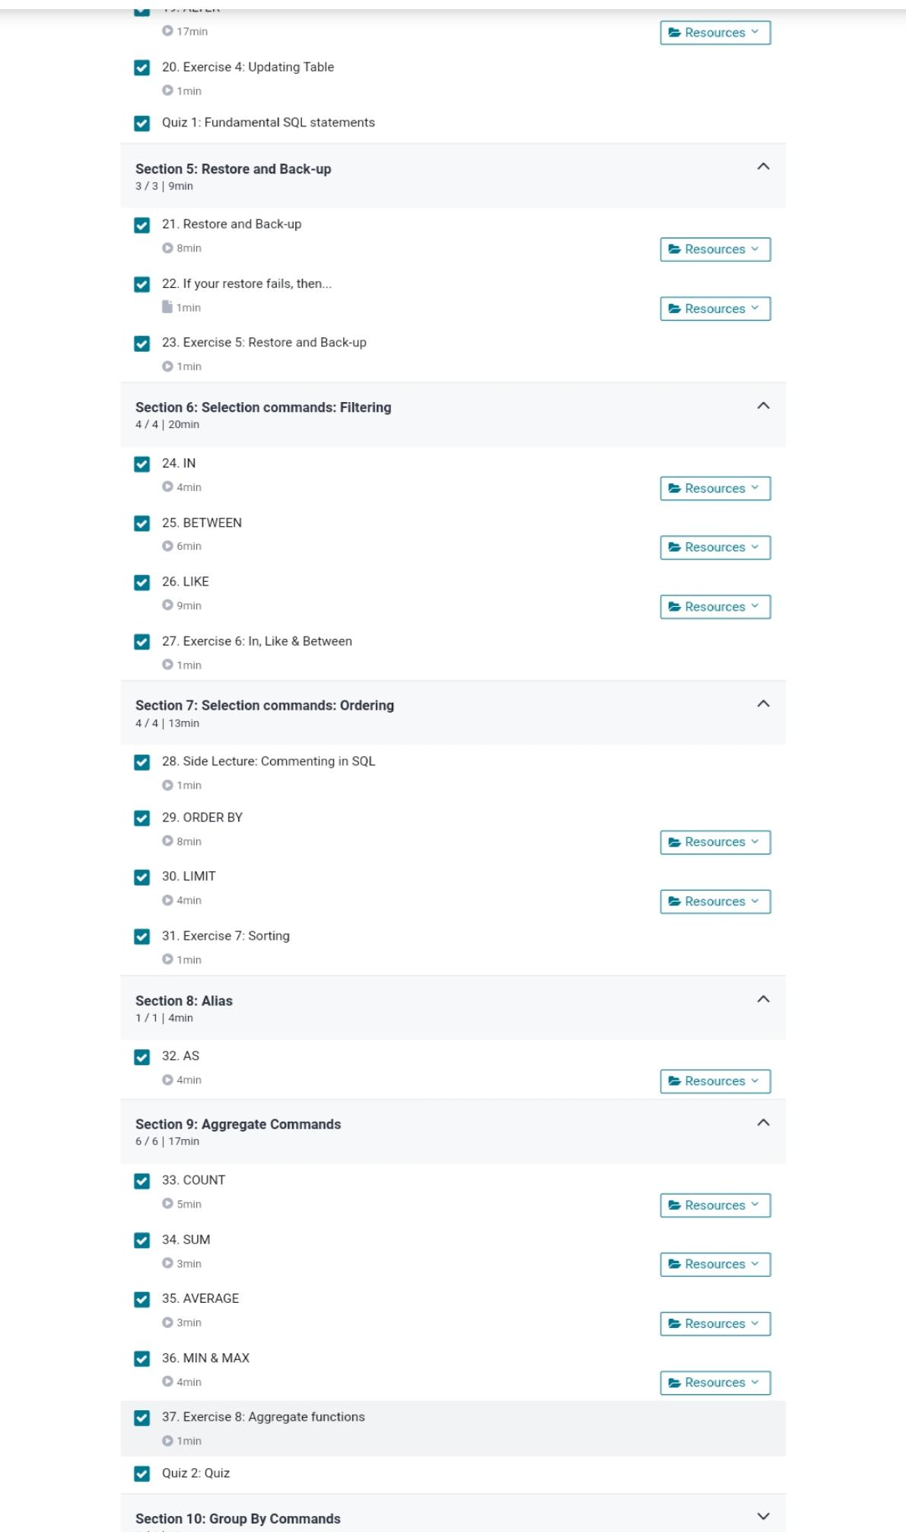Certification Course Details:

Coding Challenges :

import java.util.HashMap;

import java.util.Map;

import java.util.Set;

public class Details {

public void countDupChars(String str){

//Create a HashMap

Map<Character, Integer> map = new HashMap<Character, Integer>();

//Convert the String to char array

char[] chars = str.toCharArray();

/* logic: char are inserted as keys and their count

* as values. If map contains the char already then

* increase the value by 1

*/

for(Character ch:chars){

if(map.containsKey(ch)){

map.put(ch, map.get(ch)+1);

} else {

map.put(ch, 1);

}

}

//Obtaining set of keys

Set<Character> keys = map.keySet();

/* Display count of chars if it is

* greater than 1. All duplicate chars would be

* having value greater than 1.

*/

for(Character ch:keys){

if(map.get(ch) > 1){

System.out.println("Char "+ch+" "+map.get(ch));

}

}

}

public static void main(String a[]){

Details obj = new Details();

System.out.println("String: BeginnersBook.com");

System.out.println("-------------------------");

obj.countDupChars("BeginnersBook.com");

System.out.println("\nString: ChaitanyaSingh");

System.out.println("-------------------------");

obj.countDupChars("ChaitanyaSingh");

System.out.println("\nString: #@$@!#$%!!%@");

System.out.println("-------------------------");

obj.countDupChars("#@$@!#$%!!%@");

}

}