**DAILY ONLINE ACTIVITIES SUMMARY**

|  |  |  |  |  |  |  |  |
| --- | --- | --- | --- | --- | --- | --- | --- |
| **Date:** | **28/06/20** | | | | **Name:** | **Deena Muthappa** | |
| **Sem & Sec** | **8th sem, A sec** | | | | **USN:** | **4AL16CS028** | |
| **Online Test Summary** | | | | | | | |
| **Subject** | | **Not conducted** | | | | | |
| **Max. Marks** | |  | | **Score** | |  | |
| **Certification Course Summary** | | | | | | | |
| **Course** | **SQL Masterclass :SQL for Data Analytics** | | | | | | |
| **Certificate Provider** | | | **Udemy** | **Duration** | | | **7.2hrs** |
| **Coding Challenges** | | | | | | | |
| **Problem Statement: Java program to break integer into digital** | | | | | | | |
| **Status: Completed** | | | | | | | |
| **Uploaded the report in Github** | | | | **Yes** | | | |
| **If yes Repository name** | | | | **deenamuthaappa/Coding-Challenges** | | | |
| **Uploaded the report in slack** | | | | **Yes** | | | |

Online Test Details: Not conducted

Certification Course Details:

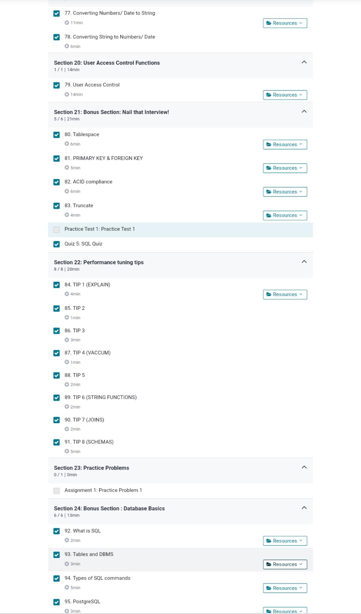

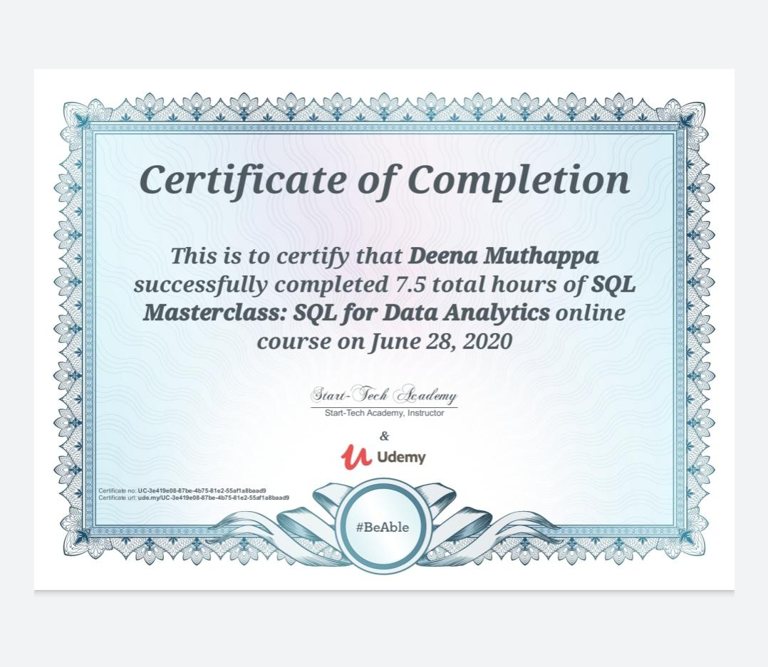

Coding Challenges Details:

//java program to break integer into digits

package com.beginnersbook;

import java.util.Scanner;

public class JavaExample

{

public static void main(String args[])

{

int num, temp, digit, count = 0;

//getting the number from user

Scanner scanner = new Scanner(System.in);

System.out.print("Enter any number:");

num = scanner.nextInt();

scanner.close();

//making a copy of the input number

temp = num;

//counting digits in the input number

while(num > 0)

{

num = num / 10;

count++;

}

while(temp > 0)

{

digit = temp % 10;

System.out.println("Digit at place "+count+" is: "+digit);

temp = temp / 10;

count--;

}

}

}