**DAILY ONLINE ACTIVITIES SUMMARY**

|  |  |  |  |  |  |  |  |
| --- | --- | --- | --- | --- | --- | --- | --- |
| **Date:** | **28/07/20** | | | | **Name:** | **Deena Muthappa** | |
| **Sem & Sec** | **8th sem, A sec** | | | | **USN:** | **4AL16CS028** | |
| **Online Test Summary** | | | | | | | |
| **Subject** | | **Not conducted** | | | | | |
| **Max. Marks** | |  | | **Score** | |  | |
| **Certification Course Summary** | | | | | | | |
| **Course** | **NodeJs React Rest Summer 2020** | | | | | | |
| **Certificate Provider** | | | **Udemy** | **Duration** | | | **26hrs** |
| **Coding Challenges** | | | | | | | |
| **Problem Statement: Write a C program to find largest palindrome in array.** | | | | | | | |
| **Status: Completed** | | | | | | | |
| **Uploaded the report in Github** | | | | **Yes** | | | |
| **If yes Repository name** | | | | **deenamuthaappa/Coding-Challenges** | | | |
| **Uploaded the report in slack** | | | | **Yes** | | | |

Online Test Details:

Certification Course Details:

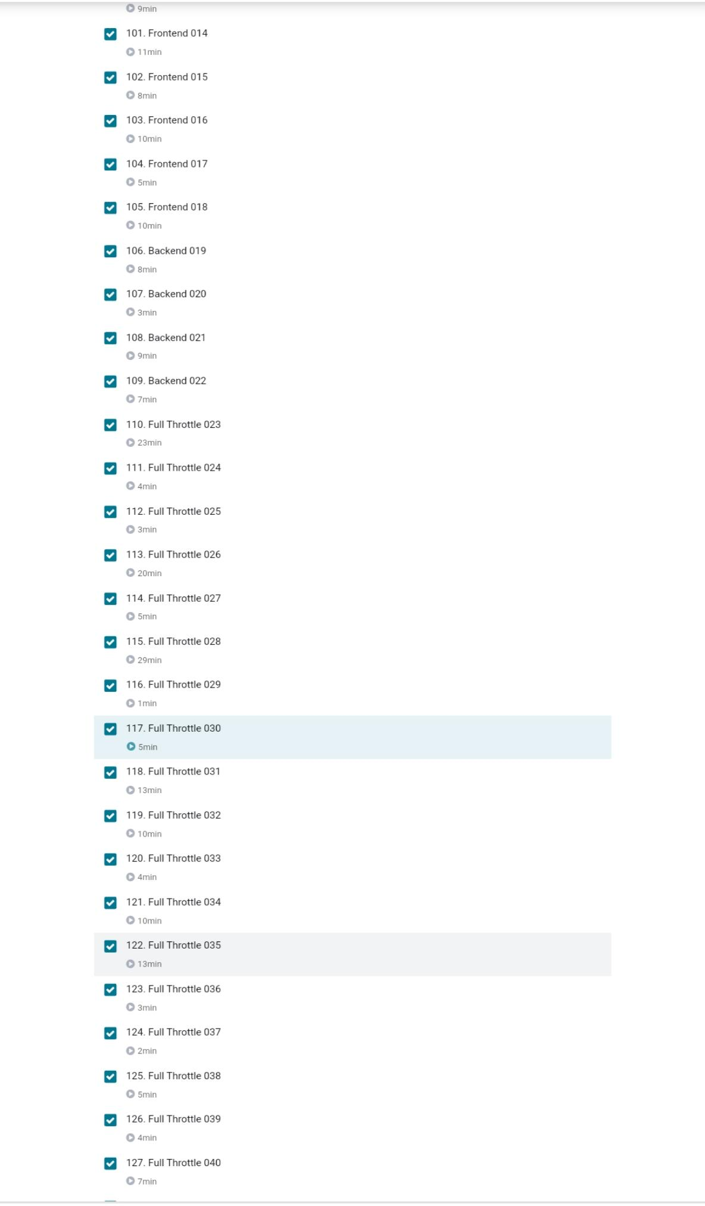

Coding Challenges

#include<stdio.h>

int check_palindrome(int n)

{

int div = 1;

while (n / div >= 10)

div *= 10;

while (n != 0)

{

int first = n / div;

int last = n % 10;

// If first and last digits are not same then return false

if (first != last)

return -1;

// Removing the leading and trailing digits from the number

n = (n % div) / 10;

// Reducing divisor by a factor of 2 as 2 digits are dropped

div = div / 100;

}

return 1;

}

int large_palindrome(int A[], int n)

{

for(int i=0; i<=n; i++)

{

for(int j=i; j<= n; j++)

{

if(A[i] >A [j])

{

int temp = A[i];

A[i] = A[j];

A[j] = temp;

}

}

}

for(int i=0; i<n; i++)

{

printf("%d ", A[i]);

}

for (int i = n - 1; i >= 0; --i)

{

if (check_palindrome(A[i]) == 1)

return A[i];

}

return -1;

}

int main()

{

int a[15], n, i;

printf("Enter the number of entries: \n");

scanf("%d", &n);

printf("Enter the elements: \n");

for(i=0; i<n; i++)

scanf("%d", &a[i]);

printf("\n Largest Palindrome: %d\n", large_palindrome(a, n));

return 0;

}