**DAILY ONLINE ACTIVITIES SUMMARY**

|  |  |  |  |  |  |  |  |
| --- | --- | --- | --- | --- | --- | --- | --- |
| **Date:** | **29/06/20** | | | | **Name:** | **Deena Muthappa** | |
| **Sem & Sec** | **8th sem, A sec** | | | | **USN:** | **4AL16CS028** | |
| **Online Test Summary** | | | | | | | |
| **Subject** | | **SMS** | | | | | |
| **Max. Marks** | | **30** | | **Score** | | **Not displayed** | |
| **Certification Course Summary** | | | | | | | |
| **Course** | **Java programming complete beginners to advanced** | | | | | | |
| **Certificate Provider** | | | **Udemy** | **Duration** | | | **2.5hrs** |
| **Coding Challenges** | | | | | | | |
| |  | | --- | | **Problem Statement: Python program to swap elements at given positions using Swap** **function** | | | | | | | | |
| **Status: Completed** | | | | | | | |
| **Uploaded the report in Github** | | | | **Yes** | | | |
| **If yes Repository name** | | | | **deenamuthaappa/Coding-Challenges** | | | |
| **Uploaded the report in slack** | | | | **Yes** | | | |

Online Test Details:

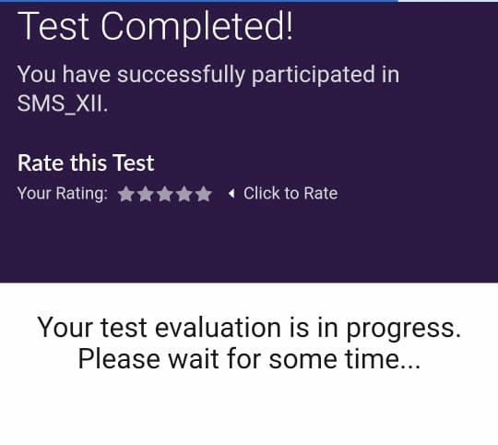

The test was on the subject System Modelling and Simulation

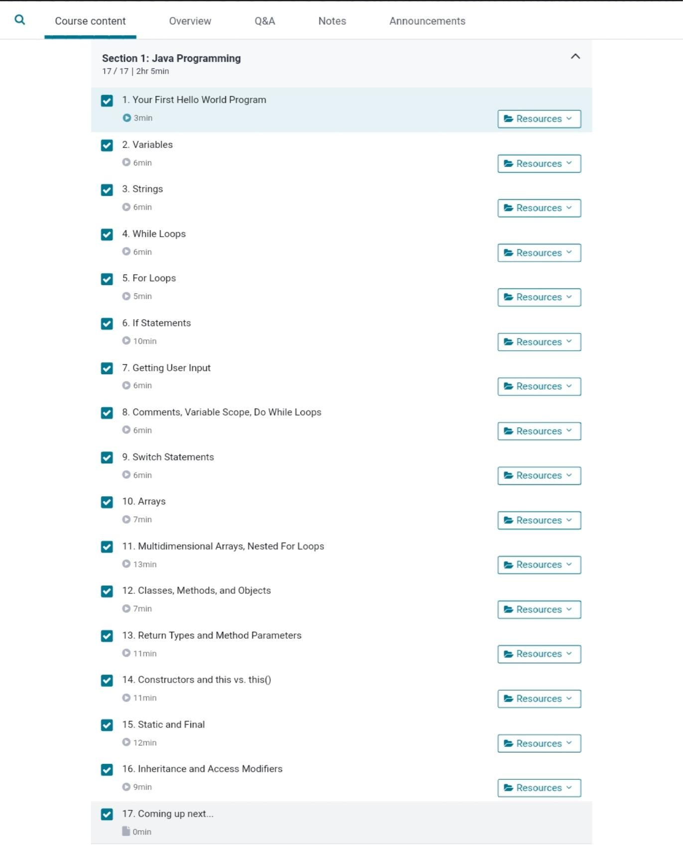Certification Course Details:

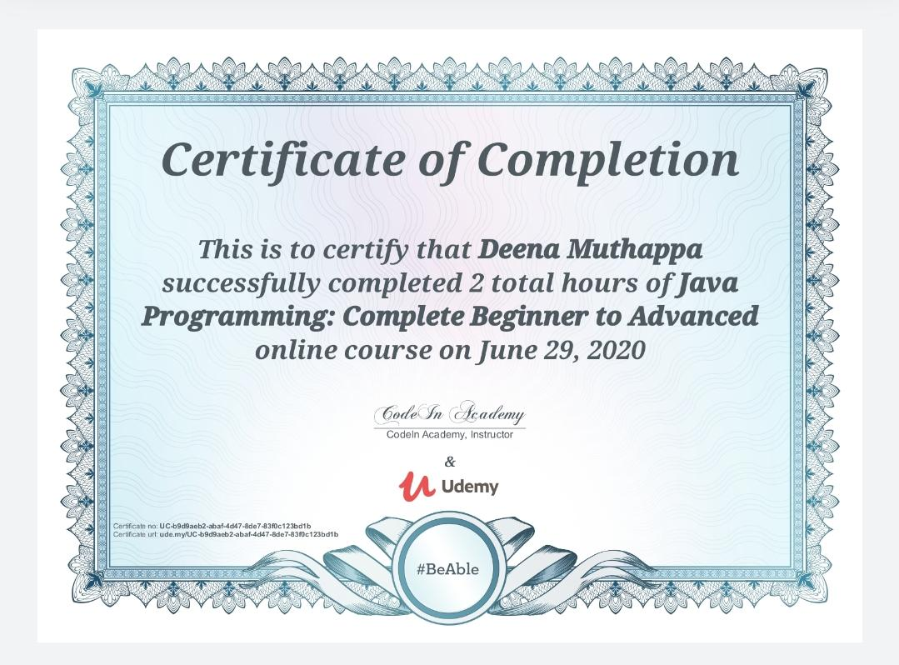

Coding Challenges Details:

def swapPositions(list, pos1, pos2):

list[pos1], list[pos2] = list[pos2], list[pos1]

return list

# Driver function

List = [23, 65, 19, 90]

pos1, pos2 = 1, 3

print(swapPositions(List, pos1-1, pos2-1))