**DAILY ONLINE ACTIVITIES SUMMARY**

|  |  |  |  |  |  |  |  |
| --- | --- | --- | --- | --- | --- | --- | --- |
| **Date:** | **30/07/20** | | | | **Name:** | **Deena Muthappa** | |
| **Sem & Sec** | **8th sem, A sec** | | | | **USN:** | **4AL16CS028** | |
| **Online Test Summary** | | | | | | | |
| **Subject** | | **Not conducted** | | | | | |
| **Max. Marks** | |  | | **Score** | |  | |
| **Certification Course Summary** | | | | | | | |
| **Course** | **NodeJs React Rest Summer** | | | | | | |
| **Certificate Provider** | | | **Udemy** | **Duration** | | | **26hrs** |
| **Coding Challenges** | | | | | | | |
| **Problem Statement: Write a c program to convert binary to octal** | | | | | | | |
| **Status: Completed** | | | | | | | |
| **Uploaded the report in Github** | | | | **Yes** | | | |
| **If yes Repository name** | | | | **deenamuthaappa/Coding-Challenges** | | | |
| **Uploaded the report in slack** | | | | **Yes** | | | |

Online Test Details:

Certification Course Details:

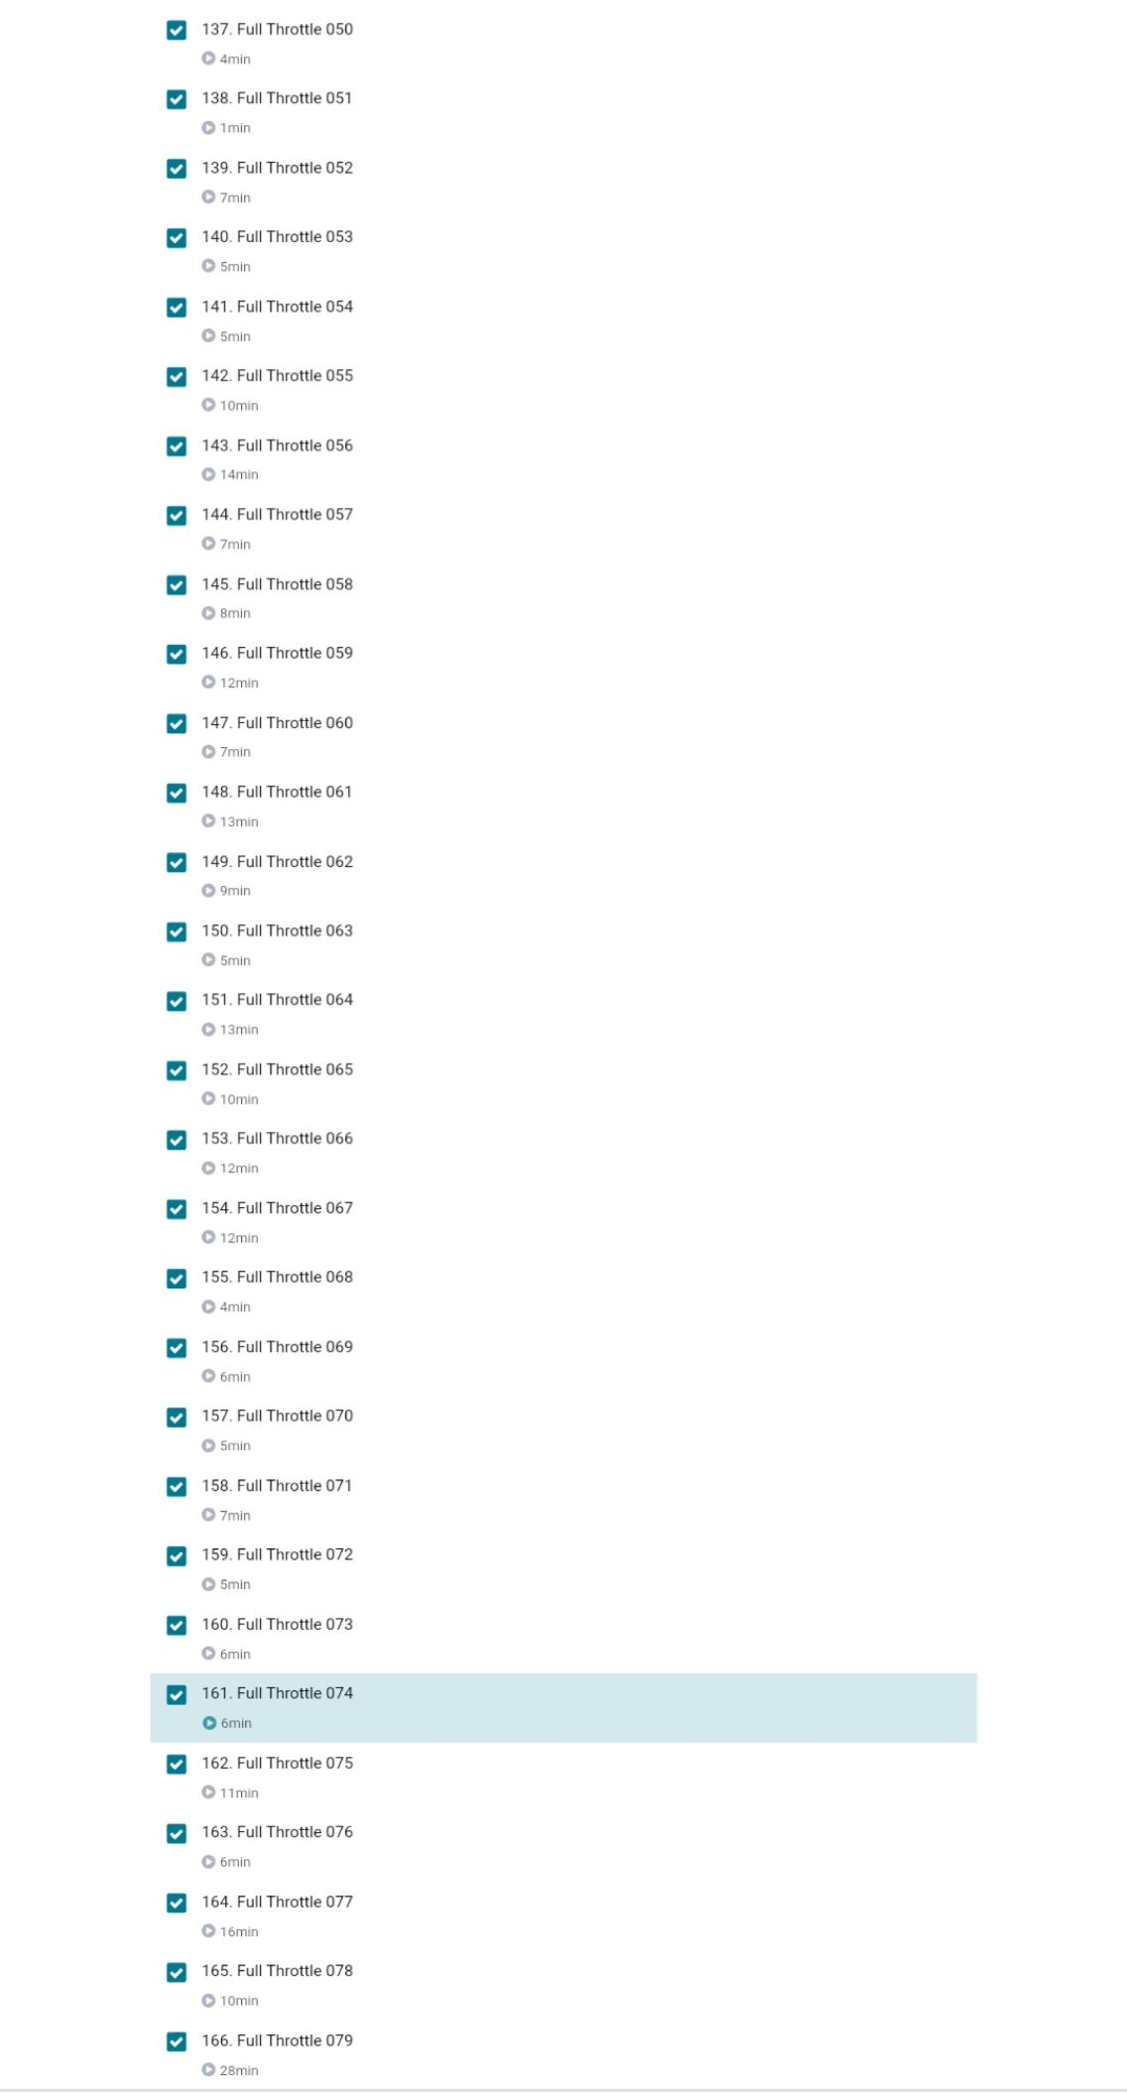

Coding Challenges

//Write a C program to convert binary to octal.

#include <math.h>

#include <stdio.h>

int convert(long long bin);

int main() {

long long bin;

printf("Enter a binary number: ");

scanf("%lld", &bin);

printf("%lld in binary = %d in octal\n", bin, convert(bin));

return 0;

}

int convert(long long bin) {

int oct = 0, dec = 0, i = 0;

// converting binary to decimal

while (bin != 0) {

dec += (bin % 10) * pow(2, i);

++i;

bin /= 10;

}

i = 1;

// converting to decimal to octal

while (dec != 0) {

oct += (dec % 8) * i;

dec /= 8;

i *= 10;

}

return oct;

}