**DAILY ONLINE ACTIVITIES SUMMARY**

|  |  |  |  |  |  |  |  |
| --- | --- | --- | --- | --- | --- | --- | --- |
| **Date:** | **31/07/20** | | | | **Name:** | **Deena Muthappa** | |
| **Sem & Sec** | **8th sem, A sec** | | | | **USN:** | **4AL16CS028** | |
| **Online Test Summary** | | | | | | | |
| **Subject** | | **Not conducted** | | | | | |
| **Max. Marks** | |  | | **Score** | |  | |
| **Certification Course Summary** | | | | | | | |
| **Course** | **NodeJs React Rest Summer** | | | | | | |
| **Certificate Provider** | | | **Udemy** | **Duration** | | | **26hrs** |
| **Coding Challenges** | | | | | | | |
| **Problem Statement :Write a c program to convert decimal to octal** | | | | | | | |
| **Status: Completed** | | | | | | | |
| **Uploaded the report in Github** | | | | **Yes** | | | |
| **If yes Repository name** | | | | **deenamuthaappa/Coding-Challenges** | | | |
| **Uploaded the report in slack** | | | | **Yes** | | | |

Online Test Details:

Certification Course Details:

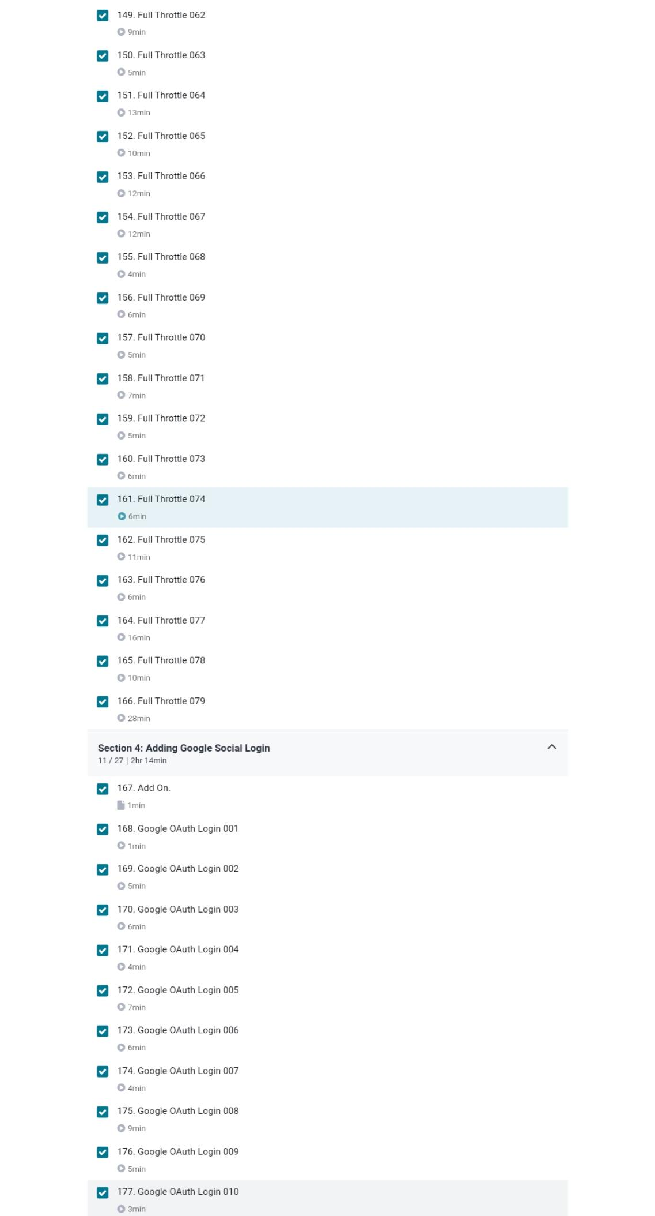

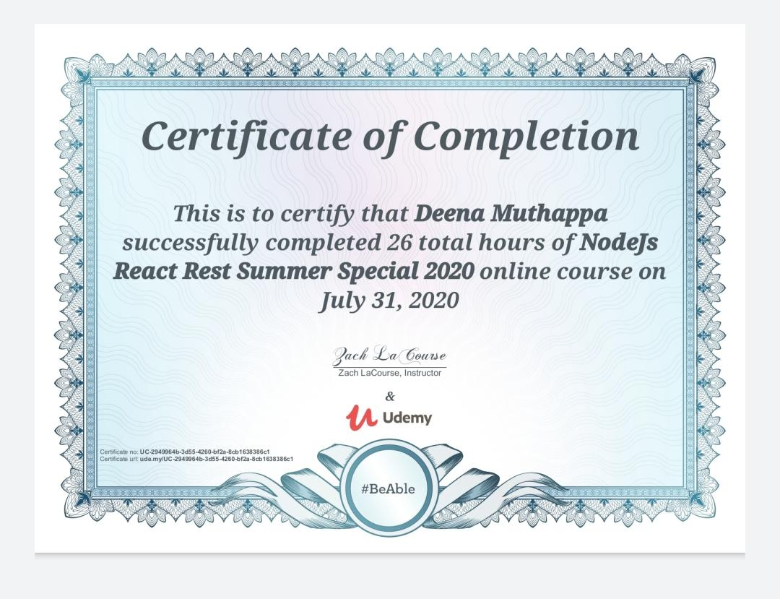

Coding Challenges

#include <stdio.h>

#include <math.h>

int convertDecimalToOctal(int decimalNumber);

int main()

{

int decimalNumber;

printf("Enter a decimal number: ");

scanf("%d", &decimalNumber);

printf("%d in decimal = %d in octal\n", decimalNumber,

convertDecimalToOctal(decimalNumber));

return 0;

}

int convertDecimalToOctal(int decimalNumber)

{

int octalNumber = 0, i = 1;

while (decimalNumber != 0)

{

octalNumber += (decimalNumber % 8) * i;

decimalNumber /= 8;

i *= 10;

}

return octalNumber;

}