- Global Rate Limiter Disabled: Commented out the globalLimiter in

backend/server.js which was restricting requests to 100 per 15 minutes.
- Auth Limiters Bypassed: Replaced

loginLimiter and

forgotPasswordLimiter in

Need to install this

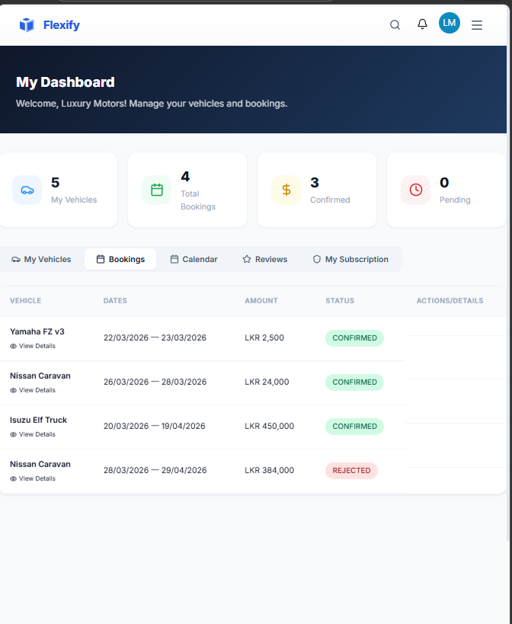Need to fix actions and details page.
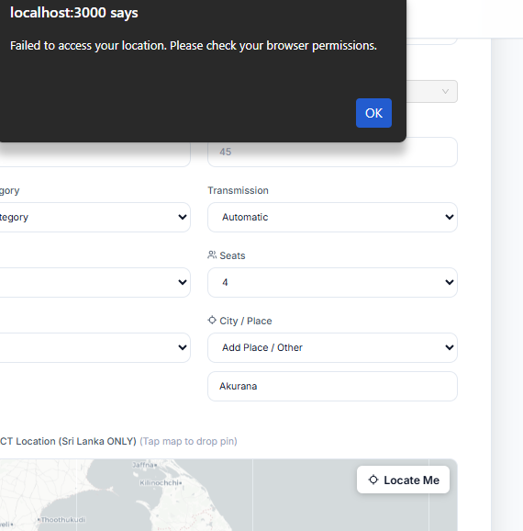

Need to do review after getting vehicle
 give access to change these details in admin page

