Seers and Exponents of Holy Vedas

Maryada Purushotam Shri Ram Chandra ji and Vedas

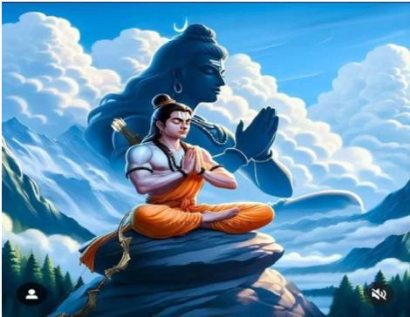

Of course, the word Rama appears in Vedas but that refers to the Supreme being or a Divine manifestation of God. Rama means all pervading. Vedas don’t refer to Maryada Purushotam Shri Ram Chandra ji, the king of Ayodhya. Shri Ram Chandra ji studied Vedas in their gurukul life. The period of Shri Ram Chandra ji, undoubtedly was Treta yuga, the second age, whereas Vedas were given to the rishis just after the human creation i.e. the beginning of Satayuga, the first age.

Veer Hanuman ji and Vedas  
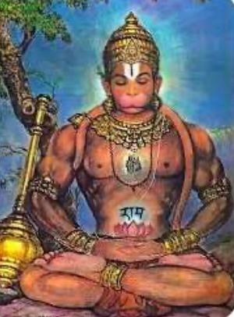

Lord Hanuman ji was an intellectual of the Vedas having deep understanding of Vedic principles and philosophies. There are stories depicting him as having profound knowledge of the scriptures, sometimes even said to have learned them directly from the Sun god, signifying his exceptional intellect and understanding of Vedic teachings.

Hanuman ji first met Lakshmana as an advance party before the meeting between Lord Rama and expelled Sugriva and converse beautifully in Sanskrit language. Lakshmana reported about the conversation to his brother Rama introducing Hanuman ji as a great scholar of Vedas.

Hanuman's intelligence played a crucial role in his service to Lord Rama, where he demonstrated strategic thinking and problem-solving abilities during the rescue of Sita.

Yogiraj Shri Krishna ji and Vedas

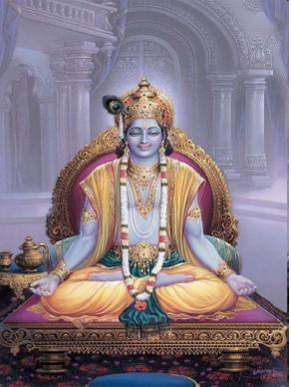

Similarly, Vedas refer to ‘Krishna’ also, but that refers to the Omnipotent Lord, God, who induces all beings to work. Thus, Vedas don’t refer to Yogiraj Shri Krishna ji, the king of Dwarika. Shri Krishna ji himself studied Vedas in Sandipani gurukul in Dwapara yuga, the third age.

Mahatma Buddha and Vedas

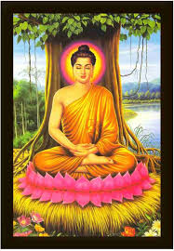

Mahatma Buddha, in the Sutta Nipata 292, has stated about Vedas -

“He who attains true knowledge of Dharma or righteousness through Vedas, attains a steady position. He does not waver. Vedas are the source of Dharma.”

Shimon Lavi, an Arabian Poet and Vedas

Shimon Lavi is credited with founding of religious institutions in Libya and served as a spiritual leader. He sang the glory of Vedas in his Aravian verses to mean -

“O blessed land of Hind (Bharat) thou art worthy of reverence, for in thee has God revealed True knowledge of Himself and He, thus, teaches all races of mankind that inhabit the earth. O my brothers, revere these, for they tell us the good news of salvation, the lessons of brotherhood.

Adi Shankaracharya ji and Vedas

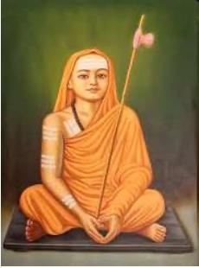

Adi Shankaracharya, an Indian philosopher and theologian, was a major contributor to the study of the Vedas and is considered a leading exponent of the Advaita Vedanta school of philosophy

At the age of four, he could recite the Vedas, and at the age of twelve, he took sanyas and left his home. He established four seats of Vedas to promote the study of four Vedas - (i) Jyotir Math (Uttarakhand) in the north (associated with the Rig Veda), (ii) Sringeri Sharada Peetham (Karnataka) in the south (Yajur Veda), (iii) Govardhana Matha (Puri, Odisha) in the east (Sama Veda), and (iv) Dwarka Sharada Peetham (Gujarat) in the west (Atharva Veda).

Sant Kabir Dass ji and Vedas

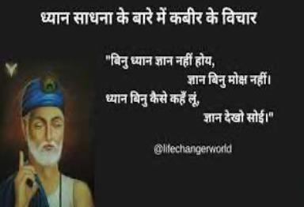

Sant Kabir's teachings align with the core concepts of the Vedas, particularly the idea of a formless, supreme God, often referred to as "Kabir" in his poetry, which he believed to be the same God mentioned in the Vedic texts. Kabir's philosophy emphasized the unity of all creation and the universality of God, a concept also found within the Vedic texts.

In one of his couplets, Kabir ji stated -

Ved kateb kahahu mat jhuthe, jhutha jo na vichaare -

Do not say that the Vedas are false. Liars are those who do not try to understand the Vedas.

Sayanacharya ji and Vedas

Sayanacharya was a priest in Vijay Nagar kingdom. He had interpretted Vedas according to his priestly mindset and is imputed by later Vedic seers and saints to have attempted to estabish casteism and rituals having no scientific foundation. Moreover, he interpretted ‘Soma’ as libals and thus, justified drinking of intoxicating liquids. He established the killing of cows in Vedic period. WhereasVedas are pre-historic and no traits of human beings can be justified with reference to Vedas. Moreover, since Vedas are impersonal i.e. apourushey, therefore neither any history nor any human behaviour can be traced from Vedas. Britishers took full advantages of such wrong interprettations to defame Vedic traditions. British Sanskritist, HH Wilson, based his Vedic works on the Bhasya of Sayanacharya. Even in the present, Sayanacharya’s commentaries are used in most of the Bharatiya universities.

Dara Shikoh and Vedas

Dara Shikoh, the son of Shahajahan and elder brother of Aurangzeb, got all the Upanishadas translated to Persian language. He wrote in these books - “After gradual research, I have come to the conclusion that long before all heavenly books, God had revealed through the Rishis of yore, His four books of knowledge, the Rig Veda, the Yajur Veda, the Sam Veda and the Atharva Veda.”

Guru Nanak Dev ji and Vedas  
  
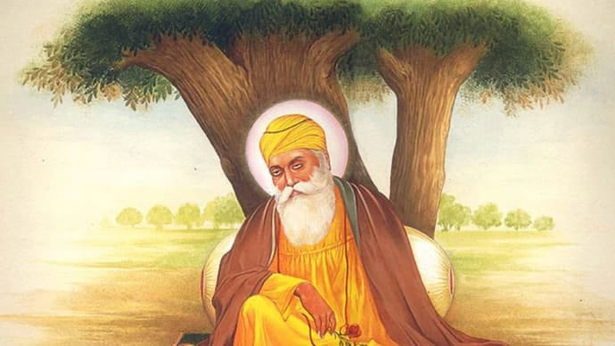

While Guru Nanak acknowledged the wisdom contained within the Vedas. He clearly mentioned that as the darkness disappears with the burning of a small earthen lamp, similarly the evil are revmoved from thse intellect after studying Vedas (diva bale anera jaye, Ved pade mati papan khaye).

Omkaar Ved nirmaaye - The Vedas were revealed by God, the Omkaar.

Asankh granth, mukhi ved paath - Though there are numberles scriptures, the recitation and study of Vedas stands first in the order of merit.

Hari aagyaa hoye Ved, paap punna vichaarya (Mahlaa 5)

The Vedas were revealed under the orders of God, so that the human beings could distinguish between sins and merits.

In Mahlaa 1, Shabad 17, names of all the four Vedas are mentioned as -

Saamved rig jajur atharvan, brahme mukh maa iyaahai traigun.

taaki keemat keet keh na sakai, kou tiu bole jid bolaaidaa.

Sam Veda, Rig, Yajur, and Atharva have been revealed by God. No one can evaluate their importance. They are inestimable and eternal.

In Mahlaa 5, Shabad 17, it is stated -

Omkaar utpaati, chaar ved chaar khaanni.

Four Vedas are four treasures given by God, the Omkaar.

He said -

odak odak bhaali thake, Ved kahin ik baat,

Shastra Ved na maane koi, aapo aape puja hoi.

People made many attempts to know truth, but Ved says only one Truth,

When people don’t accept Vedas as scripture, individual worship begins.

In Vasant Ashtpadiyan, Mahlaa 1 adhyaaya 3, it is stated -

Ved bakhaan kahahi ik kahiye, oh be-ant ant kin laiye -

How can one praise the Holy Veda? They are endless. How can their end be found.

Even the other gurus of the lineage of Guru Nanak Dev ji also followed Vedas. Guru Govind Dev ji went to the extent of declaring that -

Dharam Ved maryad jag mein chalaaun,

gau ghaat ka dosh jag se mitaun.

I with to establish the Vedic traditions in the whole world and

to destroy the sin of killing cows from the whole world.

Guru Nanak Dev ji strongly criticized the rigid interpretations of Vedas and social hierarchies that were often associated with them, particularly regarding caste systems.

Maharishi Dayananda Saraswati ji and Vedas

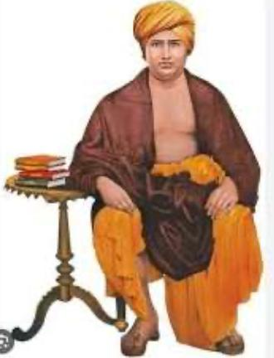

Maharishi Dayananda Saraswati believed that the Vedas were the only uncorrupted sources of Dharma and the repository of Truth. He firts wrote Rig-Vedaadi Bhasya Bhoomika, as an introduction before beginning the commentaries on Vedas. Swami ji, himself, could complete only Yajur Veda, whereas Rig Veda was left incomplete. The tenth division of the Rig Veda, Sam Veda and Atharva Veda commentaries were written by the Vedic scholars following the lines of Maharishi Dayanand ji at much later stage.

He first realised God through his penances and hard yoga practices, while travelling as a recluse. Then, upon the instructions of his Guru Swami Virjananda Saraswati ji, he travelled across India to spread Vedic knowledge and learning and consequently he countered all blind believes and evil social practices as well as raised a strong voice for the beginning of Svarajya i.e. Freedom from the British rule. He founded Arya Samaj, in the year 1875, for propogating Vedic teachings. His disciples established hundreds of gurukulams in Bharat and in other parts of the globe also.

Sri Aurobindo ji and Vedas

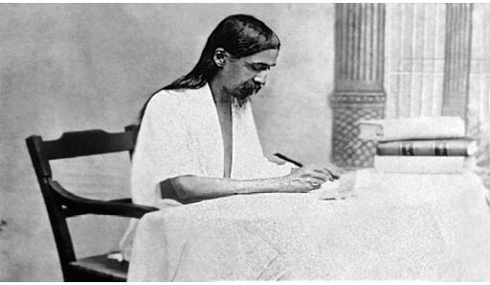

Sri Aurobindo began his study of the Veda in 1910 when he landed in Pondicherry. He had attained such a mastery of the secret meaning of the Veda that in August 1914 he began to publish his essays on the Veda under the title The Secret of the Veda.

Shri Aurobindo wrote in his book “Dayananda and Veda” -

“In the matter of the Vedic interpretation, I am convinced that what ever may be the final complete interpretation, Dayananda will be honoured as the first discoverer of the right clues. Amidst the chaos and obscurity of old ignorance and age-long misunderstanding, his was the eny of direct vision that pierced to the truth and fastened on that which was essential. He has found the keys of the doors that time had closed and rent as under the seals of the imprisoned fountains.”

Maharishi Mahesh Yogi ji and Vedas

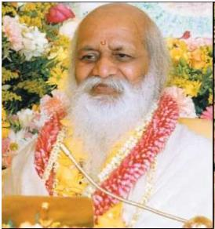

Maharishi's principle contribution to the Vedic tradition is that the Veda exists in consciousness, what he calls "the unified field whispering to itself." Those who know consciousness, know the Veda; according to Maharishi, the unfoldment of consciousness is the central theme of the Vedic literature. According to him, Vedas are the cosmic vibrations and the human body is sustained by vibrations. Therefore, it’s not difficult for human beings to raise their consciousness to that level to receive Vedas directly from cosmic vibrations. For this, he began Transcendental Meditation movement which, according to him, is a natural way to fathom the Unified Field; to develop the whole brain to function in every thought, speech, and action, and promote excellence in one's personal and professional life.

Underlining the importance of Vedas, Maharishi Mahesh Yogi said - "The Vedic Tradition, upheld in its purity by a long history of custodians, enshrines the supreme knowledge of the integration of life. From time to time a revival of man's understanding of the eternal wisdom of this Holy Tradition arises to rescue him from suffering, restoring him to the speedy path of evolution, and awakening him to a meaningful life in fulfillment. The Masters of this Tradition have been exponents of reality from earliest ages. In each new epoch, they have propounded the enduring truths of practical living and have set out those standards by which men's lives may attain the highest achievements and fulfillment, generation after generation"

He inspired for the establishment of hundreds of gurukulas across the globe to teach Vedas.

Maharishi Ramana’s life and Vedas

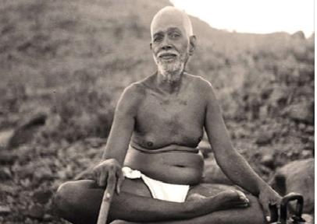

Ramana Maharshi considered the Vedas to be revelations made to ancient sages through intense meditation and self-realization. His teachings emphasized self-inquiry, devotion, mantra, and raja yoga as approaches to self-realization. Through metitational practices and silence he inspired people to unfold the consciousness within them.

Occidental scholars and Vedas  
(Max Muller)

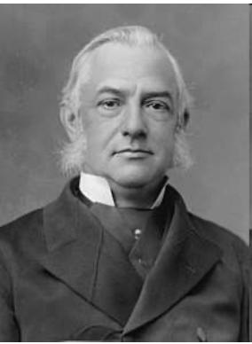

Quite a large number of scholars from western side of the globe were drawn towards understanding and interpretting Vedas, of course, with their own mindset. Dr. Stevenson, Wilson, Griffith, Benfey, Roth (Perersburg Dictionary), Grassmann geldner, Ludwig, Cowell Wallis and last but not the least Max Muller.

Max Muller, after interpreting the whole of the Veda, wrote a letter to his wife: “I have now accomplished the task of translating the whole of the Rig Veda. And when people, even in India, will read my translation and understand what the Veda contains, they will find that there is nothing in it, and then they will easily turn to Christianity and embrace it.”

Of course, we cannot impute same intentions to all of them, but their interprettations cannot be fully relied upon with faith, just for their ignorance of Vedic culture and its history.