MINI PROJECT

Raw Data: - Global-Superstore/Global_Superstore(CSV).csv at master · yannie28/Global-Superstore · GitHub
EXCEL WORK
🧹 Data Cleaning & Transformation Workflow
Step 1: Remove Duplicates
- Press CTRL + A to select all data.
- Go to Data → Remove Duplicates.
- Result: No duplicate values found.
Step 2: Fix Date Inconsistency (Columns C & D)
- Select the affected column(s).
- Navigate to Data → Text to Columns.
- Choose Delimited, then click Next.
- Untick all delimiter options, then click Next.
- Under Column Data Format, select Date → MDY.
- Click Finish.

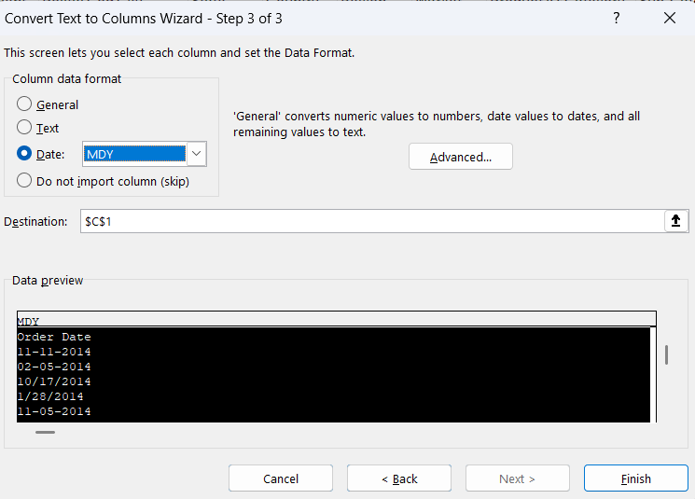

Step 3: Handle Missing Data
Replace missing values with a placeholder like "Unknown". Use ISBLANK Function,
Since the file already has City, State, Country, dropping the postal code column is the most efficient choice.
Step-by-Step in Excel

Step 4: Filtering and sorting
- Click the Order Date column header.
- Choose Sort Oldest to Newest
🧾 Procedure: Convert Data to Table Format
- Select all data (CTRL+A)
- Press CTRL + T → Excel opens the Create Table dialog.
- Ensure “My table has headers” is checked.
- Click OK → your data becomes a formatted table.

POWER BI WORK
🛠 Step-by-Step in Power Query
- Load Global Superstore Excel into Power BI
  - Home → Get Data → Excel → select the file → choose the sheet
- Open Power Query Editor
  - Click Transform Data to open the Power Query Editor.
- Create Copies of the Table
  - In the Queries pane (left side), right-click the Orders query → copy and paste.
  - Do this twice so you have three queries and rename it by right-click
    - Order Detail
    - Customer Detail
    - Product Detail
- Shape Each Table
  - Order Detail:
    - Keep columns like Row ID, Order ID, Order Date, Ship Date, Ship Mode, Customer ID, City, State, Country, Region, Market, Product ID, Sales, Quantity, Discount, Profit, Shipping Cost, Order Priority.
    - Remove descriptive fields (like Customer Name, Product Name) since they’ll live in dimension tables.

  - Customer Detail:
    - Keep columns like Customer ID, Customer Name, Segment.
    - Use Remove Duplicates on Customer ID to ensure each customer appears only once.
  - Product Detail:
    - Keep columns like Product ID, ProductName, Category, Sub-Category.
    - Use Remove Duplicates on Product ID so each product is unique.
- Apply Changes
  - Click Close & Apply to load the three shaped tables back into Power BI.
- Build Relationships
  - In Model view, connect:
    - Order Detail [Customer ID] → Customer Detail [Customer ID]
    - Order Detail [Product ID] → Product Detail [Product ID]
This gives a clean star schema:
  - Fact table: Order Detail
  - Dimension tables: Customer Detail, ProductDetail
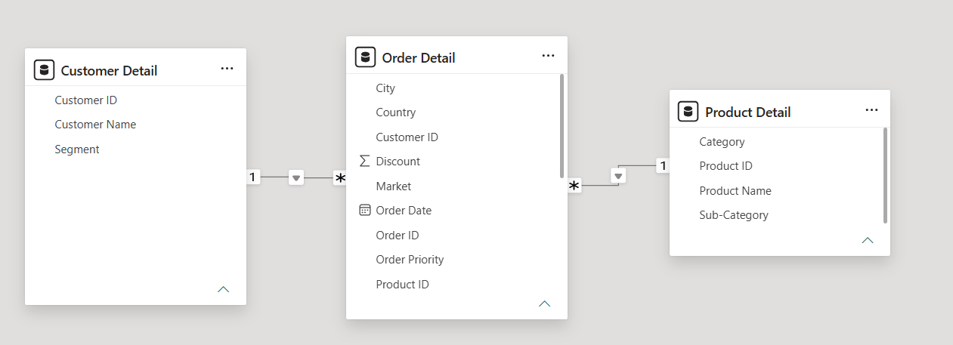
When the same Customer ID appears with different City and State, it means the customer placed orders from multiple locations (perhaps shipping to different addresses). In that case, keeping State, City, Country, Region and Market inside the Order Detail table is the correct approach ✅ because those attributes describe the context of each order, not the customer themselves.

📊 Essential DAX Measures

KPI | DAX Formula | Description
Total Sales | DAX Total Sales = SUM (Order Detail [Sales]) | Calculates total sales revenue across all orders.
Total Revenue | Total Revenue = SUM (Order Detail [Sales]) - SUM (Order Detail [Discount]) | Approximates net revenue after discount impact.
Total Profit | Total Profit = SUM (Order Detail [Profit]) | Sums profit values from all orders.
Profit Ratio | Profit Ratio = DIVIDE ([Total Profit], [Total Sales], 0) | Measures profitability as a percentage of sales.
Discount Impact | Discount Impact = DIVIDE (SUM (Order Detail [Discount]), [Total Sales], 0) | Shows how much discount affects total sales.
Order Quantity | Order Quantity = SUM (Order Detail [Quantity]) | Counts total items sold.
Profit Margin | Profit Margin = DIVIDE ([Total Profit], [Total Revenue], 0) | which areas or products drive profitability.
Average order Value | Avg Order Value= DIVIDE ([Total Sale], DISTINCTCOUNT ('Order Detail'[Order ID]),0) | Calculates the average sales value per order.
Total Customers | Total Customers = COUNT ('Customer Detail'[Customer ID]) | Counts the total number of unique customers
Total Orders | Total Orders= DISTINCTCOUNT ('Order Detail'[Order ID]) | Counts the total number of unique orders placed.
📊 Essential DAX Calculated Column

Column | DAX Formula | Description
Order Month with Year | Order Month with Year = FORMAT ('Order Detail'[Order Date], "MMM YYYY") | Displays the month and year of each order, useful for time-based trend analysis.
Profit Margin | Profit Margin = DIVIDE ('Order Detail'[Profit], 'Order Detail'[Sales]) | Calculates profit margin per order as a percentage of sales, showing profitability efficiency. (%)

🧭 Steps to Create the Dashboards

1.Dashboard Design

- Created three dashboards with distinct purposes:

  - Global Profit Pulse: Focused on overall business performance — KPIs, regional profit map, category-wise profit, and monthly trends.
  - Market Momentum Tracker: Highlighted customer and segment insights — top customers, sales by segment, category and sub-category sales, and order priority.
  - Executive Business Insights: Summarized findings — profit ratios, category performance, customer analysis, trends, and strategic recommendations.

- Visualization Setup

- Used visuals like:
  - Cards for KPIs (Total Sales, Profit Ratio, etc.)
  - Maps for regional profit distribution.
  - Pie charts for market and segment breakdowns.
  - Bar charts for category and order priority analysis.
  - Line charts for profit trends over time.
  - Tree map for sub-category sales.

- Applied consistent colour themes (dark blue background with bright highlights) for clarity and professional appearance.

- Filters and Interactivity

- Added slicers for Year, Category, Segment, and Market to allow dynamic filtering.
- Linked visuals across dashboards for interactive exploration.

- Insights and Recommendations

- Created a summary page (Executive Business Insights) using text boxes and icons to present:
  - Key metrics and trends.
  - Regional and category insights.
  - Customer and order analysis.
  - Actionable recommendations for business growth.

- Page Navigator Setup

- Added Page Navigator buttons to allow smooth movement between dashboards:

  - 🏠 Home icon → Navigates to the Global Profit Pulse page.
  - 📄 Report icon → Opens the Market Momentum Tracker page.
  - 📊 Chart icon → Opens the Executive Business Insights page.

- Used Power BI’s Page Navigator feature under Insert → Buttons → Navigator → Page Navigator.
- Customized icons, colours, and hover effects to match the dark theme for a professional look.

- Reset Button

- Added a Reset (↩️) button at the top of the sidebar to clear all filters and slicers.
- Configure it using Action → Reset Filters so users can instantly return to the default dashboard view.
- Styled it with a subtle outline and hover effect for visibility without distraction.

🧾 Executive Summary

The business achieved a total profit of $288.92K from 1.71M in sales, supported by 800 customers across 867 orders. The average order value is $1.97K, with a profit ratio of 16.89% and minimal discount impact (0.01%), reflecting strong pricing discipline.

🌍 Regional & Market Insights

- Asia Pacific (25.39%) and LATAM (23.53%) lead in profitability.
- Europe (18.80%),USCA (16.59%), and Africa (15.70%) show moderate to lower profit ratios, highlighting opportunities for improvement.
Consumer
🏷️ Category & Segment Performance

- Technology dominates with $756.98K in sales and $145K profit, followed by Furniture ($601.49K / $82K) and Office Supplies ($352.50K / $62K).
- The segment contributes over half of total sales (51.05%), while Corporate (30.64%) and Home Office (18.3%) provide steady support.

⚙️ Order & Customer Analysis

- High and Medium priority orders generate the majority of sales ($0.69M and $0.62M), showing effective prioritization.
- Adrian Barton is the top customer with $12K in sales, followed by several others in the $6K–$9K range, indicating a balanced customer base.

📈 Trends & Opportunities

- trends peak around June and December, signaling seasonal demand cycles during mid-year and year-end.
- Subcategoryanalysis highlights Phones ($417.94K) and Appliances ($289.71K) as major contributors, while smaller categories like Machines and Accessories offer Profit growth potential.

🚀 Key Recommendations

- Capitalize on June & December peaks with targeted promotions and inventory planning.
- Grow Corporate & Home Office segments with bulk deals and B2B packages.
- Diversify categories by boosting Furniture and Office Supplies with bundles or cross-sell strategies.
- Retain top customers using loyalty programs and personalized offers.

— End of Document —
Prepared by: Deenu | Date: August 2026

