PES University, Bengaluru
Department of Computer Science and Engineering
UE24CS351A — Database Management Systems
DBMS Experiential Learning — Level 3 Project Report
CTFVault: A Hybrid Database Platform for Dynamic CTF Scoring and Semantic Search
SRN | Name
PES1UG24CS144 | Deeptha Shankar
PES1UG24CS161 | Subhransi

Faculty: Dr. Nagasundari S
B.Tech CSE · Semester V · Section C · August–December 2026
Repository: github.com/deep-1005/DBMS-Project

1. Title
CTFVault: A Hybrid Database Platform for Dynamic CTF Scoring and Semantic Search
Project type: Capture The Flag (CTF) competition platform with a semantic knowledge base.
Database option: Option 2 — SQL + Vector Database (PostgreSQL 16 with the pgvector extension), as listed in requirement 3 of the project brief.
Why it is not a CRUD application: a player's score is never typed in or stored as a number. It is derived from an append-only ledger in which every new solve retroactively lowers the value of that challenge for every earlier solver, and exactly one team may ever be awarded first blood even when many submit at the same instant. On the knowledge side, writeups are retrieved by meaning rather than by matching words, and the same embeddings are used to detect copied solutions across teams.

2. Students — SRN and Name
SRN | Name | Work package | Responsibilities (database and application)
PES1UG24CS144 | Deeptha Shankar | A — Scoring and Integrity Core | Relational schema and seed (db/01–06); scoring transaction fn_submit_flag; triggers for solve awards, audit trail and submission guards; stored procedures; materialised leaderboard and views; authentication with three roles; per-team HMAC flags; API routes submit, leaderboard, challenges, auth; pages login, challenges, scoreboard and shared navigation; concurrency proof and leaderboard benchmark.
PES1UG24CS161 | Subhransi | B — Knowledge and Retrieval Layer | pgvector schema and indexes (db/10–14); writeup chunking and embedding pipeline; embedding service; hybrid semantic + full-text search with Reciprocal Rank Fusion; hint economy (sp_unlock_hint); collusion detection (sp_scan_collusion); API routes search, writeups, hints, admin; pages search, writeups, hints and admin collusion review.
Table 1. Team members and division of work
Requirement 2 asks that each member contributes to both database and application development, so the work was split vertically rather than "database person / frontend person". Each work package owns its own tables, its own advanced database features, its own API routes and its own pages. The two halves meet at three agreed points: Subhransi's tables reference the core tables by foreign key, her routes authenticate through requireRole(), and hint purchases write to the shared score ledger only through sp_unlock_hint. Migration files are numbered 01–06 (A) and 10–14 (B), so the Git history shows the two contributions separately.

3. Abstract
Capture The Flag competitions produce two kinds of data that conventional platforms handle poorly. Scoring is a consistency problem: with dynamic scoring a challenge loses value as more teams solve it, so every new solve changes the score of every team that solved it earlier, and a first-blood bonus must go to exactly one team even when many submit the correct flag in the same millisecond. Knowledge is a retrieval problem: teams publish writeups describing how they solved each challenge, but security techniques are described in inconsistent vocabulary, so keyword search fails — a search for "heap overflow with a leaked libc address" does not find a writeup about "a use-after-free into __free_hook".
CTFVault treats both as database problems. A PostgreSQL relational core stores teams, users, challenges, per-team salted flags, submissions and an append-only score ledger. Scoring runs inside one database transaction (fn_submit_flag) with an ordered row lock, an AFTER INSERT trigger that applies point decay retroactively, and a partial unique index that makes a second first blood impossible to store. A materialised view serves the scoreboard. The pgvector extension stores 384-dimensional embeddings of writeup chunks produced by the all-MiniLM-L6-v2 sentence-transformer, indexed with HNSW for cosine similarity, and combined with PostgreSQL full-text search through Reciprocal Rank Fusion. The same embeddings drive an administrator review queue for near-identical writeups from different teams. A Next.js application provides role-separated pages for players and administrators.
Measured results: with 25 clients submitting the correct flag simultaneously, the design awards exactly one first blood in 8 of 8 rounds with no client errors, whereas removing the partial unique index awards 25 first bloods in every round. The materialised scoreboard answers in 0.15 ms against 142 ms for the live aggregate at 500,000 ledger rows (944×). Semantic search retrieves all three relevant writeups for a query sharing none of their words, where keyword search returns no results, and the similarity scan flags a paraphrased copy at cosine distance 0.0106 while the closest independent pair sits at 0.3162.

4. Tech Stack
Layer | Technology | Used for
Frontend | Next.js 15.5 (App Router), React 19 | 9 pages: login, challenge board, scoreboard, writeups, search, hints, admin review
Backend / API | Next.js Route Handlers (13 routes) | Input validation, authentication, role checks, rate limiting, database access
Relational database | PostgreSQL 16.15 | Competition state: 13 tables, constraints, transactions, triggers, stored procedures, views, materialised view
Vector database | pgvector 0.8.7 (PostgreSQL extension) | VECTOR(384) column for writeup-chunk embeddings, HNSW index, cosine distance operator <=>
Full-text search | PostgreSQL tsvector + GIN index | Keyword half of the hybrid search; weighted title (A) and body (B)
Embedding model | sentence-transformers/all-MiniLM-L6-v2 | 384-dimensional normalised sentence embeddings, run locally (no third-party API)
Embedding service | Python, FastAPI, uvicorn | POST /embed — converts text to vectors for the Next.js API
Database driver | node-postgres (pg), connection pool | Parameterised queries only; transaction helper records the acting user
Authentication | bcryptjs (cost 12), jose (HS256 JWT) | Password hashing; signed httpOnly session cookie; 3 roles: admin, setter, player
Testing | psql assertion suite, Python + psycopg2 | 17 scoring assertions, three-mode concurrency proof, leaderboard benchmark
Version control | Git + GitHub | Source code, individual commit history, README with setup steps
Table 2. Technology stack

4.1 Why SQL and a vector database
Requirement 18 asks that each database be chosen because of the data, not for demonstration. The two halves of CTFVault have different kinds of data and need different guarantees:
- Relational (PostgreSQL) for competition state. Scores must be exactly right under concurrent submissions. Awarding first blood to one of 25 simultaneous solvers needs an atomic check-and-write, and a partial unique index makes a second first blood unrepresentable. Retroactive decay is a set operation over every earlier solver. These are ACID guarantees and declarative constraints that a relational database provides directly.
- Vector (pgvector) for the writeup corpus. Finding writeups by meaning is a nearest-neighbour search in a 384-dimensional embedding space using cosine distance. That operation cannot be expressed with joins, LIKE or full-text indexes. Keeping pgvector in the same PostgreSQL instance means writeups can be filtered by relational facts (only challenges the searching team has already solved) in the same SQL statement as the similarity search.

5. SQL — Database Commands
All statements below are taken from the repository files named in each heading. Outputs were produced by running them against the project database after a full demonstration session.

5.1 Schema overview
Table | Owner | Purpose | Key constraints
categories | A | Challenge categories (pwn, web, crypto …) | PK; UNIQUE(name)
teams | A | Competing teams | PK; UNIQUE(name), UNIQUE(invite_code); CHECK name length
users | A | Accounts with role and team | PK; FK→teams ON DELETE SET NULL; CHECK role IN (admin, setter, player); CHECK captain has a team; UNIQUE username, email
challenges | A | Challenge, decay parameters, live points | PK; FK→categories, users; CHECK min ≤ initial, current within band, decay > 0
challenge_flags | A | One salted flag hash per (challenge, team) | PK; FKs; UNIQUE(challenge_id, team_id)
submissions | A | Every flag attempt | PK; FKs; CHECK first blood ⇒ correct; partial UNIQUE one solve per team, one first blood per challenge
score_ledger | A | Append-only scoring events | PK; FKs; CHECK entry_type IN (solve, first_blood, decay_adjust, hint_penalty)
audit_log | A | Row-level change history (trigger-written) | PK; FK→users; CHECK action
writeups | B | Published solution text + tsvector | PK; FKs; UNIQUE(challenge_id, team_id); CHECK title ≥ 3, body ≥ 80 chars
writeup_chunks | B | Ordered passages with VECTOR(384) | PK; FK ON DELETE CASCADE; UNIQUE(writeup_id, chunk_index)
hints | B | Hint catalogue with point cost | PK; FK; CHECK cost > 0; UNIQUE(challenge_id, display_order)
hint_unlocks | B | M:N teams ↔ hints | Composite PK (team_id, hint_id)
collusion_alerts | B | Similar writeup pairs for review | PK; FKs; CHECK a < b, distance 0–2, status; UNIQUE pair
Table 3. Tables, owners and constraints (13 tables)

5.2 DDL — CREATE, ALTER, DROP
Tables are rebuilt from scratch by dropping them first (DROP … CASCADE) and recreating them with their keys and constraints. submissions is a relationship promoted to an entity: it needs its own key because score_ledger references it.

db/01_core_schema.sql — DROP and CREATE TABLE submissions
DROP TABLE IF EXISTS audit_log CASCADE;
DROP TABLE IF EXISTS score_ledger CASCADE;
DROP TABLE IF EXISTS submissions CASCADE;
DROP TABLE IF EXISTS challenge_flags CASCADE;
DROP TABLE IF EXISTS challenges CASCADE;
DROP TABLE IF EXISTS users CASCADE;
DROP TABLE IF EXISTS teams CASCADE;
DROP TABLE IF EXISTS categories CASCADE;

CREATE TABLE submissions (
submission_id BIGSERIAL PRIMARY KEY,
challenge_id INTEGER NOT NULL,
team_id INTEGER NOT NULL,
user_id INTEGER NOT NULL,
submitted_hash CHAR(64) NOT NULL,
is_correct BOOLEAN NOT NULL DEFAULT FALSE,
is_first_blood BOOLEAN NOT NULL DEFAULT FALSE,
submitted_at TIMESTAMPTZ NOT NULL DEFAULT clock_timestamp(),

CONSTRAINT fk_sub_challenge FOREIGN KEY (challenge_id)
REFERENCES challenges (challenge_id) ON DELETE CASCADE,
CONSTRAINT fk_sub_team FOREIGN KEY (team_id)
REFERENCES teams (team_id) ON DELETE CASCADE,
CONSTRAINT fk_sub_user FOREIGN KEY (user_id)
REFERENCES users (user_id) ON DELETE RESTRICT,

-- A first blood is necessarily a correct submission.
CONSTRAINT ck_first_blood_correct
CHECK (NOT is_first_blood OR is_correct)
);

db/01_core_schema.sql — append-only score ledger and ALTER TABLE
CREATE TABLE score_ledger (
entry_id BIGSERIAL PRIMARY KEY,
team_id INTEGER NOT NULL,
challenge_id INTEGER NOT NULL,
submission_id BIGINT NULL,
points INTEGER NOT NULL,
entry_type VARCHAR(16) NOT NULL,
-- clock_timestamp(), NOT now(): now() is the transaction timestamp, so
-- every row a single trigger writes would share it and the leaderboard
-- tie-break (earliest-to-reach-the-total wins) could not separate teams.
awarded_at TIMESTAMPTZ NOT NULL DEFAULT clock_timestamp(),

CONSTRAINT fk_ledger_team FOREIGN KEY (team_id)
REFERENCES teams (team_id) ON DELETE CASCADE,
CONSTRAINT fk_ledger_challenge FOREIGN KEY (challenge_id)
REFERENCES challenges (challenge_id) ON DELETE CASCADE,
CONSTRAINT fk_ledger_submission FOREIGN KEY (submission_id)
REFERENCES submissions (submission_id) ON DELETE SET NULL,

CONSTRAINT ck_ledger_type CHECK (entry_type IN
('solve', 'first_blood', 'decay_adjust', 'hint_penalty'))
);

ALTER TABLE users
ADD CONSTRAINT ck_captain_has_team
CHECK (NOT is_captain OR team_id IS NOT NULL);

5.3 Constraints and indexes
Two partial unique indexes enforce the competition rules inside the database. Because they are partial, wrong submissions can repeat freely while a second correct solve or a second first blood cannot be stored at all. In total the schema creates 20 indexes explicitly (B-tree, partial, GIN and HNSW) in addition to those behind every primary key and UNIQUE constraint.

db/02_core_indexes.sql
CREATE UNIQUE INDEX uq_one_solve_per_team
ON submissions (challenge_id, team_id)
WHERE is_correct;

-- A challenge may have at most ONE first blood, ever.
-- Two teams submitting the correct flag in the same millisecond cannot
-- both be crowned: the second INSERT is rejected by the database.
CREATE UNIQUE INDEX uq_one_first_blood
ON submissions (challenge_id)
WHERE is_first_blood;

CREATE INDEX ix_sub_wrong_recent
ON submissions (team_id, submitted_at DESC)
WHERE NOT is_correct;
Validation at the database level — three invalid writes, each rejected by a constraint rather than by application code:
ERROR: new row for relation "users" violates check constraint "ck_user_role"
DETAIL: Failing row contains (9, mallory, mallory@ctfvault.test, xxx…, superuser, …).
ERROR: new row for relation "hints" violates check constraint "ck_hint_cost"
DETAIL: Failing row contains (3, 1, Free hint, This should cost something., -10, 9).
ERROR: duplicate key value violates unique constraint "uq_one_first_blood"
DETAIL: Key (challenge_id)=(1) already exists.

5.4 Functions, triggers and stored procedures
The schema defines 6 functions, 5 triggers and 4 stored procedures. The point-decay curve is a pure function; the scoring trigger applies it and writes the ledger rows.

db/03_functions_triggers.sql — decay function
CREATE OR REPLACE FUNCTION fn_challenge_points(
p_initial INTEGER,
p_min INTEGER,
p_decay_rate INTEGER,
p_solves INTEGER
) RETURNS INTEGER
LANGUAGE plpgsql
IMMUTABLE
AS $$
DECLARE
v_ratio NUMERIC;
v_points NUMERIC;
BEGIN
IF p_solves <= 0 THEN
RETURN p_initial;
END IF;

v_ratio := LEAST(p_solves::NUMERIC / p_decay_rate::NUMERIC, 1.0);
v_points := p_initial + (p_min - p_initial) * (v_ratio * v_ratio);

RETURN GREATEST(p_min, ROUND(v_points)::INTEGER);
END;
$$;

db/03_functions_triggers.sql — scoring trigger (excerpt) and trigger definitions
v_old_points := v_ch.current_points;
v_new_points := fn_challenge_points(
v_ch.initial_points, v_ch.min_points,
v_ch.decay_rate, v_ch.solve_count + 1);

UPDATE challenges
SET solve_count = solve_count + 1,
current_points = v_new_points
WHERE challenge_id = NEW.challenge_id;

-- (2) this team's award, at the post-decay value
INSERT INTO score_ledger
(team_id, challenge_id, submission_id, points, entry_type)
VALUES
(NEW.team_id, NEW.challenge_id, NEW.submission_id,
v_new_points, 'solve');

-- (3) first-blood bonus: 10% of the challenge's opening value
IF NEW.is_first_blood THEN
v_bonus := GREATEST(1, ROUND(v_ch.initial_points * 0.10)::INTEGER);
INSERT INTO score_ledger
(team_id, challenge_id, submission_id, points, entry_type)
VALUES
(NEW.team_id, NEW.challenge_id, NEW.submission_id,
v_bonus, 'first_blood');
END IF;

-- (4) retroactive adjustment for everyone who solved earlier
v_delta := v_new_points - v_old_points;
IF v_delta <> 0 AND v_ch.solve_count > 0 THEN
INSERT INTO score_ledger
(team_id, challenge_id, submission_id, points, entry_type)
SELECT s.team_id, s.challenge_id, NULL, v_delta, 'decay_adjust'
FROM submissions s
WHERE s.challenge_id = NEW.challenge_id
AND s.is_correct
AND s.submission_id <> NEW.submission_id;
END IF;
...

CREATE TRIGGER tr_submission_award
AFTER INSERT ON submissions
FOR EACH ROW
EXECUTE FUNCTION trg_award_solve();

CREATE TRIGGER tr_audit_challenges
AFTER INSERT OR UPDATE OR DELETE ON challenges
FOR EACH ROW EXECUTE FUNCTION trg_audit_row('challenge_id');

CREATE TRIGGER tr_audit_users
AFTER INSERT OR UPDATE OR DELETE ON users
FOR EACH ROW EXECUTE FUNCTION trg_audit_row('user_id');

CREATE TRIGGER tr_submission_guard
BEFORE INSERT ON submissions
FOR EACH ROW
EXECUTE FUNCTION trg_guard_submission();
Audit trigger output. Each decay update to "Heap of Trouble" was recorded by trg_audit_row, attributed to the player whose solve caused it (the API passes the user through a transaction-scoped setting):
log_id | actor | action | points_before | points_after | solves
--------+-------+--------+---------------+--------------+--------
14 | deep | UPDATE | 500 | 475 | 1
15 | arjun | UPDATE | 475 | 400 | 2
18 | meera | UPDATE | 400 | 275 | 3
(3 rows)
Other procedures: sp_recompute_all_scores() rebuilds the whole ledger in one transaction when decay parameters change; sp_issue_team_flag() stores a team's flag hash idempotently with ON CONFLICT … DO UPDATE; sp_unlock_hint() (work package B) charges a hint exactly once:

db/12_hint_procedures.sql
-- Hint purchases are ledger events, so they are atomic and auditable.
CREATE OR REPLACE PROCEDURE sp_unlock_hint(p_team_id INTEGER, p_hint_id INTEGER)
LANGUAGE plpgsql
AS $$
DECLARE
v_hint hints%ROWTYPE;
v_inserted INTEGER;
BEGIN
SELECT h.* INTO v_hint
FROM hints h
JOIN challenges c ON c.challenge_id = h.challenge_id
WHERE h.hint_id = p_hint_id
FOR UPDATE OF c;

IF NOT FOUND THEN
RAISE EXCEPTION 'Hint does not exist' USING ERRCODE = '23503';
END IF;

INSERT INTO hint_unlocks (team_id, hint_id)
VALUES (p_team_id, p_hint_id)
ON CONFLICT (team_id, hint_id) DO NOTHING;
GET DIAGNOSTICS v_inserted = ROW_COUNT;

IF v_inserted = 1 THEN
INSERT INTO score_ledger
(team_id, challenge_id, points, entry_type)
VALUES
(p_team_id, v_hint.challenge_id, -v_hint.cost, 'hint_penalty');
END IF;
END;
$$;
Result after the same team clicked "Unlock hint" twice — one ledger penalty, not two:
team | hint | points | entry_type
---------+---------------------------+--------+--------------
ZeroDay | Find the memory primitive | -25 | hint_penalty
(1 row)

5.5 Views and materialised view
The scoreboard is a GROUP BY over the whole ledger, so it is materialised and refreshed CONCURRENTLY (which needs the unique index) a short debounce after any write to the ledger. Ties are broken by whichever team reached the total first.

db/05_views.sql
CREATE MATERIALIZED VIEW mv_leaderboard AS
SELECT
t.team_id,
t.name AS team_name,
COALESCE(SUM(l.points), 0)::INTEGER AS total_points,
COUNT(*) FILTER (WHERE l.entry_type = 'solve') AS solves,
COUNT(*) FILTER (WHERE l.entry_type = 'first_blood') AS first_bloods,
MAX(l.awarded_at) AS last_award_at,
RANK() OVER (
ORDER BY COALESCE(SUM(l.points), 0) DESC,
MAX(l.awarded_at) ASC NULLS LAST
) AS rank
FROM teams t
LEFT JOIN score_ledger l ON l.team_id = t.team_id
GROUP BY t.team_id, t.name;

-- Required for REFRESH ... CONCURRENTLY.
CREATE UNIQUE INDEX uq_mv_leaderboard_team ON mv_leaderboard (team_id);
CREATE INDEX ix_mv_leaderboard_rank ON mv_leaderboard (rank);
rank | team_name | total_points | solves | first_bloods
------+---------------+--------------+--------+--------------
1 | NullPointer | 716 | 3 | 2
2 | StackSmashers | 646 | 3 | 0
3 | HeapSpray | 627 | 3 | 1
4 | Segfault | 465 | 2 | 1
5 | ZeroDay | 206 | 1 | 0
(5 rows)
v_team_score_history uses a window function for a running total. Segfault's history shows retroactive decay: their 475-point solve was adjusted down twice, by −75 and −125, as two more teams solved the same challenge.
SELECT to_char(awarded_at, 'HH24:MI:SS.MS') AS at, challenge, entry_type, points, running_total
FROM v_team_score_history
WHERE team_id = (SELECT team_id FROM teams WHERE name = 'Segfault')
ORDER BY awarded_at, entry_id;
at | challenge | entry_type | points | running_total
--------------+-----------------+--------------+--------+---------------
14:53:51.698 | Heap of Trouble | solve | 475 | 475
14:53:51.700 | Heap of Trouble | first_blood | 50 | 525
14:53:55.413 | Heap of Trouble | decay_adjust | -75 | 450
14:53:55.475 | Heap of Trouble | decay_adjust | -125 | 325
14:53:56.337 | Cookie Monster | solve | 140 | 465
(5 rows)
v_suspicious_submission_rate uses GROUP BY with HAVING to list teams guessing far more often than they solve:
CREATE OR REPLACE VIEW v_suspicious_submission_rate AS
SELECT
t.team_id,
t.name AS team_name,
COUNT(*) AS attempts,
COUNT(*) FILTER (WHERE s.is_correct) AS solves,
ROUND(COUNT(*)::NUMERIC
/ NULLIF(COUNT(*) FILTER (WHERE s.is_correct), 0), 1)
AS attempts_per_solve
FROM teams t
JOIN submissions s ON s.team_id = t.team_id
GROUP BY t.team_id, t.name
HAVING COUNT(*) >= 20
AND COUNT(*)::NUMERIC
/ NULLIF(COUNT(*) FILTER (WHERE s.is_correct), 0) > 25
ORDER BY attempts_per_solve DESC;

5.6 DML and queries
INSERT — the seed file inserts categories, teams, users and challenges, and issues one flag per team per challenge with a cross join:
INSERT INTO challenge_flags (challenge_id, team_id, flag_hash)
SELECT c.challenge_id,
t.team_id,
encode(sha256((c.challenge_id::TEXT || ':' || t.team_id::TEXT
|| ':demo-salt')::BYTEA), 'hex')
FROM challenges c
CROSS JOIN teams t;
UPDATE — an administrator's review of a collusion alert (app/api/admin/collusion/route.js), guarded so an alert can only be reviewed once:
UPDATE collusion_alerts
SET status = $1, reviewed_by = $2, reviewed_at = now()
WHERE alert_id = $3 AND status = 'pending';
DELETE inside a transaction — deleting a writeup cascades to its chunks; rolling back restores both:
BEGIN;
SELECT count(*) AS chunks_before FROM writeup_chunks;
DELETE FROM writeups WHERE title = 'Forging the session cookie';
SELECT count(*) AS chunks_after_cascade FROM writeup_chunks;
ROLLBACK;
SELECT count(*) AS chunks_after_rollback FROM writeup_chunks;
BEGIN
chunks_before
---------------
5
(1 row)
DELETE 1
chunks_after_cascade
----------------------
4
(1 row)
ROLLBACK
chunks_after_rollback
-----------------------
5
(1 row)
JOIN, GROUP BY, aggregate FILTER, ORDER BY — solves and wrong attempts per challenge:
SELECT c.title AS challenge, cat.name AS category, c.current_points AS points,
COUNT(*) FILTER (WHERE s.is_correct) AS solves,
COUNT(*) FILTER (WHERE NOT s.is_correct) AS wrong_attempts
FROM challenges c
JOIN categories cat ON cat.category_id = c.category_id
LEFT JOIN submissions s ON s.challenge_id = c.challenge_id
WHERE c.released_at IS NOT NULL
GROUP BY c.challenge_id, c.title, cat.name, c.current_points
ORDER BY solves DESC, c.title;
challenge | category | points | solves | wrong_attempts
-----------------+-----------+--------+--------+----------------
Cookie Monster | web | 140 | 4 | 0
ECB Penguin | crypto | 231 | 3 | 0
Heap of Trouble | pwn | 275 | 3 | 1
Carved Up | forensics | 231 | 2 | 0
(4 rows)
HAVING — teams whose score has been reduced by decay at least once:
SELECT t.name AS team, COUNT(DISTINCT l.challenge_id) AS challenges_scored,
SUM(l.points) AS total, MIN(l.points) AS lowest_entry
FROM teams t JOIN score_ledger l ON l.team_id = t.team_id
GROUP BY t.team_id, t.name
HAVING COUNT(*) FILTER (WHERE l.entry_type = 'decay_adjust') > 0
ORDER BY total DESC;
team | challenges_scored | total | lowest_entry
---------------+-------------------+-------+--------------
NullPointer | 3 | 716 | -125
StackSmashers | 3 | 646 | -94
HeapSpray | 3 | 627 | -70
Segfault | 2 | 465 | -125
(4 rows)
Correlated subquery (NOT EXISTS) — challenges a team has solved but not yet written up:
SELECT t.name AS team, c.title AS solved_but_no_writeup
FROM submissions s
JOIN teams t ON t.team_id = s.team_id
JOIN challenges c ON c.challenge_id = s.challenge_id
WHERE s.is_correct
AND NOT EXISTS (SELECT 1 FROM writeups w
WHERE w.team_id = s.team_id
AND w.challenge_id = s.challenge_id)
ORDER BY team, c.title;
team | solved_but_no_writeup
---------------+-----------------------
HeapSpray | Carved Up
HeapSpray | ECB Penguin
NullPointer | ECB Penguin
Segfault | Cookie Monster
StackSmashers | Cookie Monster
StackSmashers | ECB Penguin
ZeroDay | Carved Up
(7 rows)

5.7 Transactions and concurrency
fn_submit_flag is the only way the application scores a flag. In one transaction it locks the challenge row, verifies the team's salted flag hash, inserts the submission (which fires the scoring trigger), and handles the first-blood race by catching unique_violation and retrying the losing team as an ordinary solve. The full code is shown in Figure 1 (section 8).
Concurrency test (tests/concurrency_test.py) — 25 clients on separate connections submit the correct flag for the same challenge at the same instant; 8 rounds per configuration; the first-blood count is read back from the database:
Configuration | Rounds with ≠ 1 first blood | Most first bloods in a round | Client errors | Median latency
Direct INSERT, partial unique index removed | 8 of 8 | 25 | 0 of 200 | 128.9 ms
Direct INSERT, index present | 0 of 8 | 1 | 188 of 200 rejected | 43.2 ms
Through fn_submit_flag (shipped design) | 0 of 8 | 1 | 0 of 200 | 141.4 ms
Table 4. First-blood correctness under 25 concurrent solvers (measured 31 Oct 2026)
Without the index every one of the 25 clients is crowned. With the index the database rejects the losers; wrapped in fn_submit_flag every client gets a correct answer and exactly one first blood is awarded. An earlier version that took the challenge lock inside the trigger, after the insert, deadlocked under load (SQLSTATE 40P01; 225 of 250 requests failed, median 9.6 s); taking the lock first in one fixed order removed the deadlock entirely (0 of 250 failed, median 155 ms). Details are in docs/BENCHMARKS.md.
Leaderboard query at 500,000 ledger rows | Median | Min | Max
Live aggregate over score_ledger | 142.23 ms | 129.30 ms | 245.52 ms
Read from mv_leaderboard | 0.15 ms | 0.14 ms | 0.37 ms
REFRESH MATERIALIZED VIEW CONCURRENTLY (cost paid per burst of writes) | 151.48 ms | — | —
Table 5. Materialised view benchmark, 15 runs each — 944× faster reads (an earlier run on the core-only build gave 898×)

6. NoSQL / Vector Database Commands
The vector half uses PostgreSQL with the pgvector extension (Option 2 in the project brief). Requirement 8 asks five questions about the design; they are answered here.
Question | Answer in CTFVault
What data is converted into embeddings? | The text of every published writeup, split into passages of about 500 words with 50 words of overlap (app/lib/embeddings.js). Each passage is a row in writeup_chunks, so a long writeup is searchable passage by passage instead of being averaged into one vector.
Which embedding model is used? | sentence-transformers/all-MiniLM-L6-v2: 384 dimensions, mean pooling, L2-normalised. It runs locally through a small FastAPI service (scripts/embedding_service.py), so writeups are never sent to a third party.
How are vectors stored? | In the column writeup_chunks.embedding of type VECTOR(384), alongside chunk_index and token_count, with a foreign key to writeups (ON DELETE CASCADE). Embeddings are written in the same transaction as the writeup, so a writeup is never half-indexed.
Which similarity metric? | Cosine distance, pgvector operator <=> (0 = identical direction, 1 = unrelated, 2 = opposite). The HNSW index uses vector_cosine_ops with m = 16, ef_construction = 64.
How are results retrieved? | Hybrid: the 50 nearest chunks by cosine distance and the 50 best writeups by full-text rank are combined with Reciprocal Rank Fusion, score = 1/(60 + semantic rank) + 1/(60 + keyword rank). Results are restricted in SQL to published writeups for challenges the searching team has already solved.
Table 6. Vector design — the five questions of requirement 8

6.1 Extension, table and indexes

db/10_vector_schema.sql
CREATE EXTENSION IF NOT EXISTS vector;

CREATE TABLE writeup_chunks (
chunk_id BIGSERIAL PRIMARY KEY,
writeup_id INTEGER NOT NULL REFERENCES writeups(writeup_id) ON DELETE CASCADE,
chunk_index INTEGER NOT NULL,
content TEXT NOT NULL,
embedding VECTOR(384),
token_count INTEGER NOT NULL,
created_at TIMESTAMPTZ NOT NULL DEFAULT now(),
CONSTRAINT uq_chunk_position UNIQUE (writeup_id, chunk_index),
CONSTRAINT ck_chunk_index CHECK (chunk_index >= 0),
CONSTRAINT ck_chunk_tokens CHECK (token_count > 0)
);

CREATE OR REPLACE FUNCTION set_writeup_search_vector()
RETURNS TRIGGER
LANGUAGE plpgsql
AS $$
BEGIN
NEW.search_vector :=
setweight(to_tsvector('english', coalesce(NEW.title, '')), 'A') ||
setweight(to_tsvector('english', coalesce(NEW.body, '')), 'B');
NEW.updated_at := now();
RETURN NEW;
END;
$$;

CREATE TRIGGER trg_writeup_search_vector
BEFORE INSERT OR UPDATE OF title, body ON writeups
FOR EACH ROW EXECUTE FUNCTION set_writeup_search_vector();

db/11_vector_indexes.sql
-- Access paths for hybrid retrieval and review queries.
CREATE INDEX ix_writeup_search_vector ON writeups USING GIN (search_vector);
CREATE INDEX ix_writeup_published ON writeups (published, challenge_id);
CREATE INDEX ix_chunk_writeup ON writeup_chunks (writeup_id, chunk_index);
CREATE INDEX ix_chunk_embedding ON writeup_chunks
USING hnsw (embedding vector_cosine_ops)
WITH (m = 16, ef_construction = 64);
CREATE INDEX ix_alert_status ON collusion_alerts (status, created_at);
The installed extension and the resulting table, as reported by psql:
List of installed extensions
Name | Version | Schema | Description
--------+---------+--------+------------------------------------------------------
vector | 0.8.7 | public | vector data type and ivfflat and hnsw access methods
Table "public.writeup_chunks"
Column | Type | Collation | Nullable | Default
-------------+--------------------------+-----------+----------+--------------------------------------------------
chunk_id | bigint | | not null | nextval('writeup_chunks_chunk_id_seq'::regclass)
writeup_id | integer | | not null |
chunk_index | integer | | not null |
content | text | | not null |
embedding | vector(384) | | |
token_count | integer | | not null |
created_at | timestamp with time zone | | not null | now()
Indexes:
"writeup_chunks_pkey" PRIMARY KEY, btree (chunk_id)
"ix_chunk_embedding" hnsw (embedding vector_cosine_ops) WITH (m='16', ef_construction='64')
"ix_chunk_writeup" btree (writeup_id, chunk_index)
"uq_chunk_position" UNIQUE CONSTRAINT, btree (writeup_id, chunk_index)
Check constraints:
"ck_chunk_index" CHECK (chunk_index >= 0)
"ck_chunk_tokens" CHECK (token_count > 0)
Foreign-key constraints:
"writeup_chunks_writeup_id_fkey" FOREIGN KEY (writeup_id) REFERENCES writeups(writeup_id) ON DELETE CASCADE

6.2 Nearest-neighbour search
The query vector :qv is the all-MiniLM-L6-v2 embedding of the text "heap overflow with a leaked libc address". The three heap-exploitation writeups come out closest, even though none contains the words heap, overflow, leak, libc or address; the two web writeups come last.
SELECT w.title, t.name AS team,
ROUND((wc.embedding <=> :'qv')::numeric, 4) AS cosine_distance
FROM writeup_chunks wc
JOIN writeups w ON w.writeup_id = wc.writeup_id
JOIN teams t ON t.team_id = w.team_id
ORDER BY wc.embedding <=> :'qv'
LIMIT 5;
title | team | cosine_distance
------------------------------------------+---------------+-----------------
Double free and tcache poisoning | NullPointer | 0.5688
Use-after-free into __free_hook | Segfault | 0.5728
UAF to overwrite __free_hook | StackSmashers | 0.5776
Algorithm confusion on the session token | NullPointer | 0.9030
Forging the session cookie | HeapSpray | 0.9431
(5 rows)
The query plan confirms that the HNSW index is used (the 384-number vector literal is shortened here):
SET
Limit (actual rows=5 loops=1)
-> Index Scan using ix_chunk_embedding on writeup_chunks (actual rows=5 loops=1)
Order By: (embedding <=> '[-0.0620468, 0.0144428, … 384 values]'::vector)
(3 rows)

6.3 Why keyword search alone is not enough
Full-text search requires every query term to appear, so the same question finds nothing. It remains useful for exact terms, which is why it is kept as the second half of the hybrid search:
tsquery | keyword_matches
---------------------------------------------------+-----------------
'heap' & 'overflow' & 'leak' & 'libc' & 'address' | 0
(1 row)
title | ts_rank
---------------------------------+---------
Use-after-free into __free_hook | 1.0000
UAF to overwrite __free_hook | 0.9989
(2 rows)

6.4 Hybrid search with Reciprocal Rank Fusion
The search route (Figure 3) runs this as one SQL statement with common table expressions: eligible writeups → semantic ranks → keyword ranks → fused score. Result returned by GET /api/search for the query above, signed in as a Segfault player:
Rank | Writeup | Challenge | Team | Fused score
1 | Double free and tcache poisoning | Heap of Trouble | NullPointer | 0.016393
2 | Use-after-free into __free_hook | Heap of Trouble | Segfault | 0.016129
3 | UAF to overwrite __free_hook | Heap of Trouble | StackSmashers | 0.015873
4 | Algorithm confusion on the session token | Cookie Monster | NullPointer | 0.015625
5 | Forging the session cookie | Cookie Monster | HeapSpray | 0.015385
Table 7. Hybrid search result for "heap overflow with a leaked libc address"

6.5 Collusion detection
The same embeddings, compared with each other instead of with a query, flag writeups from different teams that are almost identical in meaning — including reworded copies that a text comparison would miss.

db/13_collusion.sql
-- Idempotent similarity scan. Chunks from the same team/challenge are ignored.
CREATE OR REPLACE PROCEDURE sp_scan_collusion(p_threshold REAL DEFAULT 0.05)
LANGUAGE plpgsql
AS $$
BEGIN
INSERT INTO collusion_alerts (writeup_a_id, writeup_b_id, distance)
SELECT a.writeup_id, b.writeup_id, MIN(a.embedding <=> b.embedding)::REAL
FROM writeup_chunks a
JOIN writeup_chunks b ON a.writeup_id < b.writeup_id
JOIN writeups wa ON wa.writeup_id = a.writeup_id AND wa.published
JOIN writeups wb ON wb.writeup_id = b.writeup_id AND wb.published
WHERE a.embedding IS NOT NULL
AND b.embedding IS NOT NULL
AND wa.team_id <> wb.team_id
AND a.embedding <=> b.embedding < p_threshold
GROUP BY a.writeup_id, b.writeup_id
ON CONFLICT (writeup_a_id, writeup_b_id) DO UPDATE
SET distance = EXCLUDED.distance;
END;
$$;
CALL sp_scan_collusion(0.05);
alert_id | writeup_a | team_a | writeup_b | team_b | distance | status
----------+---------------------------------+----------+------------------------------+---------------+----------+---------
1 | Use-after-free into __free_hook | Segfault | UAF to overwrite __free_hook | StackSmashers | 0.0106 | pending
(1 row)
Cosine distance between every pair of writeups from different teams in the demonstration data:
Writeup A (team) | Writeup B (team) | Distance | Flagged
Use-after-free into __free_hook (Segfault) | UAF to overwrite __free_hook (StackSmashers) | 0.0106 | Yes
Forging the session cookie (HeapSpray) | Algorithm confusion on the session token (NullPointer) | 0.3162 | No
Use-after-free into __free_hook (Segfault) | Double free and tcache poisoning (NullPointer) | 0.3367 | No
Double free and tcache poisoning (NullPointer) | UAF to overwrite __free_hook (StackSmashers) | 0.3401 | No
Writeups for different challenges (5 pairs) |  | 0.849 – 0.884 | No
Table 8. Pairwise distances at the 0.05 threshold
The reworded copy sits at 0.0106 while the closest pair of independent writeups — two teams describing the same JWT technique in their own words — sits at 0.3162, so the 0.05 threshold separates them with a wide margin on this data. A flagged pair is a signal for an administrator to review, not an automatic verdict.

7. Next.js — Project Tree Structure
(A) marks files written in work package A (Deeptha), (B) in work package B (Subhransi).
DBMS-Project/
├── app/ Next.js App Router
│ ├── layout.js root layout: global styles + navigation
│ ├── page.js home page
│ ├── globals.css shared styles
│ ├── components/
│ │ └── Nav.js signed-in user, role and team; admin-only link (A)
│ ├── login/page.js sign in (A)
│ ├── challenges/
│ │ ├── page.js challenge board, category filter, flag submit (A)
│ │ └── [id]/hints/page.js buy hints for a challenge (B)
│ ├── scoreboard/page.js live standings (A)
│ ├── writeups/page.js publish and read writeups (B)
│ ├── search/page.js semantic writeup search (B)
│ ├── admin/collusion/page.js similarity scan and review queue (admin) (B)
│ ├── api/ Route Handlers (backend)
│ │ ├── auth/login/route.js POST sign in, set session cookie (A)
│ │ ├── auth/logout/route.js POST sign out (A)
│ │ ├── auth/me/route.js GET current user (A)
│ │ ├── challenges/route.js GET board · POST create challenge (setter) (A)
│ │ ├── submit/route.js POST flag submission -> fn_submit_flag (A)
│ │ ├── leaderboard/route.js GET standings from mv_leaderboard (A)
│ │ ├── writeups/route.js GET · POST writeup + chunk embeddings (B)
│ │ ├── search/route.js GET hybrid search (RRF) (B)
│ │ ├── hints/route.js GET · POST unlock -> sp_unlock_hint (B)
│ │ └── admin/collusion/route.js GET alerts · POST scan / review (admin) (B)
│ └── lib/
│ ├── db.js pg pool, query(), withTransaction() (A)
│ ├── auth.js bcrypt, JWT session, requireRole() (A)
│ ├── flags.js per-team HMAC flags (A)
│ ├── leaderboard.js debounced materialised-view refresh (A)
│ └── embeddings.js chunking + embedding-service client (B)
├── db/
│ ├── 01_core_schema.sql DDL: 8 core tables (A)
│ ├── 02_core_indexes.sql partial unique + access-path indexes (A)
│ ├── 03_functions_triggers.sql decay function, scoring/audit/guard triggers (A)
│ ├── 04_procedures.sql fn_submit_flag, sp_recompute_all_scores … (A)
│ ├── 05_views.sql mv_leaderboard and views (A)
│ ├── 06_seed.sql demo data (A)
│ ├── 10_vector_schema.sql pgvector tables, tsvector trigger (B)
│ ├── 11_vector_indexes.sql HNSW + GIN indexes (B)
│ ├── 12_hint_procedures.sql sp_unlock_hint (B)
│ ├── 13_collusion.sql sp_scan_collusion (B)
│ └── 14_knowledge_seed.sql demo hints (B)
├── scripts/
│ ├── reset_db.sh rebuild database in order
│ ├── issue_flags.mjs issue per-team flags (A)
│ ├── embedding_service.py FastAPI /embed service (B)
│ └── backfill_embeddings.py embed any chunks missing vectors (B)
├── tests/
│ ├── test_scoring.sql 17 scoring assertions (A)
│ ├── concurrency_test.py first-blood race proof (A)
│ ├── bench_leaderboard.py materialised-view benchmark (A)
│ └── eval_retrieval.py Recall@10 calculator (B)
├── docs/ ER diagram, relational schema, benchmarks, this report
├── .env.example configuration template (no secrets)
├── package.json scripts: dev, build, db:reset, db:flags, db:test …
└── README.md setup and run instructions

7.1 How a request reaches the database
- A page (client component) calls a Route Handler under app/api/ with fetch.
- The handler authenticates the signed session cookie and checks the role with requireRole() — players, setters and admins see different things.
- It validates input, then calls PostgreSQL through app/lib/db.js: every value is passed as a parameter ($1, $2 …), never concatenated into SQL. Multi-step writes use withTransaction(), which also records the acting user for the audit trigger.
- Scoring and hint purchases are single calls to database functions and procedures, so the rules hold even if the application layer is wrong.
- Configuration — database host, user, password, the flag-signing secret and the session secret — comes only from environment variables (.env.local, which Git ignores); .env.example documents them without values.

8. Sample Screenshots — Application Code and Demo
The demonstration below was recorded on the running application connected to PostgreSQL 16 with pgvector: seven accounts across five teams solved challenges, published writeups, searched, bought a hint and ran the collusion review. Every number in the screenshots comes from the database.

8.1 Application code
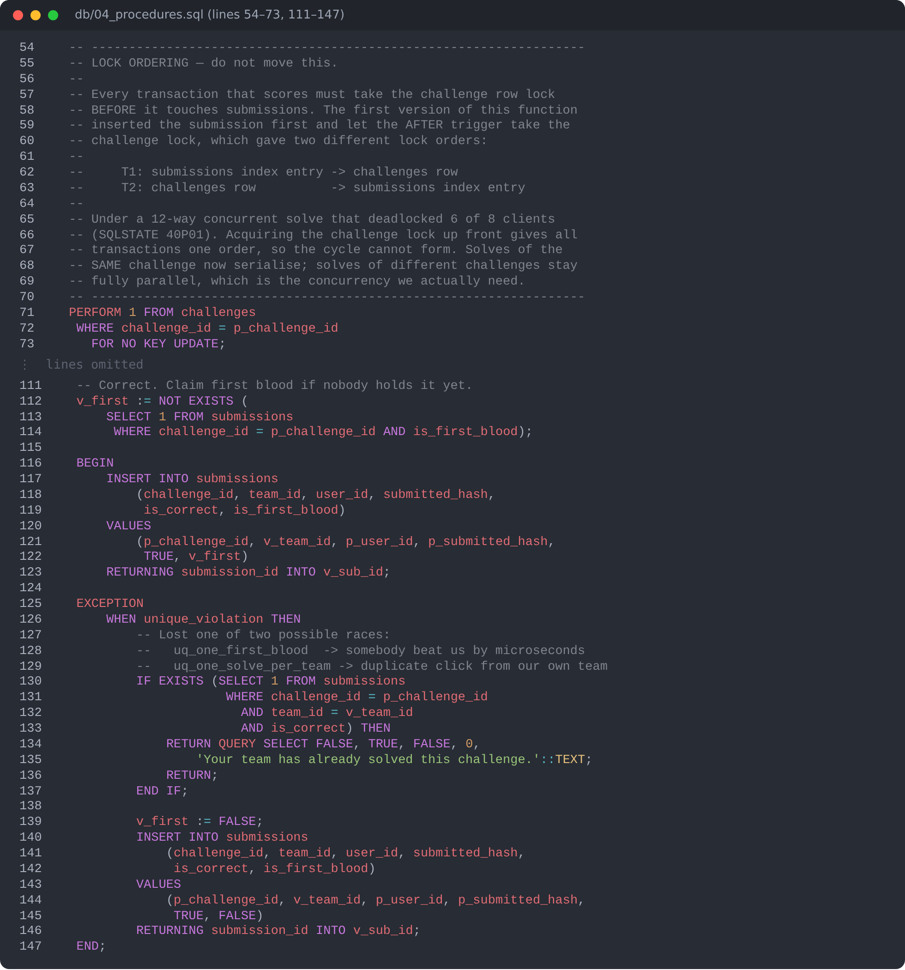
Figure 1. fn_submit_flag — the challenge row is locked first (one lock order, so no deadlock), then the first-blood race is resolved by the partial unique index (Deeptha)
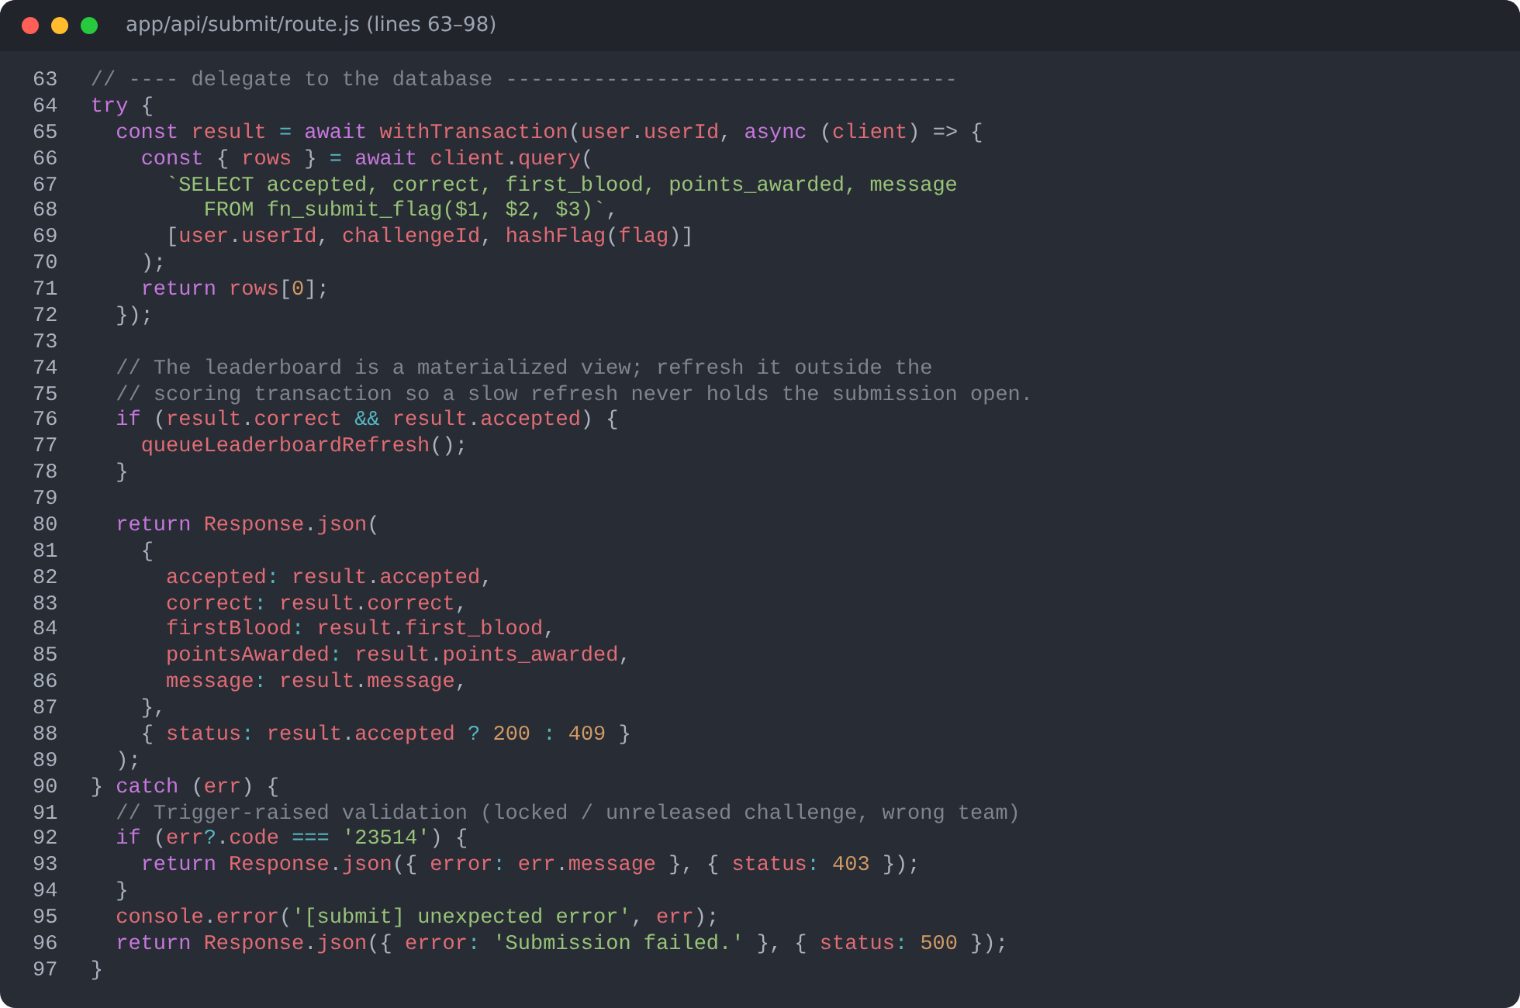
Figure 2. POST /api/submit — the route validates and rate-limits, then delegates scoring to the database inside one transaction (Deeptha)
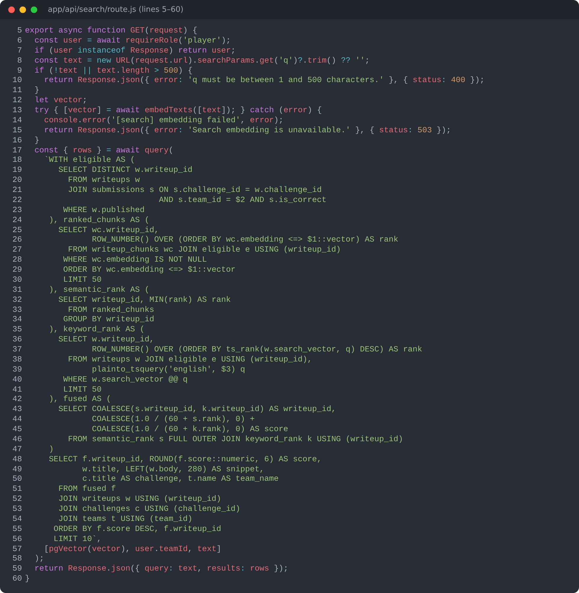
Figure 3. GET /api/search — eligible writeups, semantic and keyword ranks fused with Reciprocal Rank Fusion in one SQL statement (Subhransi)
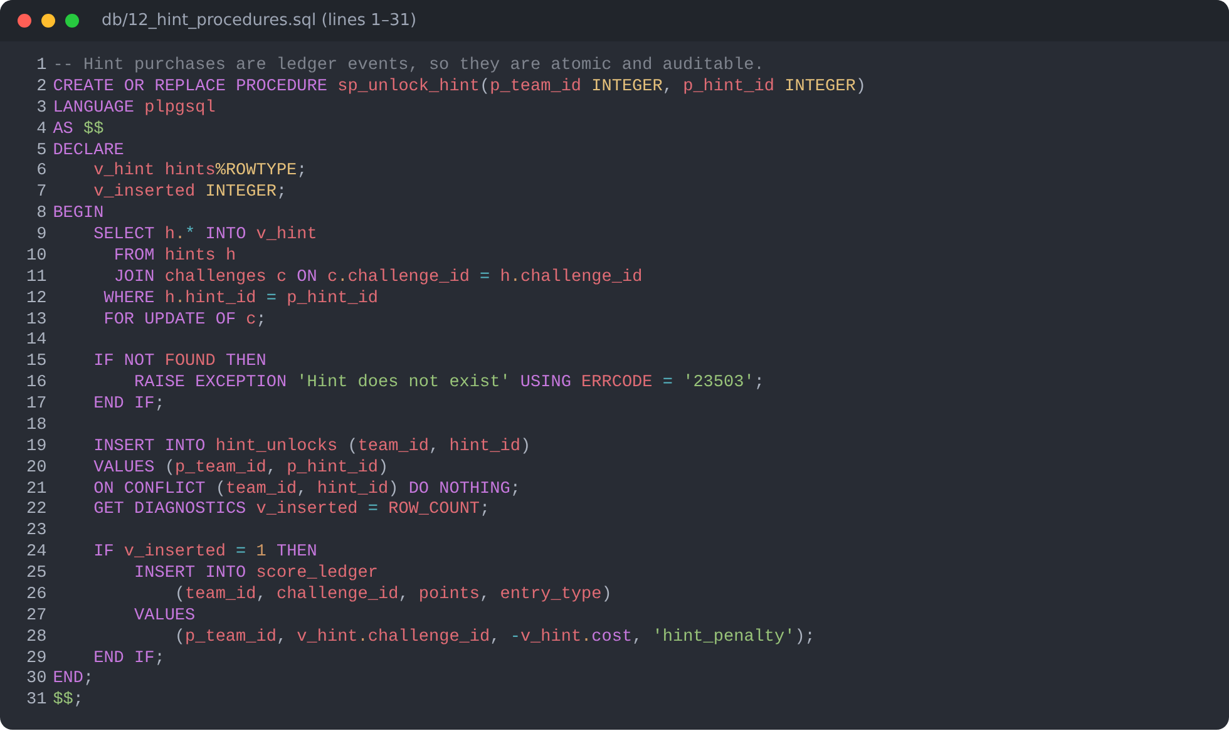
Figure 4. sp_unlock_hint — locks the challenge row (same order as scoring) and charges a hint exactly once (Subhransi)

8.2 Demonstration

Figure 5. Sign-in page. Passwords are checked against bcrypt hashes; a signed httpOnly cookie holds the session
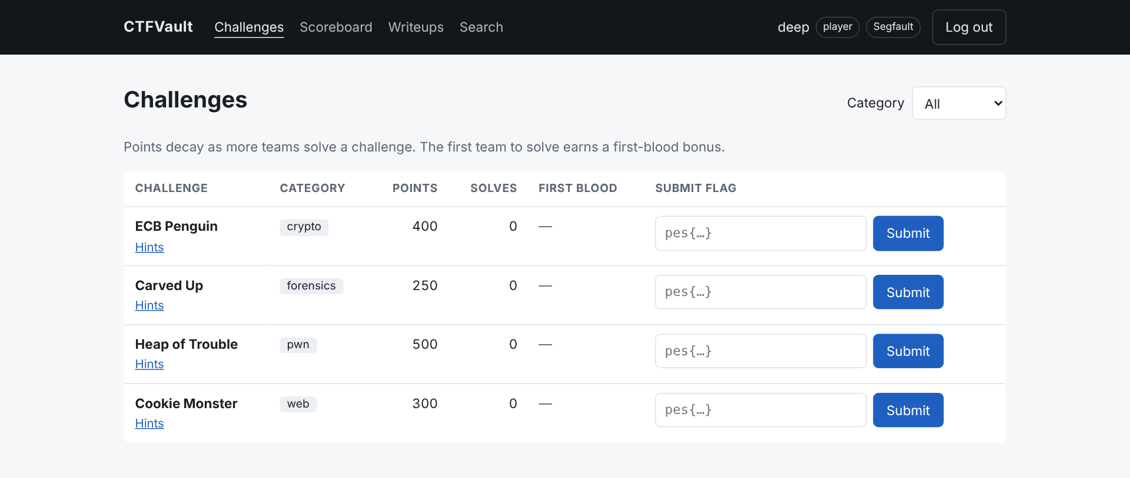
Figure 6. Challenge board for player deep (team Segfault) before any solves, with category filter
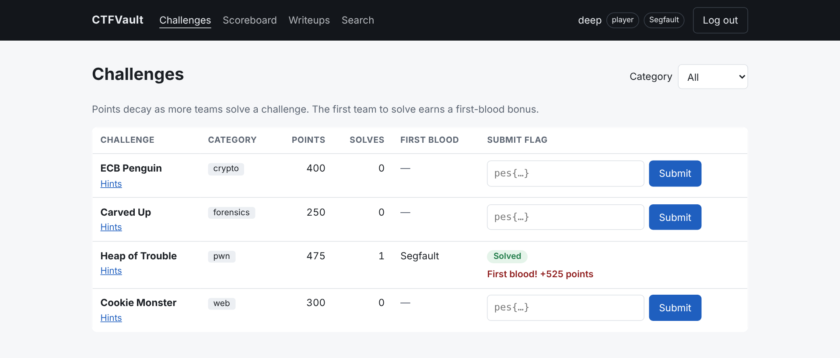
Figure 7. A wrong flag is rejected, then the correct flag wins first blood: 475 points plus a 50-point bonus
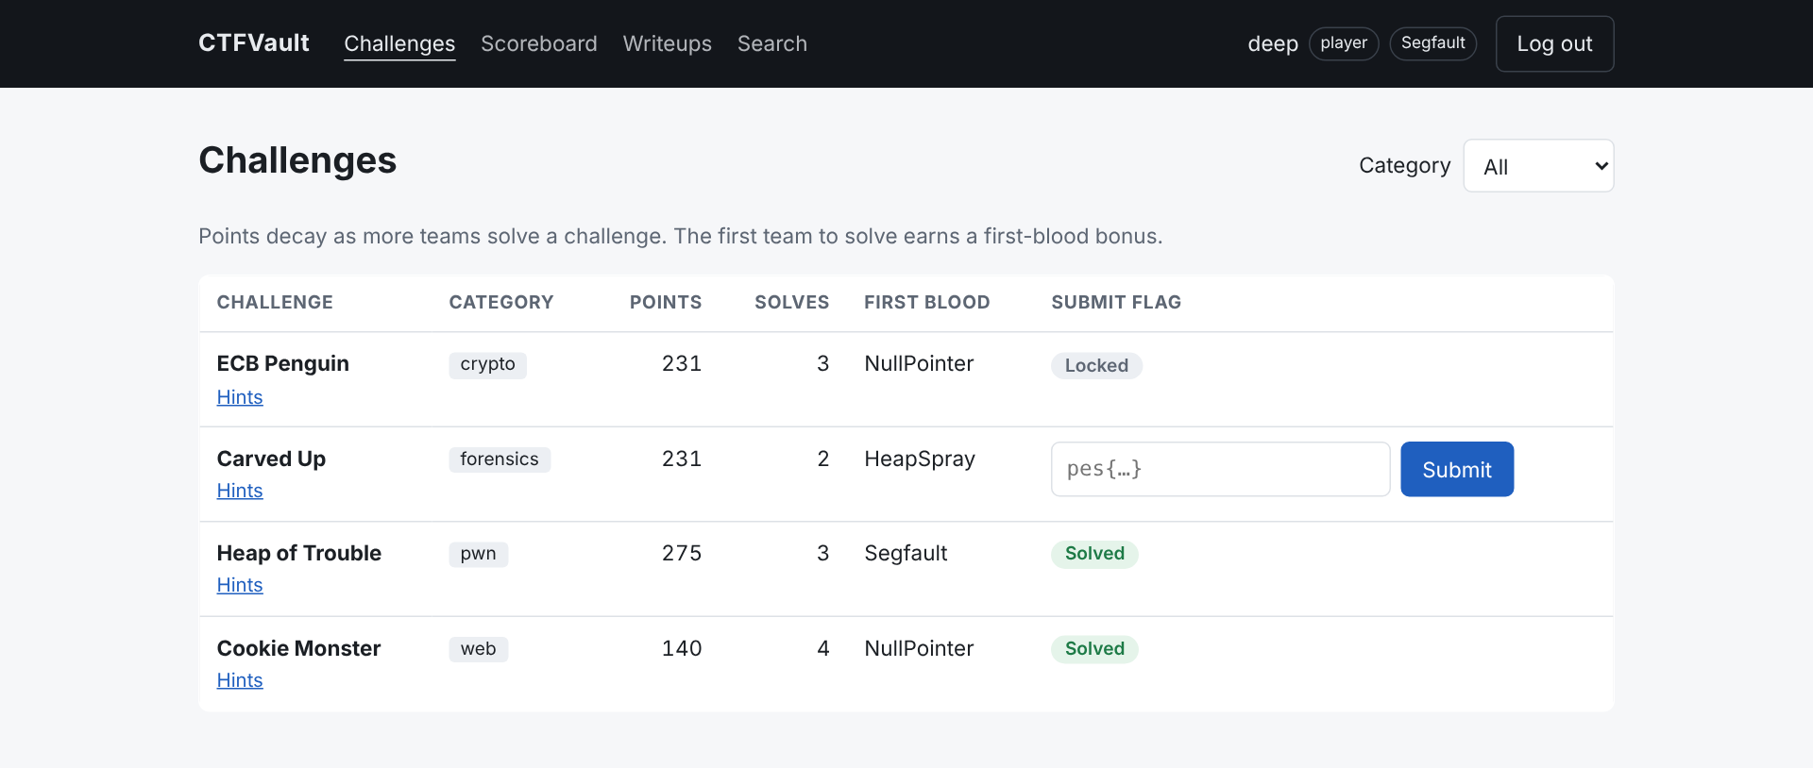
Figure 8. After other teams play: points have decayed, first-blood holders are shown, ECB Penguin locked itself after its third solve
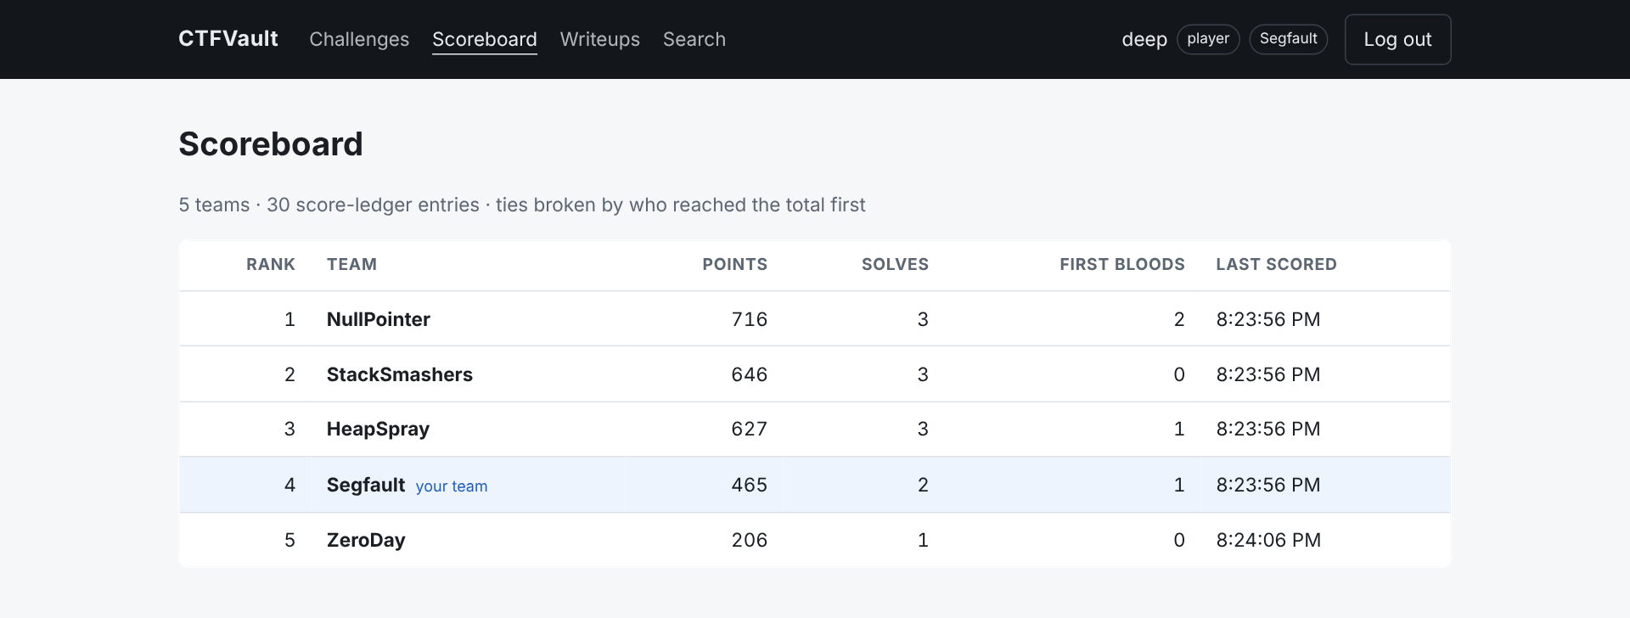
Figure 9. Scoreboard served from the materialised view; the signed-in team is highlighted; ZeroDay shows 206 after a 25-point hint
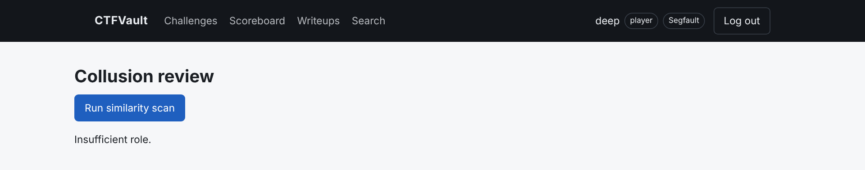
Figure 10. Role-based access: a player opening the admin page is refused by the API (HTTP 403)
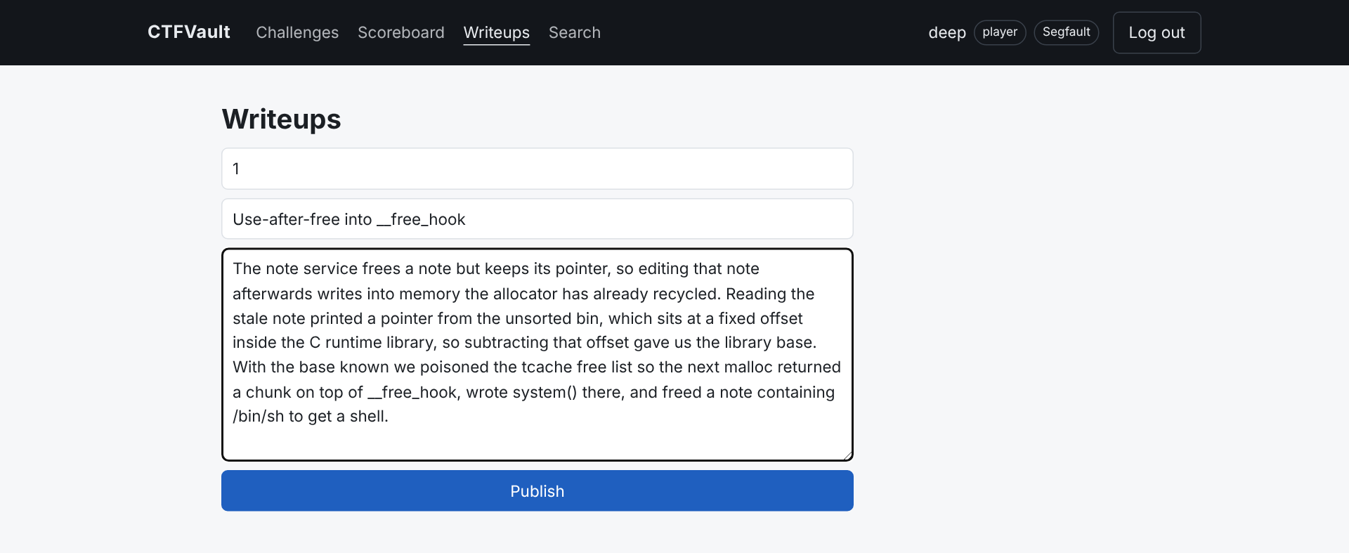
Figure 11. Publishing a writeup — the text is chunked and embedded in the same transaction as the insert
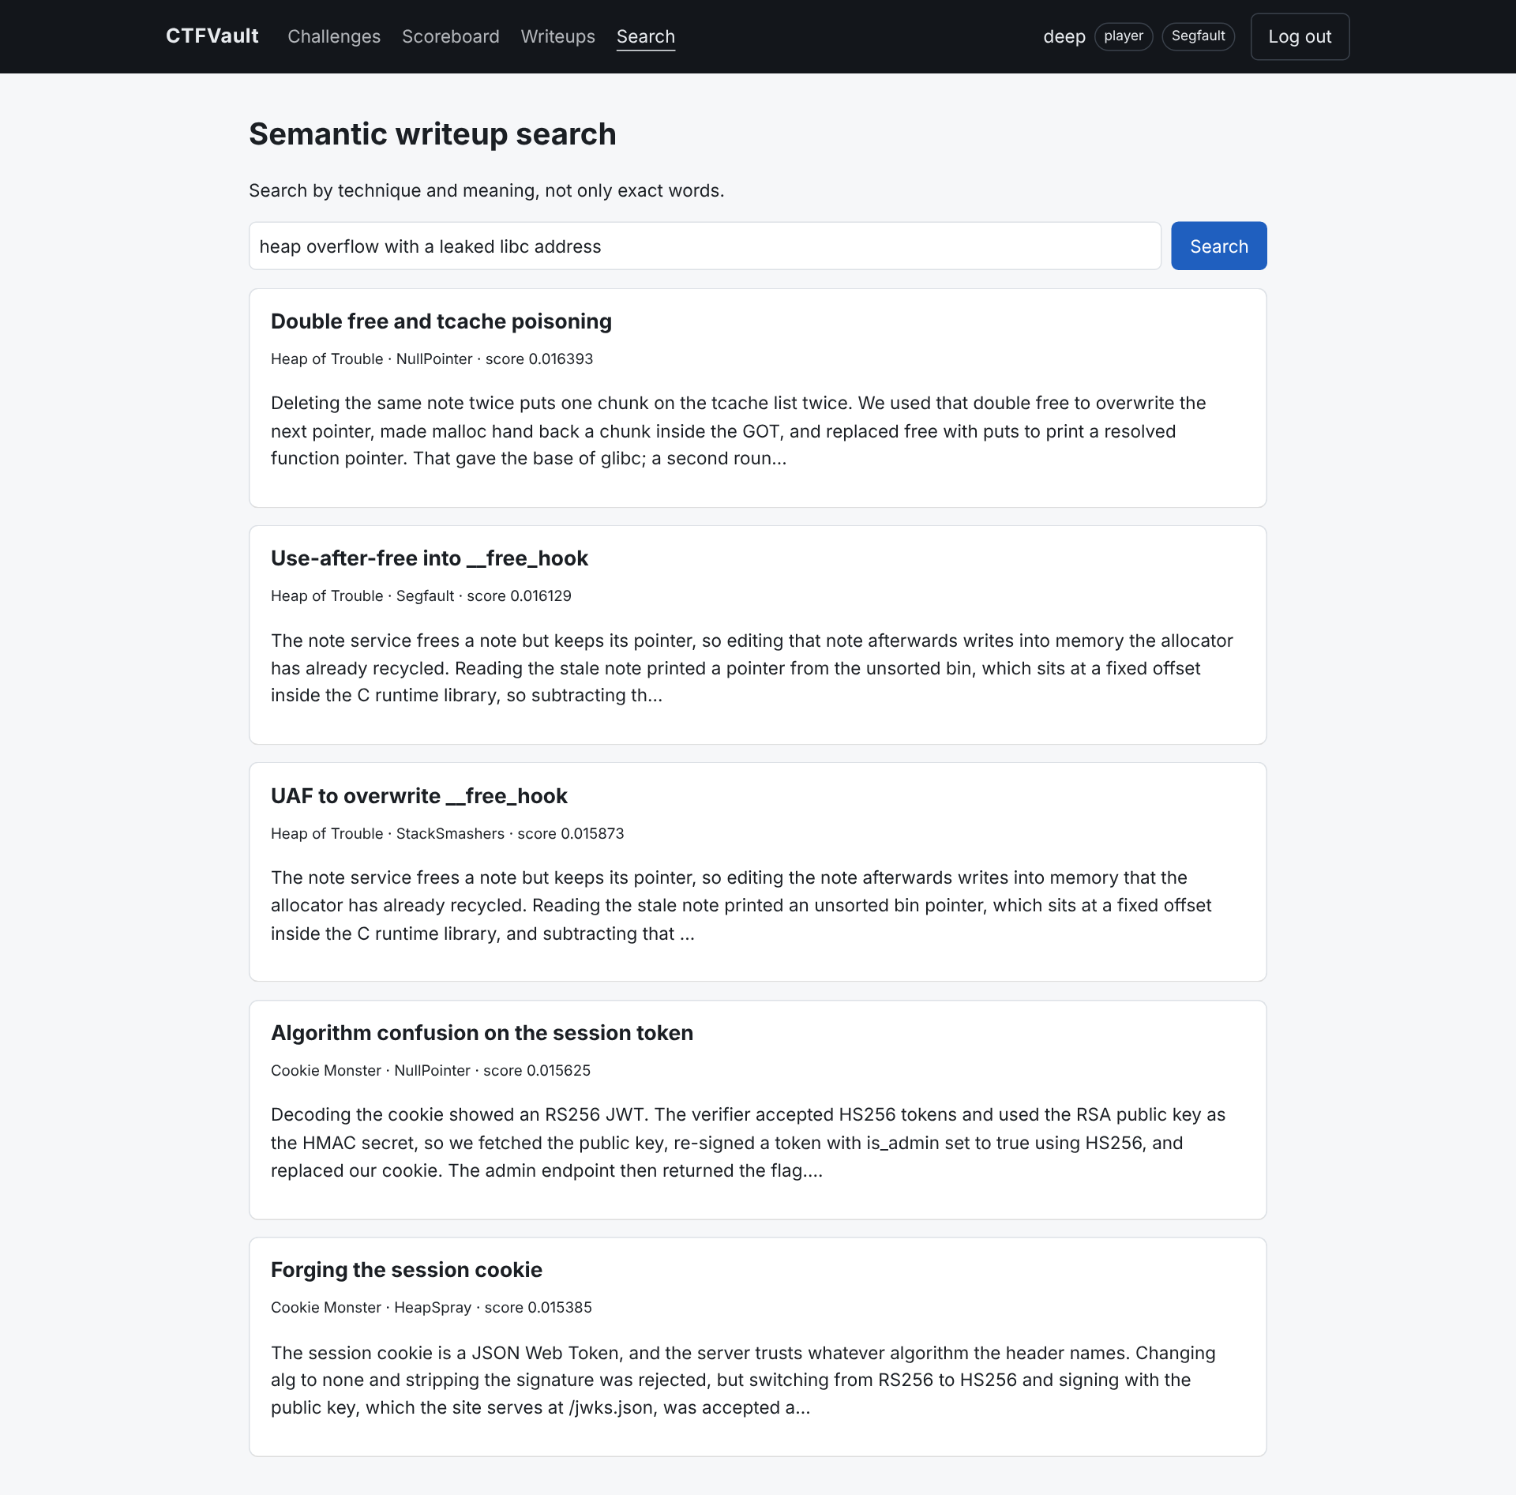
Figure 12. Semantic search: all three heap-exploitation writeups rank above the web ones although none contains the query's words
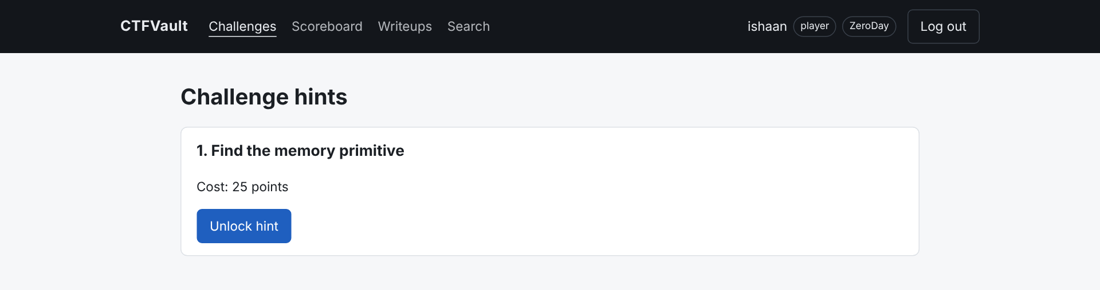
Figure 13. Hint catalogue before purchase, showing the cost
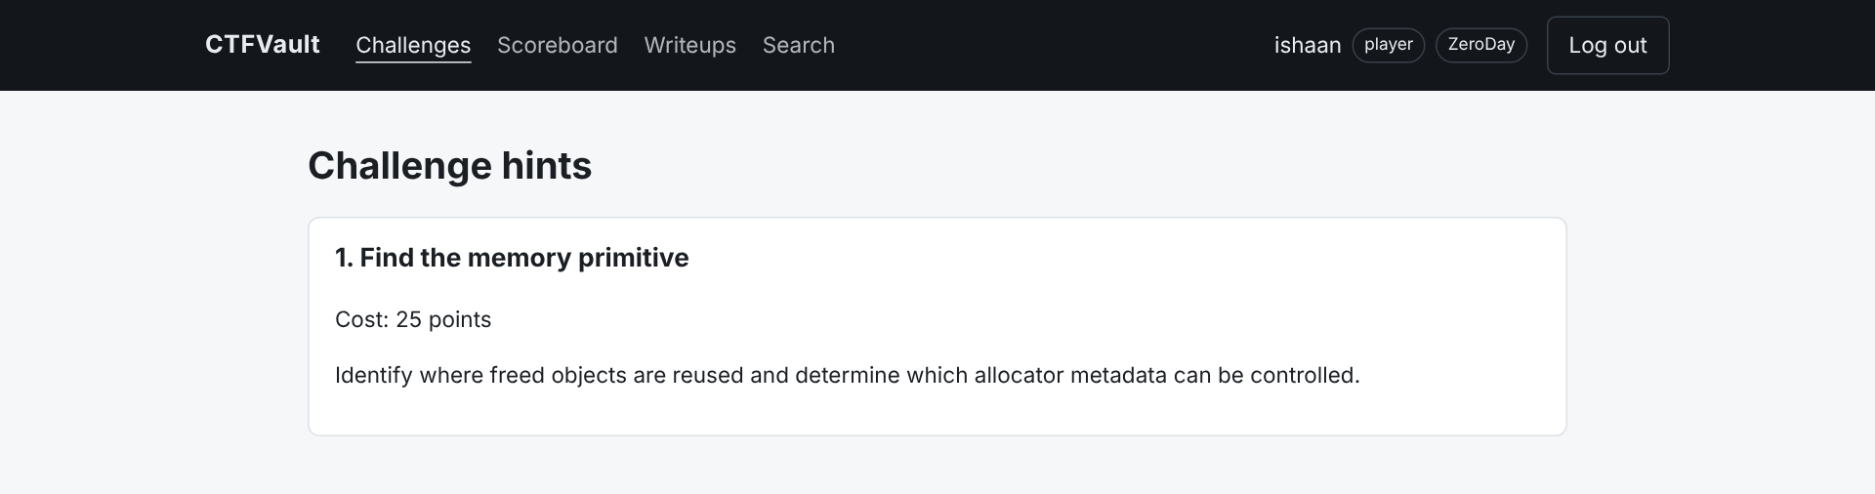
Figure 14. After unlocking — the hint text is revealed and 25 points are deducted once
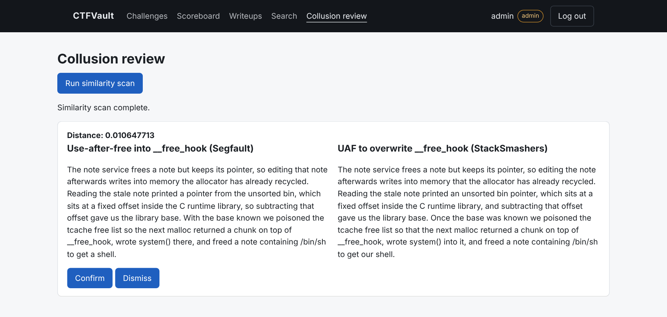
Figure 15. Admin collusion review: the similarity scan flags the reworded copy (distance 0.0106) side by side for review

8.3 Test results
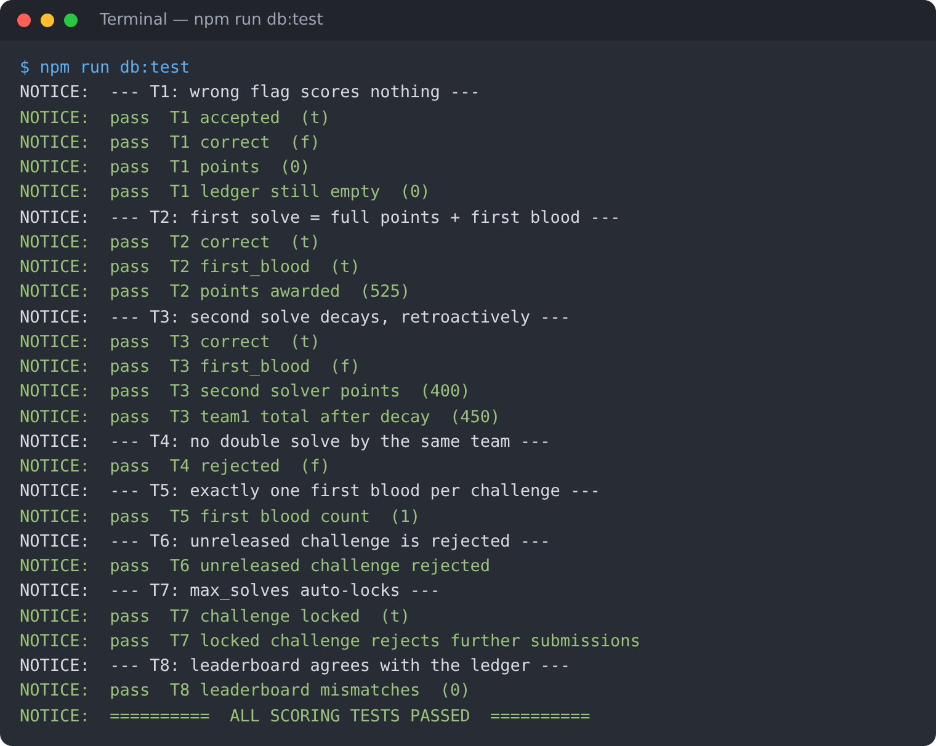
Figure 16. npm run db:test — all 17 scoring assertions pass (decay, retroactive adjustment, one first blood, locks, release guard, leaderboard reconciliation)
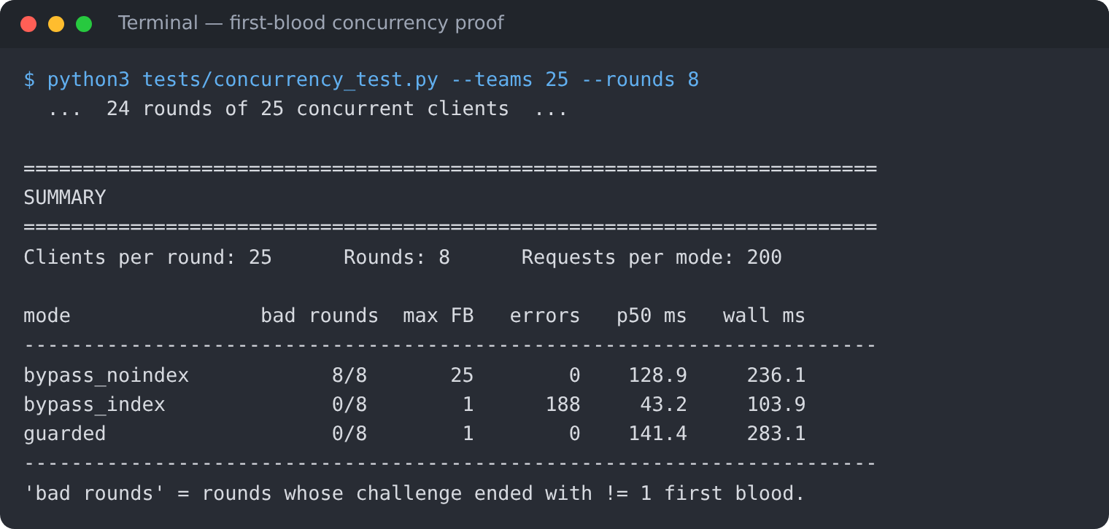
Figure 17. Concurrency proof: 25 simultaneous solvers, 8 rounds per configuration
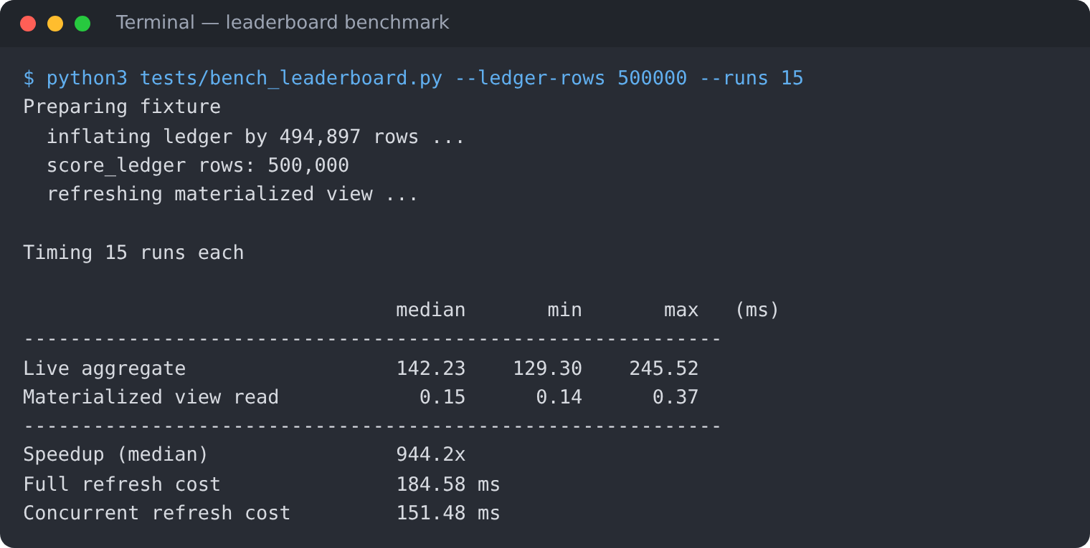
Figure 18. Leaderboard benchmark at 500,000 ledger rows

9. Evaluation Rubrics — Completion Status
Status against each of the 18 requirements in the project brief. "Partial" items are listed with what remains at the end of this section.
# | Requirement | Status | Evidence
1 | Project title — unique, real problem, not CRUD | Complete | Section 1. Scores are derived from a ledger with retroactive decay; search is by meaning.
2 | Team formation — 2 members, defined roles, both do DB and app | Complete | Section 2. Vertical split; migrations 01–06 vs 10–14; separate commits per member.
3 | Database requirement — SQL + NoSQL/vector | Complete | Option 2: PostgreSQL 16 + pgvector 0.8.7 (section 4).
4 | Database design — ER diagram, relational schema; vector data model | Partial | docs/ER_diagram.pdf and docs/relational_schema.pdf; vector model in section 6 and docs/KNOWLEDGE_LAYER.md. The diagrams predate final column names of the vector tables.
5 | SQL implementation — CREATE, ALTER, DROP, keys, constraints, indexes, views | Complete | Section 5.2–5.5: 13 tables, ALTER TABLE, DROP … CASCADE, 20 explicit indexes, 3 views + 1 materialised view.
6 | Database operations — INSERT, UPDATE, DELETE, SELECT; JOIN, GROUP BY, HAVING, ORDER BY, aggregates, subqueries | Complete | Section 5.6 with real outputs; window function in 5.5.
7 | At least four advanced database features | Complete | Seven: transactions, views/materialised view, stored procedures and functions, triggers, indexing (partial, GIN, HNSW), full-text search, vector similarity search.
8 | Vector database / semantic search, with the five explanations | Complete | Section 6, Table 6 answers all five; demonstrated in Figure 12. A Recall@10 evaluation script exists but the labelled query set has not been built.
9 | Web interface in Next.js with forms, tables, search, filtering, dashboards | Complete | 9 pages (section 7): forms, tables, category filter, search, live scoreboard, admin review.
10 | Database–application integration via an API layer; no hard-coded credentials; environment variables | Complete | 13 Route Handlers; app/lib/db.js reads PG* variables; .env.local is gitignored; .env.example has no values.
11 | Authentication and authorization, minimum 2 roles | Complete | bcrypt + signed JWT cookie; roles admin, setter, player; 403 shown in Figure 10.
12 | Validation and integrity at the database level | Complete | CHECK, FK, UNIQUE and partial unique constraints; guard trigger; audit trigger; rejected writes in section 5.3.
13 | Security — no plaintext passwords or credentials | Complete | bcrypt cost 12; per-team HMAC flags with only SHA-256 stored; parameterised SQL; rate limit on wrong flags; generic login error.
14 | Project documentation (problem, objectives, scope, FRs, ER, schema, justification, data dictionary, implementation, queries, architecture, screenshots, testing, conclusion) | Partial | README, docs/BENCHMARKS.md, docs/KNOWLEDGE_LAYER.md, docs/WORK_SPLIT.md and this report cover most items. Objectives, scope, functional requirements, a full data dictionary, an architecture diagram and a conclusion are not yet written up in one document.
15 | Git/GitHub — individual contributions, README with setup | Complete | github.com/deep-1005/DBMS-Project: commits by each member; README with setup, run and verify steps.
16 | Demonstration — problem, design, implementation, queries, interface, integration, features, tests, contributions | Ready | Demo flow in section 8; tests in 8.3; docs/KNOWLEDGE_LAYER.md checklist.
17 | Originality | Complete | Original design: per-team salted flags, retroactive-decay ledger, lock-ordered first-blood transaction, hybrid RRF search, embedding-based collusion review.
18 | Level 3 expectation — beyond CRUD; justified choice of databases | Complete | Section 4.1 justifies each database by the data it holds; measured results in sections 5.7 and 6.
Table 9. Rubric completion status

9.1 Remaining before final submission
- Requirement 4: regenerate the ER diagram and relational schema so the vector tables match the implemented columns (for example writeups.published, hints.title/body/display_order, collusion_alerts.created_at/reviewed_at, and no embedding column on hints).
- Requirement 14: add the missing documentation items — objectives, scope, functional requirements, data dictionary, system architecture diagram, and conclusion with future enhancements.
- Requirement 8 (optional strengthening): build the 30-query labelled set and run tests/eval_retrieval.py to report Recall@10 for keyword, vector and hybrid search.

