Q 1. Select unique job from EMP table.

Ans : select distinct job from emp;

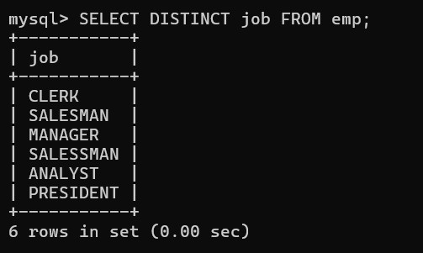

Q 2. List the details of the emps in asc order of the Dptnos and desc of Jobs?  
Ans : select * from emp order by Deptno asc;

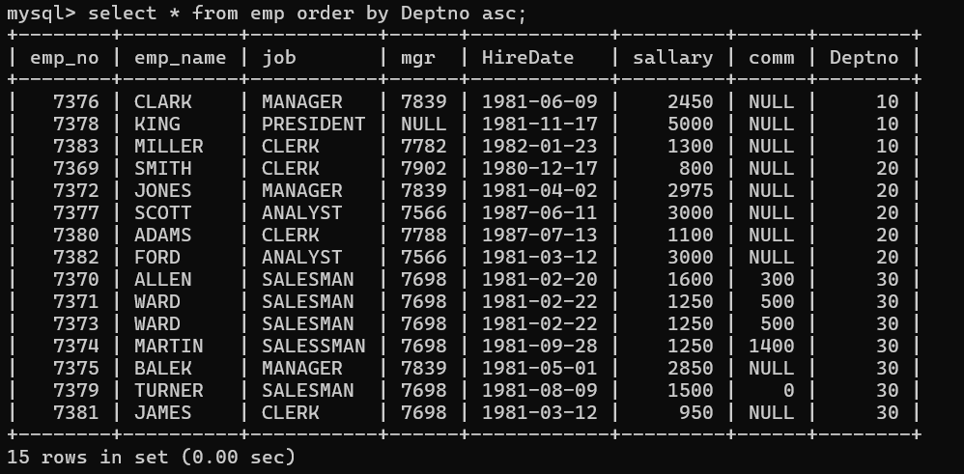

Q 3. Display all the unique job groups in the descending order?

Ans :select distinct job from emp order by job desc;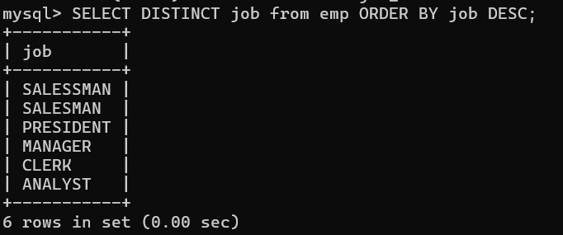

Q 4. List the emps who joined before 1981

Ans : select * from emp where HireDate <1981;

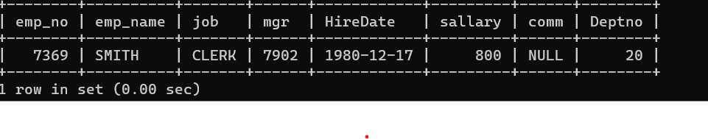

Q 5. List the Empno, Ename, Sal, Daily sal of all emps in the asc order of Annsal.

Ans : select emp_no,emp_name,salary,salary/30,12*sallary annsal from emp order by annsal asc;

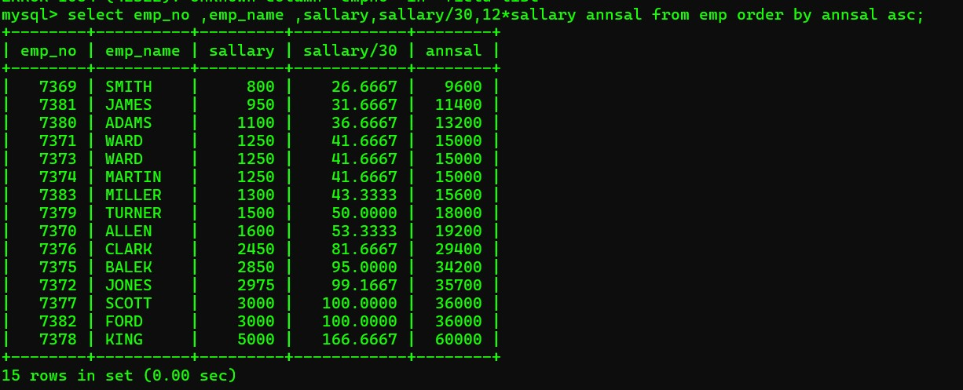

Q 6. List the Empno, Ename, Sal, Exp of all emps working for Mgr 7369.

WHERE mgr=7369;



Q 7. Display all the details of the emps who’s Comm. Is more than their Sal?

Ans : select * from emp where comm > sallary;

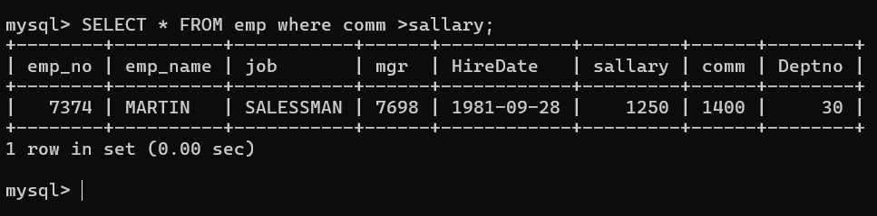

Q 8. List the emps who are either ‘CLERK’ or ‘ANALYST’ in the Desc order.

Ans : Select * from emp where job = ‘ CLERK’ OR JOB=’ANALYST’ order by job desc;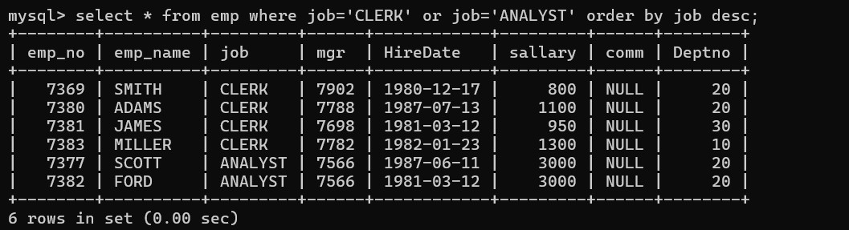

Q 9. List the emps Who Annual sal ranging from 22000 and 45000.

Ans : select * from emp where 12*sallary between 22000 and 45000;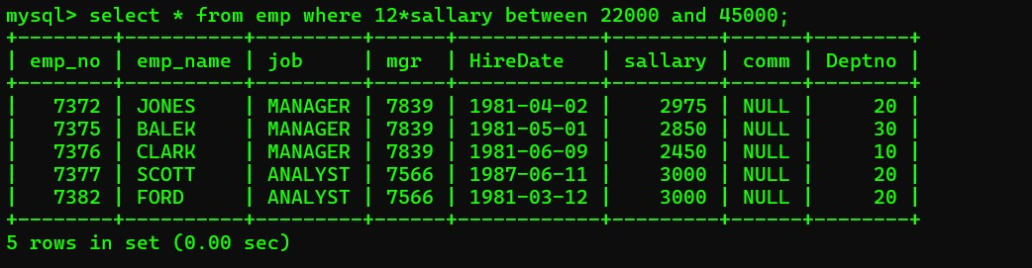

Q 10. List the Enames those are starting with ‘S’ and with five characters.

Ans : select emp_name from emp where length(emp_name) like ‘s%’;

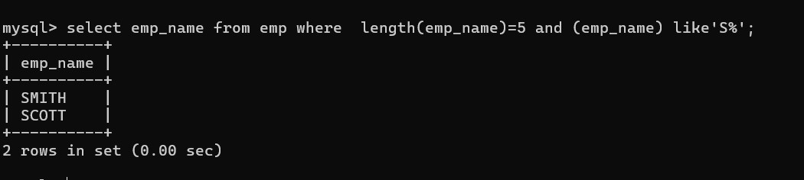

Q 11. List the emps whose Empno not starting with digit78.

Ans : select emp_no from emp where (emp_no)not like ‘78%’;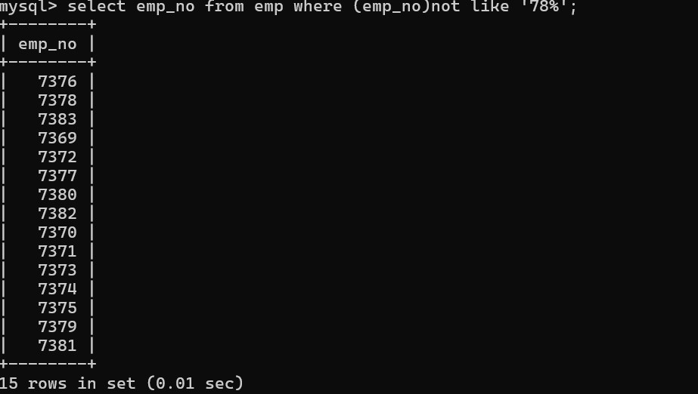

Q 12. List all the Clerks of Deptno 20.

Ans : select * from emp where job=”CLERK” and Deptno=20;

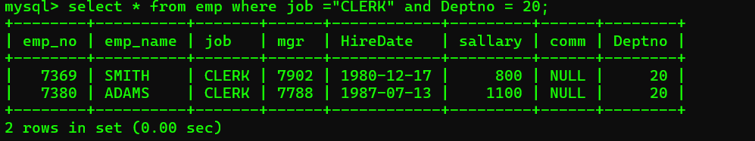

Q13 . List the Emps who are senior to their own MGRS.

Ans : 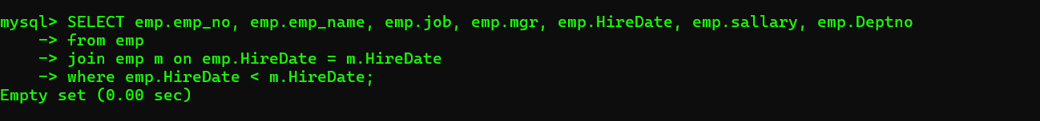

Q 14. List the Emps of Deptno 20 who’s Jobs are same as Deptno10.

Ans : select * from emp where Deptno=20 and job in(select job from emp where Deptno=10); 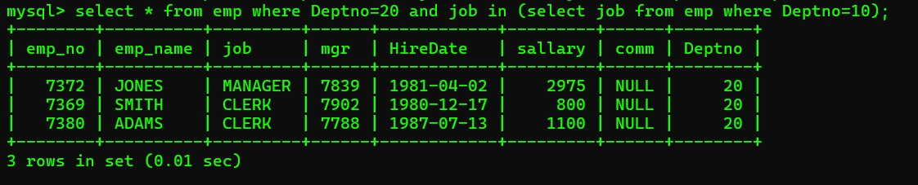

Q15. List the Emps who’s Sal is same as FORD or SMITH in desc order of Sal.

Ans : select * from emp where sallary in(select sallary from emp where(emp_name="SMITH" or emp_name="FORD")order by sallary desc);

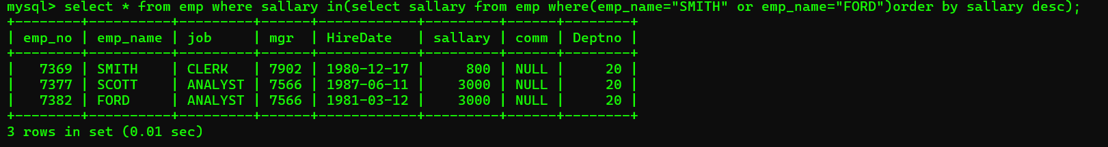

Q 16. List the emps whose jobs same as SMITH or ALLEN.

Ans : select emp_name,job from emp where job in(“CLERK”,SALESSMAN”);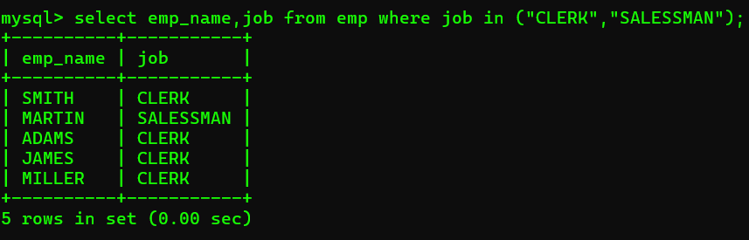

Q 17. Any jobs of deptno 10 those that are not found in deptno 20.

Ans : select emp_name, job from emp where Depton =10 or Deptno !=20;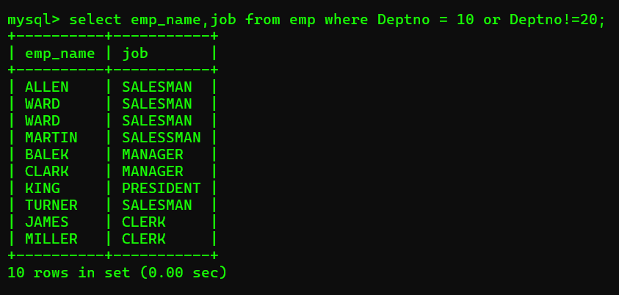

Q 18. Find the highest sal of EMP table.

Ans : select max(sallary) from emp;

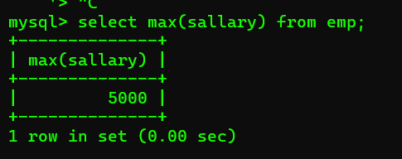

Q 19. Find details of highest paid employee.

Ans : select emp_name,sallary from emp where sallary in(selectmax(sallary)as sallary from emp);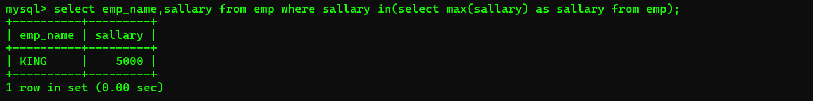

Q 20. Find the total sal given to the MGR.

Ans: select sum(mgr) from emp;

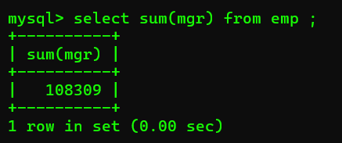

Q 21. List the emps whose names contains ‘A’.

Ans: select * from emp where emp_name like “A%”;

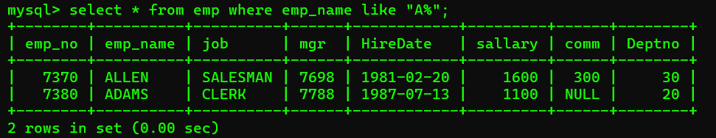

Q 22. Find all the emps who earn the minimum Salary for each job wise in ascending order.

Ans : select emp_name,sallary from emp where sallary in(select min(sallary) as sallary from emp);

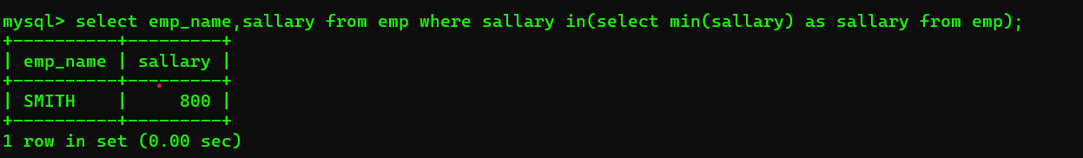

Q 23. List the emps whose sal greater than Blake’s sal.

Ans : select emp_name,sallary from emp where sallary >2850;

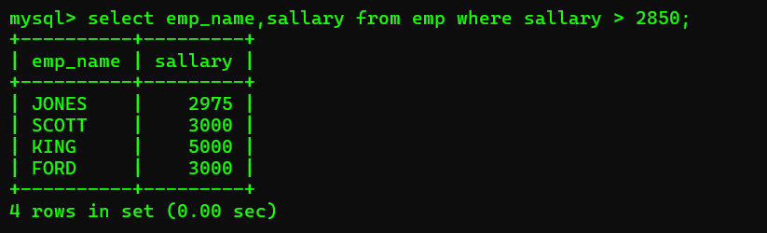

Q 24. Create view v1 to select ename, job, dname, loc whose deptno are same.

Ans : create view v1 as select emp_name,Deptno,job from emp;

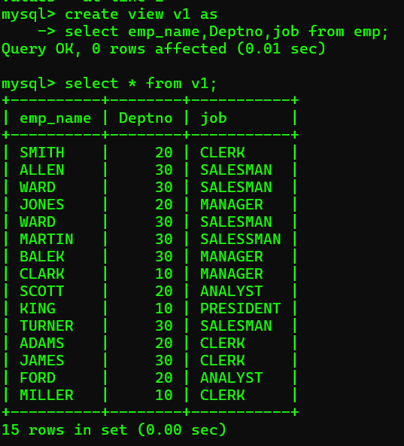

Q 25. Create a procedure with dno as input parameter to fetch ename and dname.

Ans : DELIMITER //

CREATE PROCEDURE GetEmployeesAndDepartments(IN dno INT)

Begin select e.emp_name as ename,d.Depatrment as dname

From emp e

Join dept d on e.Deptno = d.Deptno

Where e.Deptno = dno;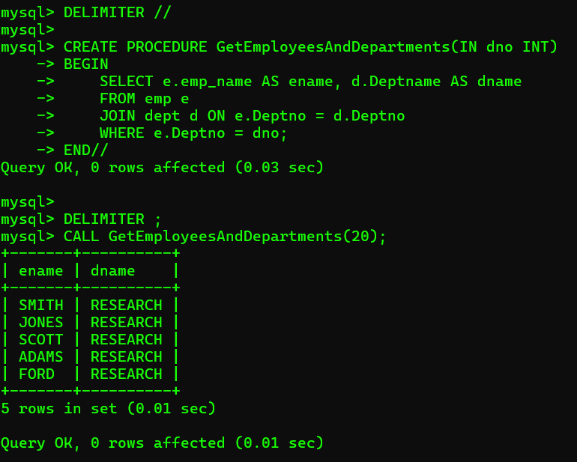

Q 26. Add column Pin with bigint data type in table student.

Ans : alter table student add column pin bigint;

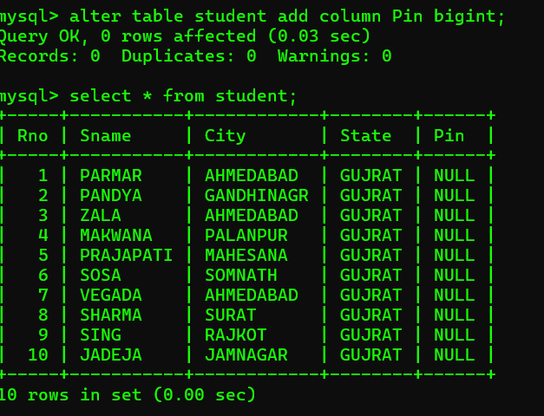

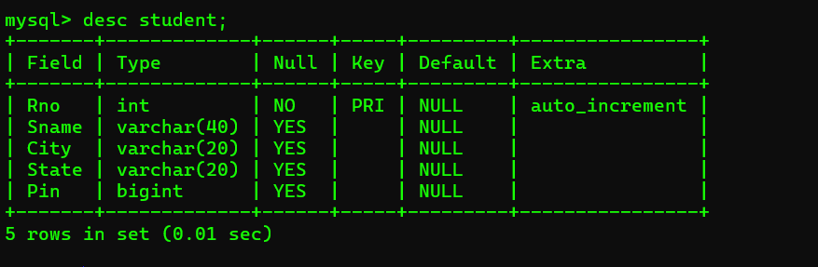

Q 27. Modify the student table to change the sname length from 14 to 40. Create trigger to insert data in emp_log table whenever any update of sal in EMP table. You can set action as ‘New Salary’.

Ans : alter table studentMODIFY COLUMN sname VARCHAR(40);