Example for finding hit count:

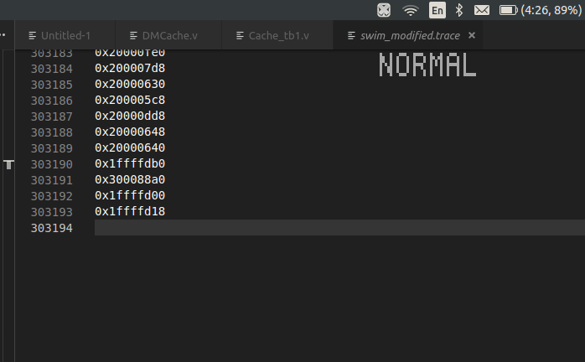
1) Open the test file and fine the last line number Eg. 303193 in swim_modified.trace

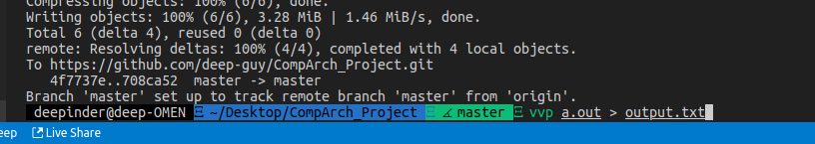
2) Pipe the output to a txt file

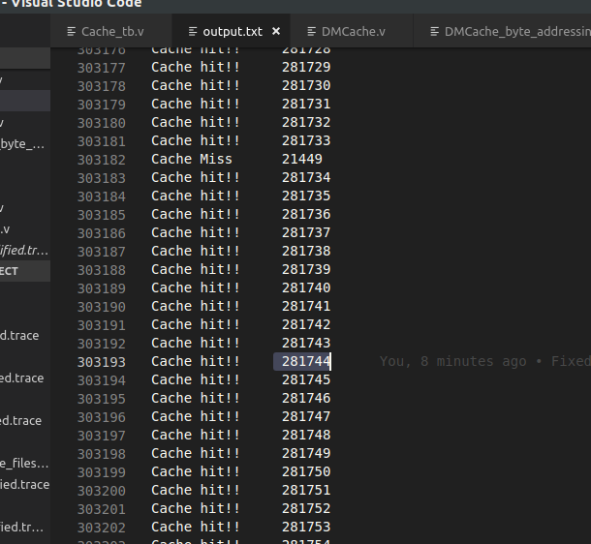
3) Find the hit count at that line number in the output file

So for Swim.trace, the hit ratio is 281744 / 303193

Repeat for other files

