# Deployment On Kubernetes

3 Microservices Deployed: tcss600users, tcss600posts, tcss600threads

Pods Deployment : 3 pods for each deployment

Services:

PODS Page:

Pods Continued…

# Prometheus Dashboard:

# Grafana Dashboard

CPU Usage, Memory Usage, Network I/O For all Pods Together & CPU Usage for the Users Deployment:

Memory Usage, Network I/O For Users Deployment

CPU Usage, Memory Usage for posts Deployment:

Network I/O For all Posts:

CPU Usage, Memory Usage & Network I/O For Threads Deployment:

CPU Usage for the Users Deployment:

Memory Usage for the Users Deployment:

Network I/O for the Users Deployment:

CPU Usage for the Posts Deployment:

Network I/O for the Posts Deployment:

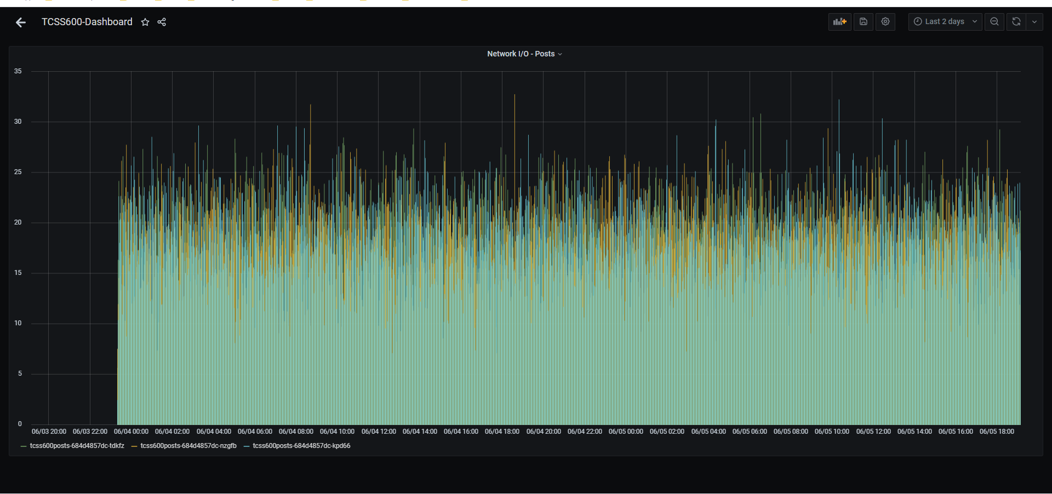

CPU Usage for the Threads Deployment:

Memory Usage for the Threads Deployment:

Network I/O for the Threads Deployment:

# LOCUST Dashboard:

500 users requesting access to the users api:

The Total Requests per second accessing the users api:

The Response Time and the Number of users accessing the users api:

