DIPIKA YADAV

### +919340881118

[dipika22yadav@gmail.com](mailto:dipika22yadav@gmail.com)

<https://www.linkedin.com/in/dipika-yadav-70647b286>

### Gumasta Nagar, Scheme 71, Indore, MP

Seeking an entry-level software developer position to apply my technical skills and contribute to innovative software solutions.

# EXPERIENCE

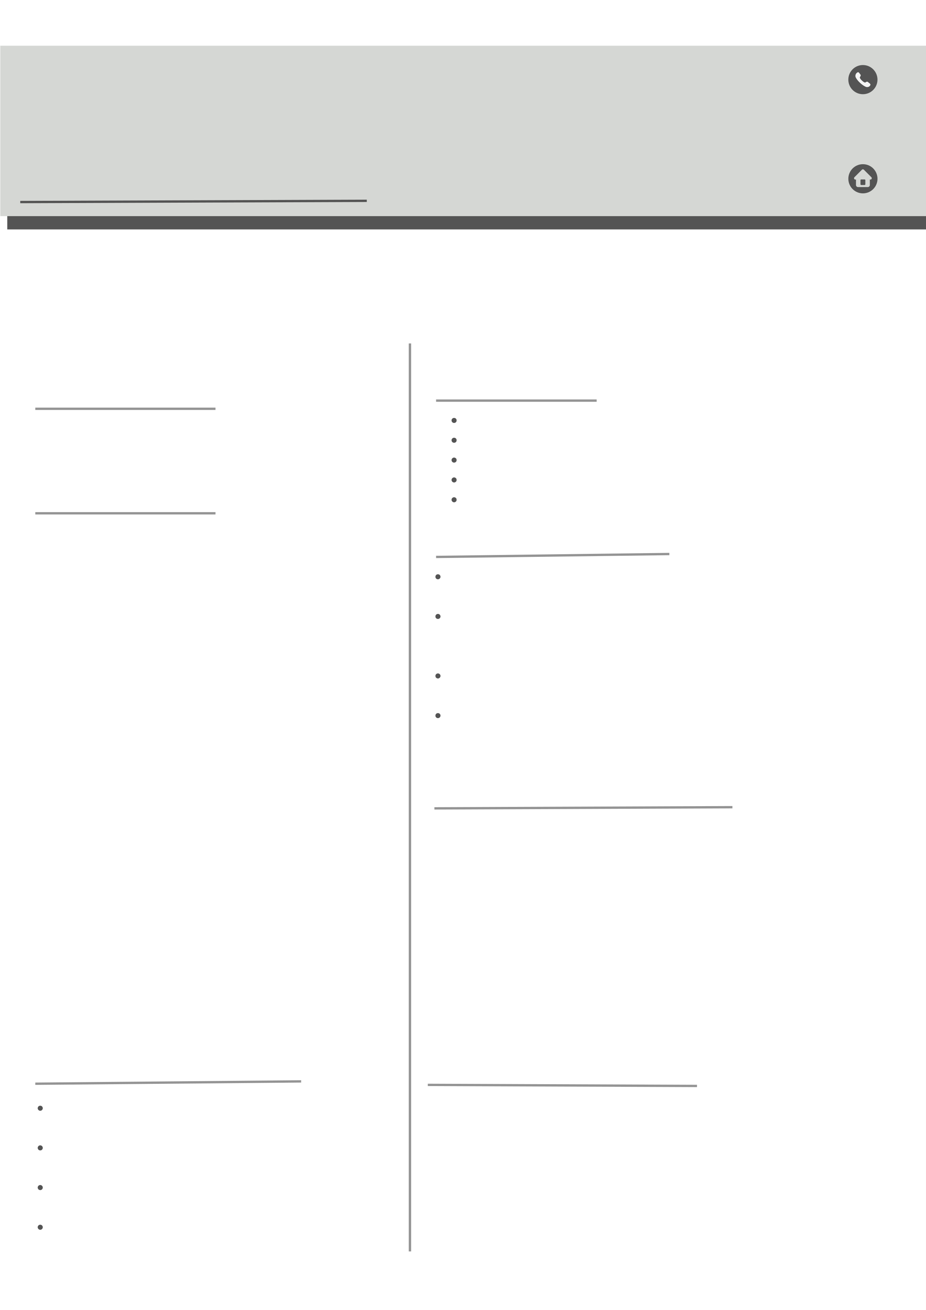

2 Years Experience in Marketing - LIC AGENCY

# EDUCATION

**RGPV University [Bhopal]**

*Shri Vaishnav Institute of Management and science [Indore]* Master of Computer Application(**MCA**) CGPA - 7.33

2023 – 2025

## Makhanlal Chaturvedi University

*Shri Srushti Computer Education[Betul]*

Bachelor of Computer Application(**BCA**) CGPA - 8.20

2020 – 2023

#### MP Board Bhopal

*Shri Saraswati Vidya Mandir School in Betul MP*

12th

parcentage - 62.4%

2018 – 2019

#### MP Board Bhopal

*Shri Saraswati Vidya Mandir School in Betul MP*

10th

parcentage - 64.6%

2016 – 2017

# TECHNICAL SKILLS

Programming Language : C, Python,VB .Net ,Basic Tally

Web Development : HTML, CSS, JS,React

Database Management :Django, SQL

, MySQL , MS Office Operating Systems : Windows, Linux

# SOFT SKILLS

Creativity Collaboration Communication Positive Attitude Problem Solving

# CERTIFICATIONS

Certificate of Excellence : C/C++ Programming Logic Development Certificate in edureka! : Full Stack web Development Intership Program.

Certificate of Completion : Front End Devlopment – HTML Certificate of Completion :

Personality Devlopment Course By Great Learning .

# ACADEMIC PROJECTS

## Title - Shopping Mall Management System

* + Developed a fully function in VB.Net, SQL, MS Access,MS Word

Role: Front-end and Back-end developer .

1. **Title - CampusElect** (Online Voting System)
   * Developed by : Backend –python , Frontend –HTML, CSS, JS
   * Framework : Django
   * DataBase : SQLite

# PERSONAL DETAILS

Father Name : Udal Yadav Mother Name : Rampyari Yadav Language : English , Hindi

Current Address : Front of SVIM Gumasta Nagar Schema 71, Indore [MP]

Permanent Address : Att.post Mandai Bujurg ,Betul [MP]