Product Line Profitability & Margin Performance
Executive Summary — Nassau Candy Distributor

Purpose
Sales volume alone is not a reliable indicator of profitability. This summary presents the headline findings of a full profitability and margin analysis of 10,180 validated Nassau Candy order records (Jan 2024 – Dec 2025, 15 products, 3 divisions), intended to inform pricing, sourcing, and product-portfolio decisions.

Headline Numbers
Metric | Value
Total Sales (period) | $141,645.58
Total Gross Profit (period) | $93,350.67
Overall Gross Margin | 65.9%
Products Generating 80% of Profit | 5 of 15 (33%)
States Generating 80% of Revenue | 16 of 59 (27%)

Key Findings
- Profit is highly concentrated. Five Chocolate-division Wonka Bar products generate 92.9% of revenue and 95.1% of gross profit. The other ten products across the Sugar and Other divisions are collectively marginal to company profitability.
- Chocolate is the strongest division by every measure — highest margin (67.4%), highest volume, and it converts revenue to profit slightly more efficiently than its revenue share alone would predict.
- The Other division underperforms structurally. At a 44.8% gross margin (more than 20 points below Chocolate), it captures less profit share than its revenue share would imply — driven largely by one product, Kazookles.
- One product requires immediate action. Kazookles sells at meaningful volume but returns only a 7.7% gross margin, with a cost-to-sales ratio of 92.3% — the highest cost burden of any product in the catalog, sourced from a single factory whose blended margin (11.9%) is far below the company average.
- A long tail of four Sugar-division products (Fizzy Lifting Drinks, SweeTARTS, Nerds, Fun Dip) contributes under 0.1% of total profit combined and is a candidate for portfolio rationalization.

Visual Snapshot
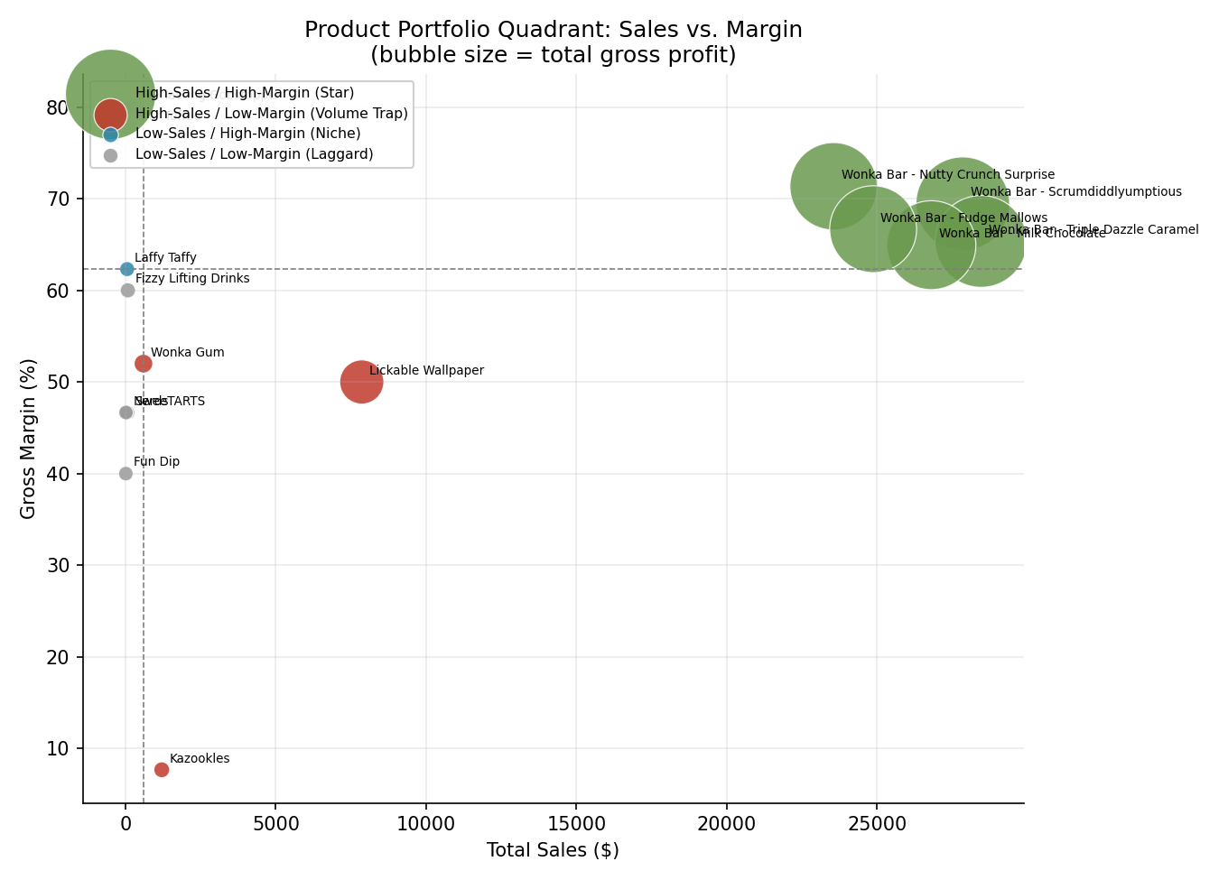
Product portfolio by sales and margin. Five Chocolate SKUs (green) anchor company profitability.

Recommended Actions
Priority | Action | Expected Impact
1 | Protect supply & shelf presence for the 5 core Wonka Bar products | Safeguards ~95% of current profit
2 | Renegotiate factory cost or reprice Kazookles; review for discontinuation if unresolved | Removes largest single margin drag
3 | Review pricing on Lickable Wallpaper & Wonka Gum (Volume Traps) | Improves Other-division margin
4 | Rationalize low-volume Sugar-division long tail | Reduces SKU overhead, minimal profit impact
5 | Monitor CA / NY / TX revenue concentration in regional planning | Reduces geographic dependency risk

Bottom Line
Nassau Candy's profitability depends on a small, high-performing core of Chocolate products. The most impactful near-term lever is not growing new products, but fixing the single largest identified margin drag — Kazookles — and making a deliberate decision on the low-volume Sugar-division tail. Full methodology, product-by-product detail, and an interactive dashboard for ongoing monitoring accompany this summary.

