🍬
Product Line Profitability & Margin
Performance Analysis
Nassau Candy Distributor
Research Paper — Exploratory Data Analysis, Insights & Recommendations
Prepared for: Nassau Candy Distributor
Analysis period: 2 Jan 2024 – 31 Dec 2025
Dataset: 10,180 validated order-level transactions across 15 products / 3 divisions

1. Executive Overview
Sales volume alone doesn’t tell Nassau Candy much about which products are actually worth selling. This report goes back through every recorded order — 10,180 validated transactions from January 2024 through December 2025, covering 15 products across three divisions (Chocolate, Sugar, Other) — and looks at them through gross margin, profit contribution, and cost structure instead of revenue alone.
The main finding is that profit at Nassau Candy is concentrated in a handful of products. Five Chocolate-division Wonka Bar items bring in roughly 95% of total gross profit, even though they make up only a third of the active catalog. The Chocolate division as a whole accounts for 92.9% of revenue but 95.1% of profit — it’s outperforming its revenue share — while the Other division (Wonka Gum, Kazookles, Lickable Wallpaper) turns a noticeably smaller share of its revenue into profit. A few low-margin, high-cost items, Kazookles above all, are dragging down blended profitability and are flagged below for pricing or sourcing review.
Company-wide gross margin sits at 65.9%, but that number hides a lot of spread — product margins range all the way from 7.7% (Kazookles) to 80.0% (Everlasting Gobstopper). Section 8’s recommendations center on three things: protecting the five Wonka Bar SKUs that drive most of the profit, repricing or renegotiating costs on the flagged high-risk items, and treating the long tail of low-volume Sugar-division products as a rationalization call rather than a growth bet.

2. Background & Problem Statement
For a distributor like Nassau Candy, sales volume can be a misleading stand-in for business health. Some products move in high volume but on thin margins. Others cost disproportionately more to source or manufacture than the revenue they bring in justifies. And some products look successful on a sales report while quietly dragging down the company’s overall margin structure.
Before this analysis, the organization had no clear view into which product lines actually deliver the highest gross margin, whether the biggest sellers are truly the most profitable, how profitability differs across the Chocolate, Sugar, and Other divisions, or which specific products carry margin risk. Without that visibility, pricing, promotion, and portfolio decisions have largely been made on intuition rather than data.

3. Data & Methodology

3.1 Dataset
The source dataset holds 10,194 order-line records across 18 fields — order and ship dates, customer geography (country, city, state/province, postal code), product division and region, product identifiers and names, and the financial fields Sales, Units, Gross Profit, and Cost. Nassau Candy also supplied a five-factory sourcing map with geographic coordinates and a product-to-factory correlation table, which we used to supplement the dataset.

3.2 Data Cleaning & Validation
- Cleaned up text fields (Division, Region, Product Name, Ship Mode, geography): trimmed whitespace and fixed inconsistent spacing and punctuation in product names, e.g. “Wonka Bar -Scrumdiddlyumptious” became “Wonka Bar - Scrumdiddlyumptious.”
- Dropped 14 rows that were exact duplicates across every field.
- Rebuilt Row ID as a clean sequential key, since the original field wasn’t reliably unique — one value showed up 449 times.
- Checked that Sales, Cost, Units, and Gross Profit were all numeric. After de-duplication, none of these fields contained non-numeric, zero, or negative values, so no additional rows needed to be dropped.
- Cross-checked Gross Profit against Sales minus Cost for every row. Everything reconciled within $0.02, which confirms the financial fields are internally consistent.
- Parsed Order Date and Ship Date out of two mixed formats in the source file (“M/D/YYYY” and “DD-MM-YYYY”). Both were read as day-first, which matches the dash-formatted rows that are unambiguous because they contain day values above 12.
- Matched every product to its sourcing factory and factory coordinates using the correlation table Nassau Candy provided.
Net effect: 10,180 of the original 10,194 rows (99.86%) made it into the analysis. One data-quality issue turned up that we deliberately left alone: recorded Ship Date values land 2.5 to 4.5 years after the matching Order Date, which isn’t operationally realistic and is almost certainly an artifact of how the data was generated. Since this project is about profitability and margin, not delivery timing, we kept Ship Date in the dataset for completeness but left it out of every KPI and chart in this report.

3.3 Key Performance Indicators
KPI | Definition
Gross Margin (%) | Gross Profit ÷ Sales
Profit per Unit | Gross Profit ÷ Units
Revenue Contribution | Product Sales ÷ Total Sales
Profit Contribution | Product Gross Profit ÷ Total Gross Profit
Margin Volatility | Standard deviation of a product's monthly gross margin % over the analysis period
Cost-to-Sales Ratio | Cost ÷ Sales (used for cost-risk flagging)

4. Product-Level Profitability Analysis
We ranked products by total gross profit and by gross margin, then sorted them into four quadrants using median product-level Sales and median Gross Margin % as the split points: Stars (high sales, high margin), Volume Traps (high sales, low margin), Niche (low sales, high margin), and Laggards (low sales, low margin).
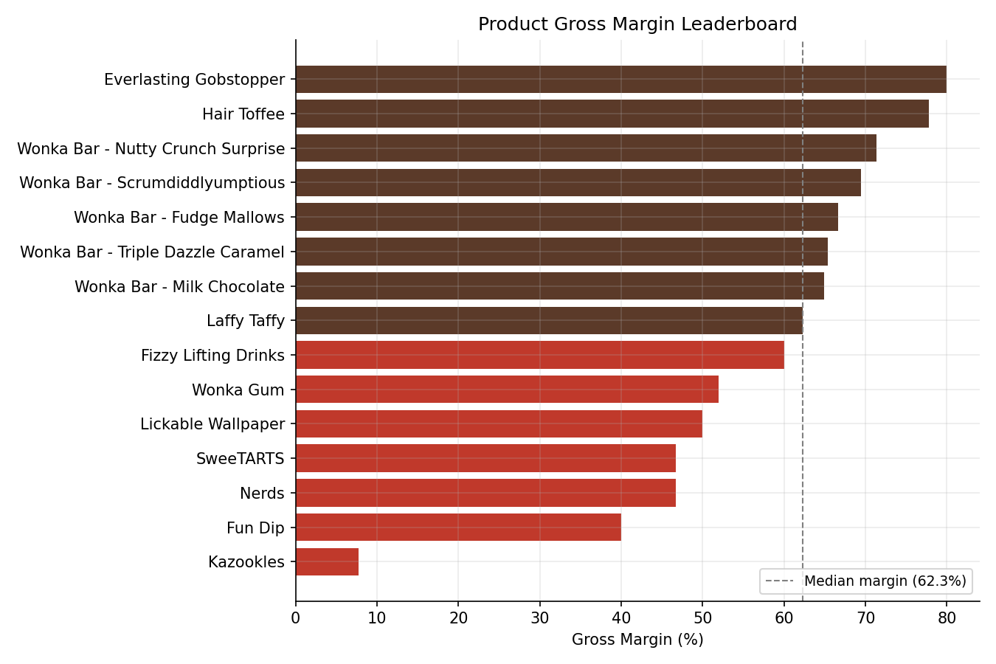
Figure 1. Gross margin by product, ranked lowest to highest. Dashed line marks the median product margin (60.0%).
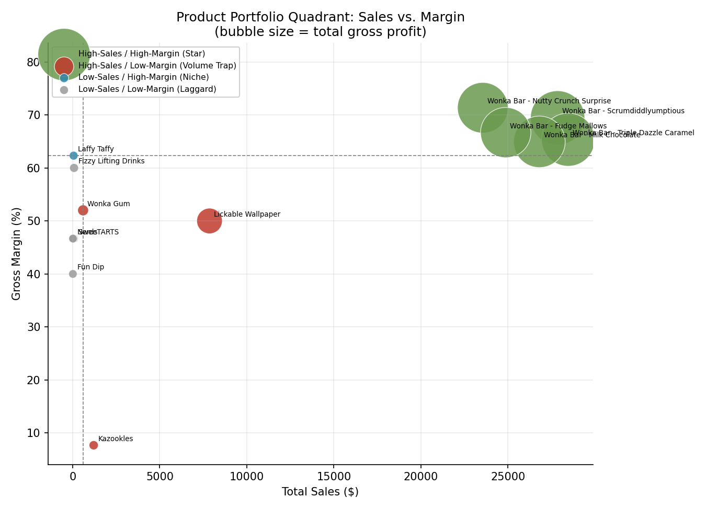
Figure 2. Sales-vs-Margin quadrant map. Bubble size = total gross profit.

4.1 High-Profit / High-Margin Products (Stars)
All five Chocolate-division Wonka Bar products land squarely in the Star quadrant. Each one contributes between 16.6% and 20.1% of total revenue and between 17.8% and 20.7% of total gross profit, at margins ranging from 64.9% to 71.3%:
Product | Sales | Gross Profit | Margin % | Profit Contribution %
Wonka Bar - Triple Dazzle Caramel | $28,462.50 | $18,595.50 | 65.3% | 19.9%
Wonka Bar - Scrumdiddlyumptious | $27,853.20 | $19,342.50 | 69.4% | 20.7%
Wonka Bar - Milk Chocolate | $26,809.25 | $17,405.39 | 64.9% | 18.7%
Wonka Bar - Nutty Crunch Surprise | $23,557.50 | $16,807.50 | 71.3% | 18.0%
Wonka Bar - Fudge Mallows | $24,872.40 | $16,581.60 | 66.7% | 17.8%
Together, these five SKUs bring in 92.9% of revenue and 95.1% of gross profit. This is the core of the business, and it should be the clear priority for supply continuity, shelf placement, and marketing spend.

4.2 High-Sales / Low-Margin Products (Volume Traps)
Three products sell in meaningful volume but turn far less of that revenue into profit — and one of them is a serious outlier:
Product | Sales | Margin % | Note
Lickable Wallpaper | $7,860.00 | 50.0% | Second-tier margin. Because its revenue base is fairly large, that 19-point margin gap versus the Chocolate line adds up to real money.
Wonka Gum | $597.50 | 52.0% | Revenue is modest, but its margin profile looks a lot like Lickable Wallpaper’s.
Kazookles | $1,205.75 | 7.7% | A serious outlier: a 92.3% cost-to-sales ratio leaves almost nothing per unit sold.
Kazookles is the clearest margin risk anywhere in the portfolio. It sells at real volume but returns essentially no profit, so from a profitability standpoint, nearly every unit sold is close to a break-even transaction — or worse.

4.3 Low-Sales / High-Margin Products (Niche)
Everlasting Gobstopper (80.0% margin), Hair Toffee (77.8%), and Laffy Taffy (62.3%) post the best unit economics in the whole catalog, but at negligible volume — under $130 each in total sales over two years. They don’t move the needle on company profit today, but they do show the kind of pricing power that could inform repricing decisions on the Volume Trap products.

4.4 Low-Sales / Low-Margin Products (Laggards)
Fizzy Lifting Drinks, SweeTARTS, Nerds, and Fun Dip each generated under $80 in total sales over two years, with margins between 40% and 62%. Combined, they account for under 0.1% of company profit. These four are prime candidates for rationalization — it’s hard to justify the SKU-maintenance, shelf-space, and sourcing overhead of carrying four separate low-volume items given how little they contribute financially.

5. Division-Level Performance Analysis
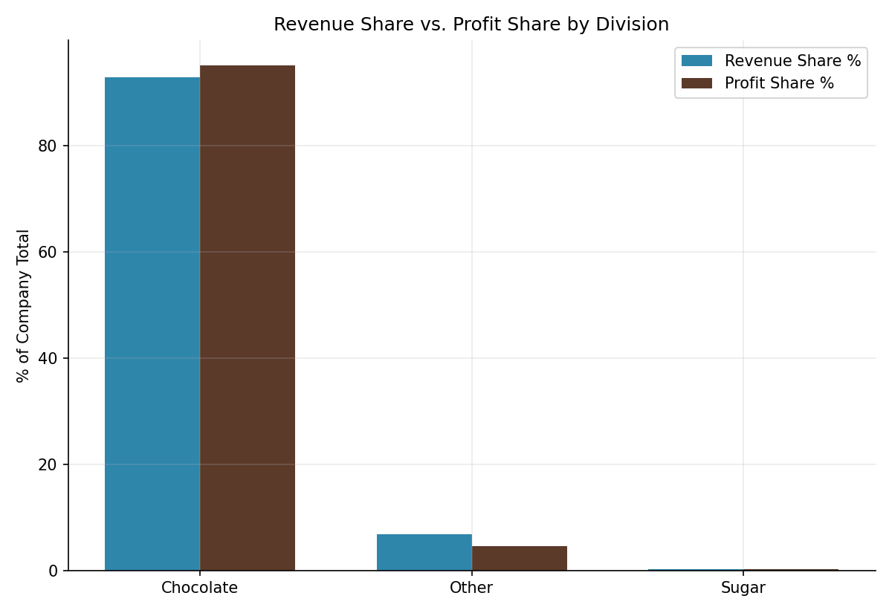
Figure 3. Revenue share vs. profit share by division.
Division | Sales | Gross Profit | Margin % | Revenue Share | Profit Share | Imbalance (pp)
Chocolate | $131,554.85 | $88,732.49 | 67.4% | 92.9% | 95.1% | +2.18
Other | $9,663.25 | $4,333.45 | 44.8% | 6.8% | 4.6% | −2.18
Sugar | $427.48 | $284.73 | 66.6% | 0.3% | 0.3% | +0.00
Chocolate leads on both volume and margin — 67.4% gross margin, well ahead of the other two divisions — and it converts revenue into profit slightly better than its revenue share alone would predict, at +2.18 percentage points of profit share versus revenue share. Structurally, this is a healthy division.
The Other division (Wonka Gum, Kazookles, Lickable Wallpaper) is the clear underperformer. Its 44.8% margin sits more than 20 points below Chocolate’s, and it captures 2.18 percentage points less of total profit than its revenue share would predict — a direct sign that Kazookles’s near-zero margin is dragging the whole division average down.
The Sugar division looks healthy on margin (66.6%), but it’s a rounding error in absolute terms — just 40 orders and $427 in total sales across two years, compared to 8,205 orders for Chocolate. Someone should figure out whether Sugar-division products are being deliberately incubated as a strategic category or simply aren’t being sold or marketed with much effort; the data on its own can’t tell us which.
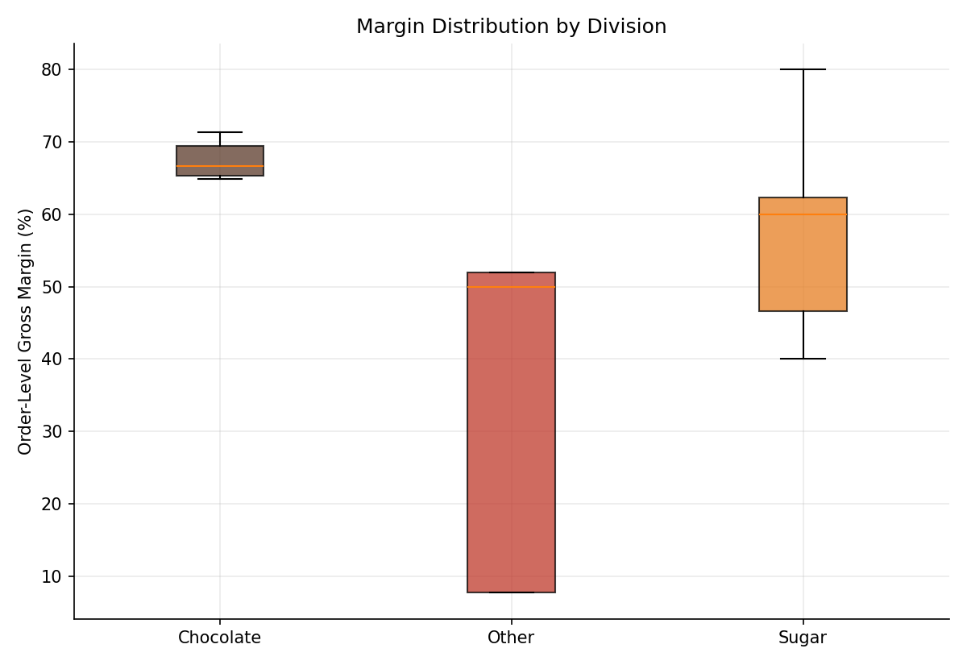
Figure 4. Order-level gross margin distribution by division. The Other division shows both a lower median margin and wider spread than Chocolate or Sugar, indicating less predictable per-order profitability.
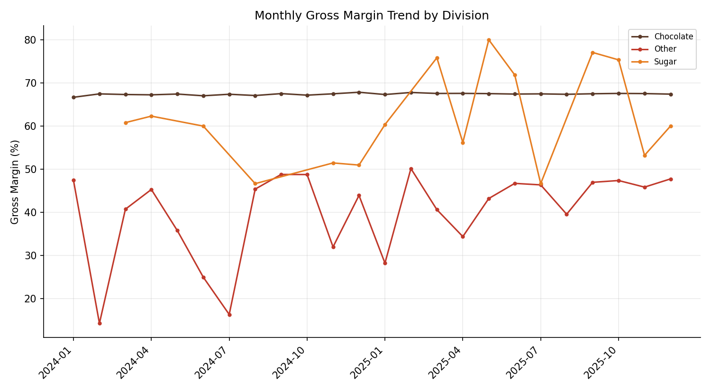
Figure 5. Monthly gross margin trend by division across the two-year analysis window.

6. Profit Concentration (Pareto) Analysis
A classic 80/20 concentration test was applied at both the product and geographic levels.
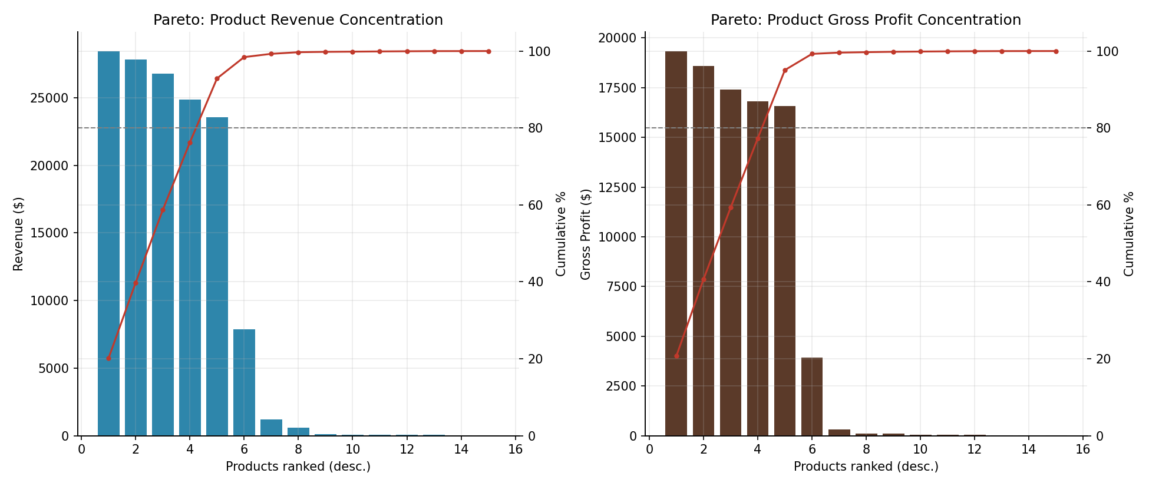
Figure 6. Pareto concentration of product revenue (left) and gross profit (right).
Just 5 of the 15 products (33%) generate 80% of total revenue, and the same five generate 80% of total gross profit — in both cases, that’s the five Chocolate Wonka Bar SKUs called out as Stars in Section 4.1. It’s a textbook Pareto pattern, and it confirms that Nassau Candy’s profitability rests on a small, concentrated core of products rather than a broad, diversified catalog.
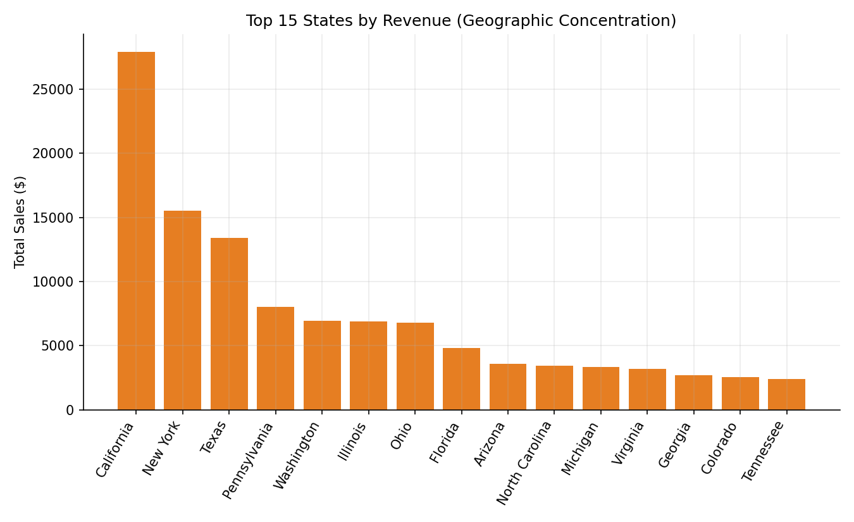
Figure 7. Top 15 states by revenue.
Geography shows a similar, if less extreme, pattern: 16 of 59 states (27%) account for 80% of total revenue, led by California ($27,903.70), New York ($15,541.03), and Texas ($13,406.34). That’s a moderate dependency risk — not as acute as the product concentration, but worth keeping an eye on, especially if any of the top three states runs into a regional demand or logistics disruption.

7. Cost Structure Diagnostics
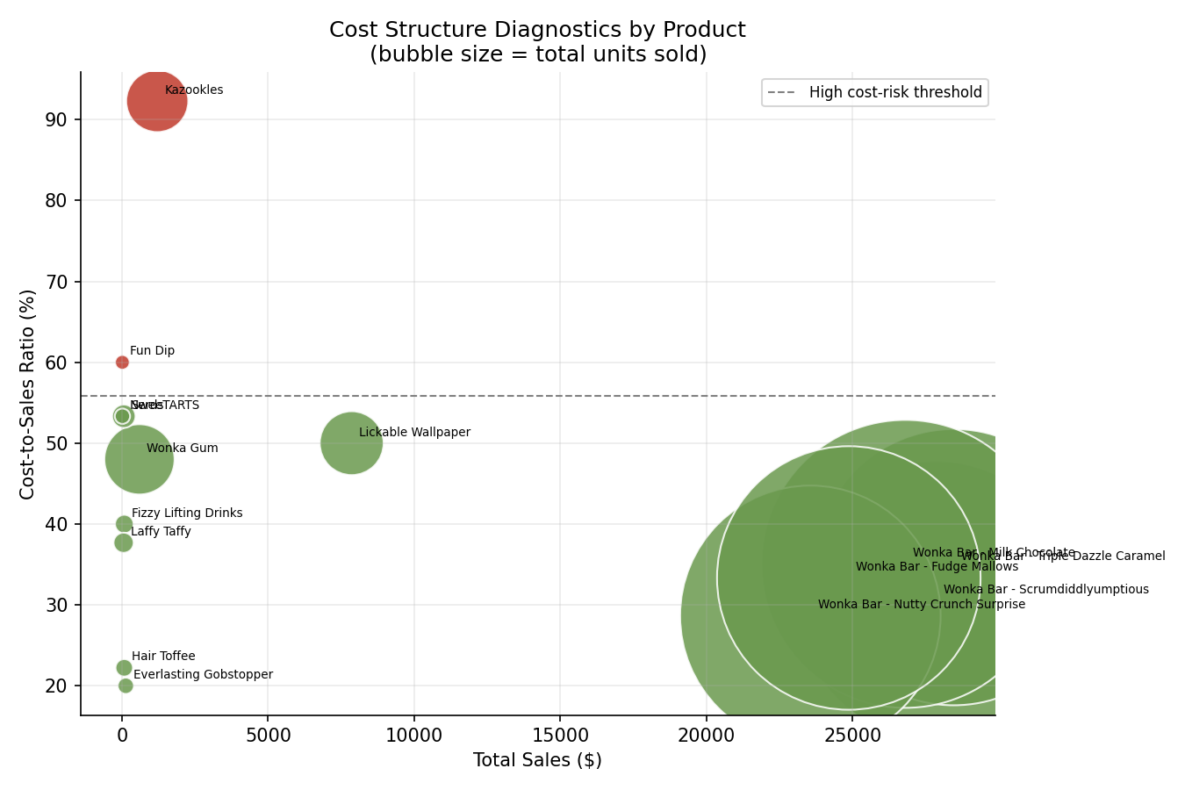
Figure 8. Cost-to-sales ratio by product (bubble size = total units sold). Products above the dashed line are flagged as high cost-risk.
Flagging any product whose cost-to-sales ratio sits more than one standard deviation above the median — a threshold of 55.0% in this dataset — turns up two products that need immediate review:
Product | Cost-to-Sales Ratio | Gross Margin % | Total Sales
Kazookles | 92.3% | 7.7% | $1,205.75
Fun Dip | 60.0% | 40.0% | $12.00
Kazookles is the single most urgent action item in this whole analysis — it combines real sales volume with a cost structure that eats 92 cents of every sales dollar. In order of preference, the next steps should be: renegotiate cost with The Other Factory, its sole sourcing plant; raise the price if market conditions allow, since its low current margin leaves plenty of room; or, if neither of those works, formally review it for discontinuation. Fun Dip’s cost ratio is also high, but its total sales are negligible ($12 over two years), so it’s a low-priority rationalization candidate rather than something worth repricing.
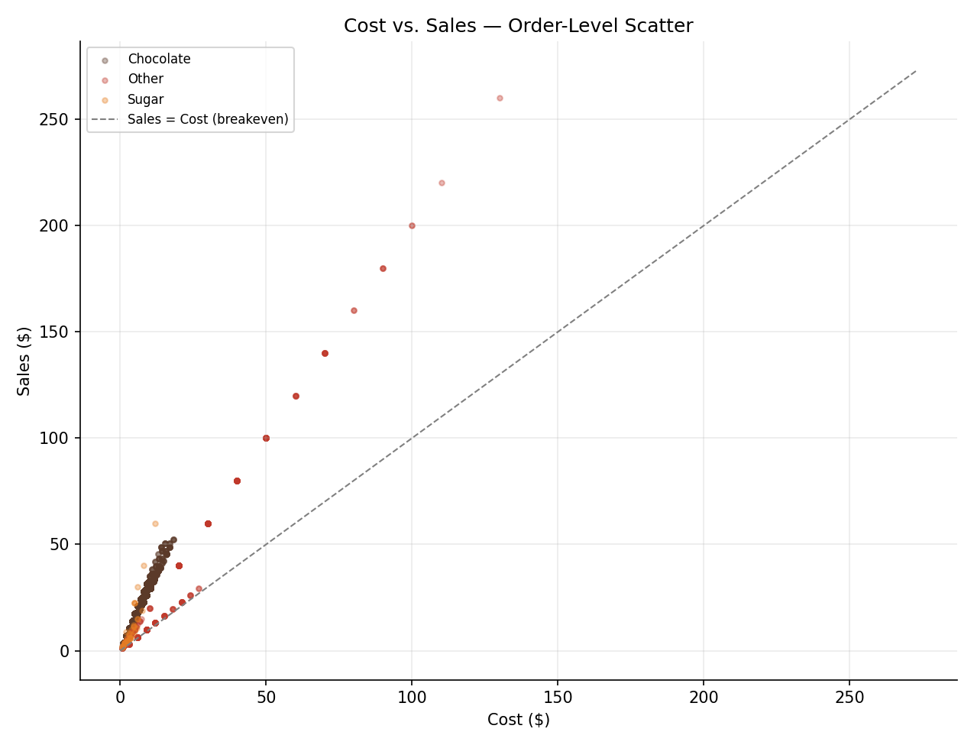
Figure 9. Order-level Cost vs. Sales, colored by division. Points closer to the dashed break-even line represent lower-margin transactions; the Other division (blue) sits visibly closer to break-even than Chocolate (brown).

7.1 Factory Sourcing Rollup
Factory | Sales | Gross Profit | Margin % | Products Sourced
Lot's O' Nuts | $76,283.10 | $52,731.60 | 69.1% | 3
Wicked Choccy's | $55,271.75 | $36,000.89 | 65.1% | 2
Secret Factory | $8,587.50 | $4,344.70 | 50.6% | 3
The Other Factory | $1,282.25 | $152.25 | 11.9% | 2
Sugar Shack | $220.98 | $121.23 | 54.9% | 5
The Other Factory, which sources Hair Toffee and Kazookles, has by far the weakest blended margin of any sourcing plant at 11.9% — and that’s driven almost entirely by Kazookles. That strengthens the case that Kazookles’s problem is really about sourcing and cost rather than demand or pricing on its own, since Hair Toffee comes from the same factory and carries a healthy 77.8% margin.

8. Recommendations

8.1 Protect and invest in the core
- Prioritize supply continuity, shelf placement, and promotional spend on the five Chocolate Wonka Bar SKUs. They generate 95% of profit and shouldn’t be treated as “mature” products competing on equal footing with the long tail for resources.

8.2 Fix Kazookles immediately
- Open a cost renegotiation with The Other Factory on Kazookles, or look at moving to a different sourcing plant — Lot’s O’ Nuts and Wicked Choccy’s both show much stronger cost efficiency.
- If cost can’t come down, test a price increase — the current 7.7% margin leaves a lot of room before the product would become uncompetitive against its category peers.
- If neither option works out within a defined review window, recommend discontinuing the product formally.

8.3 Reprice or review the Other division
- Lickable Wallpaper and Wonka Gum both sit in the Volume Trap quadrant. Even a few points of margin improvement from a targeted price or cost review would have an outsized impact, given Lickable Wallpaper’s relatively large revenue base.

8.4 Rationalize the long tail
- Fizzy Lifting Drinks, SweeTARTS, Nerds, and Fun Dip together contribute under 0.1% of profit. Consolidate or discontinue them unless there’s a non-financial, strategic reason to keep them around — for instance, anchoring a broader Sugar-division catalog for a specific retail partner.

8.5 Monitor geographic concentration
- California, New York, and Texas represent an outsized share of revenue. Factor that into regional risk planning — inventory buffers, alternate distribution routing — even though it’s a lower-urgency finding than the product-level concentration.

8.6 Data quality follow-up
- Investigate and fix whatever is producing the Ship Date values, which currently show implausible multi-year gaps between order and shipment. It doesn’t change the profitability findings here, but fixing it would meaningfully improve any future logistics or fulfillment analysis.

9. Limitations
- Sugar and Other are both small-sample divisions — 40 and 304 orders respectively, compared to 8,205 for Chocolate — so their KPIs are directionally useful but less statistically stable than Chocolate’s.
- Margin volatility is calculated from monthly aggregates. Low-volume products, most of the Sugar division included, don’t have enough monthly observations for that number to be a reliable signal, so it should be read cautiously in the dashboard.
- This is a single order-level dataset with no matched prior-period baseline, so any claims about margin “improving” or “declining” only hold within the 2024–2025 window covered here.

10. Conclusion
This analysis swaps intuition for a clear, data-driven picture of where Nassau Candy actually makes money. Profit is concentrated in five Chocolate-division products that outperform their revenue weight, while the Other division — and Kazookles specifically — is where a small, targeted move, renegotiating cost, repricing, or discontinuing, would have an outsized effect on blended margin. Sugar and the other long-tail products are financially immaterial right now and are best treated as a portfolio-rationalization decision. The accompanying Streamlit dashboard puts these findings into practice, so pricing, sourcing, and portfolio decisions can be made and tracked on an ongoing basis instead of waiting for the next annual review.

