🍬
Product Line Profitability & Margin
Performance Analysis
Nassau Candy Distributor
Research Paper — Exploratory Data Analysis, Insights & Recommendations
Prepared for: Nassau Candy Distributor
Analysis period: 2 Jan 2024 – 31 Dec 2025
Dataset: 10,180 validated order-level transactions across 15 products / 3 divisions

1. Executive Overview
Sales volume alone tells Nassau Candy very little about which products are actually worth selling. This analysis re-examines every recorded order — 10,180 validated transactions spanning January 2024 through December 2025, across 15 products in 3 divisions (Chocolate, Sugar, Other) — through the lens of gross margin, profit contribution, and cost structure rather than revenue alone.
The headline finding is that profitability at Nassau Candy is heavily concentrated: five Chocolate-division Wonka Bar products generate roughly 95% of total gross profit while representing only a third of the active product catalog. The Chocolate division alone accounts for 92.9% of revenue and 95.1% of profit, meaning it is punching above its revenue weight, while the Other division (Wonka Gum, Kazookles, Lickable Wallpaper) converts a disproportionately smaller share of its revenue into profit. A small number of low-margin, high-cost items — most notably Kazookles — actively erode blended profitability and are flagged for pricing or sourcing review.
Overall gross margin across the business is 65.9%, but this average masks wide dispersion: individual product margins range from 7.7% (Kazookles) to 80.0% (Everlasting Gobstopper). The recommendations in Section 8 focus on protecting the five profit-driving Wonka Bar SKUs, repricing or renegotiating costs on the flagged high-risk items, and treating the long tail of low-volume Sugar-division products as a rationalization decision rather than a growth opportunity.

2. Background & Problem Statement
For a distributor like Nassau Candy, sales volume is a misleading proxy for business health. Some products sell in high volume but generate thin margins; others consume disproportionate cost to manufacture or source relative to the revenue they bring in; and some products appear successful on a sales report while quietly weakening the company's overall margin structure.
Prior to this analysis, the organization lacked visibility into: which product lines deliver the highest gross margin; whether high-sales products are actually profitable; how profitability varies across the Chocolate, Sugar, and Other product divisions; and which specific products represent a margin risk. Without this insight, pricing, promotion, and product-portfolio decisions have necessarily been reactive and intuition-driven rather than data-driven.

3. Data & Methodology

3.1 Dataset
The source dataset contains 10,194 order-line records with 18 fields, including order and ship dates, customer geography (country, city, state/province, postal code), product division and region, product identifiers and names, and the financial fields Sales, Units, Gross Profit, and Cost. It was supplemented with a five-factory sourcing map (geographic coordinates) and a product-to-factory correlation table supplied by Nassau Candy.

3.2 Data Cleaning & Validation
- Standardized text fields (Division, Region, Product Name, Ship Mode, geography) — trimmed whitespace and normalized inconsistent spacing/punctuation in product names (e.g. “Wonka Bar -Scrumdiddlyumptious” → “Wonka Bar - Scrumdiddlyumptious”).
- Removed 14 fully duplicated order rows (identical values across every field).
- Regenerated Row ID as a clean sequential key, since the source Row ID field was not reliably unique (one value was reused 449 times).
- Validated Sales, Cost, Units, and Gross Profit as numeric; the dataset contained no non-numeric, zero, or negative values in these fields after de-duplication, so no rows were dropped on that basis.
- Reconciled Gross Profit against Sales − Cost for every row; all rows already reconciled within $0.02, confirming financial-field integrity.
- Parsed Order Date and Ship Date from two co-mingled formats present in the source file (“M/D/YYYY” and “DD-MM-YYYY”); both were interpreted as day-first, consistent with the unambiguous dash-formatted rows (which contain day values above 12).
- Mapped every product to its sourcing factory and factory coordinates using the supplied product–factory correlation table.
Net effect: 10,180 of 10,194 original rows (99.86%) were retained for analysis. One data-quality anomaly was identified but deliberately not “fixed”: recorded Ship Date values fall 2.5 to 4.5 years after the corresponding Order Date, which is not operationally plausible and is almost certainly a data-generation artifact. Because this project's scope is profitability and margin analysis (not delivery lead time), Ship Date was retained in the dataset for completeness but excluded from every KPI and chart in this report.

3.3 Key Performance Indicators
KPI | Definition
Gross Margin (%) | Gross Profit ÷ Sales
Profit per Unit | Gross Profit ÷ Units
Revenue Contribution | Product Sales ÷ Total Sales
Profit Contribution | Product Gross Profit ÷ Total Gross Profit
Margin Volatility | Standard deviation of a product's monthly gross margin % over the analysis period
Cost-to-Sales Ratio | Cost ÷ Sales (used for cost-risk flagging)

4. Product-Level Profitability Analysis
Products were ranked by total gross profit and by gross margin, then classified into four quadrants using the median product-level Sales and median Gross Margin % as split points: Stars (high sales, high margin), Volume Traps (high sales, low margin), Niche (low sales, high margin), and Laggards (low sales, low margin).
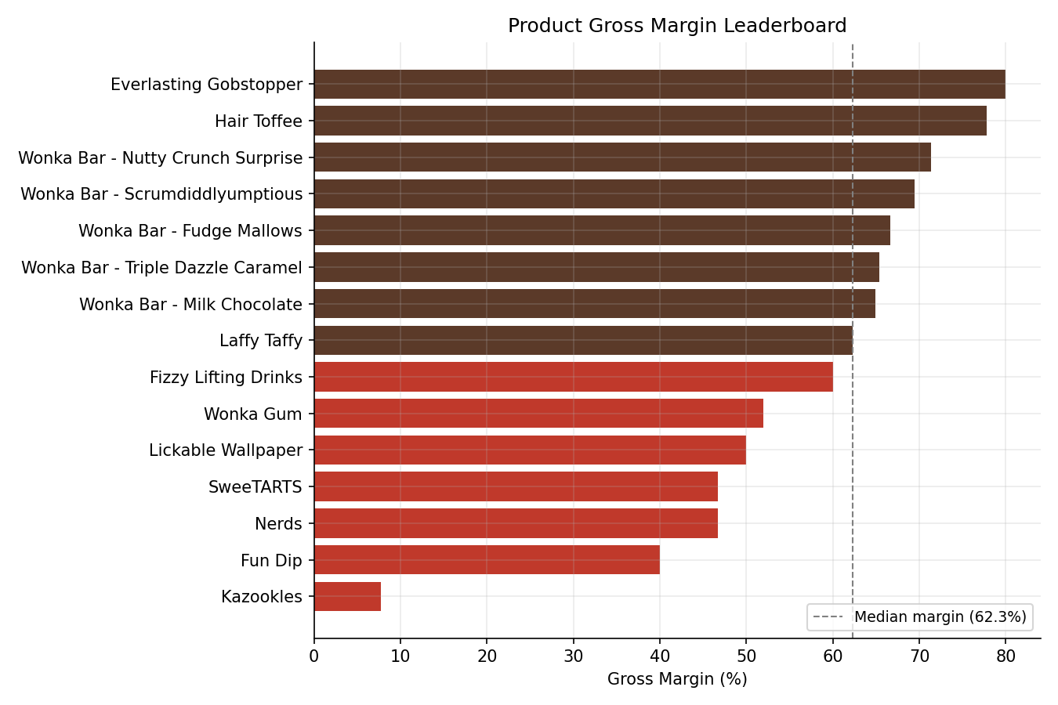
Figure 1. Gross margin by product, ranked lowest to highest. Dashed line marks the median product margin (60.0%).
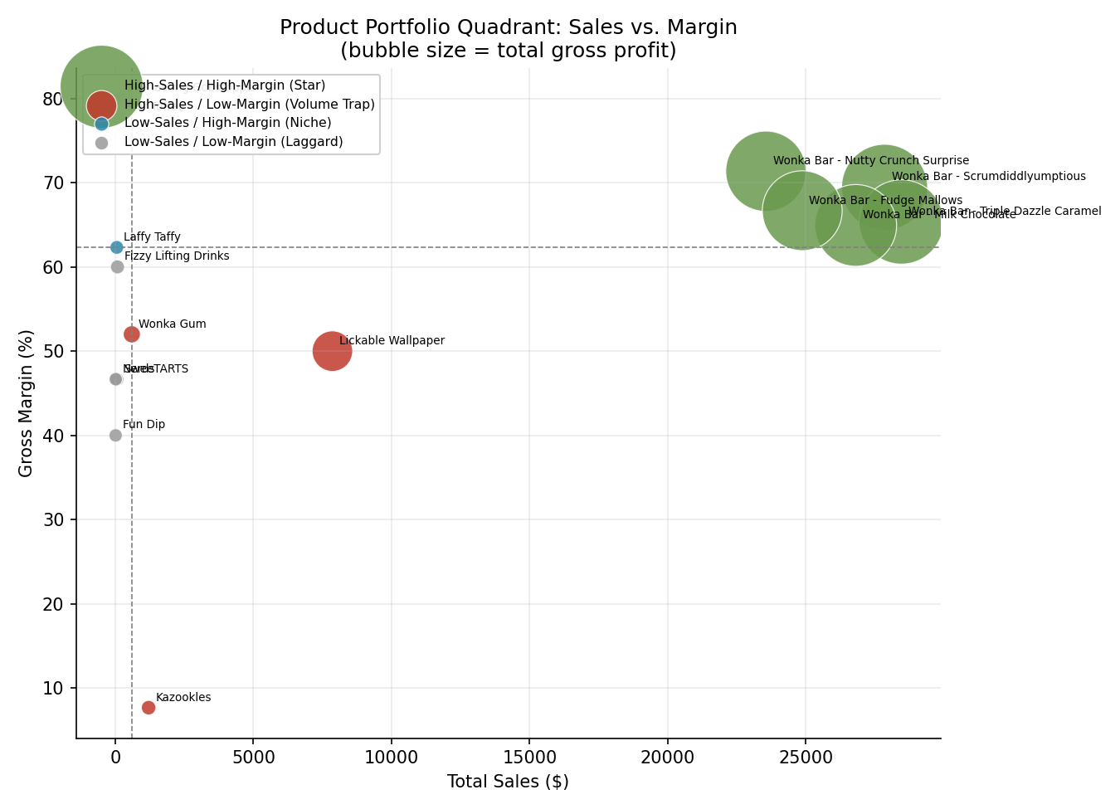
Figure 2. Sales-vs-Margin quadrant map. Bubble size = total gross profit.

4.1 High-Profit / High-Margin Products (Stars)
All five Chocolate-division Wonka Bar products land in the Star quadrant, each contributing between 16.6% and 20.1% of total revenue and between 17.8% and 20.7% of total gross profit, at margins between 64.9% and 71.3%:
Product | Sales | Gross Profit | Margin % | Profit Contribution %
Wonka Bar - Triple Dazzle Caramel | $28,462.50 | $18,595.50 | 65.3% | 19.9%
Wonka Bar - Scrumdiddlyumptious | $27,853.20 | $19,342.50 | 69.4% | 20.7%
Wonka Bar - Milk Chocolate | $26,809.25 | $17,405.39 | 64.9% | 18.7%
Wonka Bar - Nutty Crunch Surprise | $23,557.50 | $16,807.50 | 71.3% | 18.0%
Wonka Bar - Fudge Mallows | $24,872.40 | $16,581.60 | 66.7% | 17.8%
Together these five SKUs generate 92.9% of revenue and 95.1% of gross profit. This is the core product line and the clear priority for supply continuity, shelf placement, and marketing investment.

4.2 High-Sales / Low-Margin Products (Volume Traps)
Three products sell in meaningful volume but convert far less of that revenue into profit, and one is an acute outlier:
Product | Sales | Margin % | Note
Lickable Wallpaper | $7,860.00 | 50.0% | Second-tier margin; large revenue base makes the 19-point margin gap versus the Chocolate line materially costly.
Wonka Gum | $597.50 | 52.0% | Modest revenue but structurally similar to Lickable Wallpaper's margin profile.
Kazookles | $1,205.75 | 7.7% | Severe outlier — cost-to-sales ratio of 92.3% leaves almost no margin per unit sold.
Kazookles is the single clearest margin risk in the portfolio: it sells at meaningful volume but returns essentially no profit, meaning every unit sold is close to a break-even (or effectively wasted) transaction from a profitability standpoint.

4.3 Low-Sales / High-Margin Products (Niche)
Everlasting Gobstopper (80.0% margin), Hair Toffee (77.8%), and Laffy Taffy (62.3%) post the strongest unit economics in the catalog but at negligible sales volume (under $130 each in total sales over two years). These are not currently material to company profit, but they demonstrate pricing power that could inform repricing decisions on the Volume Trap products.

4.4 Low-Sales / Low-Margin Products (Laggards)
Fizzy Lifting Drinks, SweeTARTS, Nerds, and Fun Dip each generated under $80 in total sales over the two-year period, with margins between 40% and 62%. Collectively they represent under 0.1% of company profit. These are prime candidates for product-line rationalization: it is unlikely that the SKU-maintenance, shelf-space, and sourcing overhead of carrying four separate low-volume items is justified by their financial contribution.

5. Division-Level Performance Analysis
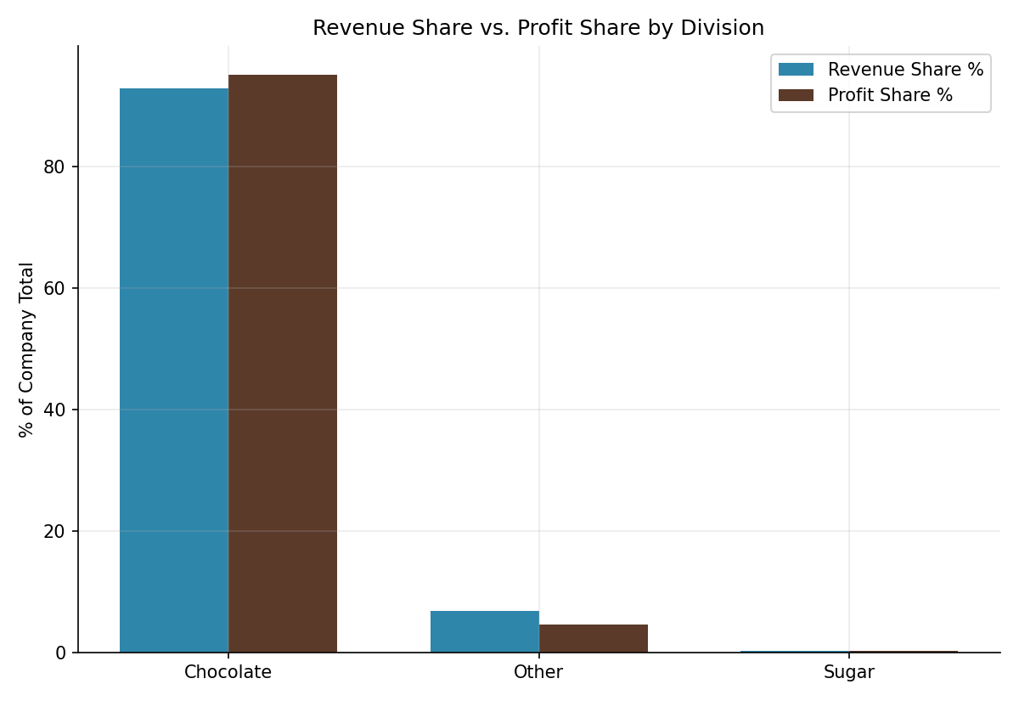
Figure 3. Revenue share vs. profit share by division.
Division | Sales | Gross Profit | Margin % | Revenue Share | Profit Share | Imbalance (pp)
Chocolate | $131,554.85 | $88,732.49 | 67.4% | 92.9% | 95.1% | +2.18
Other | $9,663.25 | $4,333.45 | 44.8% | 6.8% | 4.6% | −2.18
Sugar | $427.48 | $284.73 | 66.6% | 0.3% | 0.3% | +0.00
Chocolate is both the volume leader and the margin leader (67.4% gross margin, the highest of the three divisions by a meaningful gap), and it converts revenue into profit slightly more efficiently than its revenue share alone would predict (+2.18 percentage points of profit share versus revenue share). This is a structurally healthy division.
The Other division (Wonka Gum, Kazookles, Lickable Wallpaper) is the clear underperformer: its 44.8% margin is more than 20 points below Chocolate's, and it captures 2.18 percentage points less of total profit than its revenue share alone would suggest — a direct fingerprint of Kazookles's near-zero margin dragging the division average down.
The Sugar division is financially healthy on a margin basis (66.6%) but is a rounding error in absolute scale — 40 orders and $427 in total sales across two years, versus 8,205 orders for Chocolate. Sugar-division products should be evaluated for whether they are a strategic incubation category or simply not being actively sold/marketed; the current data cannot distinguish between the two.
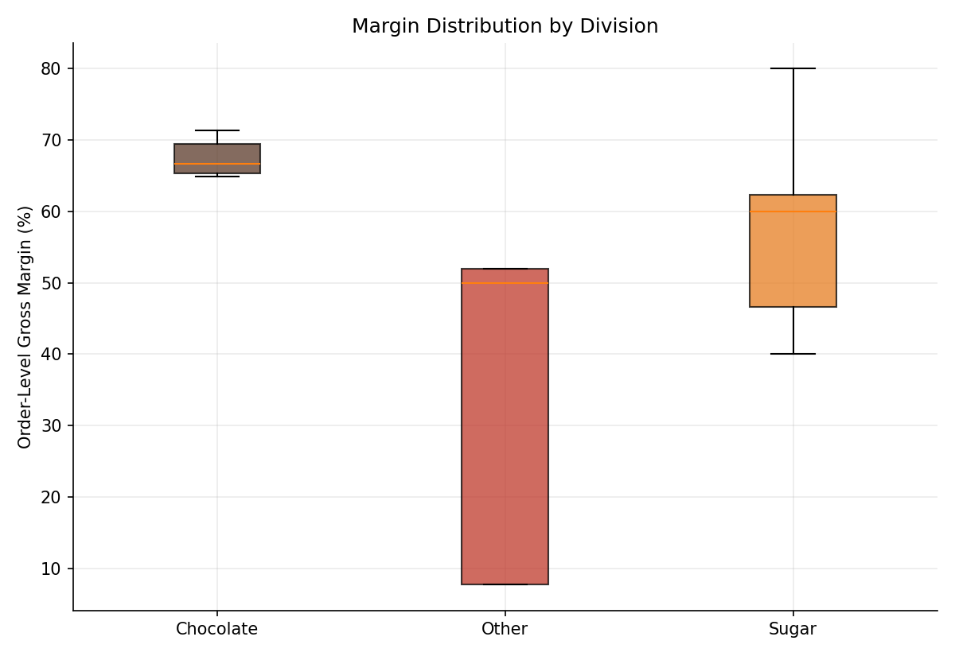
Figure 4. Order-level gross margin distribution by division. The Other division shows both a lower median margin and wider spread than Chocolate or Sugar, indicating less predictable per-order profitability.
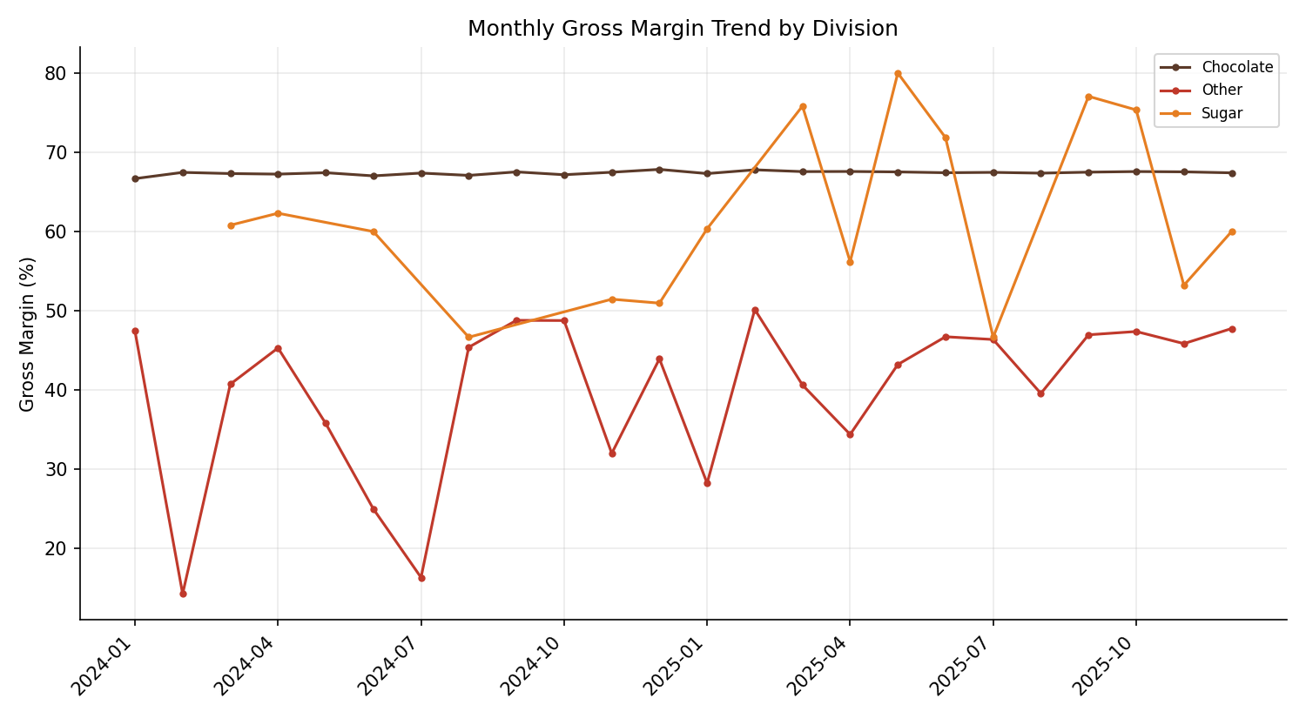
Figure 5. Monthly gross margin trend by division across the two-year analysis window.

6. Profit Concentration (Pareto) Analysis
A classic 80/20 concentration test was applied at both the product and geographic levels.
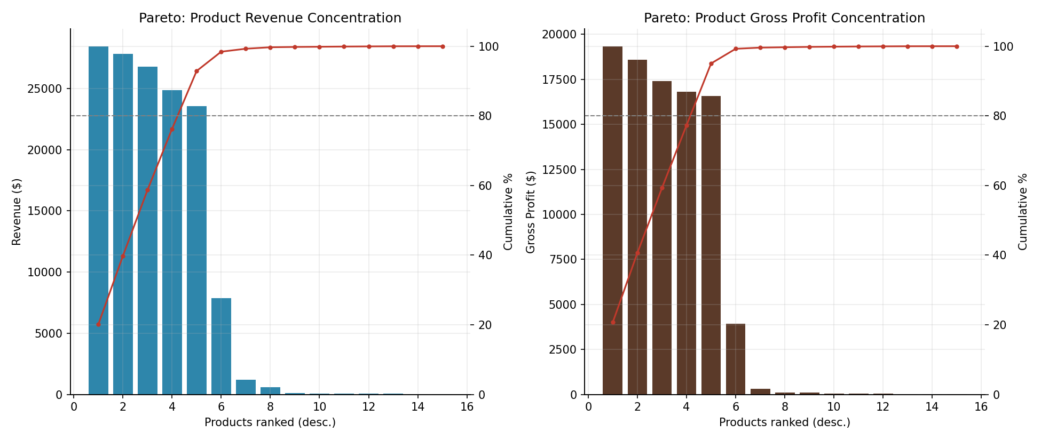
Figure 6. Pareto concentration of product revenue (left) and gross profit (right).
Just 5 of the 15 products (33%) generate 80% of total revenue, and the same 5 products generate 80% of total gross profit — in both cases, these are the five Chocolate Wonka Bar SKUs identified as Stars in Section 4.1. This is a textbook Pareto pattern and confirms that Nassau Candy's profitability is structurally dependent on a small, concentrated product core rather than a broad, diversified catalog.
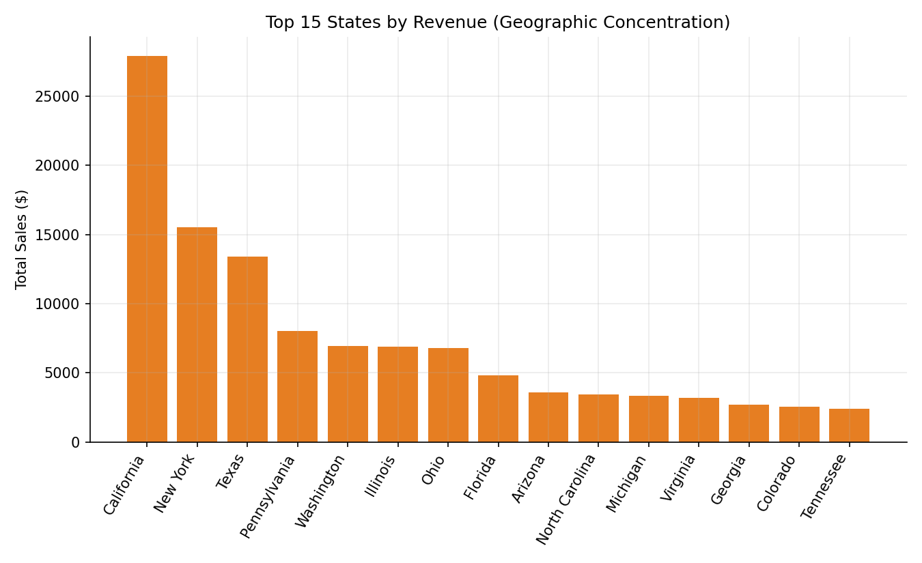
Figure 7. Top 15 states by revenue.
Geographic concentration follows a similar, if less extreme, pattern: 16 of 59 states (27%) account for 80% of total revenue, led by California ($27,903.70), New York ($15,541.03), and Texas ($13,406.34). This is a moderate dependency risk — not as acute as the product concentration, but worth monitoring, particularly if the top three states experience any regional demand or logistics disruption.

7. Cost Structure Diagnostics
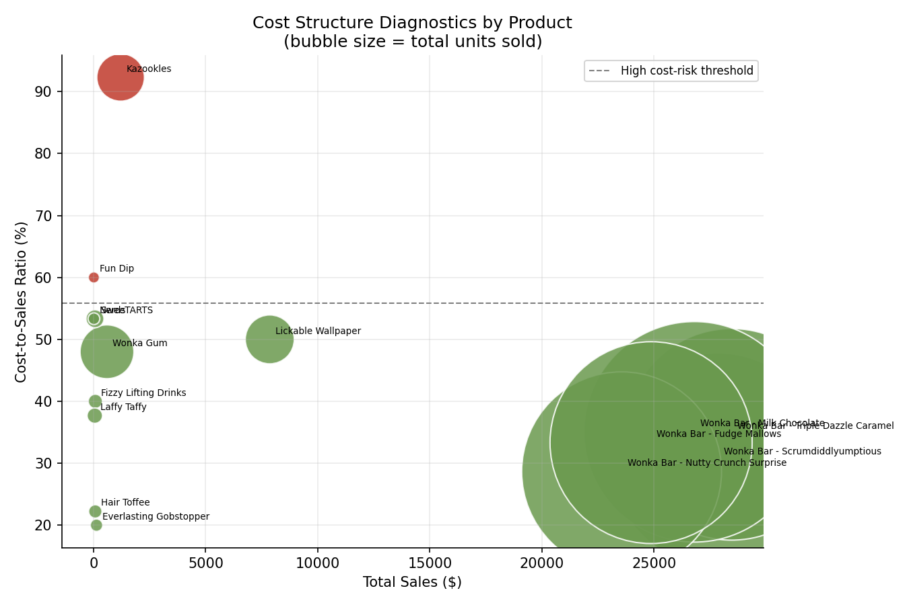
Figure 8. Cost-to-sales ratio by product (bubble size = total units sold). Products above the dashed line are flagged as high cost-risk.
Flagging products whose cost-to-sales ratio exceeds one standard deviation above the median (a threshold of 55.0% in this dataset) surfaces two products for immediate review:
Product | Cost-to-Sales Ratio | Gross Margin % | Total Sales
Kazookles | 92.3% | 7.7% | $1,205.75
Fun Dip | 60.0% | 40.0% | $12.00
Kazookles is the priority action item in this entire analysis: it combines meaningful sales volume with a cost structure that consumes 92 cents of every sales dollar. Recommended next steps are, in order of preference: (1) renegotiate factory cost with The Other Factory, its sole sourcing plant; (2) reprice the product upward if market conditions allow, given its low current margin leaves substantial room; or (3) formally review it for discontinuation if neither lever is available. Fun Dip's cost ratio is also elevated but its total sales are immaterial ($12 over two years), making it a low-priority rationalization candidate rather than a repricing project.
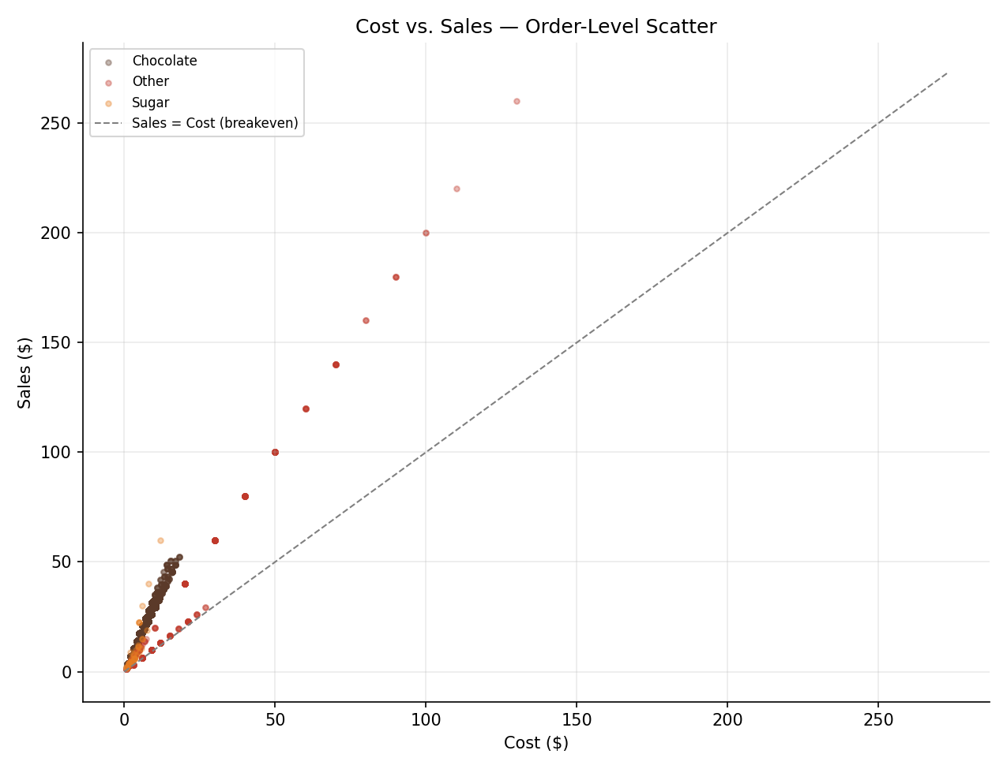
Figure 9. Order-level Cost vs. Sales, colored by division. Points closer to the dashed break-even line represent lower-margin transactions; the Other division (blue) sits visibly closer to break-even than Chocolate (brown).

7.1 Factory Sourcing Rollup
Factory | Sales | Gross Profit | Margin % | Products Sourced
Lot's O' Nuts | $76,283.10 | $52,731.60 | 69.1% | 3
Wicked Choccy's | $55,271.75 | $36,000.89 | 65.1% | 2
Secret Factory | $8,587.50 | $4,344.70 | 50.6% | 3
The Other Factory | $1,282.25 | $152.25 | 11.9% | 2
Sugar Shack | $220.98 | $121.23 | 54.9% | 5
The Other Factory (sourcing Hair Toffee and Kazookles) has by far the weakest blended margin of any sourcing plant, at 11.9% — driven almost entirely by Kazookles. This strengthens the case that Kazookles's margin problem is a sourcing/cost issue rather than a demand or pricing issue in isolation, since Hair Toffee, from the same factory, carries a healthy 77.8% margin.

8. Recommendations

8.1 Protect and invest in the core
- Prioritize supply continuity, shelf placement, and promotional spend on the five Chocolate Wonka Bar SKUs — they generate 95% of profit and should not be treated as “mature” products competing equally for resources against the long tail.

8.2 Fix Kazookles immediately
- Open a cost renegotiation with The Other Factory on Kazookles pricing, or evaluate an alternate sourcing plant given Lot's O' Nuts and Wicked Choccy's demonstrate much stronger cost efficiency.
- If cost cannot be reduced, test a price increase — current margin (7.7%) leaves wide room before the product would become uncompetitive on price versus its category peers.
- If neither lever is viable within a defined review window, recommend formal discontinuation.

8.3 Reprice or review the Other division
- Lickable Wallpaper and Wonka Gum sit in the Volume Trap quadrant; a targeted price or cost review (even a few points of margin improvement) has outsized impact given Lickable Wallpaper's relatively large revenue base.

8.4 Rationalize the long tail
- Fizzy Lifting Drinks, SweeTARTS, Nerds, and Fun Dip together contribute under 0.1% of profit. Consolidate or discontinue unless there is a strategic (non-financial) reason to retain them, such as anchoring a broader Sugar-division catalog for a specific retail partner.

8.5 Monitor geographic concentration
- California, New York, and Texas represent an outsized share of revenue; incorporate this into regional risk planning (e.g., inventory buffers, alternate distribution routing) even though it is a lower-urgency finding than the product-level concentration.

8.6 Data quality follow-up
- Investigate and correct the Ship Date generation/recording process, which currently produces implausible multi-year gaps between order and shipment — this does not affect the profitability findings in this report but would materially improve any future logistics or fulfillment analysis.

9. Limitations
- Sugar and Other divisions have very small sample sizes (40 and 304 orders respectively, versus 8,205 for Chocolate); their KPIs are directionally useful but statistically less stable than Chocolate's.
- Margin volatility was computed on monthly aggregates; low-volume products (e.g. most of the Sugar division) have too few monthly observations for volatility to be a reliable signal, and should be interpreted cautiously in the dashboard.
- The analysis is a single order-level dataset without a matched prior-period baseline, so directional trend claims (e.g. “improving” or “declining” margin) are limited to the 2024–2025 window covered here.

10. Conclusion
This analysis replaces intuition with a clear, data-driven picture of where Nassau Candy actually makes money. Profitability is concentrated in five Chocolate-division products that punch above their revenue weight; the Other division — and Kazookles in particular — is where a small, targeted intervention (cost renegotiation, repricing, or discontinuation) would have an outsized positive effect on blended margin. Sugar and other long-tail products are financially immaterial today and should be evaluated as a portfolio-rationalization decision. The accompanying Streamlit dashboard operationalizes these findings so pricing, sourcing, and product-portfolio decisions can be made and monitored on an ongoing basis rather than revisited only at the next annual review.

