ELECTROMAGNETIC THEORY:

Electromagnetics: It is the study of interaction of fields that are generated by time-varying charge distributions and currents.

EMT can be considered as a superset of Circuit theory
From circuit theory we learn that frequency of source and length of wire does not matter.
Also from circuit theory , shape of wire also doesn’t matter.
From EMT , the bend wire at low frequencies looks like an inductor and at high frequencies looks like a transmission line.
In circuit theory, lenght of interconnects between circuit elements do not matter but in EMT a long wire causes delay; voltage and current is actually a wave that experiences time delay.

- A wire is not just a wire

- Ordinary circuit theory cannot account for these effects whereas emt can.
Electromagnetics In Optical Fibre:

EM Theory and antennas:
- Antennas radiate and receive EM waves
- EMT is necessary to understand principles of antenna design and analysis
KCL and KVL are special cases of EMT via Maxwell’s equation,where time delay is neglected

Charge: It is a fundamental property
Charges are of two types: Positive or Negative
- During lightning charge collected is 10-20C
- 1e⁻ = 1.6*10⁻¹⁹C
- 1C= 1/1.6*10⁻¹⁹ = 6.25*10¹⁸ electrons
Coulomb’s law: We have two charges q1,q2 and assume that distance between two charges is very large as compared to their dimensions. So we have to find the force exerted by one charge on another.
- During point charge calculations we have nothing to deal with charge distributions.

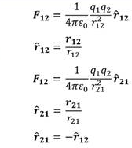
Electric Charge Distributions:
- In many situations we need to consider charges distributed on a line,surface, or a volume in space
- Although such charge distribution is granular on atomic and molecular scale, we take these distribution to be continuous functions.
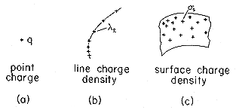
Lets consider a line charge in which charge density would be varying at different positions, but since there are large no. Of electrons we say that how many charges are present per unit length defining Charge density,ρ_{L}=charge per unit length , when charges are distributed over a surface,ρ_{S} =charges per unit area and when charges distributed in a region of space
ρ_{V} = charges per unit volume
- Total charge obtained by:
= ∫_{l} ρ_{l} dl, total charge on a line
Q_{total} = ∫_{S} ρ_{S} dS, total charge on surface
=∫_{V} ρ_{v} dV, total charge in a volume
ε₀ =Permivity of free space
ε= ε₀ ε_{r} If object is in a medium
ε_{r} = F_{vacuum}/ F_{medium}
Vector Analysis
- Vector addition is commutative and associative(can be performed in any order)
- The vector operation is graphical operation in which we add , sub. ,etc two or three vectors but as the no. Of vectors increased we have to use algebric method which uses coodinate system
Coordinate System
Importance: Coordinate System helps us to specify a location in space by numbers as well as describe a method in which a vector can be described equivalently by set of numbers.
This is a great as a vector which could be oriented in a random direction in space is now described by a set of numbers and if we also find out how to add or sub these numbers then the entire process can be calculated algebrically which is easier than graphical method.
- Note: A vector doesn’t depend on Coordinate system for its existance
- All vectors are drawn with their origin sitting at origin of the coordinate system
1. Rectangular Coordinate System:
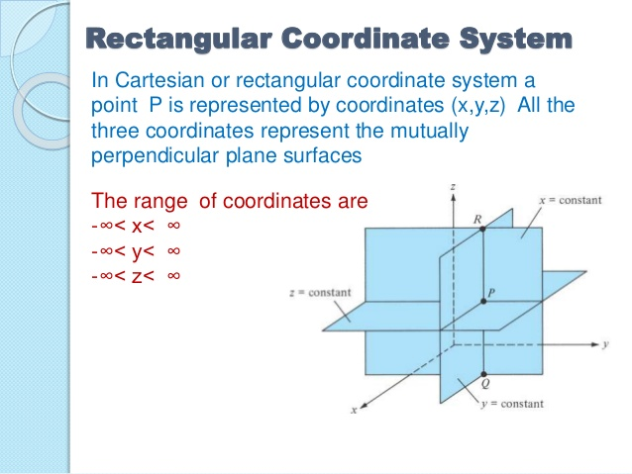
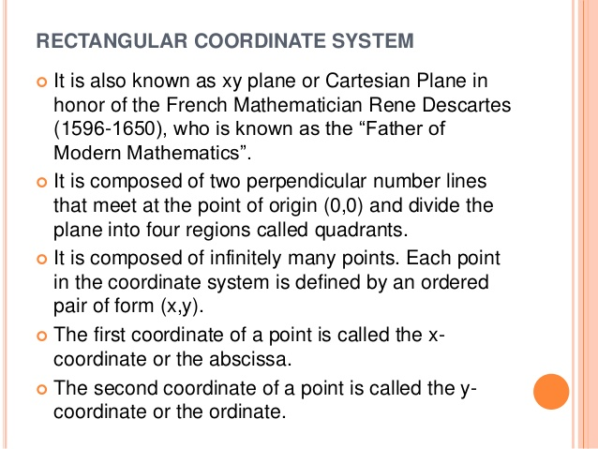
It is further of three types:
1D,2D,3D
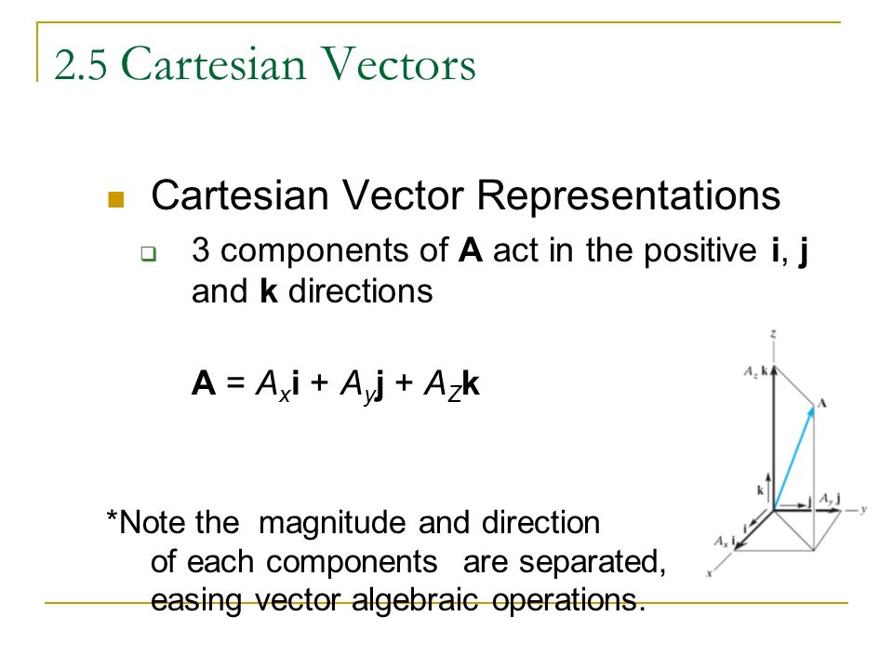
- 3D can be assumed as a right handed coordinate system
- Given point which has three coordinates is the intersection of three planes .
- Intersection two planes give two coordinates.

Now we can draw a line from origin to that point defining a vector.

Resolving a vector means taking a vector and taking its component along different directions.
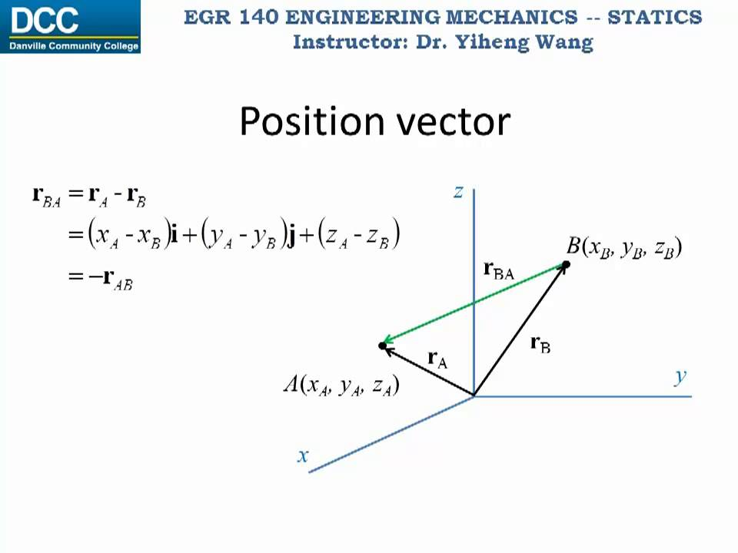
- In resolving a 3D vector , we are basically generating three mutually perpendicular vectors .
- Any point in space can be now considered as a vector with its tail at origin and also we can define a position vector with respect to two points.
- For add, sub the individual components of vector can be added or sub.
- In figure r_{ba} is a position vector
- In coulomb’s law , force to be calculated b/w two charges is basically a position vector w.r.t q1 and q2
Source Charge: The charge which is producing electric field
Let source charge q1 are located at r`
Test Charge: The charge which is experiencing electric field
Let test charge q2 are located at r
Then force experienced by test charge at field point:
F(r)= q1(r΄)q2(r) (r-r΄)
/4Л ε₀ε_{r} |r-r΄|³
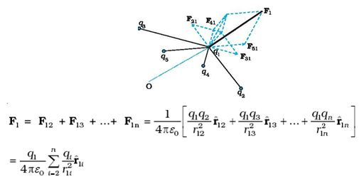
- In case of more no. Of charges ,we use superposition theorem

here the test charge is located at a fixed position
Therefore we will calculate forces due to each charges one by one and then finally add them to obtain our result
- This force is not contact force , but action at a distance law

When a source charge applies force on test charge , test charge doesn’t move instantaneously but there is some delay occurs, this leads to invention of field.Field embodies the concept of cause and response.
Field: Field is the intermediate agency which seems to carry the cause and transfers to the particular other location after certain time.
Field is earlier developed for mathematical convenience ,but later founds to have real phenomenon like energy,momentum, making it feel as real as particles.
- While analysing fields of a source charge , source charge is kept fixed and we move test charge for testing
Characteristics of Field:
1. For every point in location around the source charge, we can associate a vector, such a distribution of vectors in space is known as vector field.
Therfore , vector field is basically the distribution of vectors.
2. At each position of space we can put down a no. Representing charge .Such a distribution of no’s in space is known as Scalar field.

Electric Field = It is defined as ‘force experienced by the test charge per unit test charge’
E(r) = F_{t}/q_{t}

- A test charge has its own field , so if it overwhelmes field of source charge our calculations come out to be wrong, so test charge should be small
- A test charge cannot be 0 as smallest charge present is that of electron
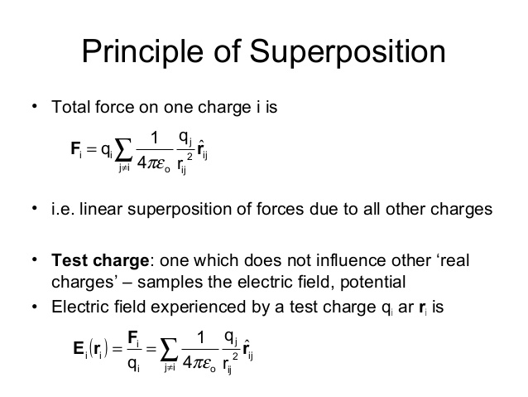
- A test cannot be 1C as 1C is much larger charge (sinceC=Aε₀/d=q/v
If q=1C then if we apply 5-6V then A\d is of the order of 10¹⁰ therefore separation is very
small and length is very large therefore 1C is quite big charge )
When we want to locate a point in 3D we first move in x-dir then y-dir and then in z, but instead if we know the distance and angle in which point is located we can reach that point quite easily, this leads to Cylindrical Coordinate System
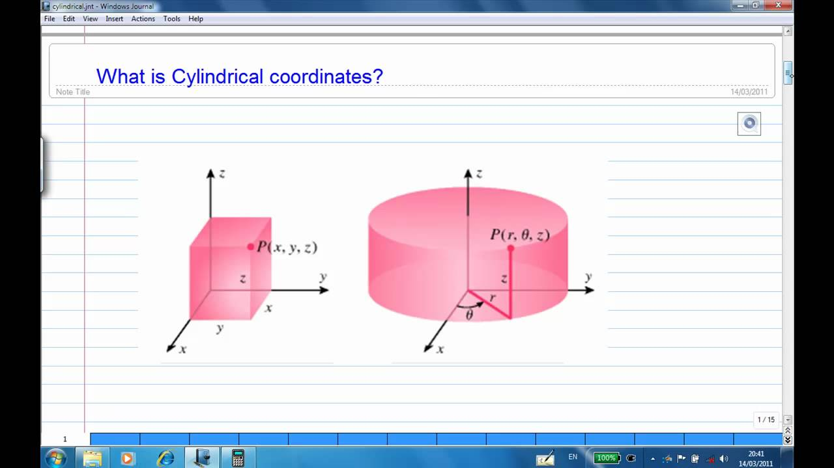
If P is our point then drop this point in xy plane

