PETNOCARE

STARTUP EXPENSE

The table provided contains two sections: startup costs and profit/loss projections.

In the startup costs section, the following cost elements are listed:

1. Market Research: The cost of conducting market research is INR 50,000. This will be outsourced to a market research firm.

2. Website Development: The cost of developing and maintenance of a website is INR 50,000. This will be outsourced to a web development company.

3. Legal and Registration: The cost of legal and registration fees is INR 100,000. This includes registering the business, obtaining necessary licenses, and legal fees.

4. Office Equipment and Furniture: The cost of office equipment and furniture is INR 75,000. This includes chairs, tables, cabinets, computers, and other necessary office equipment.

5. Marketing and Advertising: The cost of marketing and advertising expenses is INR 200,000. This will include online and offline advertising, social media marketing, and other promotional activities.

6. Van and Equipment: The cost of purchasing a van and equipment is INR 750,000. This includes the cost of the van, driver salary, and veterinary equipment and medicines.

7. Initial Inventory: The cost of purchasing initial inventory is INR 500,000. This includes the initial stock of pet food, pet accessories, and other necessary pet care items.

8. Working Capital: The cost of working capital for initial operations is INR 1,500,000. This will cover salaries, rent, utilities, and other operational expenses for the first three months.

9. Loan: The cost of the loan taken to cover initial startup costs is INR 2,000,000.

In the profit/loss projections section, the following revenue and expense elements are listed:

Revenue:

- Consultation Services: The revenue generated by online consultation services is INR 250,000, based on 500 hours at a rate of INR 500 per hour.

The revenue generated by offline consultation services is INR 187,500, based on 250 hours at a rate of INR 750 per hour.

- Pet Treatment: The revenue generated by pet treatment through the van is INR 225,000, based on 150 treatments at a rate of INR 1,500 per treatment.

- Pet Accessories: The revenue generated by the sale of pet accessories is INR 250,000, based on the sale of 5,000 pieces at a rate of INR 50 per piece.

- Pet Food: The revenue generated by the sale of pet food is INR 500,000, based on the sale of 5,000 kg at a rate of INR 100 per kg.

The total revenue generated is INR 1,412,500.

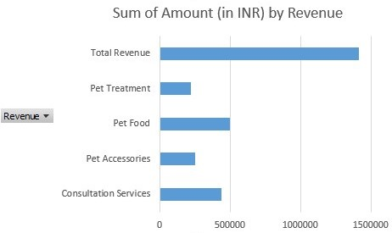

Expenses:

- Employee Salary: The cost of employee salaries is INR 200,000, based on 10 employees at a monthly salary of INR 20,000.

- Rent: The cost of rent for office space and van parking is INR 100,000 per month.

- Utilities: The cost of electricity, water, and internet is INR 25,000 per month.

- Van Maintenance: The cost of van maintenance and repairs is INR 20,000 per month.

- Inventory Cost: The cost of purchasing pet care items for inventory is INR 400,000 (exact unit description and unit nos are not specified).

- Advertising and Promotion: The cost of marketing and advertising expenses is INR 100,000.

The total expenses are INR 1,045,000.

Based on the revenue and expenses, the profit/loss projection is INR 367,500.

Assignment - 4 ( Cost and Revenue )

Project title - Petnocare

Team Members :

Abhay Diwakar 2020164

Deep Shekhar 2020193

Dheerender Singh 2020195

Dushyant 2020198