1) Total Seats
SELECT DISTINCT COUNT(Parliament_Constituency) from constituencywise_results;
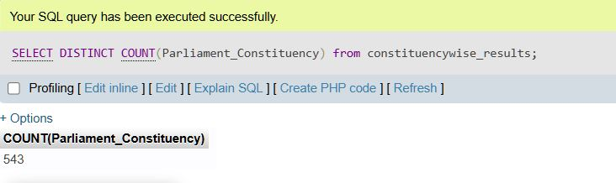

2)What is the toal number of seats available for electins in each state.
SELECT
s.State AS State_name,
COUNT(cr.Parliament_Constituency) AS sum_seats
FROM
constituencywise_results cr
INNER JOIN
statewise_results sr ON cr.Parliament_Constituency = sr.Parliament_Constituency
INNER JOIN
states s ON sr.State_ID = s.State_id
GROUP BY
s.State
ORDER BY
s.State

SELECT
'Total' AS State_name,
COUNT(cr.Parliament_Constituency) AS sum_seats
FROM
constituencywise_results cr;
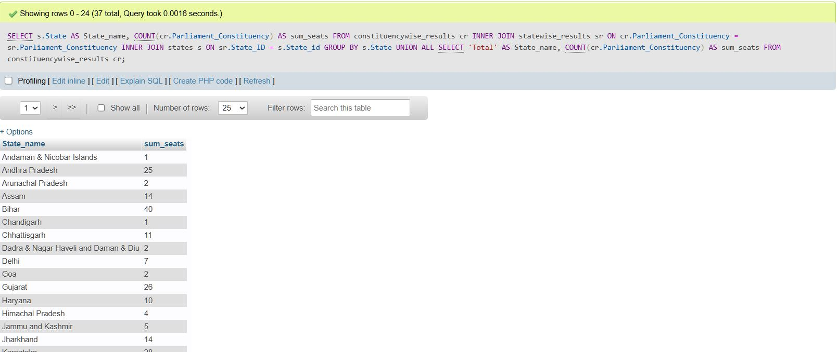

3)total seats won by NDA alince
SELECT
SUM( CASE
WHEN party IN (
'Bharatiya Janata Party - BJP',
'Asom Gana Parishad - AGP',
'Telugu Desam - TDP',
'Janata Dal (United) - JD(U)',
'Shiv Sena - SHS',
'AJSU Party - AJSUP',
'Apna Dal (Soneylal) - ADAL',
'Hindustani Awam Morcha (Secular) - HAMS',
'Janasena Party - JnP',
'Janata Dal (Secular) - JD(S)',
'Lok Janshakti Party(Ram Vilas) - LJPRV',
'Nationalist Congress Party - NCP',
'Rashtriya Lok Dal - RLD',
'Sikkim Krantikari Morcha - SKM'
) THEN Won
ELSE 0 END
) AS NDA_Total_Seats_Won
FROM partywise_results;
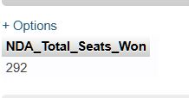
4)seats won by nda aliance parties
select
party as Party_Name,
Won as Seats_Won
from partywise_results
where
party in(
'Bharatiya Janata Party - BJP',
'Asom Gana Parishad - AGP',
'Telugu Desam - TDP',
'Janata Dal (United) - JD(U)',
'Shiv Sena - SHS',
'AJSU Party - AJSUP',
'Apna Dal (Soneylal) - ADAL',
'Hindustani Awam Morcha (Secular) - HAMS',
'Janasena Party - JnP',
'Janata Dal (Secular) - JD(S)',
'Lok Janshakti Party(Ram Vilas) - LJPRV',
'Nationalist Congress Party - NCP',
'Rashtriya Lok Dal - RLD',
'Sikkim Krantikari Morcha - SKM'
)
order by Seats_won DESC
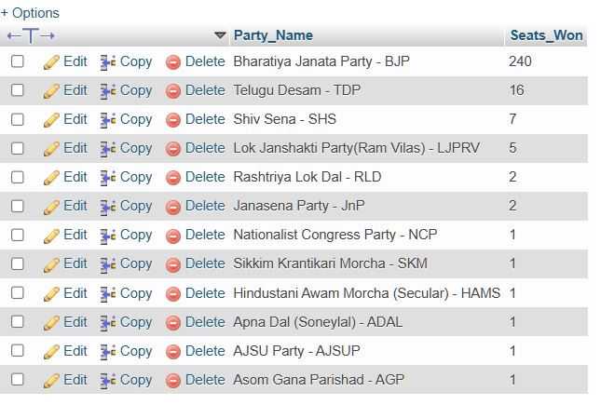
4)seats won by I.N.D.I.A aliance
SELECT
SUM( CASE
WHEN party IN (
'Aam Aadmi Party - AAAP',
'All India Trinamool Congress - AITC',
'Communist Party of India - CPI',
'Communist Party of India (Marxist-Leninist) (Liberation) - CPI(ML)(L)',
'Communist Party of India (Marxist) - CPI(M)',
'Dravida Munnetra Kazhagam - DMK',
'Indian National Congress - INC',
'Indian Union Muslim League - IUML',
'Jammu & Kashmir National Conference - JKN',
'Jharkhand Mukti Morcha - JMM',
'Kerala Congress - KEC',
'Marumalarchi Dravida Munnetra Kazhagam - MDMK',
'Rashtriya Janata Dal - RJD',
'Revolutionary Socialist Party - RSP',
'Samajwadi Party - SP',
'Viduthalai Chiruthaigal Katchi - VCK',
'Rashtriya Loktantrik Party - RLTP',
'Bharat Adivasi Party - BHRTADVSIP',
'Nationalist Congress Party Sharadchandra Pawar - Ncpsp',
'Shiv Sena (Uddhav Balasaheb Thackrey) - SHSUBT'
) THEN Won
ELSE 0
END
) AS NDA_Total_Seats_Won
FROM
partywise_results;
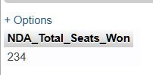

5)seats won by I.N.D.I.A. Alliance Parties

SELECT
party,
won from partywise_results
WHERE party IN (
'Aam Aadmi Party - AAAP',
'All India Trinamool Congress - AITC',
'Communist Party of India - CPI',
'Communist Party of India (Marxist-Leninist) (Liberation) - CPI(ML)(L)',
'Communist Party of India (Marxist) - CPI(M)',
'Dravida Munnetra Kazhagam - DMK',
'Indian National Congress - INC',
'Indian Union Muslim League - IUML',
'Jammu & Kashmir National Conference - JKN',
'Jharkhand Mukti Morcha - JMM',
'Kerala Congress - KEC',
'Marumalarchi Dravida Munnetra Kazhagam - MDMK',
'Rashtriya Janata Dal - RJD',
'Revolutionary Socialist Party - RSP',
'Samajwadi Party - SP',
'Viduthalai Chiruthaigal Katchi - VCK',
'Rashtriya Loktantrik Party - RLTP',
'Bharat Adivasi Party - BHRTADVSIP',
'Nationalist Congress Party Sharadchandra Pawar - Ncpsp',
'Shiv Sena (Uddhav Balasaheb Thackrey) - SHSUBT'
)
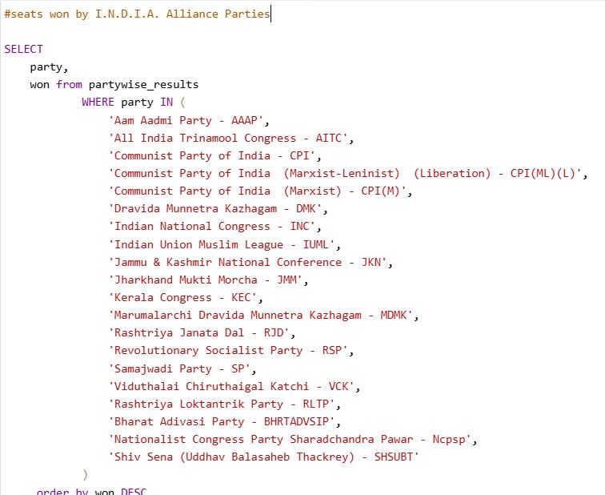
order by won DESC

6)Add new column field in table partywise_results to get the party allianz as NDA, I.N.D.I.A. and OTHER
alter table partywise_results add party_alliance varchar(50) ;
update partywise_results
set party_alliance='I.N.D.I.A.'
WHERE party in (
'Aam Aadmi Party - AAAP',
'All India Trinamool Congress - AITC',
'Communist Party of India - CPI',
'Communist Party of India (Marxist-Leninist) (Liberation) - CPI(ML)(L)',
'Communist Party of India (Marxist) - CPI(M)',
'Dravida Munnetra Kazhagam - DMK',
'Indian National Congress - INC',
'Indian Union Muslim League - IUML',
'Jammu & Kashmir National Conference - JKN',
'Jharkhand Mukti Morcha - JMM',
'Kerala Congress - KEC',
'Marumalarchi Dravida Munnetra Kazhagam - MDMK',
'Rashtriya Janata Dal - RJD',
'Revolutionary Socialist Party - RSP',
'Samajwadi Party - SP',
'Viduthalai Chiruthaigal Katchi - VCK',
'Rashtriya Loktantrik Party - RLTP',
'Bharat Adivasi Party - BHRTADVSIP',
'Nationalist Congress Party Sharadchandra Pawar - Ncpsp',
'Shiv Sena (Uddhav Balasaheb Thackrey) - SHSUBT'
)
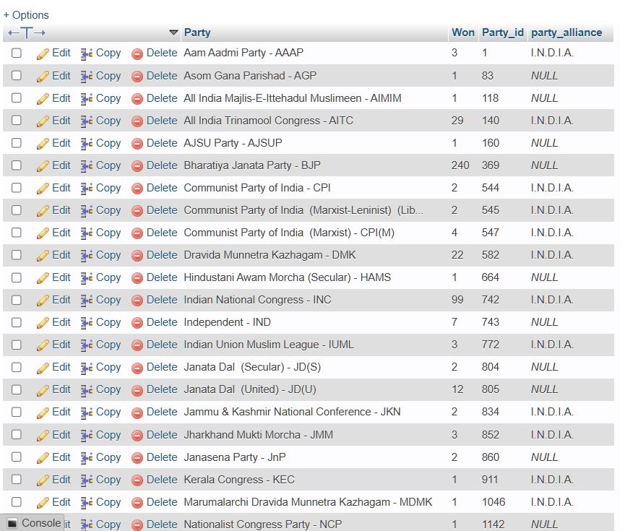
# NDA
update partywise_results
set party_alliance='N.D.A'
WHERE party in (
'Bharatiya Janata Party - BJP',
'Asom Gana Parishad - AGP',
'Telugu Desam - TDP',
'Janata Dal (United) - JD(U)',
'Shiv Sena - SHS',
'AJSU Party - AJSUP',
'Apna Dal (Soneylal) - ADAL',
'Hindustani Awam Morcha (Secular) - HAMS',
'Janasena Party - JnP',
'Janata Dal (Secular) - JD(S)',
'Lok Janshakti Party(Ram Vilas) - LJPRV',
'Nationalist Congress Party - NCP',
'Rashtriya Lok Dal - RLD',
'Sikkim Krantikari Morcha - SKM'
)
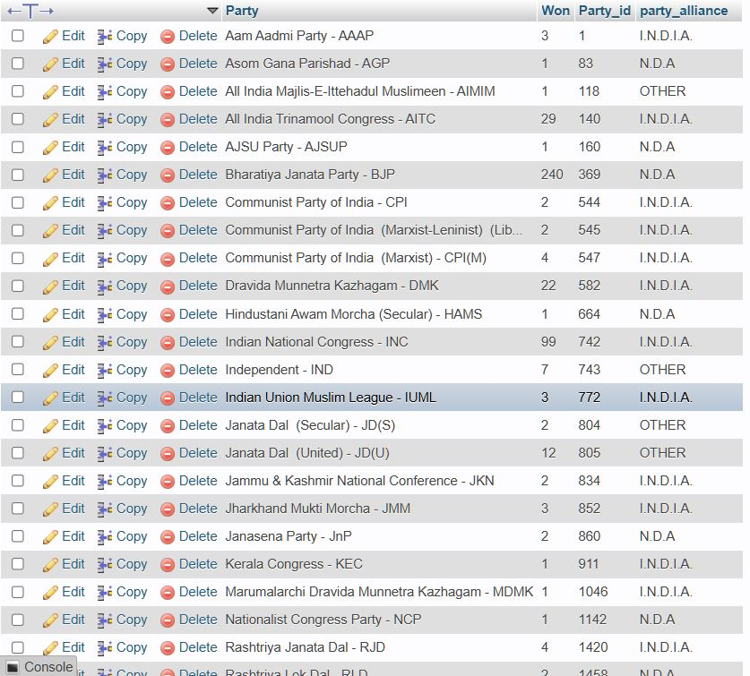

# OTHER
UPDATE partywise_results set party_alliance='OTHER ' where party_alliance is null
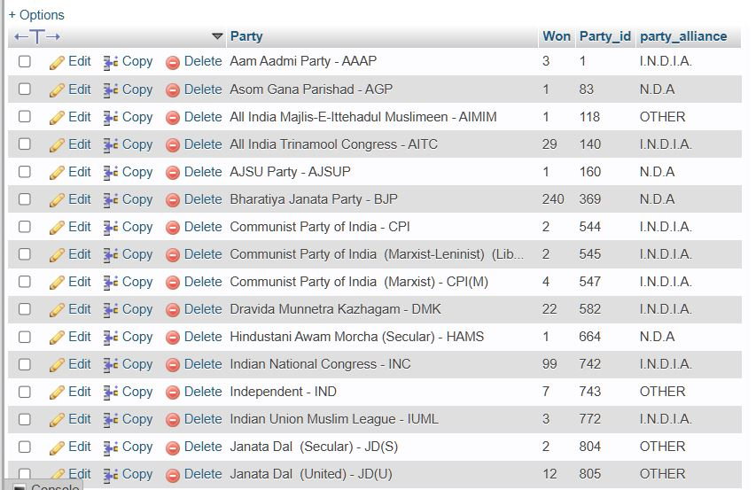

7)Which party alliance (NDA, I.N.D.I.A, or OTHER) won the most seats across all states?
SELECT
p.party_alliance,
COUNT(cr.Constituency_ID) AS Seats_Won
FROM
constituencywise_results cr
JOIN
partywise_results p ON cr.Party_ID = p.Party_ID
WHERE
p.party_alliance IN ('NDA', 'I.N.D.I.A', 'OTHER')
GROUP BY
p.party_alliance

ORDER BY
Seats_Won DESC;
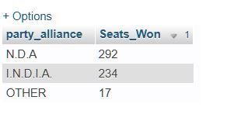
8)Winning candidate's name, their party name, total votes, and the margin of victory for a specific state and constituency?
SELECT cr.Winning_Candidate, p.Party, p.party_alliance, cr.Total_Votes, cr.Margin, cr.Constituency_Name, s.State
FROM constituencywise_results cr
JOIN partywise_results p ON cr.Party_ID = p.Party_ID
JOIN statewise_results sr ON cr.Parliament_Constituency = sr.Parliament_Constituency
JOIN states s ON sr.State_ID = s.State_ID
WHERE s.State = 'GUJARAT' AND cr.Constituency_Name = 'RAJKOT';

9)What is the distribution of EVM votes versus postal votes for candidates in a specific constituency?
SELECT
cd.Candidate,
cd.Party,
cd.EVM_Votes,
cd.Postal_Votes,
cd.Total_Votes,
cr.Constituency_Name
FROM
constituencywise_details cd
JOIN
constituencywise_results cr ON cd.Constituency_ID = cr.Constituency_ID
WHERE
cr.Constituency_Name = 'RAJKOT'
ORDER BY cd.Total_Votes DESC;
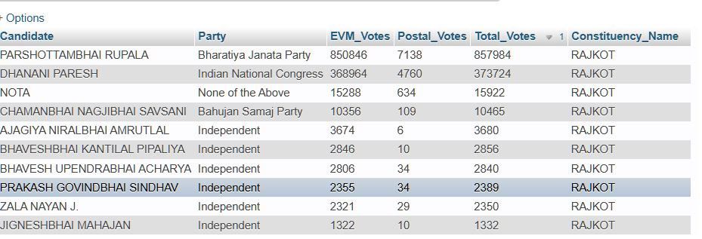

10) Which parties won the most seats in s State, and how many seats did each party win?
SELECT
p.Party,
SUM(p.won) AS Seats_Won
FROM
constituencywise_results cr
JOIN
partywise_results p ON cr.Party_ID = p.Party_ID
JOIN
statewise_results sr ON cr.Parliament_Constituency = sr.Parliament_Constituency
JOIN states s ON sr.State_ID = s.State_ID
WHERE
s.state = 'GUJARAT'
GROUP BY
p.Party
ORDER BY
Seats_Won DESC;
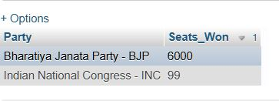
11)what is the total number of seats won by each party alliance (NDA, I.N.D.I.A, AND OTHER) in each state for the india elections 2024
SELECT
s.State AS State_Name,
SUM(CASE WHEN pr.party_alliance = 'N.D.A' THEN 1 ELSE 0 END) AS NDA_Seats_Won,
SUM(CASE WHEN pr.party_alliance = 'I.N.D.I.A.' THEN 1 ELSE 0 END) AS INDIA_Seats_Won,
SUM(CASE WHEN pr.party_alliance = 'OTHER' THEN 1 ELSE 0 END) AS OTHER_Seats_Won
FROM
constituencywise_results cr
JOIN
partywise_results pr ON cr.Party_ID = pr.Party_ID
JOIN
statewise_results sr ON cr.Parliament_Constituency = sr.Parliament_Constituency
JOIN
states s ON sr.State_ID = s.State_ID

GROUP BY
s.State

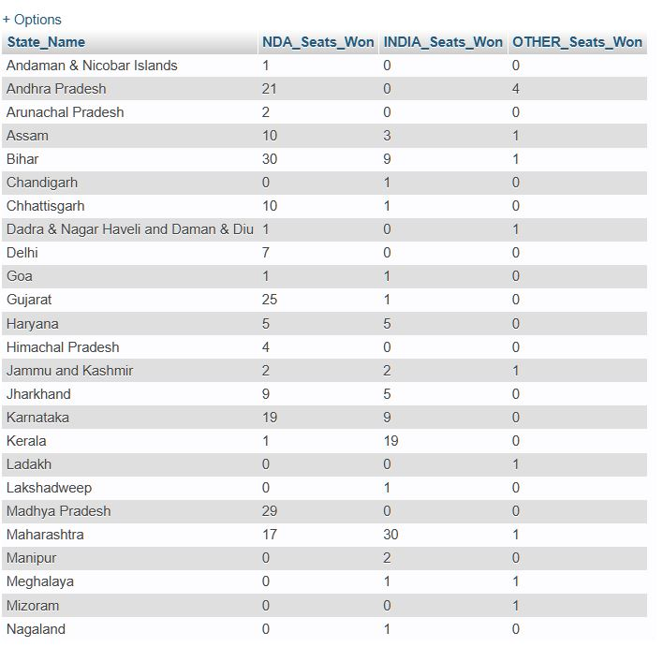
12)which candidate received the highest number of EVM votes in each constituency(Top 10)?
SELECT
cr.Constituency_Name,
cd.Constituency_ID,
cd.Candidate,
cd.EVM_Votes
FROM
constituencywise_details cd
JOIN
constituencywise_results cr ON cd.Constituency_ID = cr.Constituency_ID
WHERE
cd.EVM_Votes = (
SELECT MAX(cd1.EVM_Votes)
FROM constituencywise_details cd1
WHERE cd1.Constituency_ID = cd.Constituency_ID
)
ORDER BY
cd.EVM_Votes DESC
LIMIT 10;
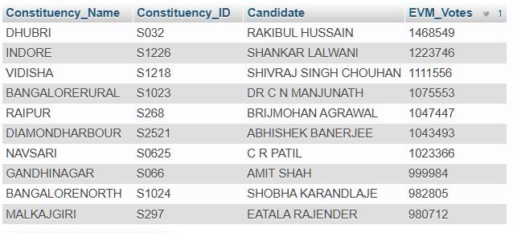

13)which candidate won and which candidate was the runner-up in each consituency of state for the 2024 elecatons?
WITH RankedCandidates AS (
SELECT
cd.Constituency_ID,
cd.Candidate,
cd.Party,
cd.EVM_Votes,
cd.Postal_Votes,
cd.EVM_Votes + cd.Postal_Votes AS Total_Votes,
ROW_NUMBER() OVER (PARTITION BY cd.Constituency_ID ORDER BY cd.EVM_Votes + cd.Postal_Votes DESC) AS VoteRank
FROM
constituencywise_details cd
JOIN
constituencywise_results cr ON cd.Constituency_ID = cr.Constituency_ID
JOIN
statewise_results sr ON cr.Parliament_Constituency = sr.Parliament_Constituency
JOIN
states s ON sr.State_ID = s.State_ID
WHERE s.State = 'Maharashtra'
)

SELECT
cr.Constituency_Name,
MAX(CASE WHEN rc.VoteRank = 1 THEN rc.Candidate END) AS Winning_Candidate,
MAX(CASE WHEN rc.VoteRank = 2 THEN rc.Candidate END) AS Runnerup_Candidate
FROM
RankedCandidates rc
JOIN
constituencywise_results cr ON rc.Constituency_ID = cr.Constituency_ID
GROUP BY
cr.Constituency_Name
ORDER BY
cr.Constituency_Name;

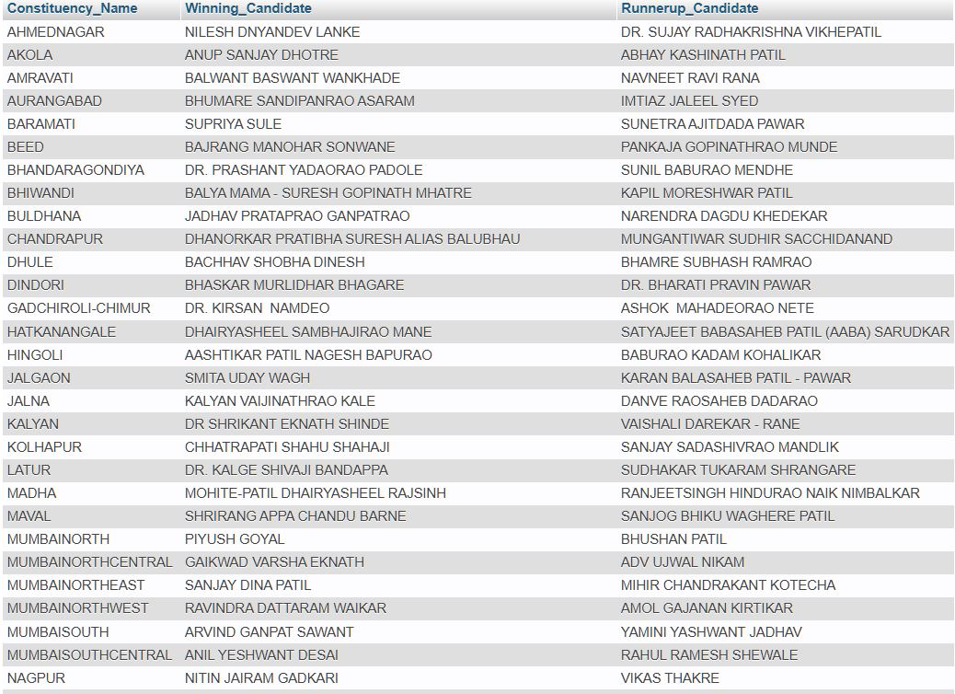

14)for the state of Gujarat, what are the total number of seats,total number of candidatetotal number of parties, total votes(Including EVM and postal),and the breakdown of EVM and postal votes?
SELECT
COUNT(DISTINCT cr.Constituency_ID) AS Total_Seats,
COUNT(DISTINCT cd.Candidate) AS Total_Candidates,
COUNT(DISTINCT p.Party) AS Total_Parties,
SUM(cd.EVM_Votes + cd.Postal_Votes) AS Total_Votes,
SUM(cd.EVM_Votes) AS Total_EVM_Votes,
SUM(cd.Postal_Votes) AS Total_Postal_Votes
FROM
constituencywise_results cr
JOIN
constituencywise_details cd ON cr.Constituency_ID = cd.Constituency_ID
JOIN
statewise_results sr ON cr.Parliament_Constituency = sr.Parliament_Constituency
JOIN
states s ON sr.State_ID = s.State_ID
JOIN
partywise_results p ON cr.Party_ID = p.Party_ID
WHERE
s.State = 'Gujarat';
