To add captions to my Chess_Video.mp4, I first did Chatgpt Auto (free version). It gave me code which used TextClip functionality from moviepy to overlay text onto each image clip. This code gave me an **OSError** which kept occurring to me. Below is the error message.

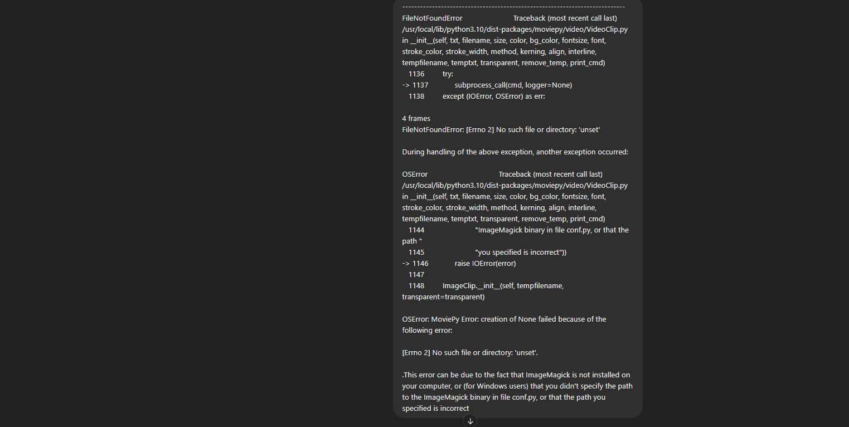

I tried to fix this by talking to ChatGPT and it gave multiple solutions such as to install various libraries which can be seen in **part2.ipynb** file, but those solutions did not work.

Later I instructed ChatGPT to give me a solution with another approach.

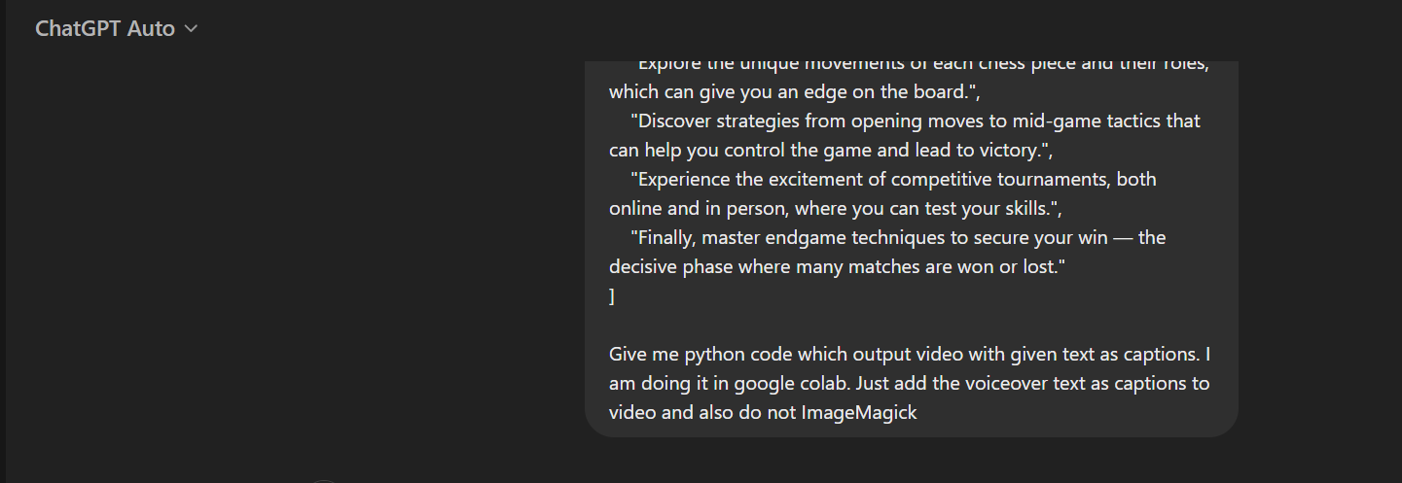

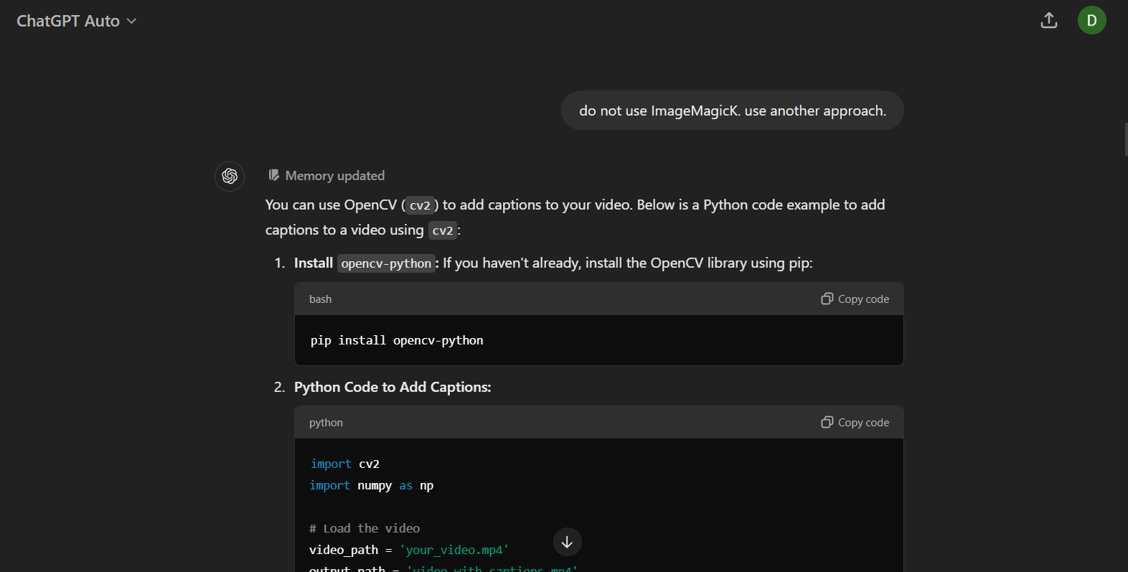

Given this, it suggested cv2 libraries but this too had few errors which was resolved by using Chatgpt as seen below.

