Part 3: <https://huggingface.co/spaces/deep3072/part3>

Part 4: <https://0535d65db5a34bee22.gradio.live/>

Below is the screenshot for part3 running on hugging space.

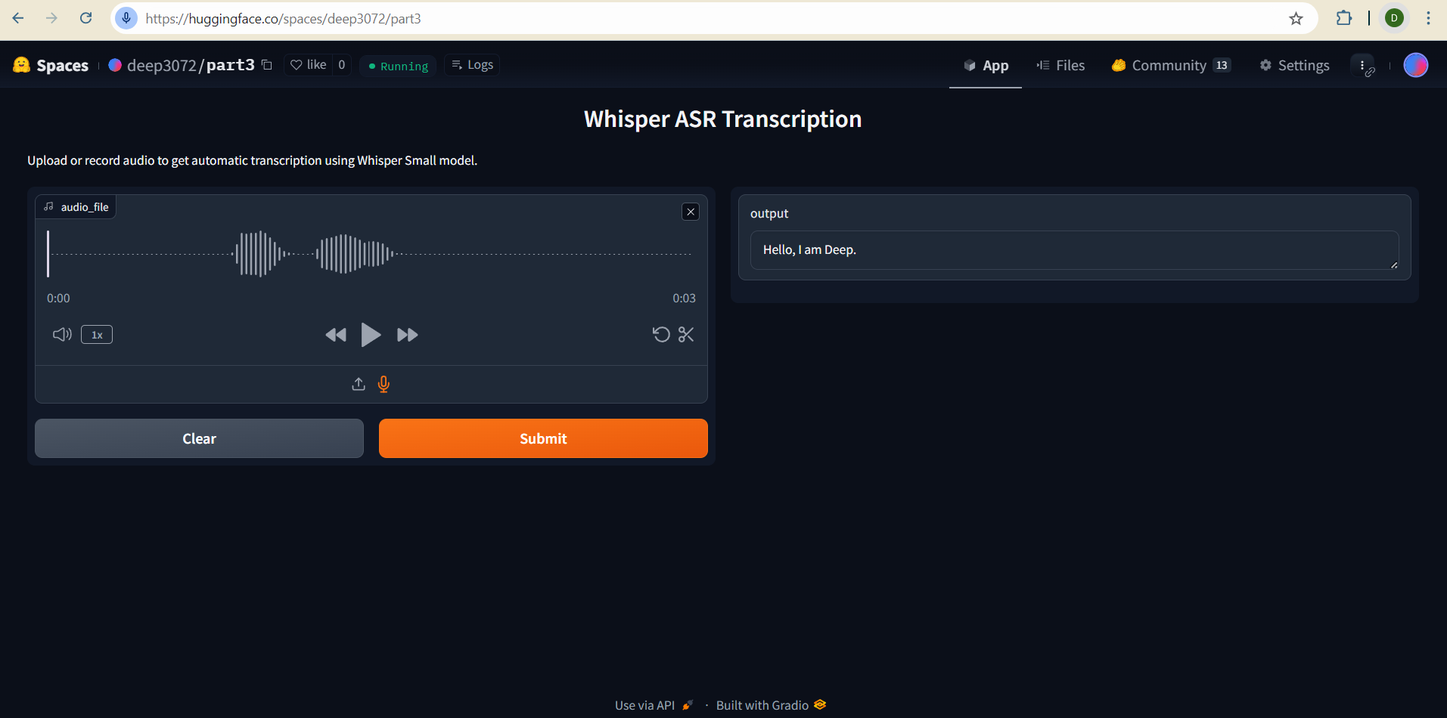

Used tmux to keep running my instance in the background. Below is the screenshot for python app.py command run

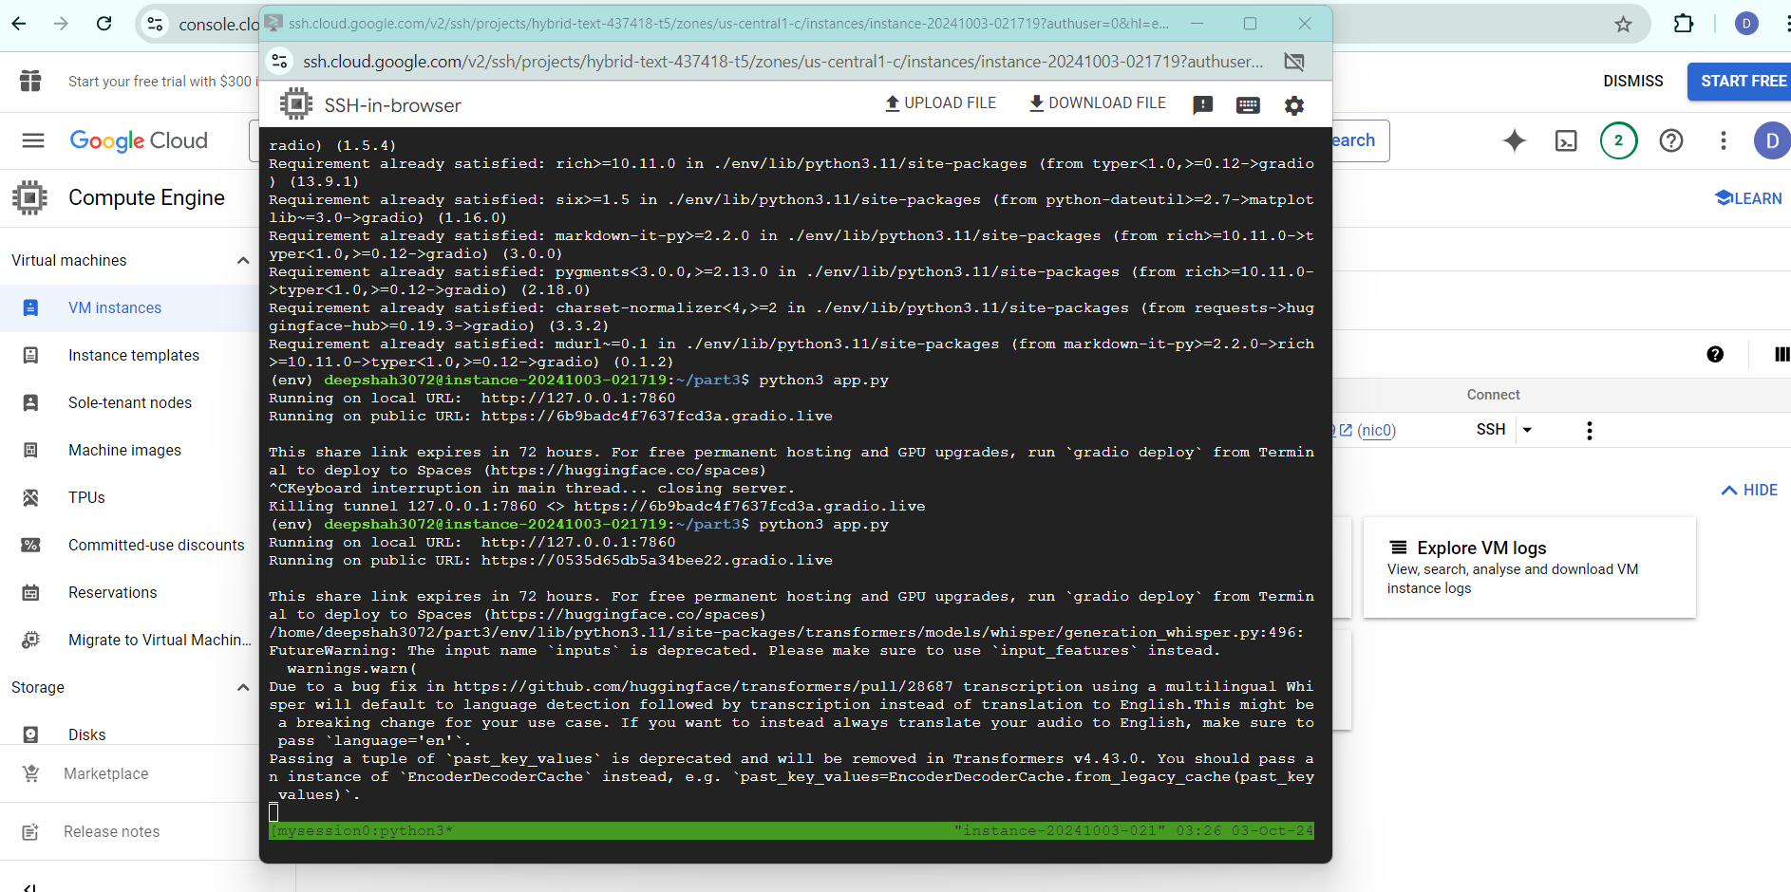

Below is the screenshot for the actual test on the deployed site.

