**Screenshots**

HW3 have been used to implement AOP in it and print my initial “DS” by intercepting all public methods in controllers, services, repositories

“DS” getting printed while doing multiple API calls using postman

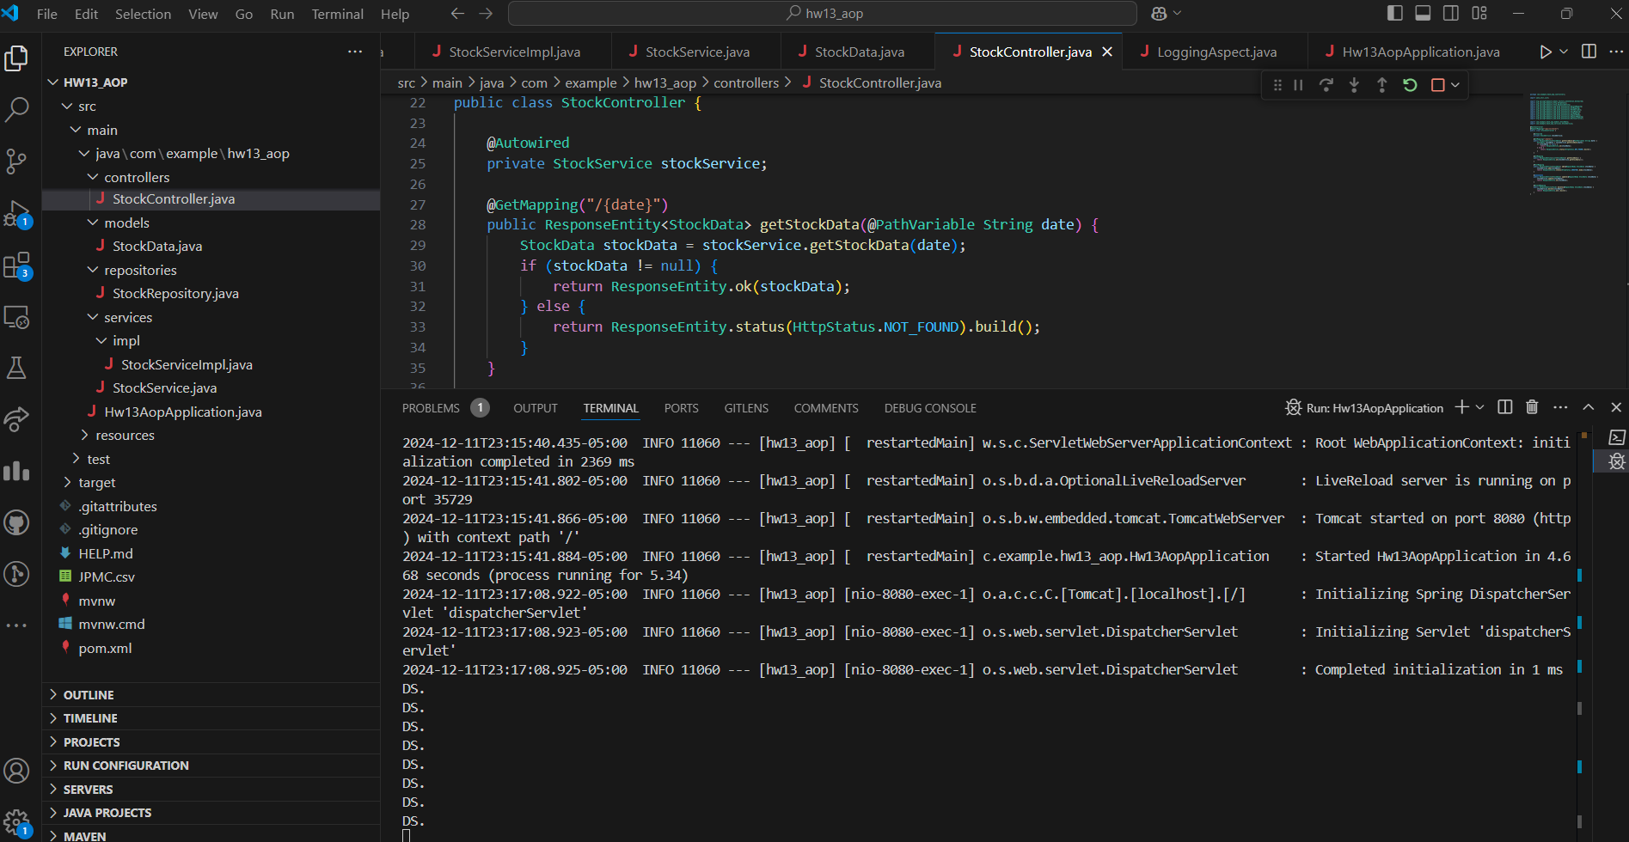

Postman: GET all stocks data using <http://localhost:8080/api/v1/stocks>

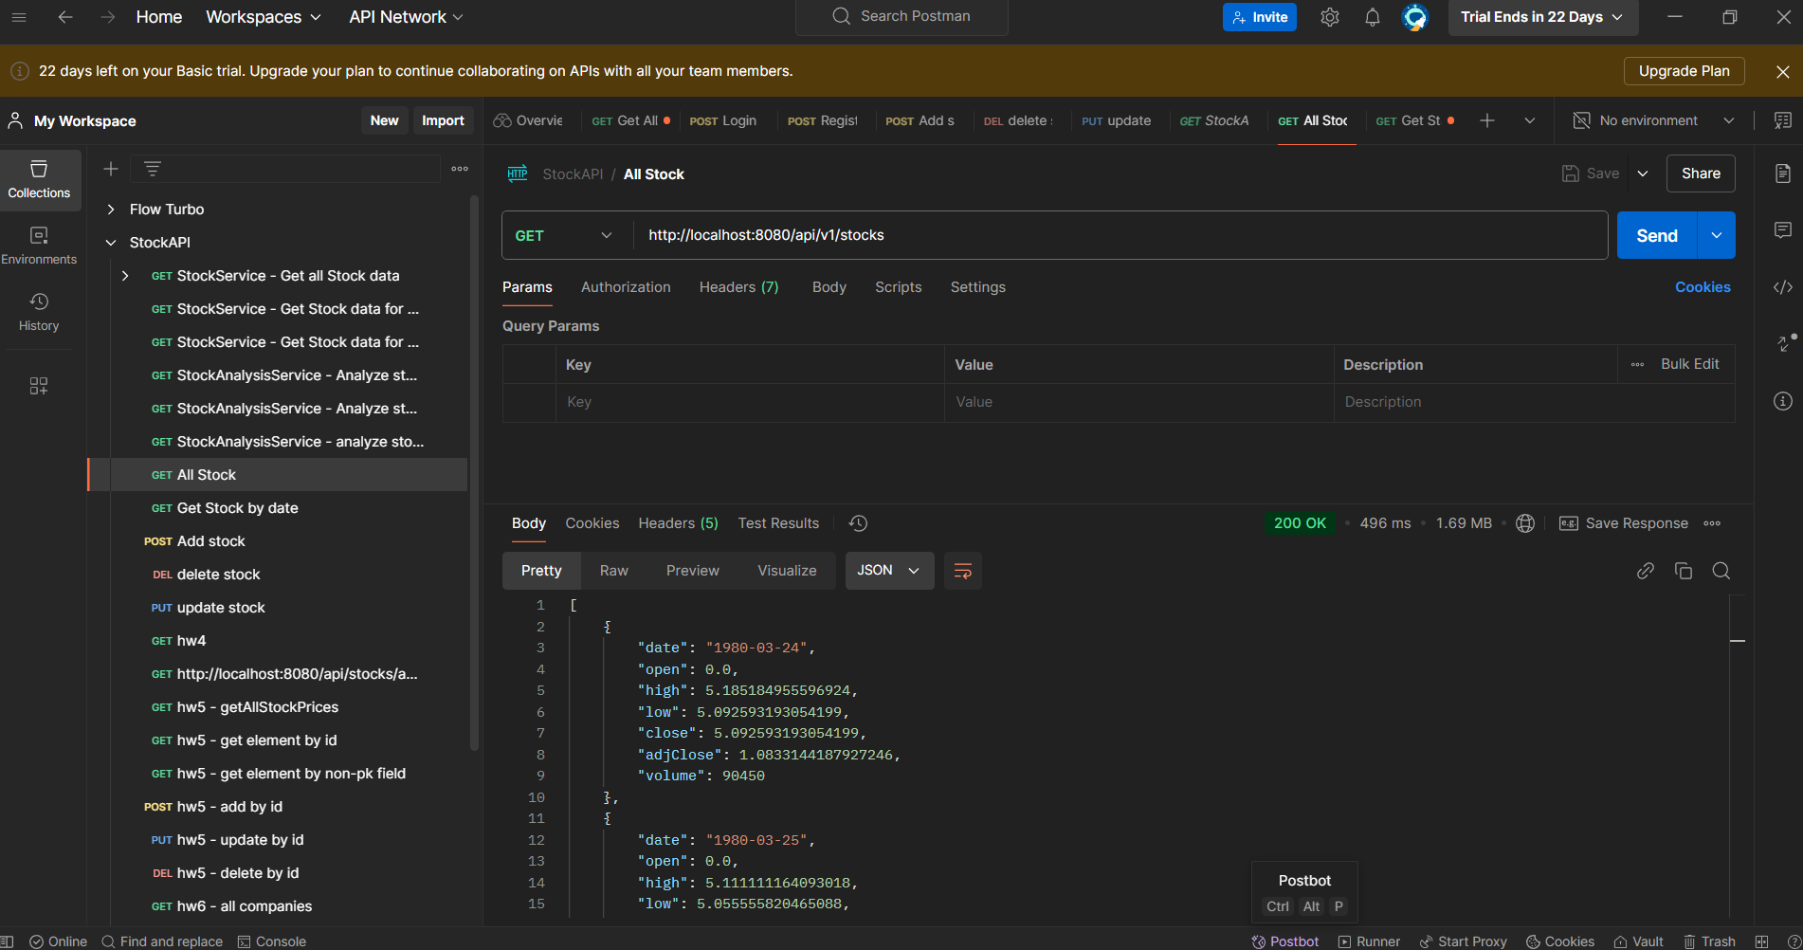

GET stock data using date: <http://localhost:8080/api/v1/stocks/1980-03-24>

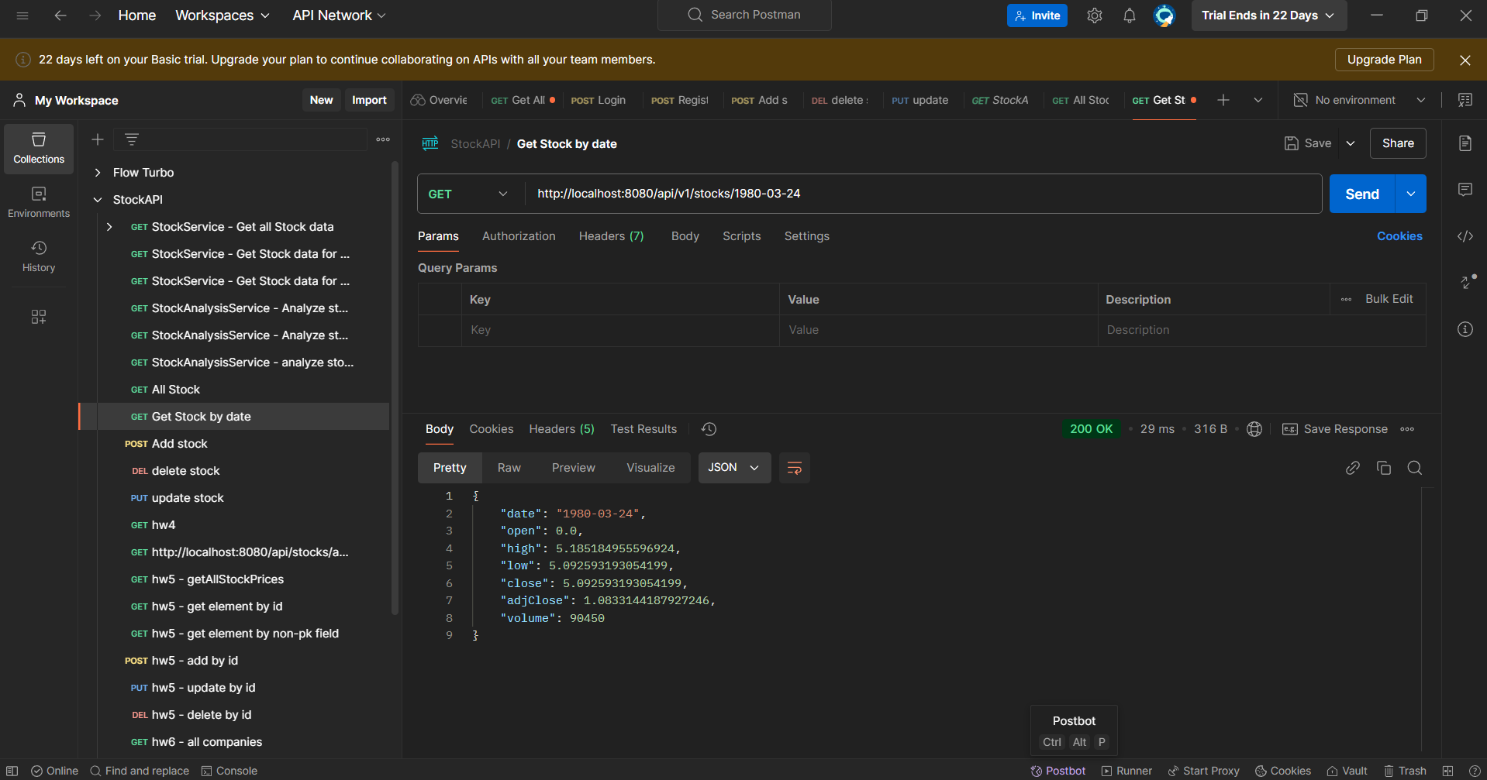

POST Add stock data: <http://localhost:8080/api/v1/stocks>

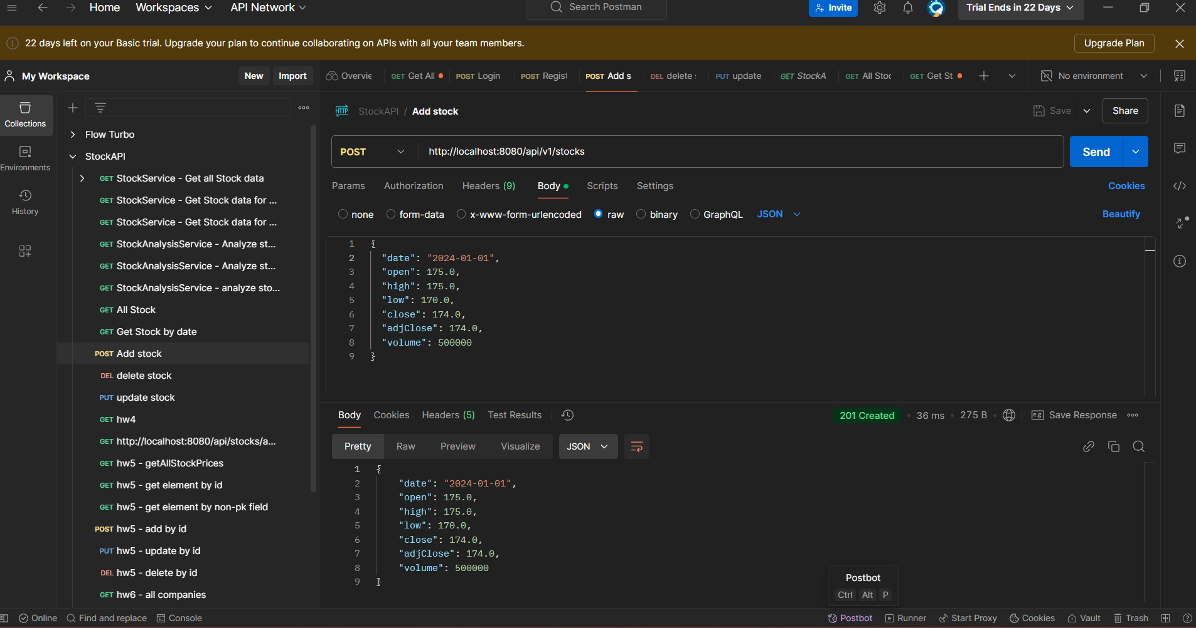

PUT Add stock data: <http://localhost:8080/api/v1/stocks>

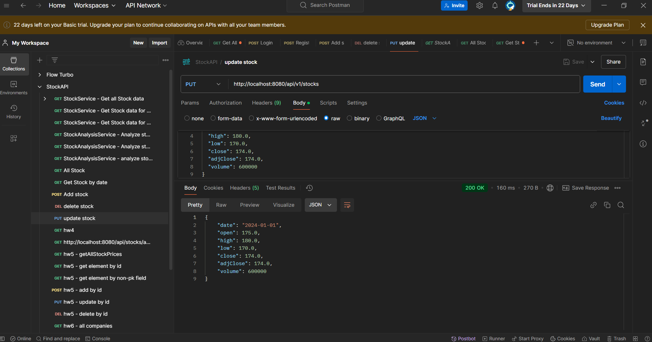

DELETE Add stock data: <http://localhost:8080/api/v1/stocks>

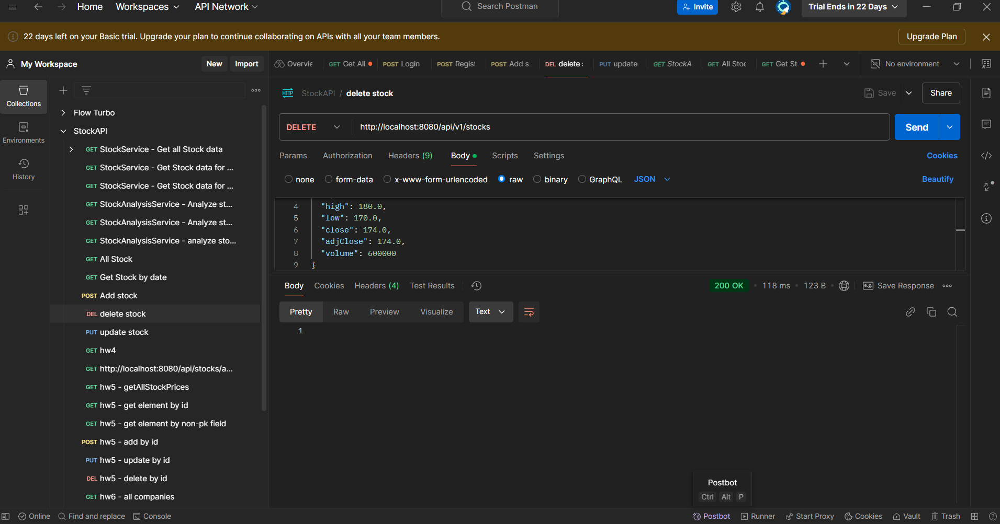

After running all apis, below are log statements

