1. StockService - Get all Stock data

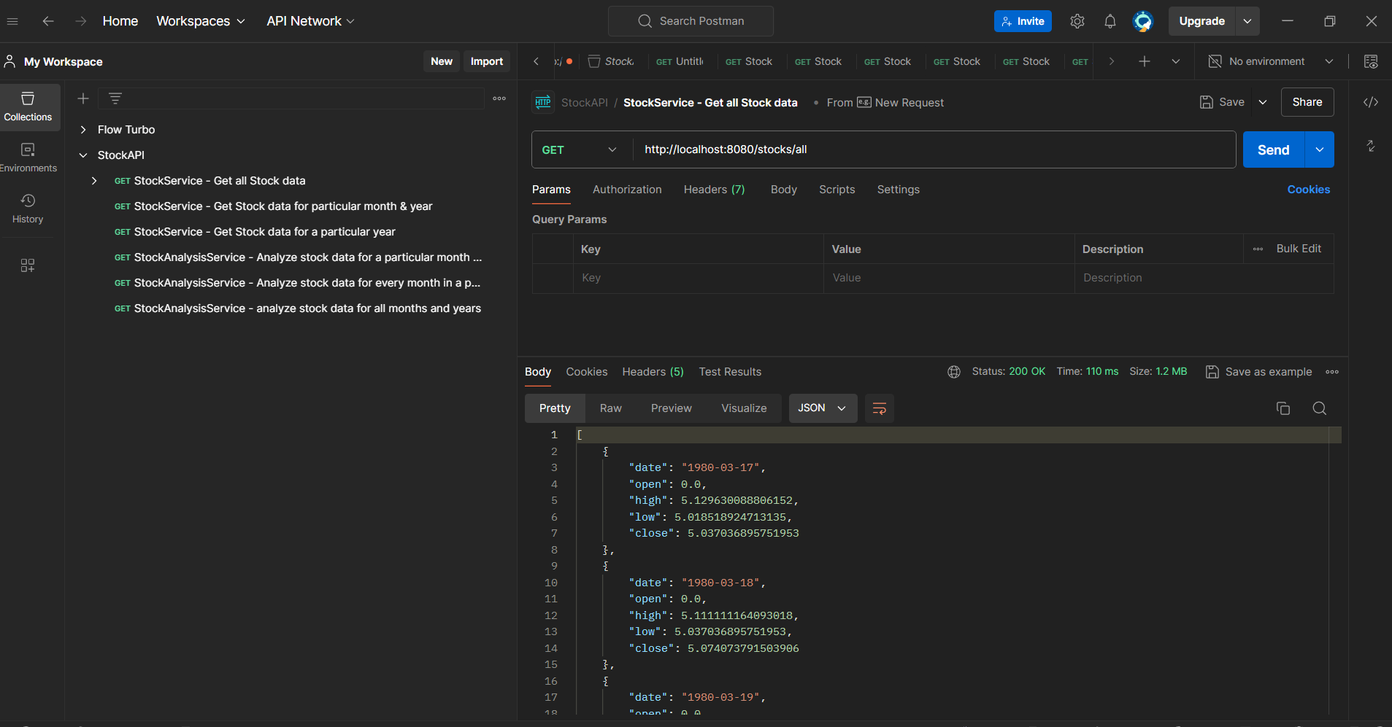

1. StockService - Get Stock data for particular month & year

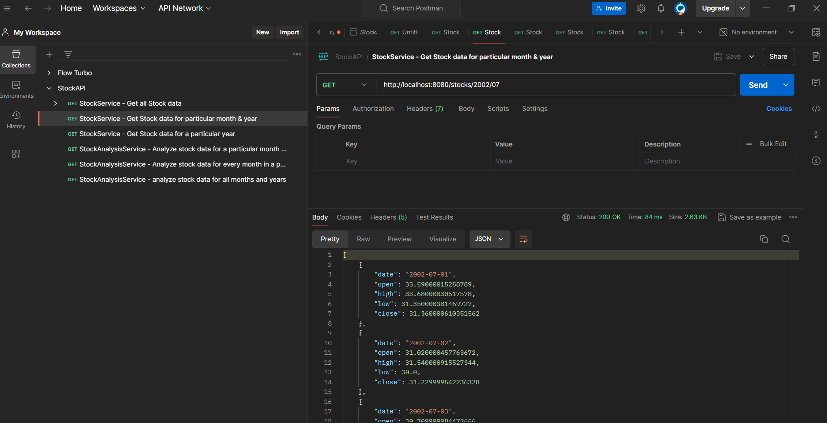

1. StockService - Get Stock data for a particular year

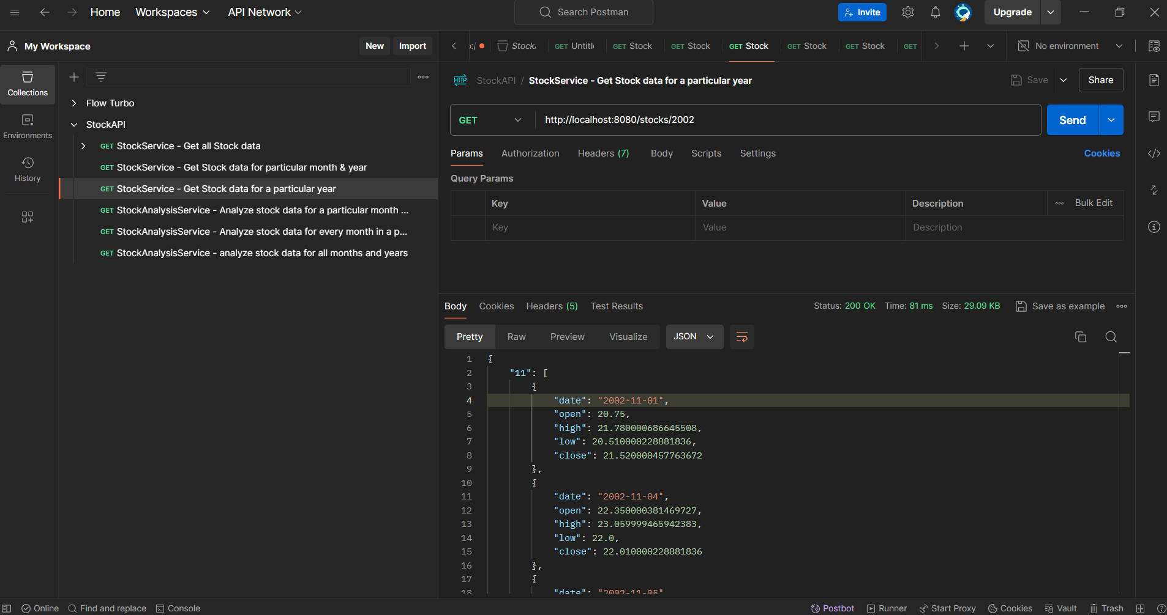

1. StockAnalysisService - Analyze stock data for a particular month and year

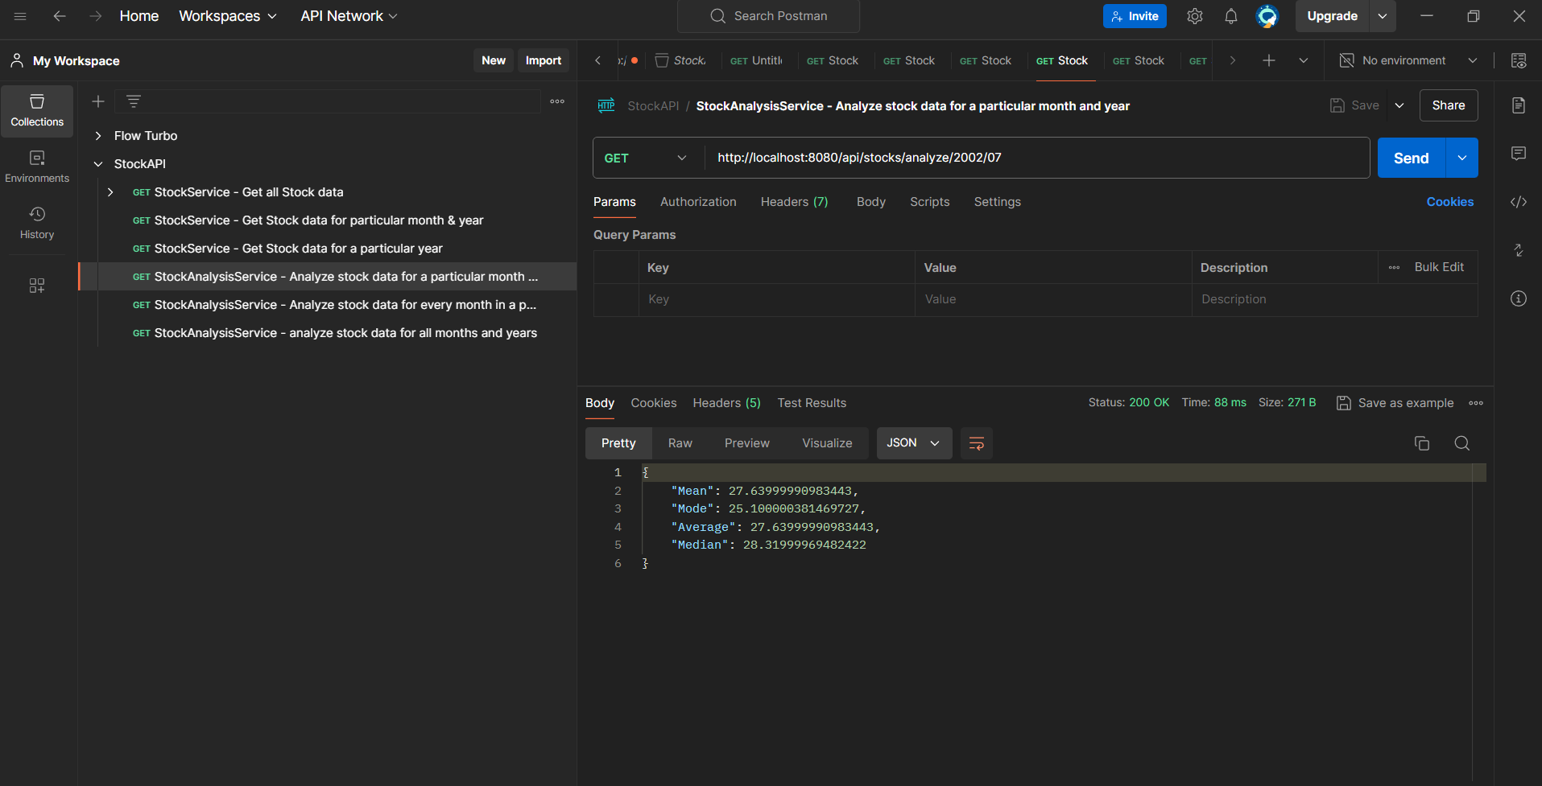

1. StockAnalysisService - Analyze stock data for every month in a particular year

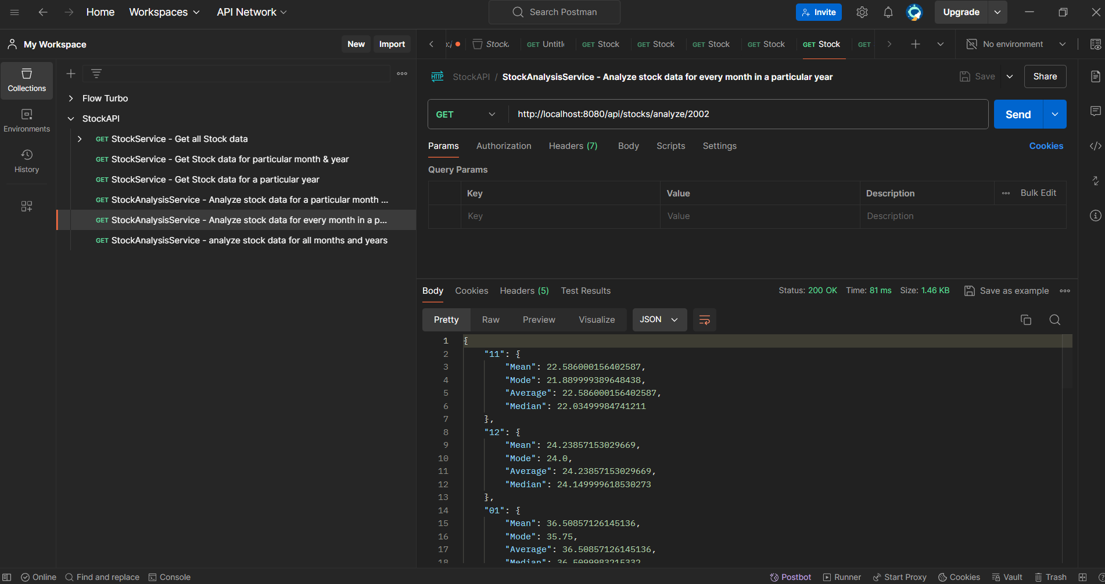

1. StockAnalysisService - analyze stock data for all months and years

