CERTIFICATE
Shah and Anchor Kutchhi Engineering College
B.Tech Cybersecurity

This is to certify that Mr. Deep Kalpesh Modh (Roll No. 27) of B.Tech Cybersecurity, semester V/, has satisfactorily completed the Continuous Internal Assessment Practical (CIAP) Microproject for the course DevSecOps Lab titled “VisionAssist: A DevSecOps-Based Assistive Web Application for Visually Impaired Users”, as per the requirements prescribed by the institute.

]
DevSecOps Lab
Continuous Internal Assessment Practical (CIAP) – Microproject
VisionAssist
Requirements-Driven Design of an Assistive Application for Visually Impaired Users
A DevSecOps implementation using Git, Docker, Jenkins, Terraform (AWS), SonarQube and Trivy
Aligned with UN SDG 9: Industry, Innovation and Infrastructure
Submitted by
Deep Kalpesh Modh
Roll No. 27 | B.Tech Cybersecurity
Shah and Anchor Kutchhi Engineering College
October 2026
GitHub: https://github.com/deep5679/Visionassist
TABLE OF CONTENTS
1. Introduction 1
1.1 Alignment with SDG 9 1
2. Problem Definition and Scope 1
2.1 Problem statement 1
2.2 Objectives 1
2.3 Scope 1
2.4 Tools used 1
3. Design and Methodology 1
3.1 Application architecture 1
3.2 DevSecOps workflow 1
3.3 Security-by-design decisions 1
3.4 Methodology 1
4. Implementation and Results 1
4.1 Website 1
4.2 Version control with Git and GitHub 1
4.3 Docker 1
4.4 Jenkins CI/CD pipeline 1
4.5 Infrastructure with Terraform on AWS 1
4.6 Project management with JIRA 1
5. Security Assessment and Basic Vulnerability Report 1
5.1 Scope of the scans 1
5.2 Trivy: Docker image 1
5.3 Trivy: Terraform configuration and project files 1
5.4 SonarQube analysis 1
5.5 Basic vulnerability report 1
6. Analysis and Interpretation 1
6.1 Testing results 1
6.2 Pipeline performance 1
6.3 Interpreting the security findings 1
6.4 Challenges and how they were solved 1
6.5 Limitations 1
7. Conclusion and Future Scope 1
7.1 Conclusion 1
7.2 Future scope 1
8. References 1
9. Project Reflection 1
10. Evidence of Completion 1
10.1 Links 1

1. Introduction
Reading printed material such as notices, forms, medicine labels and exam papers is an everyday task that visually impaired and low-vision people often cannot do independently. Screen readers work well on digital text, but printed text must first be converted into digital text before any assistive technology can read it. Optical Character Recognition (OCR) combined with text-to-speech can bridge this gap.
VisionAssist is a lightweight web application built around that idea. A user takes or chooses a photo of printed text; the application recognises the text in the browser using Tesseract.js and reads it aloud using the browser’s Web Speech API. The interface follows accessibility-oriented design choices: large controls, high-contrast dark and light themes, adjustable text size, keyboard focus indicators, a skip link and screen-reader announcements for status changes. The Atkinson Hyperlegible typeface, which was designed for low-vision readers, is used throughout.
This microproject takes VisionAssist, the topic assigned for the Software Engineering Practices (SEP) CIAP, and delivers it as a secure, automated and reproducible system. The emphasis is on the DevSecOps practices required by the course: version control with Git and GitHub, containerisation with Docker, a Jenkins CI/CD pipeline, infrastructure as code with Terraform on AWS, and security scanning with SonarQube and Trivy, with the findings interpreted and acted on.

1.1 Alignment with SDG 9
The project supports UN Sustainable Development Goal 9 (Industry, Innovation and Infrastructure) in three ways. First, it applies innovation to a real accessibility problem, which relates to the goal’s aim of increasing access to information and communication technology (target 9.c). Second, it delivers the application on automated, repeatable infrastructure, with the whole AWS environment described in code, which supports the goal’s emphasis on reliable and resilient infrastructure (target 9.1). Third, security is built into the delivery process through automated scanning, so that the system is not only innovative but also safe to operate. The application also contributes indirectly to SDG 10 (Reduced Inequalities) by improving independence for visually impaired users.

2. Problem Definition and Scope

2.1 Problem statement
Visually impaired users need a simple, accessible way to convert printed text into speech without installing specialised software or depending on another person. At the same time, any such system must be built, tested and deployed in a way that is secure and repeatable. The problem addressed by this microproject therefore has two parts: (a) delivering a usable assistive application, and (b) delivering it through a DevSecOps workflow that detects and reduces security risks before and after deployment.

2.2 Objectives
- Develop a functional, accessible website that reads printed text aloud.
- Manage the source code with Git and GitHub.
- Containerise the website with Docker and run it from a container.
- Automate build, test and scanning with a Jenkins pipeline.
- Provision the AWS infrastructure with Terraform and deploy the website.
- Analyse the code with SonarQube and scan the image and configuration with Trivy, then report and act on the findings.
- Track the work in JIRA and document the design with diagrams.

2.3 Scope
In scope: a static single-page web application; browser-side OCR and speech; a Docker image served by nginx; a Jenkins pipeline on a local machine; a single-server AWS deployment (EC2, security group, Elastic IP) created with Terraform; static and image security analysis.
Out of scope: user accounts or a database; server-side processing of uploaded photos; multi-language OCR; high-availability or auto-scaling infrastructure; HTTPS and a custom domain; formal accessibility testing with visually impaired users; unit-test coverage measurement.

2.4 Tools used
Area | Tool | Purpose in this project
Website | HTML, CSS, JavaScript, Tesseract.js, Web Speech API | OCR in the browser and text-to-speech
Version control | Git, GitHub, GitHub Desktop | Source code, history, repository for the pipeline and server
Containerisation | Docker (nginx-unprivileged on Alpine) | Packages the site as an image and runs it as a container
CI/CD | Jenkins | Automates checkout, tests, scanning and build
Infrastructure | Terraform, AWS (EC2, Security Group, Elastic IP) | Provisions and deploys the website
Code quality and security | SonarQube Community | Static analysis of JavaScript, HTML, Dockerfile and Terraform
Vulnerability scanning | Trivy | Scans the Docker image, Terraform configuration and project files
Project management | JIRA | Task tracking and progress
Diagrams | Draw.io style diagrams | Architecture and CI/CD workflow

3. Design and Methodology

3.1 Application architecture
The application is a static website. All processing happens in the user’s browser: the photo never leaves the device, Tesseract.js performs the OCR, and the Web Speech API produces the audio. On the server side, nginx running as a non-root user inside a Docker container serves the four site files. The container runs on an AWS EC2 instance that sits behind a security group allowing inbound web traffic only, and the instance is reached through an Elastic IP.
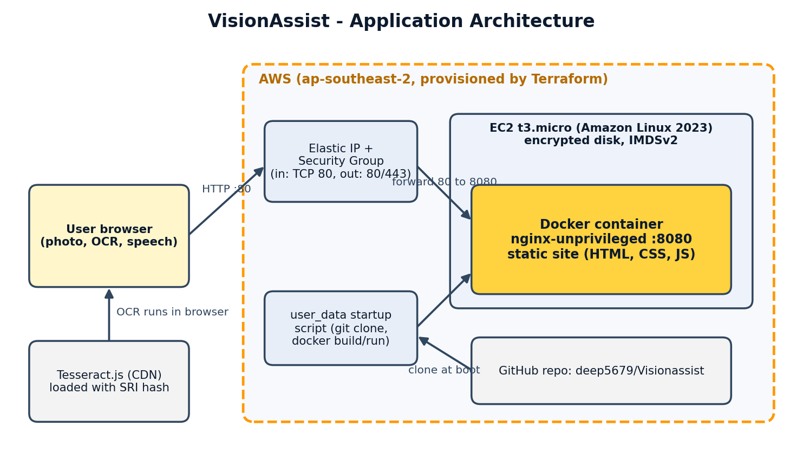
Figure 3.1: VisionAssist application architecture

3.2 DevSecOps workflow
Work follows a loop of plan, code, build, test, scan and deploy. Tasks are planned in JIRA; code is committed to GitHub; Jenkins checks out the repository and runs the unit tests, the SonarQube analysis, the Docker build and the Trivy image scan; Terraform provisions the AWS environment on which the container runs. Security checks run at several stages instead of only at the end, so that problems found in one scan feed straight into the next change.
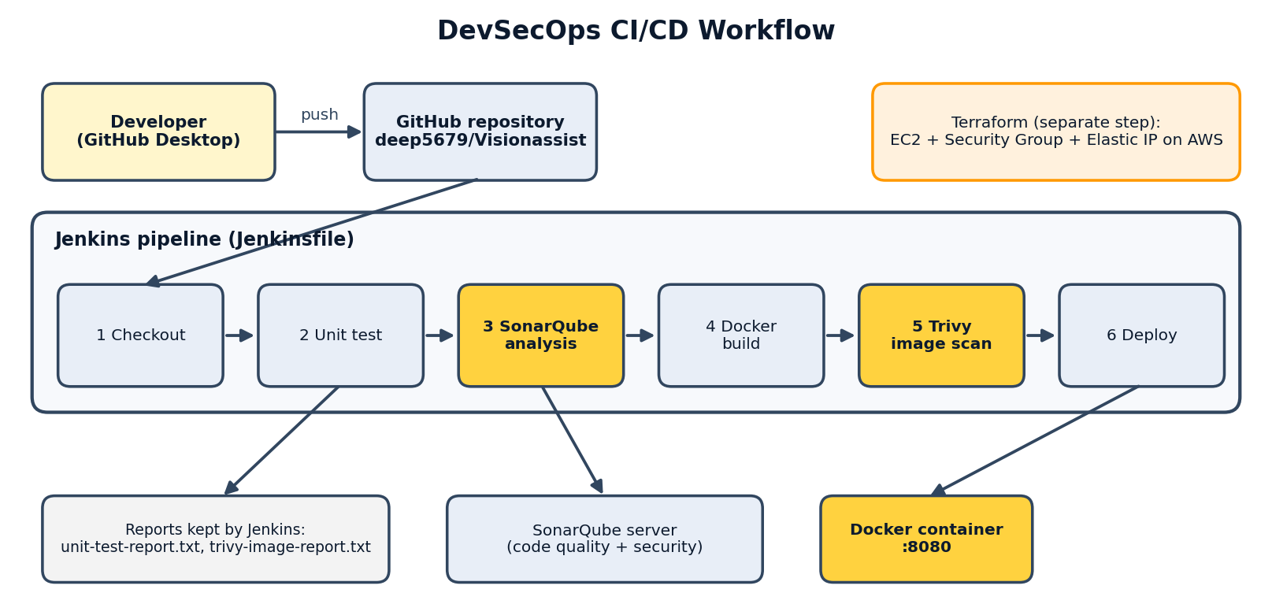
Figure 3.2: DevSecOps CI/CD workflow
[CHECK: make the stage list in Figure 3.2 match your Jenkinsfile exactly, in particular the Deploy stage. Redraw both figures in draw.io if your faculty requires that tool.]

3.3 Security-by-design decisions
- Non-root container: the final image runs as a normal user (UID 101), not root.
- Patched base image: OS packages are upgraded during the image build.
- Minimal network exposure: the AWS security group allows inbound TCP 80 only, and outbound traffic is limited to TCP 443 and 80.
- Instance hardening: encrypted root disk and IMDSv2 only.
- Supply-chain control: the Tesseract.js script carries a Subresource Integrity (SRI) hash so the browser rejects a modified file.
- Security headers: nginx sets X-Content-Type-Options, X-Frame-Options, Referrer-Policy and Permissions-Policy.
- Privacy: photos are processed in the browser and are not uploaded.

3.4 Methodology
The project was built incrementally, with each stage verified before the next one started: website, then GitHub, then Docker, then Terraform and AWS, then the scans, then Jenkins. Each scan was run twice where possible, once to establish a baseline and once after the fix, so that the effect of every change is measurable.

4. Implementation and Results

4.1 Website
The site consists of index.html, style.css, app.js and utils.js. The user selects or captures a photo; Tesseract.js (loaded from the jsDelivr CDN) recognises the text; the result appears in an editable text box; and the Web Speech API reads it aloud with an adjustable speed. The text-cleaning logic lives in utils.js so that it can be unit-tested outside the browser. The interface offers A−/A+ text size buttons and a dark/light high-contrast toggle.
Testing was carried out by running the site locally, in the Docker container and on AWS, and by running OCR on a screenshot containing printed form text. The text was recognised and displayed, with a few expected errors on small text (for example “choose File” read as “chooseFile”), which shows that photo quality affects accuracy.
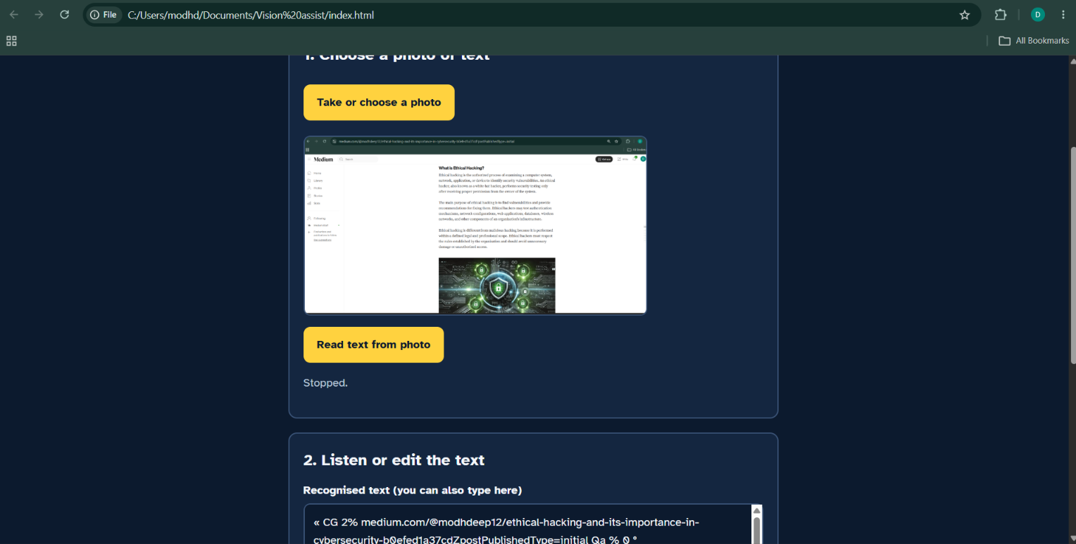Figure 4.1: VisionAssist website running and recognising text

4.2 Version control with Git and GitHub
The repository https://github.com/deep5679/Visionassist is public and holds the website source, Dockerfile, nginx configuration, Terraform files, SonarQube configuration and Jenkins files. Changes were committed in separate, descriptive commits, for example the initial website, the Dockerfile and nginx configuration, the Terraform configuration, and the fixes made after the security scans.
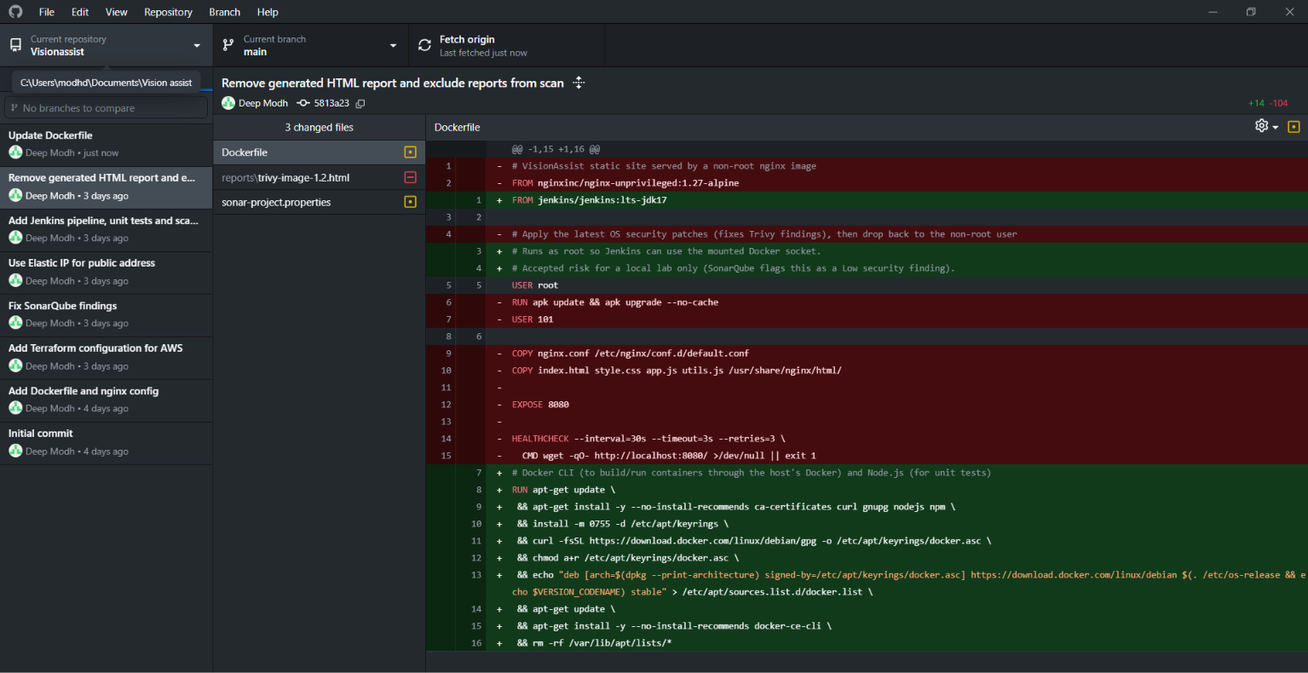Figure 4.2: GitHub repository

4.3 Docker
The site is packaged by the Dockerfile in the project root. It starts from nginxinc/nginx-unprivileged:1.27-alpine, upgrades the Alpine packages, switches back to the non-root user, copies the nginx configuration and the four site files, exposes port 8080 and defines a health check.
FROM nginxinc/nginx-unprivileged:1.27-alpine
USER root
RUN apk update && apk upgrade --no-cache
USER 101
COPY nginx.conf /etc/nginx/conf.d/default.conf
COPY index.html style.css app.js utils.js /usr/share/nginx/html/
EXPOSE 8080
HEALTHCHECK --interval=30s --timeout=3s --retries=3 CMD wget -qO- http://localhost:8080/ || exit 1

The image was built and run with the following commands, and the site was confirmed at http://localhost:8080:
docker build -t visionassist:1.2 .
docker run -d -p 8080:8080 --name visionassist visionassist:1.2
Three image versions were built: 1.0 (original), 1.1 (OS packages patched after the Trivy scan) and 1.2 (after the SonarQube-driven changes to index.html and utils.js). 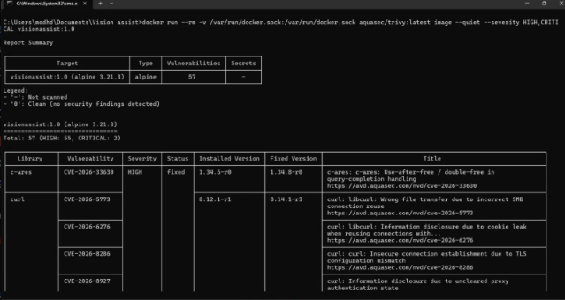Figure 4.3: Docker build and running container

4.4 Jenkins CI/CD pipeline
Jenkins (version 2.541.3) runs in a Docker container on the development machine at port 8081, with a pipeline job named visionassist-pipeline that reads the Jenkinsfile from the GitHub repository. The pipeline checks out the code, runs the unit tests for utils.js, runs the SonarQube analysis, builds the Docker image and scans it with Trivy. The unit-test output and the Trivy output are archived as build artifacts (unit-test-report.txt and trivy-image-report.txt).
Build #3 completed successfully in 2 minutes 22 seconds. Builds #4 and #5 were stopped manually. The Jenkins job page also shows the SonarQube Quality Gate result for the latest analysis.
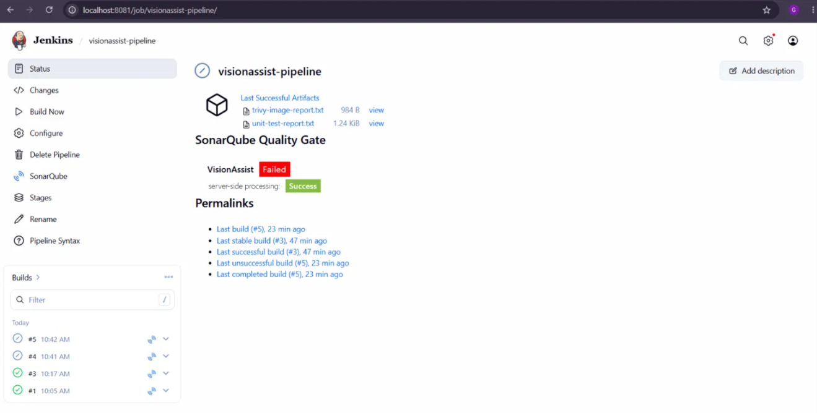Figure 4.4: Jenkins pipeline run

4.5 Infrastructure with Terraform on AWS
The infrastructure is described in three files: main.tf, variables.tf and outputs.tf. It creates a t3.micro EC2 instance running Amazon Linux 2023 with an encrypted root volume and IMDSv2 enforced; a security group allowing inbound TCP 80 and outbound TCP 443 and 80 only; and an Elastic IP. A user_data script runs when the instance first boots. It waits for internet access, installs Docker and git, clones the GitHub repository, builds the image and starts the container, mapping port 80 on the server to port 8080 in the container.
The planned region was Mumbai (ap-south-1), but terraform plan was denied with an explicit-deny message from a service control policy (SCP) in the AWS Organization that the account belongs to. Testing showed that EC2 calls were allowed in Sydney (ap-southeast-2), so the default region in variables.tf was changed to ap-southeast-2. terraform apply then created the resources successfully, and the website was reachable at the Elastic IP address (http://13.210.165.170 during testing).
A second apply replaced the instance (2 added, 1 changed, 1 destroyed) after the security fixes described in Section 5, which tightened the egress rules and switched the public address to an Elastic IP. The resources are removed with terraform destroy after the demonstration to avoid charges.
Figure 4.5: Terraform apply
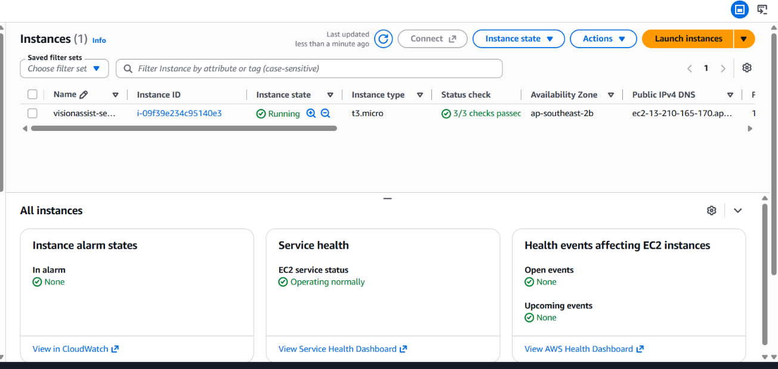Figure 4.6: Deployment on AWS

4.6 Project management with JIRA
Task | Description | Status
1 | Build the VisionAssist website | Done
2 | Create the GitHub repository and push the code | Done
3 | Write the Dockerfile and run the container | Done
4 | Write the Terraform configuration and deploy to AWS | Done
5 | Scan the image, configuration and files with Trivy | Done
6 | Analyse the code with SonarQube and fix findings | Done
7 | Create the Jenkins pipeline | Done

5. Security Assessment and Basic Vulnerability Report
Three kinds of scan were run: Trivy on the Docker image, Trivy on the Terraform configuration and project files, and SonarQube on the source code. Each scan was repeated after the fixes. The results below are taken from the scan outputs captured during the project.

5.1 Scope of the scans
Scan | Target | Command / method
Trivy image | visionassist:1.0, 1.1 and 1.2 (Alpine 3.21.3 base) | aquasec/trivy image --quiet [--severity HIGH,CRITICAL]
Trivy configuration | terraform/ folder | aquasec/trivy config
Trivy file system | Project folder (the .terraform provider folder excluded) | aquasec/trivy fs --scanners vuln,secret
SonarQube | All project files (JavaScript, HTML, CSS, Dockerfile, Terraform) | sonar-scanner-cli through Docker, project key visionAssist

5.2 Trivy: Docker image
The first scan of visionassist:1.0 reported 57 vulnerabilities at HIGH and CRITICAL severity (55 High and 2 Critical). All were in operating-system packages inherited from the base image, none in the website files, and every one had a fixed version available. Adding an apk upgrade step to the Dockerfile and rebuilding (visionassist:1.1) reduced the HIGH/CRITICAL count to 0.
Image | HIGH | CRITICAL | Total HIGH + CRITICAL
visionassist:1.0 (before) | 55 | 2 | 57
visionassist:1.1 (after apk upgrade) | 0 | 0 | 0
Note: the scans of 1.0 and 1.1 were filtered to HIGH and CRITICAL severities, so lower-severity findings (for example Medium) were not part of that comparison. Add the totals for all severities from your re-scan of 1.2 in the last row.
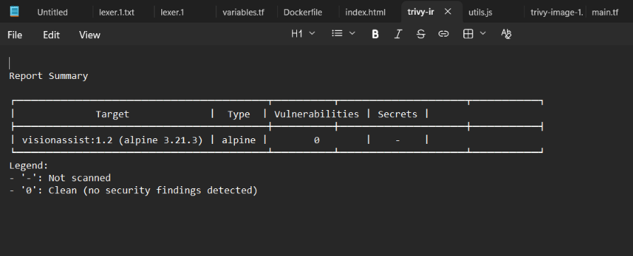
Figure 5.1: Trivy image scan before and after the fix

5.3 Trivy: Terraform configuration and project files
The configuration scan of the first main.tf reported one CRITICAL misconfiguration, AWS-0104: the security group allowed unrestricted outbound traffic to any address. Outbound traffic was then limited to TCP 443 and 80, which the server needs for package, GitHub and image downloads. Trivy still reports AWS-0104 for the two remaining rules, because the destination is still 0.0.0.0/0 (the IP ranges of GitHub, Docker Hub and the AWS package mirrors change, so they cannot be listed safely). This is therefore recorded as a mitigated, accepted risk and not as a resolved finding.
The file-system scan found no secrets. The vulnerability scanner had nothing to analyse, because the project has no dependency manifest (such as package.json); the Tesseract.js library is loaded in the browser from a CDN and is outside what Trivy can see. This is listed under future scope.

5.4 SonarQube analysis
Scan | Lines | Security | Reliability | Maintainability | Open issues
1. Baseline | 274 | E (2) | C (1) | A (0) | 3
2. After code fixes | 278 | E (1) | A (0) | A (0) | 1
3. After Elastic IP | 288 | A (0) | A (0) | A (0) | 0
4. With Jenkins files | 334 | A (0) after acceptance | A (0) | A (0) | 0 open, 2 accepted

Coverage was 0.0% and duplication 0.0% in every scan. The Quality Gate showed Passed for scans 1 and 3. After the Jenkins files were added the project card showed Failed even though all three ratings were A
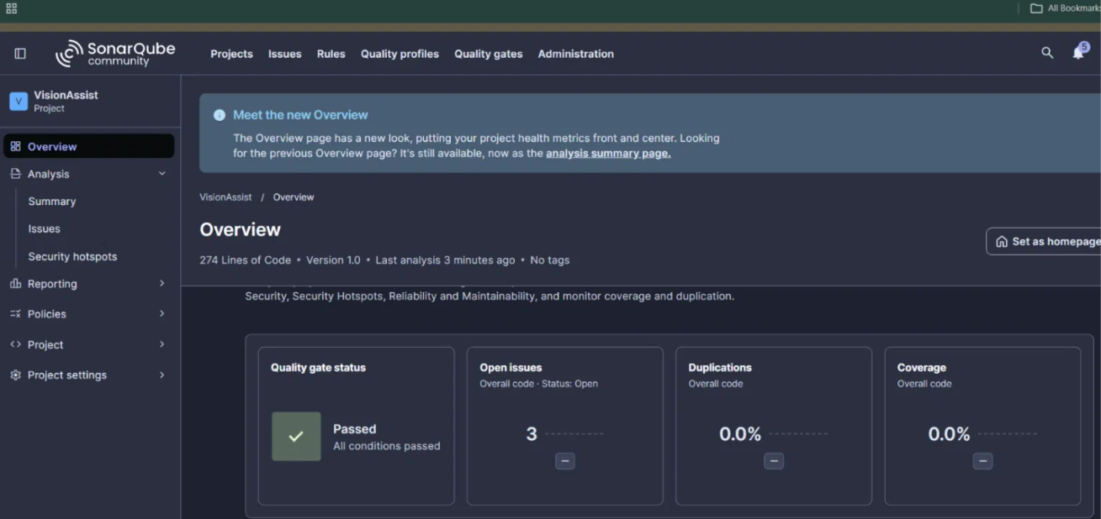Figure 5.2: SonarQube results

5.5 Basic vulnerability report
Finding | Location | Severity | Possible threat | Suggested fix | Status
libcrypto3 (OpenSSL) CVE-2026-31789 | Image 1.0 | Critical | Heap buffer overflow when parsing a large X.509 certificate (32-bit systems) | Upgrade 3.3.3-r0 to 3.3.7-r0 (apk upgrade) | Fixed in 1.1
c-ares CVE-2026-33630 | Image 1.0 | High | Use-after-free / double-free in query completion handling | Upgrade 1.34.5-r0 to 1.34.8-r0 | Fixed in 1.1
curl / libcurl (4 CVEs, e.g. CVE-2026-5773, -6276, -8286, -8927) | Image 1.0 | High | Wrong file transfer on SMB reuse, cookie and proxy-state information disclosure, insecure TLS connection | Upgrade 8.12.1-r1 to 8.14.1-r3 | Fixed in 1.1
zlib CVE-2026-22184 | Image 1.0 | High | Buffer overflow in the tgz utility, possible code execution | Upgrade 1.3.1-r2 to 1.3.2-r0 | Fixed in 1.1
Other High findings (about 45 more) | Image 1.0 | High | Various memory-safety and information-disclosure flaws in OS packages | apk upgrade --no-cache | Fixed in 1.1
AWS-0104 unrestricted egress | main.tf | Critical (Trivy) | A compromised server could send data out or contact an attacker’s server | Egress limited to TCP 443 and 80 | Mitigated; accepted risk
Public network access | main.tf (line 59 / 65) | Blocker (SonarQube) | A public server can be probed and attacked | Required for a public website; inbound limited to port 80, non-root container, egress limited. Public address now an Elastic IP | Accepted risk (finding no longer reported)
Regex with super-linear backtracking | utils.js line 7 | Medium | Slow input could freeze the page (denial of service) | Replaced the regex with a line-by-line trim | Fixed
Script loaded without integrity check | index.html line 58 | Low | A tampered CDN file would run in the user’s browser | Added SRI hash and crossorigin="anonymous" | Fixed
Default user root in Dockerfile | Dockerfile line 5, Jenkins/Dockerfile line 17 | Low | Container running as root is riskier if compromised | Root used only while patching packages; final user is non-root. Jenkins image is build tooling, not deployed | Accepted with comment

6. Analysis and Interpretation

6.1 Testing results
The website worked in all three environments: opened locally from files, served from the Docker container and served from AWS. OCR produced readable text from a screenshot of form text with minor recognition errors on small characters, and the text-to-speech and display controls worked. A unit test for utils.js runs inside the Jenkins pipeline and its report is archived. Test coverage is not measured by SonarQube (0.0%), which is a limitation of this project.

6.2 Pipeline performance
A complete successful Jenkins run (build #3) took 2 minutes 22 seconds. The first Trivy run also had to download its vulnerability database (about 129 MB, roughly one and a half minutes on the development machine), which is cached afterwards.

6.3 Interpreting the security findings
- The 57 image findings were all in the base image, not in the project’s own files. A single apk upgrade step cleared all the High and Critical ones, which shows how much risk comes from outdated base images.
- A vulnerability being present is not the same as it being exploitable. The container only serves static files and does not process certificates, archives or SMB connections, so the practical risk of most findings was low. Patching is still the correct response, because the image should not carry known flaws.
- The regex finding was a real but low-impact flaw; the replacement behaves the same on the sample inputs tested but cannot be slowed down by long runs of spaces.
- Scanners are not the same as solutions. When the public IP was changed to an Elastic IP, SonarQube stopped reporting it, but the website is just as public as before. It is therefore documented as an accepted risk with mitigations.
- The Trivy and SonarQube results complement each other: Trivy examines the packages inside the image and the infrastructure code, while SonarQube examines the source code and configuration files.

6.4 Challenges and how they were solved
Challenge | Resolution
Site appeared unstyled when opened from a zip file | Files were extracted into a normal folder so that the HTML could find its CSS and JavaScript.
GitHub Desktop created an empty repository inside the project folder | Used “Add existing repository” with the project folder instead of “Create new repository”.
docker run failed because the command was split over two lines | Re-typed the command on one line.
AWS plan denied in Mumbai by an organization service control policy | Tested other regions with read-only commands and deployed in Sydney (ap-southeast-2).
AWS access keys appeared in screenshots | The keys were deleted in IAM and replaced with new ones; tokens and account numbers are hidden in submitted evidence.
SonarQube project key did not match (case-sensitive) | Changed sonar.projectKey to visionAssist.
Trivy printed many warnings about unavailable CVE details | Used the --quiet option; the warnings did not affect the results.
A mistyped integrity hash would make the browser block the Tesseract script | Computed the SHA-384 hash from the downloaded file and pasted it from the clipboard instead of retyping it; OCR was re-tested and worked.

6.5 Limitations
- The site uses HTTP, not HTTPS, so browsers show “Not secure”.
- The Tesseract.js worker and language data are still fetched from a CDN at run time; only the main script has an integrity hash.
- OCR accuracy depends on photo quality, and only English is configured.
- The application was not tested with visually impaired users, so accessibility claims are based on design choices and not on user testing.
- Unit-test coverage is not reported to SonarQube.

7. Conclusion and Future Scope

7.1 Conclusion
VisionAssist was delivered as a working assistive web application and taken through a complete DevSecOps workflow: source control on GitHub, a hardened Docker image, a Jenkins pipeline, Terraform-provisioned AWS infrastructure, and security scanning with Trivy and SonarQube. The scans found real issues: 57 High and Critical vulnerabilities in the original base image, a Critical egress misconfiguration, a backtracking regular expression and a missing integrity check. Most were fixed and measured before and after, and the rest were recorded as accepted risks with reasons. The project shows that security checks are most useful when they run repeatedly and feed back into the code, and it supports SDG 9 by combining innovation, automation and secure, reproducible infrastructure.

7.2 Future scope
- Add HTTPS with a certificate and a custom domain, and place the site behind a CDN or load balancer with a web application firewall.
- Self-host Tesseract.js and its language data to remove the third-party CDN dependency, and add a dependency manifest so Trivy can scan libraries.
- Add automated tests with coverage reporting to SonarQube and a Quality Gate suited to the project.
- Run the application in a private subnet with VPC endpoints and a restricted egress allow-list.
- Add multi-language OCR, image pre-processing for better accuracy and a progressive web app mode for offline use.
- Test with visually impaired users and audit against WCAG guidelines.

8. References
- Docker Inc., Docker Documentation. https://docs.docker.com
- HashiCorp, Terraform Documentation and AWS Provider. https://developer.hashicorp.com/terraform/docs
- Jenkins project, Jenkins User Documentation. https://www.jenkins.io/doc/
- SonarSource, SonarQube Documentation. https://docs.sonarsource.com/sonarqube/
- Aqua Security, Trivy Documentation. https://trivy.dev
- Amazon Web Services, Amazon EC2 and VPC User Guides. https://docs.aws.amazon.com
- Tesseract.js, JavaScript OCR library. https://github.com/naptha/tesseract.js
- Mozilla, Web Speech API (MDN Web Docs). https://developer.mozilla.org/docs/Web/API/Web_Speech_API
- Mozilla, Subresource Integrity (MDN Web Docs). https://developer.mozilla.org/docs/Web/Security/Subresource_Integrity
- W3C, Web Content Accessibility Guidelines (WCAG). https://www.w3.org/WAI/standards-guidelines/wcag/
- Braille Institute, Atkinson Hyperlegible typeface. https://brailleinstitute.org/freefont
- United Nations, Sustainable Development Goal 9. https://sdgs.un.org/goals/goal9
- OWASP Foundation, OWASP Top 10. https://owasp.org/www-project-top-ten/
- nginx, nginx documentation and nginx-unprivileged image. https://nginx.org/en/docs/

9. Project Reflection
Before this project I thought of security as something you add at the end, by running a scanner just before submission. Building VisionAssist changed that view. Every stage I added, from the Docker image to the Terraform files, produced its own security questions, and the scanners turned those questions into concrete numbers I could act on.
The Trivy scan of my first Docker image was the biggest surprise. I had written only a few lines of Dockerfile and a small website, yet the image contained 57 serious vulnerabilities. They came from the base image, not from my code. Adding one patch step brought the count to zero. That showed me that the software I depend on is part of my responsibility, and that a small, repeatable fix can remove a large amount of risk.
SonarQube taught me a different lesson. It found a regular expression in my own helper function that could slow down on unusual input, and a script loaded from a CDN with no integrity check. These are exactly the kind of mistakes I would not have noticed by testing the website normally, because the site worked perfectly. Fixing them and scanning again gave me a clear before-and-after comparison.
I also learned to be honest about what a tool result means. When I changed how the server gets its public address, SonarQube stopped reporting the issue, but the website was still just as public. I understood that a clean report is not the same as a safe system, and that some findings have to be accepted as risks with a written reason and a mitigation, instead of being hidden.
The practical side was full of problems that no tutorial warned me about. My AWS account belonged to an organization whose policy blocked the region I wanted, so I had to test other regions and deploy in Sydney. I made mistakes with credentials, which made me understand why keys must never appear in screenshots or repositories, and I replaced them. I split a Docker command over two lines, ran commands in the wrong folder and used the wrong GitHub Desktop option. Each mistake taught me to read error messages carefully and to check where I am before I run anything.
Working on an assistive application also changed how I think about design. Large buttons, strong contrast and clear status messages are not decoration. They decide whether someone can use the tool at all. I know that I have not tested VisionAssist with real visually impaired users, and I would treat that as the most important next step.
Overall, this project taught me that DevSecOps is a habit of building, checking and fixing in small repeated steps. I now understand how Git, Docker, Jenkins, Terraform and the scanners fit together, and I can explain why each one is there. If I continued the project I would add HTTPS, automated tests with coverage and a safer way to load the OCR library.

10. Evidence of Completion

10.1 Links
Item | Link / location
GitHub repository | https://github.com/deep5679/Visionassist
Live Link | http://13.210.165.170
Presentation (PPT) | VisionAssist_DevSecOps.pptx
Vulnerability report | Section 5 of this report, with the scan screenshots in section 10.2

