|  |
| --- |
|  |
| SELF CHECKOUT SHOPPING CART |
| BY |
|  |
| SIDDHANT JAJOO |
| SATYA MEHTA  DEEPESH SONIGRA |

**UNDER THE GUIDANCE OF:**

PROFESSOR TIMOTHY SCHERR, RANDY SPALDING

UNIVERSITY OF COLORADO BOULDER

|  |
| --- |
|  |

9/7/2019

TABLE OF CONTENTS

INTRODUCTION 2

PROBLEMS FACED 2

SOLUTIONS 2

FUNCTIONAL BLOCK DIAGRAM 3

BOARD BLOCK DIAGRAM 4

FEATURES 4

FUTURE SCOPE 5

# INTRODUCTION

The “Self-Checkout Shopping Cart” is an innovative consumer purchasing product that is designed to help shoppers fast-track their shopping experience! The shopping cart has an inbuilt barcode scanner which can be used to scan the items to be purchased. The device communicates with the phone over the Bluetooth and bill is generated based on the items. Android app can be used for payment and faster checkout. With the advent of energy efficient devices and low power nodes, it has become imperative to design boards that consume low power which can last longer. To that end, we are designing nodes in order to consume minimal energy and address the issues mentioned below.

# PROBLEMS FACED

1. Customers usually get annoyed because of the long queues in the billing section of the huge shopping markets.
2. In addition to that keeping track of all the bills and budget is a very burdensome task.
3. Usage of lot of manpower in large supermarkets which can be expensive.
4. Stock management in supermarkets.

All these problems could be addressed by our “Self-Checkout Shopping Cart”.

SOLUTIONS

1. Fast self-checkout saves time of customers and helps them buy items according to their budget.
2. Electronic bill is generated and saved in the cloud which makes it easy to keep track of all the bills and saves paper.
3. By letting customers handle their own scanning and bagging, workers can spend their time helping customers find what they need.
4. Better shopping experience for the customers and an innovative way for the sellers to attract customers.

# FUNCTIONAL BLOCK DIAGRAM

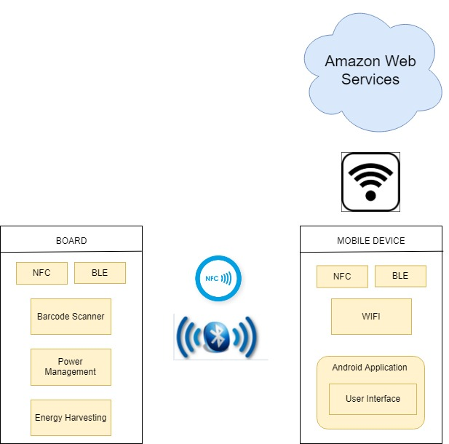

# BOARD BLOCK DIAGRAM

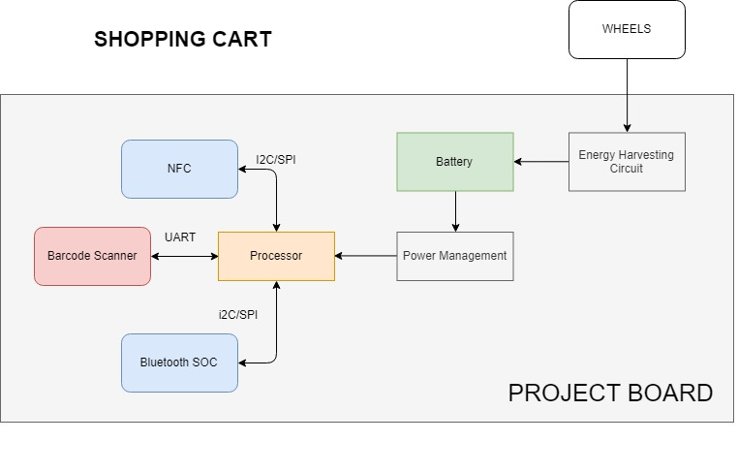

FEATURES

* The device connects with the mobile using Bluetooth with Bluetooth authentication done using NFC for faster and secure connection.
* The device is battery operated with the capability of energy harvesting from the movement of the wheels.
* The Android application is capable of displaying all items scanned and total price of the items in the cart.
* The Android application pushes data to the cloud to keep track of past bills and calculate the amount spent in certain time frame.

SPECIFICATIONS

* Dimensions: 70mm x 50mm (Approx)
* Battery: 9V Battery (1) - Rechargeable
* Wireless Range: 60 meters /180ft
* Temperature Range: 30~140°F
* Temperature Accuracy: Typical: ±0.3°C /± 0.5°F, Max: ±0.5°C /±0.9°F
* Humidity Range: 0~99%RH
* Humidity Accuracy (25°C/ 77°F, 20%~80%RH): Typical: ±3%RH, Max: ±4.5%RH
* Warranty: 2-3 years.

PRODUCT INCLUDES

1. Processing Device
2. Barcode Scanner
3. Batteries

FUTURE SCOPE

* Budget Alert feature where the app notifies the user about budget limit crossed.
* Load cell can be incorporated for the items which has to be purchased in weight rather than in quantity.
* We can analyze the data for stock and asset management.
* Secured automatic payment through the android application.