|  |
| --- |
|  |
| SELF CHECKOUT SHOPPING CART |
| BY |
|  |
| SIDDHANT JAJOO |
| SATYA MEHTA  DEEPESH SONIGRA |

**UNDER THE GUIDANCE OF:**

PROFESSOR TIMOTHY SCHERR, RANDY SPALDING

UNIVERSITY OF COLORADO BOULDER

|  |
| --- |
|  |

9/14/2019

TABLE OF CONTENTS

INTRODUCTION 2

PROBLEMS FACED 2

SOLUTIONS 2

FUNCTIONAL BLOCK DIAGRAM 3

BOARD BLOCK DIAGRAM 4

FEATURES 4

GOALS ACCOMPLISHED PAST WEEK 5

GOALS PLANNED FOR NEXT WEEK 5

COMPONENT SELECTION 6

SPECIFICATIONS 7

USE CASE MODEL - ENERGY MODES 8

FUTURE SCOPE 8

# INTRODUCTION

The “Self-Checkout Shopping Cart” is an innovative consumer purchasing product that is designed to help shoppers fast-track their shopping experience! The shopping cart has an inbuilt barcode scanner which can be used to scan the items to be purchased. The device communicates with the phone over the Bluetooth and bill is generated based on the items. Android app can be used for payment and faster checkout. With the advent of energy efficient devices and low power nodes, it has become imperative to design boards that consume low power which can last longer. To that end, we are designing nodes in order to consume minimal energy and address the issues mentioned below.

# PROBLEMS FACED

1. Customers usually get annoyed because of the long queues in the billing section of the huge shopping markets.
2. In addition to that keeping track of all the bills and budget is a very burdensome task.
3. Usage of lot of manpower in large supermarkets which can be expensive.
4. Stock management in supermarkets.

All these problems could be addressed by our “Self-Checkout Shopping Cart”.

SOLUTIONS

1. Fast self-checkout saves time of customers and helps them buy items according to their budget.
2. Electronic bill is generated and saved in the cloud which makes it easy to keep track of all the bills and saves paper.
3. By letting customers handle their own scanning and bagging, workers can spend their time helping customers find what they need.
4. Better shopping experience for the customers and an innovative way for the sellers to attract customers.

# FUNCTIONAL BLOCK DIAGRAM

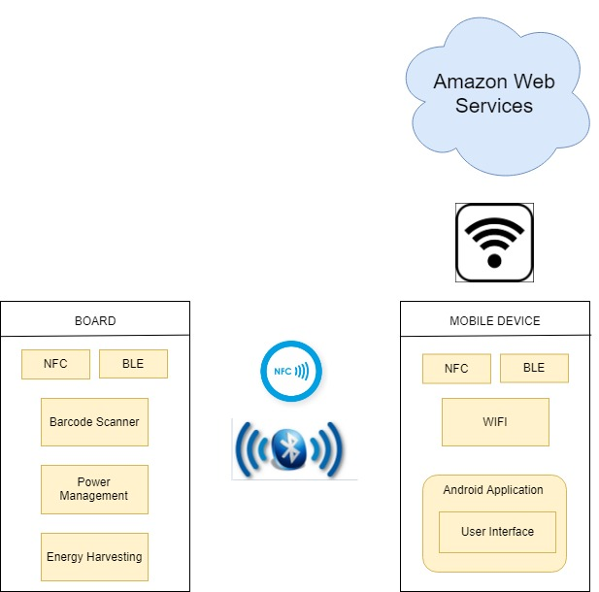

# BOARD BLOCK DIAGRAM

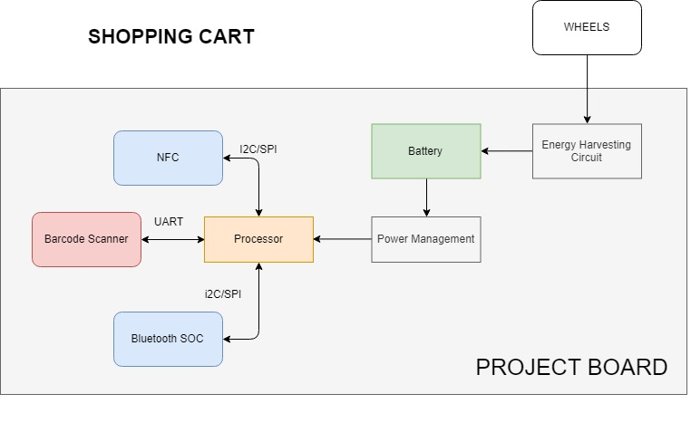

FEATURES

* The device connects with the mobile using Bluetooth with Bluetooth authentication done using NFC for faster and secure connection.
* The device is battery operated with the capability of energy harvesting (optional) from the movement of the wheels.
* The Android application is capable of displaying all the scanned items and total price of the items in the cart.
* The Android application pushes data to the cloud to keep track of past bills and calculate the amount spent in certain time frame.

GOALS ACCOMPLISHED PAST WEEK

|  |  |  |  |
| --- | --- | --- | --- |
| **SR. NO.** | **TASK** | **DESCRIPTION** | **STATUS** |
| 1 | Altium | Setup and Hands-on | Completed |
| 2 | Component Selection | Processor (SOC) - EFR32BG13 | Completed |
| 3 | Component Selection | NFC Module | Completed |
| 4 | Component Selection | Sensor - Barcode Scanner | Completed |
| 5 | Component Selection | Battery – Lipo Lithium Ion | Completed |
| 6 | Android | Environment Setup | Completed |
| 7 | Energy Consumption | Use Case Model | Completed |

# GOALS PLANNED FOR NEXT WEEK

|  |  |  |  |
| --- | --- | --- | --- |
| **SR. NO.** | **TASK** | **DESCRIPTION** | **STATUS** |
| 1 | Design | Power Requirement Calculations | NA |
| 2 | Component Selection | Power Management IC (Module) | NA |
| 3 | Component Selection | Energy Harvesting IC | NA |
| 4 | Android | Initial application template | NA |
| 5 | Schematic Design | Processor | NA |
| 6 | Schematic Design | Power | NA |
| 7 | Schematic Design | Radio | NA |

# COMPONENT SELECTION

1. **Processor - Blue Gecko EFR32BG13:** This is a processor (SOC) sold by Silicon Labs, which has Bluetooth stack built into it with peripherals such as I2C, SPI, UART and 31 GPIO pins. This processor would serve as a controller for the entire system and would also be responsible for executing commands related to the Bluetooth stack. The SOC supports low energy modes and has provisions for load power management (i.e EM0, EM1, EM2, EM3, EM4) thus making it the appropriate choice for a low power project.

The EFR32BG13 Blue Gecko Bluetooth Low Energy SOC Family Data sheet can be found here - <https://www.silabs.com/documents/public/data-sheets/efr32bg13-datasheet.pdf>

The Blue gecko to be used for this project is: EFR32BG13P732F512GM48-D.

1. **NFC Module - NXP NTAG NFC Module:** This NFC module would be used for hands-free quick Bluetooth pairing authentication between the cart and the mobile phone. The interface used for NFC module is I2C which is available in the processor selected above. This module can interact with an NFC device as well as unpowered NFC chips such as tags, stickers, key fobs and cards which do not require batteries. This module also has the NFC energy harvesting capability if required. The module also consists of different modes for energy saving purposes.

The datasheet for this module can be found here:

<https://www.nxp.com/docs/en/data-sheet/NT3H2111_2211.pdf>

1. **Sensor - Barcode Scanner:** This barcode scanner was chosen because it gave us the lowest sleep mode current in comparison to all the other bar code scanners. It consists of a USB and UART interface. The module has different modes such as sleep, standby and scanning modes for load power management. There are very small amounts of portable barcode scanners available in the market which consume low current and most of them support UART or RS232 interface. Thus, we did not have much flexibility in choosing an interface for the barcode scanner.

The user manual/datasheet for this module can be found here:

<https://www.waveshare.com/w/upload/3/3c/Barcode_Scanner_Module_User_Manual_EN.pdf>

1. **Battery - Lipo Lithium Ion battery:** Since our sensor operates on 5V, it made sense to have a battery whose voltage level is more than 5V. The battery has a 1000mAh capacity. This battery specification is subject to modifications as per the power calculations in subsequent weeks.

Battery Manual: <https://cdn.sparkfun.com/datasheets/Prototyping/Lithium%20Ion%20Battery%20MSDS.pdf>

# SPECIFICATIONS

1. Processor (SOC) – Blue Gecko EFR32BG13P732F512GM48-D, freq band: 2.4 Ghz @19 dBm, Flash: 512kB, RAM: 64kB, GPIO: 31, Operating Range: -40°C to 85°C.
2. NFC Module: Working Voltage: 3.3V or 5V, Baud Rate: 115200 bps, Operating range: 2 to 5 cm, Size: 11cm x 5cm.
3. Sensor - Barcode Scanner: Operating Voltage: 5V, Operating Temperature: 0°C - 50°C, Size: 53.3mm x 21.4mm
4. Battery - Weight: 85g, Size: 70mm x 35mm x 18mm.
5. Dimensions: 120mm x 50mm (Approx)
6. Battery: 7V Battery (1) - Rechargeable
7. Wireless Range: 60 meters /180ft
8. Temperature Range: 0 - 50°C
9. Temperature Accuracy: Typical: ±0.3°C /± 0.5°F, Max: ±0.5°C /±0.9°F
10. Humidity Range: 0~99%RH
11. Humidity Accuracy (25°C/ 77°F, 20%~80%RH): Typical: ±3%RH, Max: ±4.5%RH
12. Warranty: 2-3 years.

# USE CASE MODEL - ENERGY MODES

The above image represents our use case model broken into generic time slots showing current consumption for different phases of the system. The sleep mode would represent EM2, EM3 depending on the interface used. I2C can go down till EM2, GPIOs can be used till EM3. The above graph is just an approximate representation of the energy modes that the entire system goes through. Small fluctuations while pairing using NFC and Bluetooth are considered on the same level. A detailed use case model would be updated in the subsequent weeks after power calculations.

# FUTURE SCOPE

* Budget Alert feature where the app notifies the user about budget limit crossed.
* Load cell can be incorporated for the items which has to be purchased in weight rather than in quantity.
* We can analyze the data for stock and asset management.
* Secured automatic payment through the android application.