|  |
| --- |
|  |
| SELF CHECKOUT SHOPPING CART |
| BY |
|  |
| SIDDHANT JAJOO |
| SATYA MEHTA  DEEPESH SONIGRA |

**UNDER THE GUIDANCE OF:**

PROFESSOR TIMOTHY SCHERR, RANDY SPALDING

UNIVERSITY OF COLORADO BOULDER

|  |
| --- |
| **TEAM NAME: ASHWATHAMA** |

9/21/2019

TABLE OF CONTENTS

INTRODUCTION 2

PROBLEMS FACED 2

SOLUTIONS 2

FUNCTIONAL BLOCK DIAGRAM 3

BOARD BLOCK DIAGRAM 4

FEATURES 4

GOALS ACCOMPLISHED PAST WEEK 5

GOALS PLANNED FOR NEXT WEEK 5

COMPONENT SELECTION 6

SPECIFICATIONS 8

POWER MANAGEMENT UNIT 8

OVERVIEW 8

ENERGY STORAGE ELEMENT 9

USE CASE MODEL 9

ENERGY MODES 9

AVERAGE DC CURRENT MATH 11

FUTURE SCOPE 12

# INTRODUCTION

The “Self-Checkout Shopping Cart” is an innovative consumer purchasing product that is designed to help shoppers fast-track their shopping experience! The shopping cart has an inbuilt barcode scanner which can be used to scan the items to be purchased. The device communicates with the phone over the Bluetooth and bill is generated based on the items. Android app can be used for payment and faster checkout. With the advent of energy efficient devices and low power nodes, it has become imperative to design boards that consume low power which can last longer. To that end, we are designing nodes in order to consume minimal energy and address the issues mentioned below.

# PROBLEMS FACED

1. Customers usually get annoyed because of the long queues in the billing section of the huge shopping markets.
2. In addition to that keeping track of all the bills and budget is a very burdensome task.
3. Usage of lot of manpower in large supermarkets which can be expensive.
4. Stock management in supermarkets.

All these problems could be addressed by our “Self-Checkout Shopping Cart”.

SOLUTIONS

1. Fast self-checkout saves time of customers and helps them buy items according to their budget.
2. Electronic bill is generated and saved in the cloud which makes it easy to keep track of all the bills and saves paper.
3. By letting customers handle their own scanning and bagging, workers can spend their time helping customers find what they need.
4. Better shopping experience for the customers and an innovative way for the sellers to attract customers.

# FUNCTIONAL BLOCK DIAGRAM

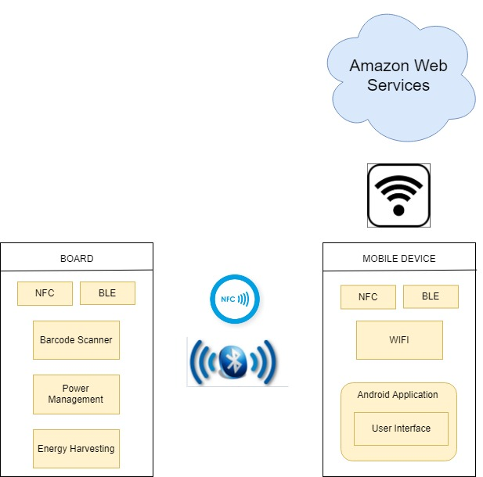

# BOARD BLOCK DIAGRAM

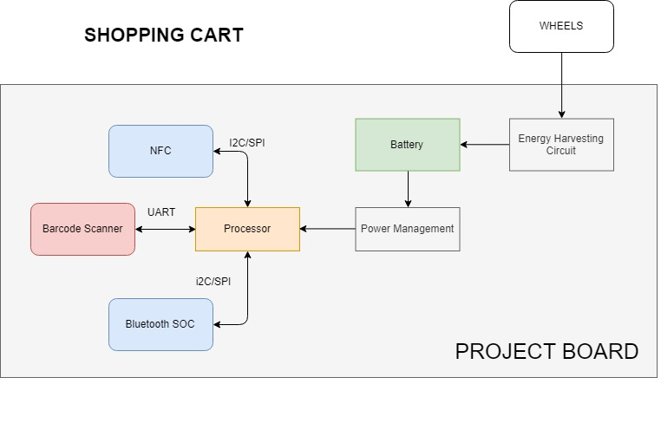

FEATURES

* The device connects with the mobile using Bluetooth with Bluetooth authentication done using NFC for faster and secure connection.
* The device is battery operated with the capability of energy harvesting (optional) from the movement of the wheels.
* The Android application is capable of displaying all the scanned items and total price of the items in the cart.
* The Android application pushes data to the cloud to keep track of past bills and calculate the amount spent in certain time frame.

GOALS ACCOMPLISHED PAST WEEK

|  |  |  |  |
| --- | --- | --- | --- |
| **SR. NO.** | **TASK** | **DESCRIPTION** | **STATUS** |
| 1 | Design | Power Requirement Calculations | Completed |
| 2 | Component Selection | Power Management IC (Module) | Completed |
| 3 | Component Selection | Energy Harvesting Method | Completed |
| 4 | Component Selection | Battery Charging IC | Completed |
| 5 | Android | Initial application template | Completed |
| 6 | Schematic Design | Processor | In Progress |
| 7 | Schematic Design | Power | In Progress |
| 8 | Schematic Design | Radio | In Progress |

# GOALS PLANNED FOR NEXT WEEK

|  |  |  |  |
| --- | --- | --- | --- |
| **SR. NO.** | **TASK** | **DESCRIPTION** | **STATUS** |
| 1 | Schematic Design | Processor | In Progress |
| 2 | Schematic Design | Power | In Progress |
| 3 | Schematic Design | Radio | In Progress |

# COMPONENT SELECTION

1. **Processor - Blue Gecko EFR32BG13:** This is a processor (SOC) sold by Silicon Labs, which has Bluetooth stack built into it with peripherals such as I2C, SPI, UART and 31 GPIO pins. This processor would serve as a controller for the entire system and would also be responsible for executing commands related to the Bluetooth stack. The SOC supports low energy modes and has provisions for load power management (i.e EM0, EM1, EM2, EM3, EM4) thus making it the appropriate choice for a low power project.

The EFR32BG13 Blue Gecko Bluetooth Low Energy SOC Family Data sheet can be found here - <https://www.silabs.com/documents/public/data-sheets/efr32bg13-datasheet.pdf>

Reference Manual: <https://www.silabs.com/documents/public/reference-manuals/efr32xg13-rm.pdf>

Mouser Link to purchase: Purchase [here](https://www.mouser.com/ProductDetail/Silicon-Labs/EFR32BG13P732F512GM48-D?qs=sGAEpiMZZMuReUCzg6bfTAYlATJbN4Oc5QTtA8qQDVJzoYCcTOwW2w%3D%3D)

The Blue gecko to be used for this project is: EFR32BG13P732F512GM48-D.

1. **NFC Module - NXP NTAG NFC Module:** This NFC module would be used for hands-free quick Bluetooth pairing authentication between the cart and the mobile phone. The interface used for NFC module is I2C which is available in the processor selected above. This module can interact with an NFC device as well as unpowered NFC chips such as tags, stickers, key fobs and cards which do not require batteries. This module also has the NFC energy harvesting capability if required. The module also consists of different modes for energy saving purposes.

Digikey Link to purchase: Purchase [here](https://www.digikey.com/product-detail/en/nxp-usa-inc/OM5569-NT322EM/568-12907-ND/5872984)

The datasheet for this module can be found here:

<https://www.nxp.com/docs/en/data-sheet/NT3H2111_2211.pdf>

1. **Sensor - Barcode Scanner:** This barcode scanner was chosen because it gave us the lowest sleep mode current in comparison to all the other bar code scanners. It consists of a USB and UART interface. The module has different modes such as sleep, standby and scanning modes for load power management. There are very small amounts of portable barcode scanners available in the market which consume low current and most of them support UART or RS232 interface. Thus, we did not have much flexibility in choosing an interface for the barcode scanner.

Link to purchase: Purchase [here](https://www.waveshare.com/barcode-scanner-module.html)

The user manual/datasheet for this module can be found here:

<https://www.waveshare.com/w/upload/3/3c/Barcode_Scanner_Module_User_Manual_EN.pdf>

1. **Energy Storage Element: Battery - Lipo Lithium Ion battery:** Since our sensor operates on 5V, it made sense to have a battery whose voltage level is more than 5V. The battery has a 1000mAh capacity. This battery is a dual cell battery which consists of two 3.7V cells in series. This battery specification is subject to modifications as per the power calculations in subsequent weeks.

Sparkfun Link to purchase: Purchase [here](https://www.sparkfun.com/products/11855)

Battery Manual: <https://cdn.sparkfun.com/datasheets/Prototyping/Lithium%20Ion%20Battery%20MSDS.pdf>

1. **Power Management IC:**
   1. Buck-Boost Converter (TPS6307RNMR) -

The battery specified above has a maximum voltage rating of 7.4 voltage and can drop till a minimum of 4 volts for the system to remain operational. The Barcode Scanner sensor would require a rail voltage of 5V. Thus, it is required to have a buck-boost converter in order to improve the battery life of the system. The buck-boost converter would be able to provide a rail voltage of 5V at battery voltages above 5V and even if the battery voltage drops below 5V.

Digikey Link to purchase: Purchase [here](https://www.digikey.com/products/en/integrated-circuits-ics/pmic-voltage-regulators-dc-dc-switching-regulators/739?k=TPS63070&k=&pkeyword=TPS63070&sv=0&pv7=2&pv129=2118&sf=0&FV=ffe002e3&quantity=&ColumnSort=0&page=1&stock=1&pageSize=25)

Datasheet: <http://www.ti.com/lit/ds/symlink/tps63070.pdf>

* 1. Low Dropout Voltage Regulator (LDO) (LM117) -

The NXP NTAG - NFC reader and the processor have an operating voltage 0V-4.6V and 1.8V-3.8V respectively. Since the minimum operating voltage for the battery is 4V, it was apt to use an LDO or a buck converter instead of a buck-boost converter to generate a rail voltage of 3.3V. Voltage dropout consideration is not required in this case as there is a wide gap between the minimum operating battery voltage and the rail voltage required by barcode sensor. In terms of efficiency for our application, the LDO provides a respectable efficiency as compared to a buck converter. Since the LDO provides the smallest solution footprint and is the cheapest option, LDO was selected in order to obtain a 3.3V for the barcode sensor.

Digikey Link to purchase: Purchase [here](https://www.digikey.com/product-detail/en/texas-instruments/LM1117MPX-3.3-NOPB/LM1117MPX-3.3-NOPBCT-ND/1010516)

Datasheet: <http://www.ti.com/general/docs/suppproductinfo.tsp?distId=10&gotoUrl=http%3A%2F%2Fwww.ti.com%2Flit%2Fgpn%2Flm1117>

* 1. Battery Charge Management IC (MCP73213) -

The MCP73213 is a highly integrated Li-Ion battery charge management controller for use in space-limited and cost-sensitive applications. This IC would be required in order to charge the Lipo battery using energy harvesting methods or using USB. Since charging requires a constant current and voltage across the battery, it is imperative to use an IC which provides regulated voltage and current. In addition to this, the 7.4V battery would require voltage greater than 7.4V for charging it. This IC would convert the 5V supplied by the USB to Output Voltage options such as 8.20V, 8.4V, 8.7V, 8.8V. This IC support fast charging mode which can charge 7.4V battery by sourcing current upto 1100mA which can fully charge our battery in an hour.

Digikey Link to purchase: Purchase [here](https://www.digikey.com/product-detail/en/microchip-technology/MCP73213T-A6BI-MF/MCP73213T-A6BI-MFCT-ND/7898468)

Datasheet: <http://ww1.microchip.com/downloads/en/devicedoc/20002190c.pdf>

# SPECIFICATIONS

1. Processor (SOC) - Blue Gecko EFR32BG13P732F512GM48-D, Operating Voltage: 1.8V-3.8V freq band: 2.4 Ghz@19 dBm, Flash: 512kB, RAM: 64kB, GPIO: 31, Operating Range: -40°C to 85°C
2. NFC Module: Working Voltage: Baud Rate: 115200 bps, Operating Voltage: 0V-4.6V, Operating range: 2 to 5 cm, Size: 11cm x 5cm
3. Sensor - Barcode Scanner: Operating Voltage: 5V, Operating Temperature: 0°C - 50°C, Size: 53.3mm x 21.4mm
4. Buck-Boost Converter: Input Voltage Range: 2V to 16V, Output Voltage: 2.5V to 9V, 2A output current in buck and boost mode, Size: 367mm x 367mm x 35mm
5. Low Dropout Voltage Regulator (LDO): Output Voltage: 3.3V, Output Current: 800mA, Size: 6.50mm x 3.50mm
6. Battery Charge Management IC (MCP73213): Battery Charge Voltage Option: 8.20V, 8.4V, 8.7V, 8.8V, fast charge current: 130mA -1100mA, Size: 3mm x 3mm.
7. Battery - Weight: 85g, Size: 70mm x 35mm x 18mm
8. Dimensions: 120mm x 50mm (Approx)
9. Battery: 7V Battery (1) - Rechargeable
10. Wireless Range: 60 meters /180ft
11. Temperature Range: 0 - 50°C
12. Temperature Accuracy: Typical: ±0.3°C /± 0.5°F, Max: ±0.5°C /±0.9°F
13. Humidity Range: 0~99%RH
14. Humidity Accuracy (25°C/ 77°F, 20%~80%RH): Typical: ±3%RH, Max: ±4.5%RH
15. Warranty: 2-3 years.

# POWER MANAGEMENT UNIT

## OVERVIEW

The Power management unit would consist of a circuitry to supply regulated power supply since the barcode scanner requires a rail voltage of 5V, NXP NTAG requires a voltage of 0V-4.6V and processor requires a voltage between 1.8V-3.6V. Thus, NXP NTAG and the processor have wide voltage inputs. The operating voltages of all the ICs have been specified in the specifications section. In order to generate all the rail voltages according to different sensors and processor input voltage requirements, buck-boost and LDO is required.

The battery specified above has a maximum voltage rating of 7.4 voltage and can drop till a minimum of 4 volts for the system to remain operational. The Barcode Scanner sensor would require a rail voltage of 5V. Thus, it is required to have a buck-boost converter in order to improve the battery life of the system. The buck-boost converter would be able to provide a rail voltage of 5V at battery voltages above 5V and even if the voltage drops below 5V.

LDO would be required for NXP NTAG – NFC and the processor as their operating voltages are predominantly below 4V.

## ENERGY STORAGE ELEMENT

The Energy Storage Element used would be a battery as specified in the component selection section.

|  |  |  |
| --- | --- | --- |
| **COMPONENT** | **ENERGY MODE** | **CURRENT(mA)** |
| NXP NTAG – NFC | I2C (Idle Mode) | 0.195 |
| I2C (Active Mode) | 0.24 |
| Barcode Scanner | Sleep Mode | 2 |
| Active Mode | 135 |
| Processor – EFR32BG13 | EM2 (I2C) | 0.002 |
| EM1 (UART) | 3 |
| EM0 (Radio on) | 10 |

# USE CASE MODEL

## ENERGY MODES

1. **Mode 1 - Deep Sleep Mode**

In deep sleep mode, the barcode sensor is powered down, NXP NTAG and the processor are in sleep mode. The idea behind this principle is that the device shouldn’t start scanning until it is connected to the phone. The power to the sensor is GPIO controlled, providing us the capability to turn if off when not in use.

NFC sleep current = 195uA

EFR32BG13 Sleep mode = 2uA

Total current in this mode = 197uA

1. **Mode 2 – Connection Initialization**

The NFC tag is triggered shifting into Active mode as specified in the table above using the Android app on the phone. This trigger will be used to turn on the radio and start Bluetooth advertising thus, switching the processor in EM0 mode (radio on). The authentication of Bluetooth is done using NFC. During this mode the sensor is powered down.

NFC active mode = 240 uA

EFR32BG13 radio on = 10mA

Total current in this mode = 0.240mA + 10mA = 10.24mA

After this mode the NFC would always be in idle state.

1. **Mode 3 – Connected Mode**

In this mode the barcode sensor is in sleep mode. The processor is in EM1 mode waiting for a successful read. Both the sensor and processor are in sleep mode.

Barcode Sensor Sleep Mode = 2mA

EFR32BG13 EM1 Mode = 3mA

NFC Sleep Mode = 195uA

Total current = 2mA + 3mA + 0.195mA = 5.195mA

1. **Mode 4 – Product Scanning mode**

In this mode the barcode sensor scans the items and transfers data to the board using I2C interface.

Barcode sensor Active Mode = 135mA

EFR32BG13 EM1 Mode = 3mA

NFC Sleep Mode = 195uA

Total Current = 135mA + 3mA = 138.195mA

1. **Mode 5 – Transmission Mode**

In this mode the Bluetooth radio communicates with the android app to send over the details of scanned items

EFR32BG13 radio on = 10mA

Sensor Sleep Mode = 2mA

NFC Sleep Mode = 195uA

Total current = 10mA +2mA = 12.195mA

## AVERAGE DC CURRENT MATH

All the duration times considered in the following calculations are worst case scenarios.

1. **Connection Initialization Mode**

Time duration = 2 seconds

Considering 1 connection per hour with a consumption of 26mA current per connection

Total Current Consumed = 26mA

1. **Product Scanning Mode**

Assuming the barcode scanner will successfully scan an item barcode in 1 second and considering 100 successful scans per hour with a consumption of 137mA current per scan.

Total Current Consumed = 138.195mA * 100 = 13819.5mA.

1. **Transmission Mode**

Assuming 1 second per transmission considering failed attempts and retries (worst case).

Considering 100 successful transmissions per hour with a consumption of 12mA current per transmission.

Current Consumed = 12.195mA * 100 = 1219.5mA

1. **Connected Mode**

Being in connected mode without any data transmission for the remaining time i.e 1 hr – time consumed in previous modes = 3397 seconds.

Current Consumed = 3398 * 5.195 = 17647mA

Average DC current in one hour = Total Current consumed in all modes/3600

= 9.08mA

Battery Capacity chosen = 1000mAh

Total operating hours in single full charge = Battery Capacity/9.08mA

= 1000/9.08 = 110.13 hours

Approximately 4-5 days of continuous operation for 24 hours with 100 scans per hours.

These calculations are for worst case scenarios. In order to have better continuous days of operation, better results can be achieved by reducing the current consumption in connected mode. In addition to this, energy harvesting methods can also improve the operating hours of the product.

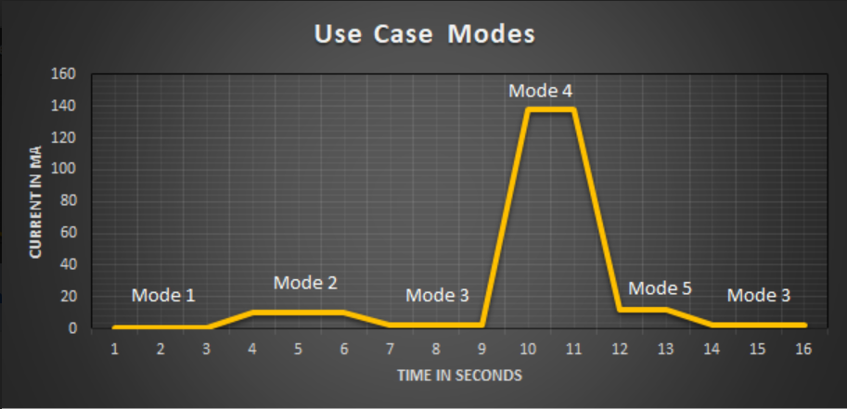

The above image represents our use case model broken into generic time slots showing current consumption for different phases of the system. The above graph is just an approximate representation of the energy modes that the entire system goes through.

# FUTURE SCOPE

* Budget Alert feature where the app notifies the user about budget limit crossed.
* Load cell can be incorporated for the items which has to be purchased in weight rather than in quantity.
* We can analyze the data for stock and asset management.
* Secured automatic payment through the android application.