Machine Learning
Definition of Machine Learning:~
Arthur Samuel. (1959)
He defined machine learning as the field of study
that gives computers the ability to learn without being explicitly learned.
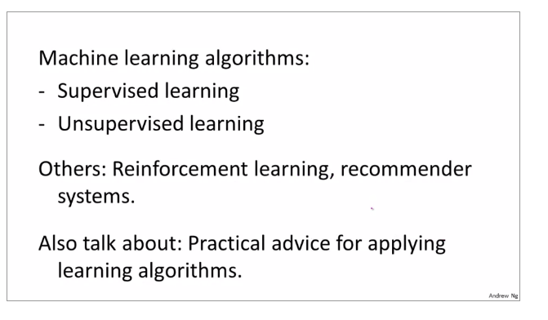
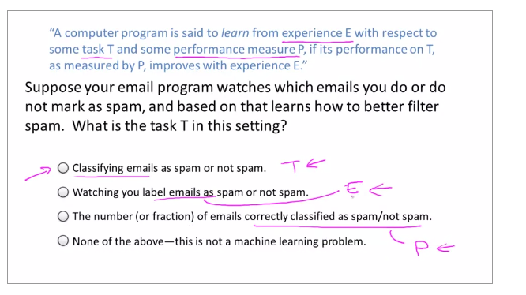

What is Machine Learning?
Two definitions of Machine Learning are offered. Arthur Samuel described it as: "the field of study that gives computers the ability to learn without being explicitly programmed." This is an older, informal definition.
Tom Mitchell provides a more modern definition: "A computer program is said to learn from experience E with respect to some class of tasks T and performance measure P, if its performance at tasks in T, as measured by P, improves with experience E."
Example: playing checkers.
E = the experience of playing many games of checkers
T = the task of playing checkers.
P = the probability that the program will win the next game.
In general, any machine learning problem can be assigned to one of two broad classifications:
Supervised learning and Unsupervised learning.

Supervised Learning :~

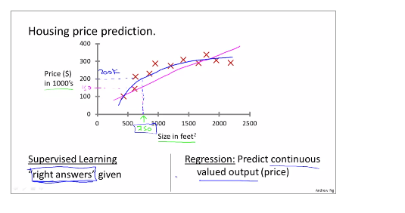

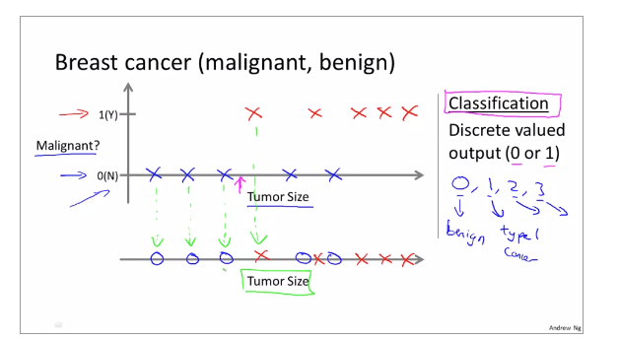

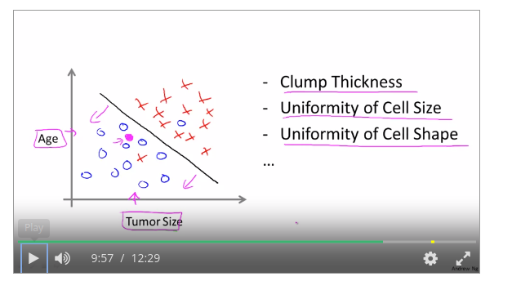

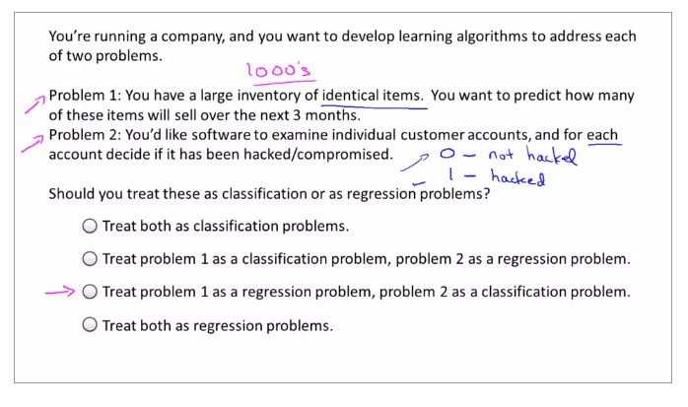

Supervised Learning
In supervised learning, we are given a data set and already know what our correct output should look like, having the idea that there is a relationship between the input and the output.
Supervised learning problems are categorized into "regression" and "classification" problems. In a regression problem, we are trying to predict results within a continuous output, meaning that we are trying to map input variables to some continuous function. In a classification problem, we are instead trying to predict results in a discrete output. In other words, we are trying to map input variables into discrete categories.
Example 1:
Given data about the size of houses on the real estate market, try to predict their price. Price as a function of size is a continuous output, so this is a regression problem.
We could turn this example into a classification problem by instead making our output about whether the house "sells for more or less than the asking price." Here we are classifying the houses based on price into two discrete categories.
Example 2:
(a) Regression - Given a picture of a person, we have to predict their age on the basis of the given picture
(b) Classification - Given a patient with a tumor, we have to predict whether the tumor is malignant or benign.
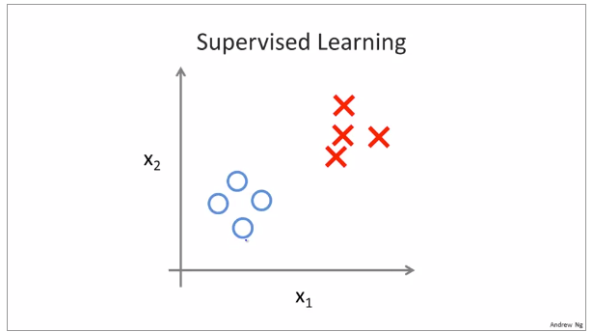

So for each example in Supervised Learning, we were told explicitly what
is the so-called right answer, whether it's benign or malignant.

Unsupervised Learning, we're given data that looks different than data that looks like
this that doesn't have any labels or that all has the same label or really no labels.

Unsupervised Learning algorithm might decide that the data lives in two different clusters.
And so there's one cluster and there's a different cluster.

Supervised Learning algorithm may break these data into these two separate clusters.
So this is called a clustering algorithm. And this turns out to be used in many places.
One example where clustering is used is in Google News and if you have not seen this before, you can actually go to this URL news.google.com to take a look. What Google News does is everyday
it goes and looks at tens of thousands or hundreds of thousands of new stories on the web and it groups them into cohesive news stories.

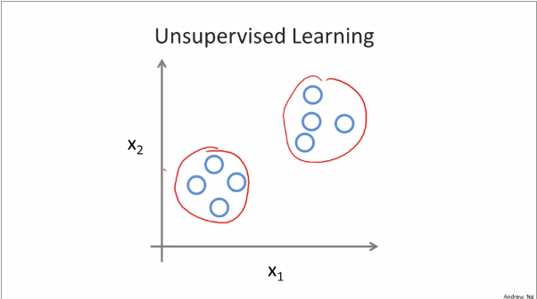
Custom Algorithm used for news.google.com

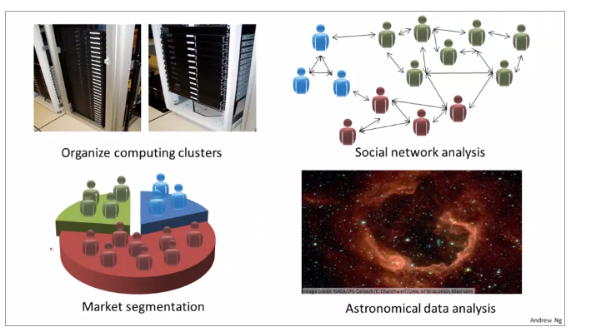

Unsupervised Learning is also used for surprisingly astronomical data analysis and these clustering algorithms gives surprisingly interesting useful theories of how galaxies are formed.
All of these are examples of clustering, which is just one type of Unsupervised Learning. Let me tell you about another one. I'm gonna tell you about the cocktail party problem. two speakers recorded by a researcher. Let me play for you the first, what the first microphone sounds like. One (uno), two (dos), three (tres), four (cuatro), five (cinco), six (seis), seven (siete), eight (ocho), nine (nueve), ten (y diez).
All right, maybe not the most interesting cocktail party, there's two people counting from one to ten
in two languages but you know. What you just heard was the first microphone recording, here's the second recording.
Uno (one), dos (two), tres (three), cuatro (four), cinco (five), seis (six), siete (seven), ocho (eight), nueve (nine) y diez (ten). So we can do, is take these two microphone recorders and give them to an Unsupervised Learning algorithm called the cocktail party algorithm, and tell the algorithm
- find structure in this data for you

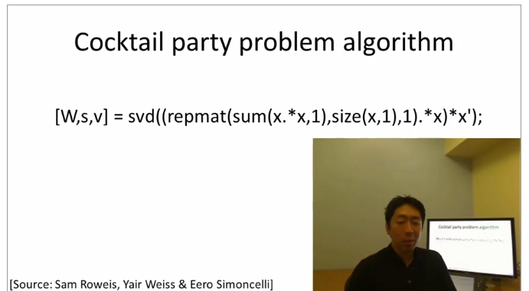

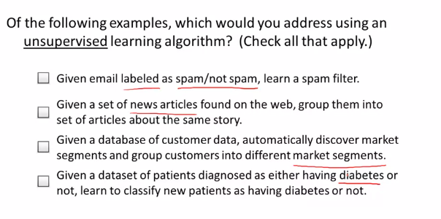
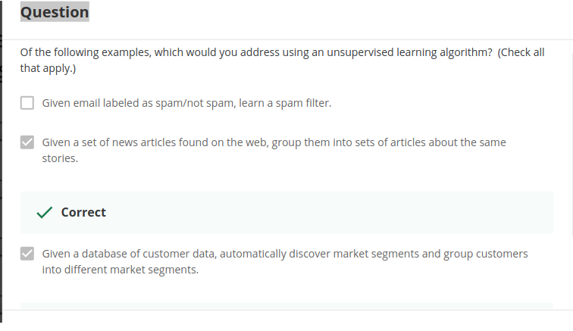

Unsupervised Learning

Unsupervised Learning
Unsupervised learning allows us to approach problems with little or no idea what our results should look like. We can derive structure from data where we don't necessarily know the effect of the variables.
We can derive this structure by clustering the data based on relationships among the variables in the data.
With unsupervised learning there is no feedback based on the prediction results.
Example:
Clustering: Take a collection of 1,000,000 different genes, and find a way to automatically group these genes into groups that are somehow similar or related by different variables, such as lifespan, location, roles, and so on.
Non-clustering: The "Cocktail Party Algorithm", allows you to find structure in a chaotic environment. (i.e. identifying individual voices and music from a mesh of sounds at a cocktail party).
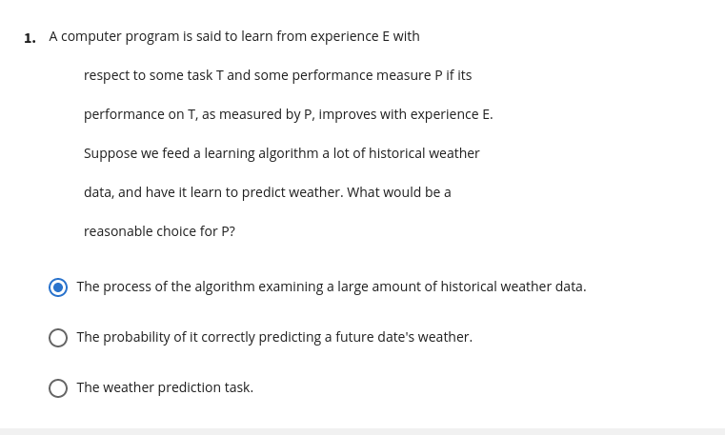
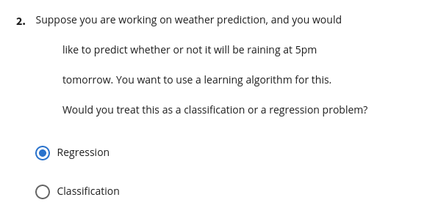
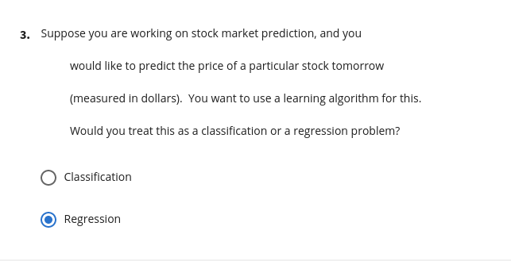
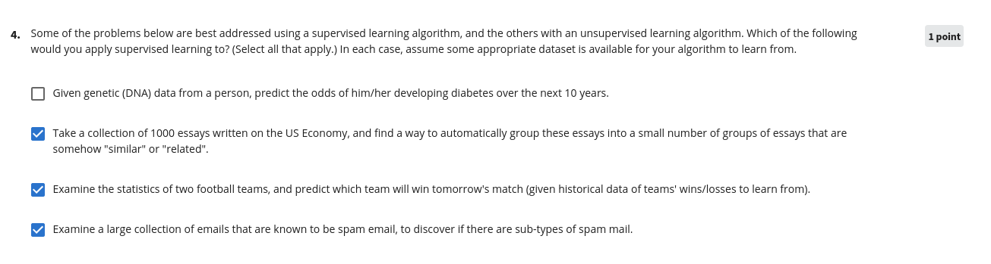

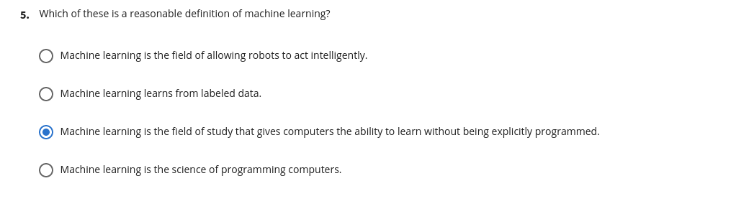

A computer program is said to learn from experience E with respect to some task T and some performance measure P if its performance on T, as measured by P, improves with experience E. Suppose we feed a learning algorithm a lot of historical weather data, and have it learn to predict weather. In this setting, what is E?

Answer
The process of the algorithm examining a large amount of historical weather data.

Explanation
T := The weather prediction task.
P := The probability of it correctly predicting a future date's weather.
E := The process of the algorithm examining a large amount of historical weather data.

Question 2
Suppose you are working on weather prediction, and you would like to predict whether or not it will be raining at 5pm tomorrow. You want to use a learning algorithm for this. Would you treat this as a classification or a regression problem?

Answer
Classification

Explanation
Classification is appropriate when we are trying to predict one of a small number of discrete-valued outputs, such as whether it will rain (which we might designate as class 0), or not (say class 1).

Question 3
Suppose you are working on stock market prediction, and you would like to predict the price of a particular stock tomorrow (measured in dollars). You want to use a learning algorithm for this. Would you treat this as a classification or a regression problem?

Answer
Regression

Explanation
Regression is appropriate when we are trying to predict a continuous-valued output, since as the price of a stock (similar to the housing prices example in the lectures).

Question 4
Some of the problems below are best addressed using a supervised learning algorithm, and the others with an unsupervised learning algorithm. Which of the following would you apply supervised learning to? (Select all that apply.) In each case, assume some appropriate dataset is available for your algorithm to learn from.

Explanation
- Take a collection of 1000 essays written on the US Economy, and find a way to automatically group these essays into a small number of groups of essays that are somehow "similar" or "related". :=
This is an unsupervised learning/clustering problem (similar to the Google News example in the lectures).
- Given a large dataset of medical records from patients suffering from heart disease, try to learn whether there might be different clusters of such patients for which we might tailor separate treatements. :=
This can be addressed using an unsupervised learning, clustering, algorithm, in which we group patients into different clusters.
- Given genetic (DNA) data from a person, predict the odds of him/her developing diabetes over the next 10 years. :=
This can be addressed as a supervised learning, classification, problem, where we can learn from a labeled dataset comprising different people's genetic data, and labels telling us if they had developed diabetes.
- Given 50 articles written by male authors, and 50 articles written by female authors, learn to predict the gender of a new manuscript's author (when the identity of this author is unknown). :=
This can be addressed as a supervised learning, classification, problem, where we learn from the labeled data to predict gender.
- In farming, given data on crop yields over the last 50 years, learn to predict next year's crop yields. :=
This can be addresses as a supervised learning problem, where we learn from historical data (labeled with historical crop yields) to predict future crop yields.
- Examine a large collection of emails that are known to be spam email, to discover if there are sub-types of spam mail. :=
This can addressed using a clustering (unsupervised learning) algorithm, to cluster spam mail into sub-types.
- Examine a web page, and classify whether the content on the web page should be considered "child friendly" (e.g., non-pornographic, etc.) or "adult." :=
This can be addressed as a supervised learning, classification, problem, where we can learn from a dataset of web pages that have been labeled as "child friendly" or "adult."
- Examine the statistics of two football teams, and predicting which team will win tomorrow's match (given historical data of teams' wins/losses to learn from). :=
This can be addressed using supervised learning, in which we learn from historical records to make win/loss predictions.

Question 5
Which of these is a reasonable definition of machine learning?

Answer
Machine learning is the field of study that gives computers the ability to learn without being explicitly programmed.

Explanation
This was the definition given by Arthur Samuel (who had written the famous checkers playing, learning program).

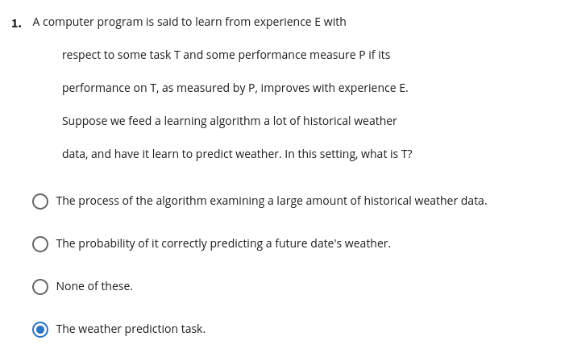
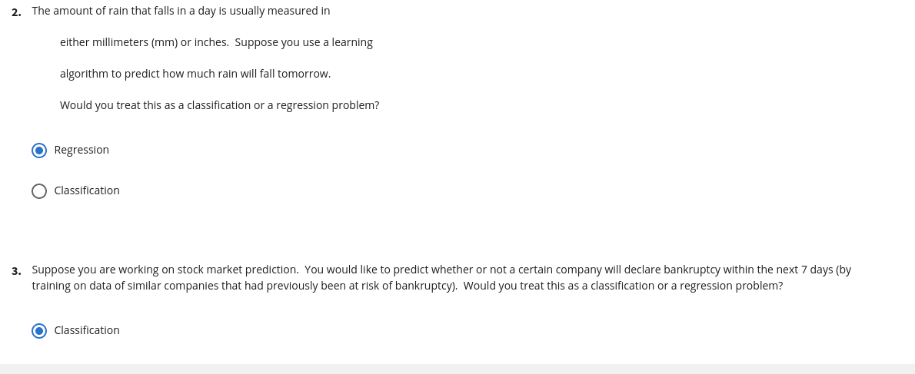

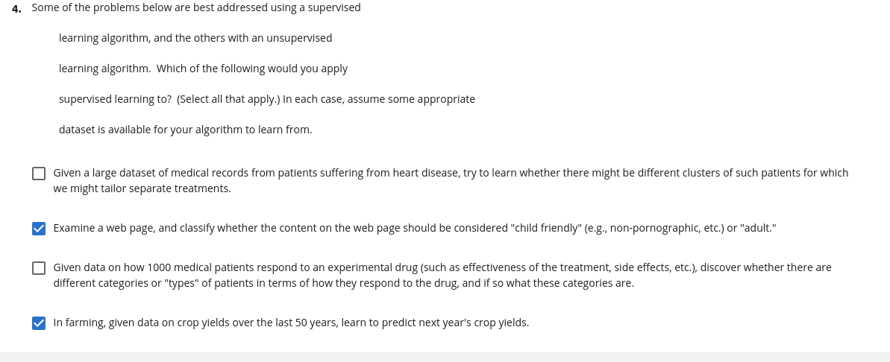
Q1. A computer program is said to learn from experience E with respect to some task T and some performance measure P if its performance on T, as measured by P, improves with experience E. Suppose we feed a learning algorithm a lot of historical weather data, and have it learn to predict weather. In this setting, what is T?
- The weather prediction task.
- The probability of it correctly predicting a future date's weather.
- None of these.
- The process of the algorithm examining a large amount of historical weather data.
A1. The weather prediction task.
Q2. The amount of rain that falls in a day is usually measured in either millimeters (mm) or inches. Suppose you use a learning algorithm to predict how much rain will fall tomorrow. Would you treat this as a classification or a regression problem?
- Regression
- Classification
A2. Regression
Q3. Suppose you are working on stock market prediction. You would like to predict whether or not a certain company will declare bankruptcy within the next 7 days (by training on data of similar companies that had previously been at risk of bankruptcy). Would you treat this as a classification or a regression problem?
- Classification
- Regression
A3. Classification
Q4. Some of the problems below are best addressed using a supervised learning algorithm, and the others with an unsupervised learning algorithm. Which of the following would you apply supervised learning to? (Select all that apply.) In each case, assume some appropriate dataset is available for your algorithm to learn from.
- Given historical data of children's ages and heights, predict children's height as a function of their age.
- Examine a large collection of emails that are known to be spam email, to discover if there are sub-types of spam mail.
- Take a collection of 1000 essays written on the US Economy, and find a way to automatically group these essays into a small number of groups of essays that are somehow "similar" or "related".
- Given 50 articles written by male authors, and 50 articles written by female authors, learn to predict the gender of a new manuscript's author (when the identity of this author is unknown).
A4. 1 and 4
Q5. Which of these is a reasonable definition of machine learning?
- Machine learning is the field of study that gives computers the ability to learn without being explicitly programmed.
- Machine learning learns from labeled data.
- Machine learning is the science of programming computers.
- Machine learning is the field of allowing robots to act intelligently.
A5. 1

Model Representation
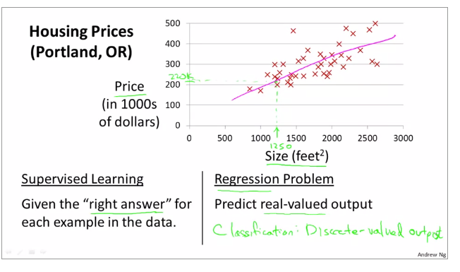
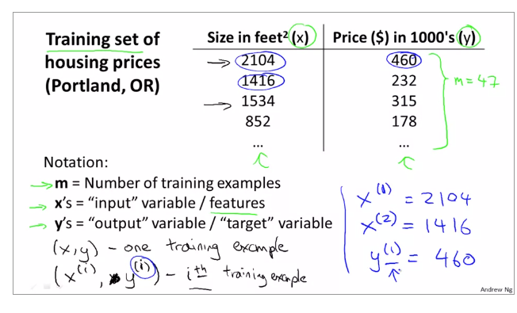
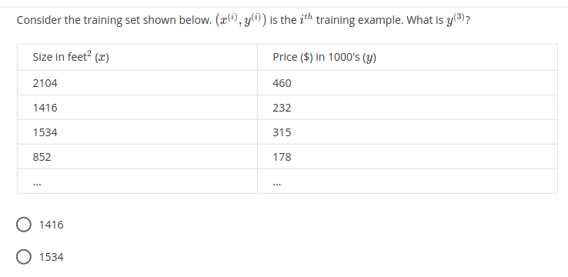

Answer :~ 315

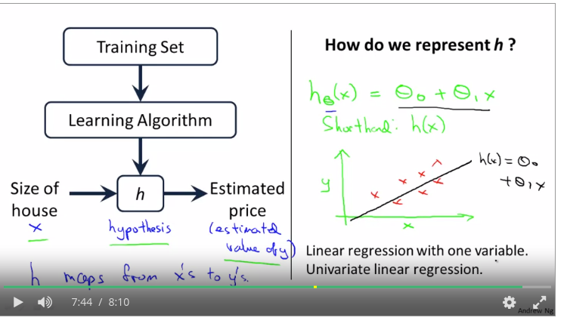

Model Representation
To establish notation for future use, we’ll use x(i) to denote the “input” variables (living area in this example), also called input features, and y(i) to denote the “output” or target variable that we are trying to predict (price). A pair (x(i),y(i)) is called a training example, and the dataset that we’ll be using to learn—a list of m training examples (x(i),y(i));i=1,...,m—is called a training set. Note that the superscript “(i)” in the notation is simply an index into the training set, and has nothing to do with exponentiation. We will also use X to denote the space of input values, and Y to denote the space of output values. In this example, X = Y = ℝ.
To describe the supervised learning problem slightly more formally, our goal is, given a training set, to learn a function h : X → Y so that h(x) is a “good” predictor for the corresponding value of y. For historical reasons, this function h is called a hypothesis. Seen pictorially, the process is therefore like this:
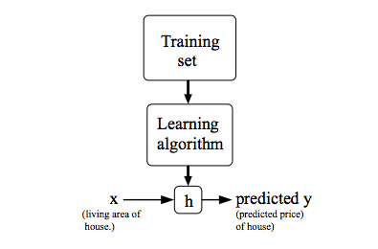

When the target variable that we’re trying to predict is continuous, such as in our housing example, we call the learning problem a regression problem. When y can take on only a small number of discrete values (such as if, given the living area, we wanted to predict if a dwelling is a house or an apartment, say), we call it a classification problem.

Cost Function:
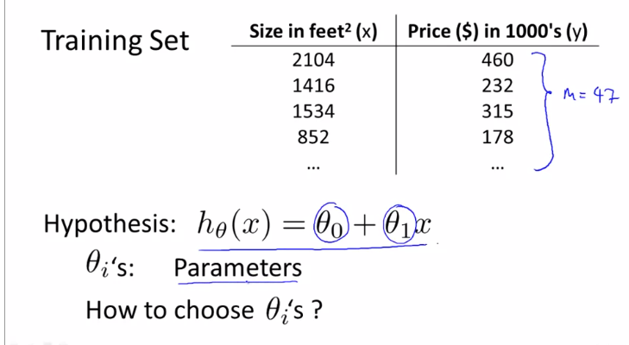

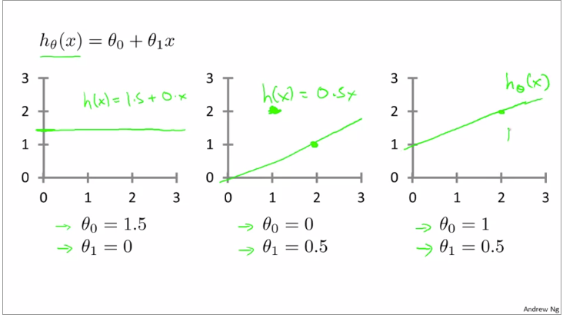

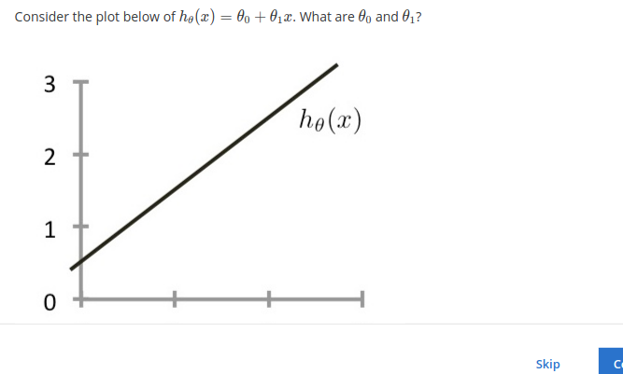

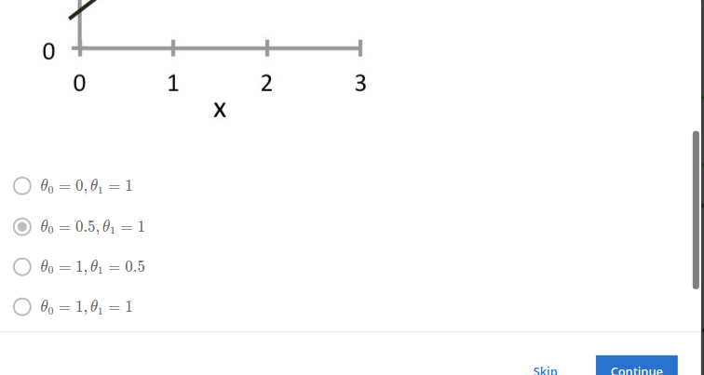

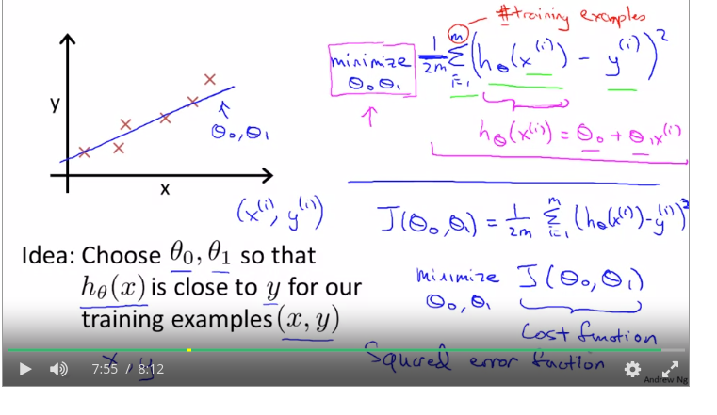

Cost Function
We can measure the accuracy of our hypothesis function by using a cost function. This takes an average difference (actually a fancier version of an average) of all the results of the hypothesis with inputs from x's and the actual output y's.
J(θ0​,θ1​)=2m1​i=1∑m​(y^​i​−yi​)2=2m1​i=1∑m​(hθ​(xi​)−yi​)2
To break it apart, it is 21​ xˉ where xˉ is the mean of the squares of hθ​(xi​)−yi​ , or the difference between the predicted value and the actual value.
This function is otherwise called the "Squared error function", or "Mean squared error". The mean is halved (21​) as a convenience for the computation of the gradient descent, as the derivative term of the square function will cancel out the 21​ term. The following image summarizes what the cost function does:

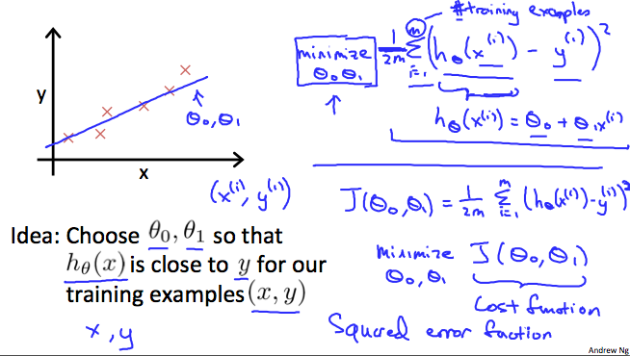

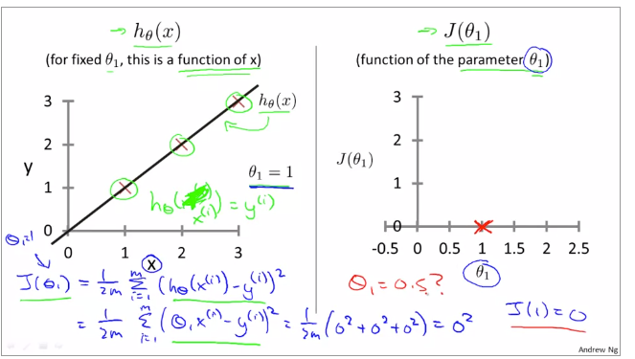

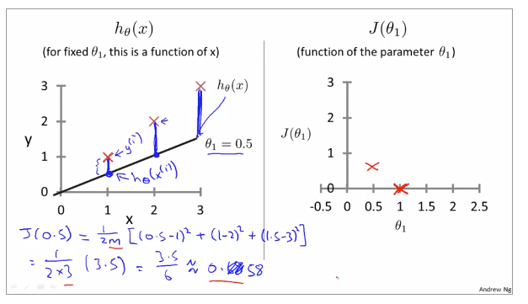

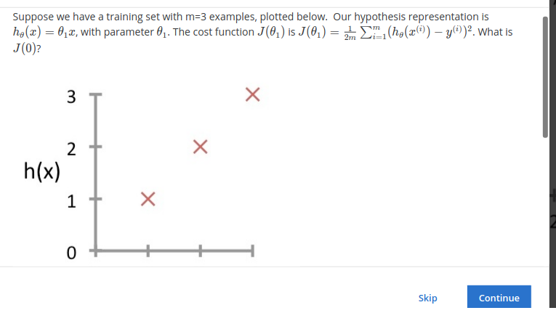

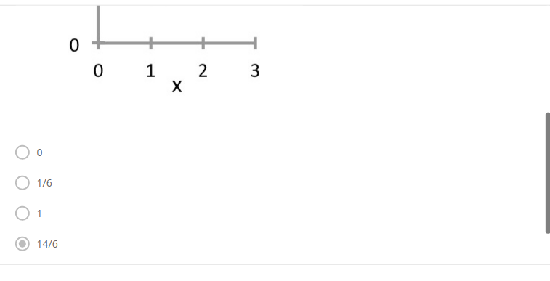

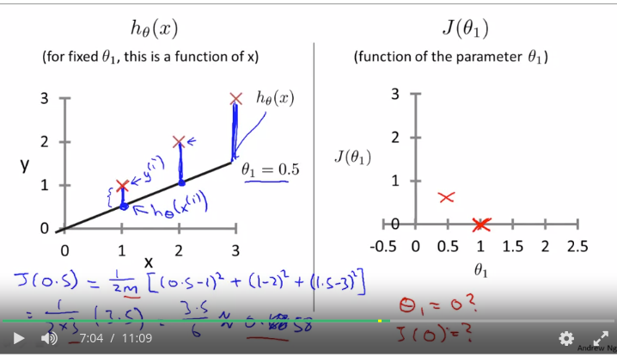

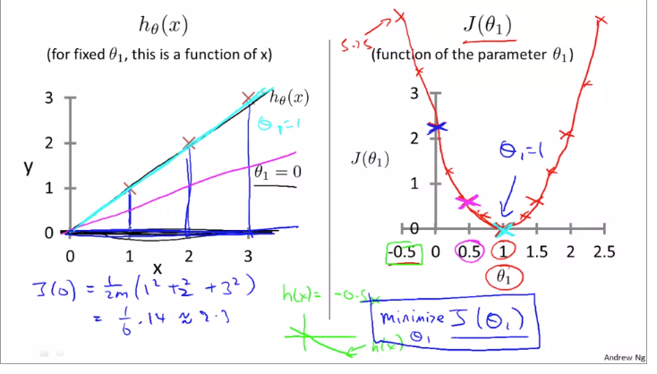

Cost Function - Intuition I

Cost Function - Intuition I
If we try to think of it in visual terms, our training data set is scattered on the x-y plane. We are trying to make a straight line (defined by hθ​(x)) which passes through these scattered data points.
Our objective is to get the best possible line. The best possible line will be such so that the average squared vertical distances of the scattered points from the line will be the least. Ideally, the line should pass through all the points of our training data set. In such a case, the value of J(θ0​,θ1​) will be 0. The following example shows the ideal situation where we have a cost function of 0.
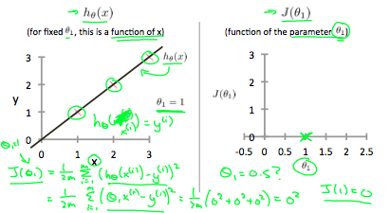
When θ1​=1, we get a slope of 1 which goes through every single data point in our model. Conversely, when θ1​=0.5, we see the vertical distance from our fit to the data points increase.
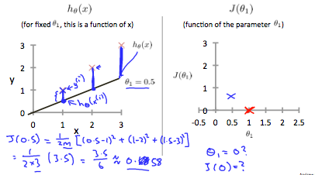
This increases our cost function to 0.58. Plotting several other points yields to the following graph:
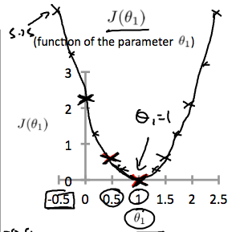
Thus as a goal, we should try to minimize the cost function. In this case, θ1​=1 is our global minimum.

Cost Function - Intuition II

Cost Function - Intuition II
A contour plot is a graph that contains many contour lines. A contour line of a two variable function has a constant value at all points of the same line. An example of such a graph is the one to the right below.
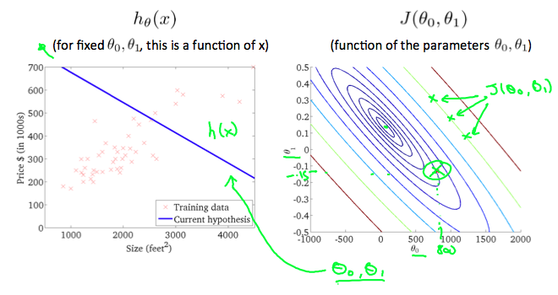
Taking any color and going along the 'circle', one would expect to get the same value of the cost function. For example, the three green points found on the green line above have the same value for J(θ0​,θ1​) and as a result, they are found along the same line. The circled x displays the value of the cost function for the graph on the left when θ0​ = 800 and θ1​= -0.15. Taking another h(x) and plotting its contour plot, one gets the following graphs:
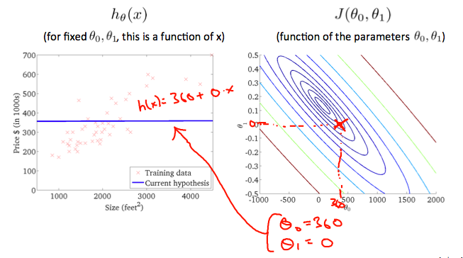
When θ0​ = 360 and θ1​ = 0, the value of J(θ0​,θ1​) in the contour plot gets closer to the center thus reducing the cost function error. Now giving our hypothesis function a slightly positive slope results in a better fit of the data.
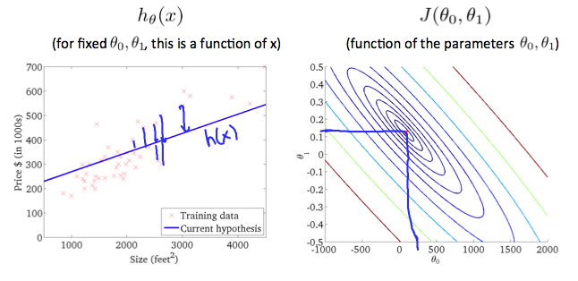
The graph above minimizes the cost function as much as possible and consequently, the result of θ1​ and θ0​ tend to be around 0.12 and 250 respectively. Plotting those values on our graph to the right seems to put our point in the center of the inner most 'circle'.

Gradient Descent

Gradient Descent
So we have our hypothesis function and we have a way of measuring how well it fits into the data. Now we need to estimate the parameters in the hypothesis function. That's where gradient descent comes in.
Imagine that we graph our hypothesis function based on its fields θ0​ and θ1​ (actually we are graphing the cost function as a function of the parameter estimates). We are not graphing x and y itself, but the parameter range of our hypothesis function and the cost resulting from selecting a particular set of parameters.
We put θ0​ on the x axis and θ1​ on the y axis, with the cost function on the vertical z axis. The points on our graph will be the result of the cost function using our hypothesis with those specific theta parameters. The graph below depicts such a setup.
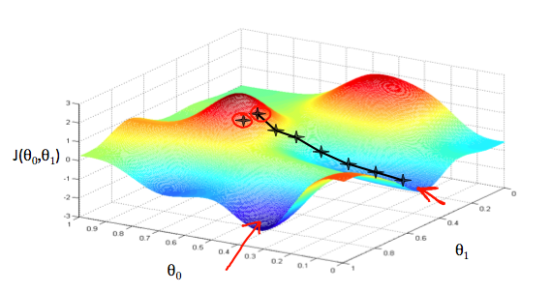
We will know that we have succeeded when our cost function is at the very bottom of the pits in our graph, i.e. when its value is the minimum. The red arrows show the minimum points in the graph.
The way we do this is by taking the derivative (the tangential line to a function) of our cost function. The slope of the tangent is the derivative at that point and it will give us a direction to move towards. We make steps down the cost function in the direction with the steepest descent. The size of each step is determined by the parameter α, which is called the learning rate.
For example, the distance between each 'star' in the graph above represents a step determined by our parameter α. A smaller α would result in a smaller step and a larger α results in a larger step. The direction in which the step is taken is determined by the partial derivative of J(θ0​,θ1​). Depending on where one starts on the graph, one could end up at different points. The image above shows us two different starting points that end up in two different places.
The gradient descent algorithm is:
repeat until convergence:
θj​:=θj​−α∂θj​∂​J(θ0​,θ1​)
where
j=0,1 represents the feature index number.
At each iteration j, one should simultaneously update the parameters θ1​,θ2​,...,θn​. Updating a specific parameter prior to calculating another one on the j(th) iteration would yield to a wrong implementation.
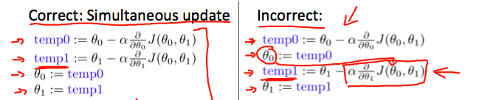

Gradient Descent Intuition

Gradient Descent Intuition
In this video we explored the scenario where we used one parameter θ1​ and plotted its cost function to implement a gradient descent. Our formula for a single parameter was :
Repeat until convergence:
θ1​:=θ1​−αdθ1​d​J(θ1​)
Regardless of the slope's sign for dθ1​d​J(θ1​), θ1​ eventually converges to its minimum value. The following graph shows that when the slope is negative, the value of θ1​ increases and when it is positive, the value of θ1​ decreases.
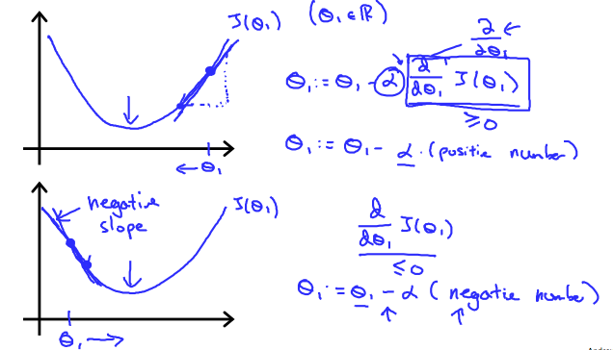
On a side note, we should adjust our parameter α to ensure that the gradient descent algorithm converges in a reasonable time. Failure to converge or too much time to obtain the minimum value imply that our step size is wrong.
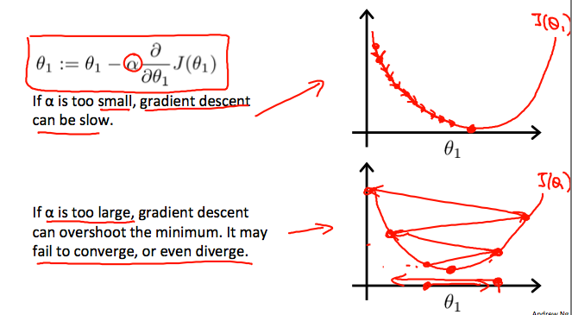

How does gradient descent converge with a fixed step size α?
The intuition behind the convergence is that dθ1​d​J(θ1​) approaches 0 as we approach the bottom of our convex function. At the minimum, the derivative will always be 0 and thus we get:
θ1​:=θ1​−α∗0
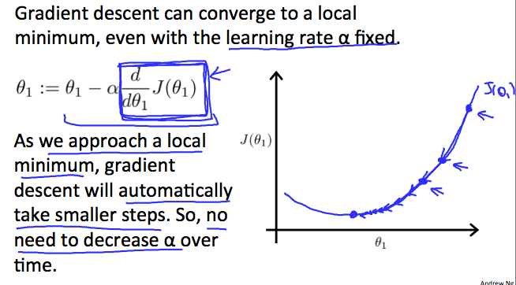

Gradient Descent For Linear Regression

Gradient Descent For Linear Regression
Note: [At 6:15 "h(x) = -900 - 0.1x" should be "h(x) = 900 - 0.1x"]
When specifically applied to the case of linear regression, a new form of the gradient descent equation can be derived. We can substitute our actual cost function and our actual hypothesis function and modify the equation to :
repeat until convergence: {θ0:=θ1:=}θ0−α1m∑i=1m(hθ(xi)−yi)θ1−α1m∑i=1m((hθ(xi)−yi)xi)
where m is the size of the training set, θ0​ a constant that will be changing simultaneously with θ1​ and xi​,yi​are values of the given training set (data).
Note that we have separated out the two cases for θj​ into separate equations for θ0​ and θ1​; and that for θ1​ we are multiplying xi​ at the end due to the derivative. The following is a derivation of ∂θj​∂​J(θ) for a single example :
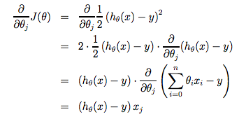
The point of all this is that if we start with a guess for our hypothesis and then repeatedly apply these gradient descent equations, our hypothesis will become more and more accurate.
So, this is simply gradient descent on the original cost function J. This method looks at every example in the entire training set on every step, and is called batch gradient descent. Note that, while gradient descent can be susceptible to local minima in general, the optimization problem we have posed here for linear regression has only one global, and no other local, optima; thus gradient descent always converges (assuming the learning rate α is not too large) to the global minimum. Indeed, J is a convex quadratic function. Here is an example of gradient descent as it is run to minimize a quadratic function.
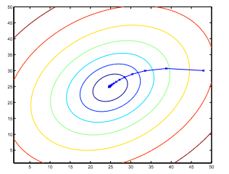
The ellipses shown above are the contours of a quadratic function. Also shown is the trajectory taken by gradient descent, which was initialized at (48,30). The x’s in the figure (joined by straight lines) mark the successive values of θ that gradient descent went through as it converged to its minimum.

Linear Regression with One Variable
Latest Submission Grade 80%

1.
Question 1
Consider the problem of predicting how well a student does in her second year of college/university, given how well she did in her first year.
Specifically, let x be equal to the number of "A" grades (including A-. A and A+ grades) that a student receives in their first year of college (freshmen year). We would like to predict the value of y, which we define as the number of "A" grades they get in their second year (sophomore year).
Here each row is one training example. Recall that in linear regression, our hypothesis is hθ​(x)=θ0​+θ1​x, and we use m to denote the number of training examples.
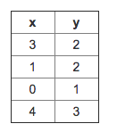
For the training set given above (note that this training set may also be referenced in other questions in this quiz), what is the value of m? In the box below, please enter your answer (which should be a number between 0 and 10).
1 / 1 point
Correct

2.
Question 2
Consider the following training set of m=4 training examples:
x | y
1 | 0.5
2 | 1
4 | 2
0 | 0
Consider the linear regression model hθ​(x)=θ0​+θ1​x. What are the values of θ0​ and θ1​ that you would expect to obtain upon running gradient descent on this model? (Linear regression will be able to fit this data perfectly.)
1 / 1 point
Correct

3.
Question 3
Suppose we set θ0​=−1,θ1​=2 in the linear regression hypothesis from Q1. What is hθ​(6)?
1 / 1 point
Correct

4.
Question 4
Let f be some function so that
f(θ0​,θ1​) outputs a number. For this problem,
f is some arbitrary/unknown smooth function (not necessarily the
cost function of linear regression, so f may have local optima).
Suppose we use gradient descent to try to minimize f(θ0​,θ1​)
as a function of θ0​ and θ1​. Which of the
following statements are true? (Check all that apply.)
1 / 1 point
Correct

5.
Question 5
Suppose that for some linear regression problem (say, predicting housing prices as in the lecture), we have some training set, and for our training set we managed to find some θ0​, θ1​ such that J(θ0​,θ1​)=0.
Which of the statements below must then be true? (Check all that apply.)
0 / 1 point
Incorrect

