Stochastic Gradient Descent 📚

Stochastic Gradient Descent is an optimization algorithm or advanced and improved version of Batch Gradient descent as we have seen, so in this notebook you will learn about SGD in detail.
We use SGD for larger datasets because the standard batch gradient descent tends to work slow on larger datasets. So as an example, let's assume we have 10,000 data points and 10 features. The sum of squared residuals consists of as many terms as there are data points, so 10000 terms in our case. We need to compute the derivative of this function with respect to each of the features, so in effect we will be doing 10000 10 = 100,000 computations per iteration. It is common to take 1000 iterations, in effect we have 100,000 1000 = 100000000 computations to complete the algorithm.
So, That's why we use SGD for larger datasets.

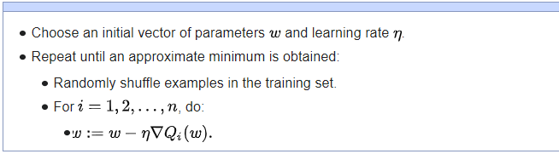
from IPython.display import IFrame
wiki = IFrame(src='https://en.wikipedia.org/wiki/Stochastic_gradient_descent',
width=1000,
height=400)
display(wiki)

Performance Metrics for classification models

- TP :- True Positive (It means that the outcome where the model correctly predicts the positive class. )
- TN :- True Negative (an outcome where the model correctly predicts the negative class. )
- FP :- False Positive ( an outcome where the model incorrectly predicts the positive class.)
- FN :- False Negative ( an outcome where the model incorrectly predicts the negative class. )

Confusion Matrix
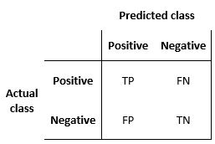

Precision :- The number of true positives divided by the number of true positives plus the number of false positives. It answers this question "What proportion of positive identifications was actually correct?"
Recall :- Recall answers this question What proportion of actual positives was identified correctly? ( TP / TP + FN )

Errata In ML001 Course
In ML001, Instructor had made some mistakes while writing formulas, so all the erata in this course can be found here.
1.) Errata in Fundamentals of Machine Learning:-
Instructor have told dicrete, it should be discrete and other mispronounced term was deriviative, it should be derivative.
2.) Errata in Linear Regression:-

Errata 1: TimeStamp : 57:15
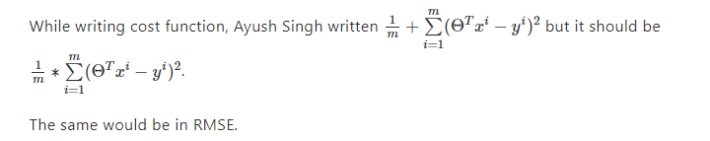
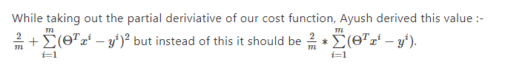
Here there are some clarification and derivation fof this is given in clarification.md
2.) Errata in Logistic Regression:-
Instructor haven’t found any Errata in this Section, If you find one plz feel free to make a PR.
3.) Errata in Regularization:-
Instructor haven’t found any Errata in this Section, If you find one plz feel free to make a PR.
4.) Errata for further sections can be added here.
Some Points while adding Errata:-
- Please Include the timestamps including the section name and correct that errata.
- If you find anything which can be explained better, do email me, I will make another video on the same topic on Newera.

Building a breat cancer detection system From Scratch📚
Welcome to this programming assignment of the session. In this programming assignment you will work on developing your own logistic regression model from scratch.
📑📑 After this Assignment, you will be having a good conceptual understanding of logistic regression, be able to argue on this topic, can answer the interview based questions.
So, let's start with this programming assignment.
In [ ]:
# Importing Packages #
import numpy as np # for scientific computation
import pandas as pd # for working with data
from sklearn.model_selection import train_test_split # for splitting the data
from sklearn.datasets import load_breast_cancer # dataset that we will be using
import warnings # optional
warnings.filterwarnings( "ignore" ) # optional

Sigmoid Function 📚
In the following exercise you need to implement Sigmoid function that you have studied in the class.
In [ ]:
def Sigmoid(z):
'''
Input:
***********
z:- output from the hypothesis
***********

Output:
-----------
y_hat:- final output
-----------

Instructions:-
-----------
In you have to write your code where is indicated you have to remove TODO
and then write your code. Your code should be completed within 2 lines of code.
-----------

Hints:-
use, np.exp()

'''

# ==================================== YOUR CODE START HERE ====================≈ 2 Lines
y_hat = # TODO: YOUR CODE HERE
return # TODO: YOUR CODE HERE
# ==================================== YOUR CODE END HERE ======================

raise NotImplementedError
In [ ]:
# ================================ TEST CASES ===================================

assert Sigmoid(0) == 0.5, 'You have implemented it wrong'
assert Sigmoid(1.5) == 0.8175744761936437, 'Check your Implementation'
assert Sigmoid(0.9999999999999999999) == 0.7310585786300049,'Make Sure that you have used the correct functions'
print("Good Job, All test cases passed 😊, You're ready to move on 👍")

Building Model 📚
In this exercise you will implement Gradient Descent for training your model.
In [ ]:
def gradientDescent(x, y, theta, alpha, num_iters):
'''
Input:
********
x: matrix of features which is (m,n+1)
y: corresponding labels of the input matrix x, dimensions (m,1)
theta: weight vector of dimension (n+1,1)
alpha: learning rate
num_iters: number of iterations you want to train your model for
********

Output:
----------
theta: your final weight vector
----------
'''
# =============================== YOUR CODE HERE =============================
m = len(y) # TODO : CODE HERE

for i in range(0, num_iters):

# get z, the dot product of x and theta
z = None

# get the sigmoid of z
h = None

# calculate the cost function
J = None

# update the weights theta
theta = None
# =============================== YOUR CODE END HERE ==========================

return theta
In [ ]:
# ================================ TEST CASES ===================================
np.random.seed(1)
Test_X = np.append(np.ones((10, 1)), np.random.rand(10, 2) * 2000, axis=1)
Test_Y = (np.random.rand(10, 1) > 0.35).astype(float)
Test_theta = gradientDescent(Test_X , Test_Y, np.zeros((3, 1)), 1e-8, 700)
value = print(f"The resulting vector of weights is {[round(t, 8) for t in np.squeeze(Test_theta)]}")
assert value == value

Loading Data and Training📚
In [ ]:
from sklearn.datasets import load_breast_cancer # loading data form the sklearn api
data = load_breast_cancer() # instantiating

print(data.DESCR) # You can take a look at what data we are working on
In [ ]:
from sklearn.model_selection import train_test_split # for dividing the data

X = data.data # loads the data
y = data.target # loads the target variable

X_train, X_test, Y_train, Y_test = train_test_split(X,y,test_size = 0.3, random_state=0 )
print(X_train.shape)
print(Y_train.shape)
print(X_test.shape)
print(Y_test.shape)
In [ ]:
# ================================== Training your Model =============================
theta = gradientDescent(X_train, Y_train, np.zeros((30)), 0.001, 700)
print(f"The resulting vector of weights is {[round(t, 8) for t in np.squeeze(theta)]}")
Expected Output

The resulting vector of weights is [0.26710018, 0.42972718, 1.5782131, 0.98107781, 0.00252358, -0.0004329, -0.00379412, -0.00170445, 0.00473013, 0.00200138, 0.00016844, 0.03043851, -0.01000972, -0.79385023, 0.00017963, 5.59e-06, -0.00018409, 2.707e-05, 0.00048862, 6.335e-05, 0.27866735, 0.544369, 1.58675777, -1.15944894, 0.0032222, -0.00251253, -0.00721919, -0.00171032, 0.00677563, 0.00202829]
Now, you got the learned weights and now using these you can make the predictions

Testing and Evaluating your Model 📚
In [ ]:
def predictions(X, theta):
'''
---------------
input:
X : input
theta : feature weights
----------------
output:
Y : 0 Or 1
----------------
Instructions:-
-----------
In you have to write your code where is indicated you have to remove TODO and then write
your code. Your code should be completed within 1 lines of code.
-----------

Hints:-
Hint 1.) Take out the z by taking the dot product of X and Theta and then apply Sigmoid for y_hat.
Hint 2.) Yse np.where to get prediction as 1 or 0.
'''
# =================================== YOUR CODE HERE ===========================
Z = None # TODO : YOUR CODE HERE
Y = None # TODO : YOUR CODE HERE
# ==================================== END HERE ================================
return Y

# ========================= TEST CASE ==============================
y_pred = predictions(X_test, theta) ### Predicting on the test set
print(y_pred)
# Expected Output:-
array([0, 1, 1, 0, 1, 1, 1, 1, 1, 1, 1, 1, 1, 1, 1, 0, 1, 0, 1, 0, 0, 0,
1, 1, 1, 1, 1, 1, 1, 0, 1, 0, 1, 0, 1, 0, 1, 0, 1, 0, 0, 1, 0, 1,
1, 0, 1, 1, 1, 0, 0, 1, 0, 1, 1, 1, 1, 1, 1, 0, 0, 0, 1, 1, 0, 1,
0, 0, 0, 1, 0, 0, 1, 1, 0, 1, 1, 1, 1, 1, 0, 0, 0, 1, 0, 1, 1, 1,
0, 0, 1, 0, 1, 1, 1, 1, 0, 1, 1, 1, 1, 1, 1, 1, 0, 1, 0, 0, 0, 1,
1, 0, 0, 1, 1, 1, 1, 1, 1, 1, 1, 1, 1, 1, 0, 1, 0, 1, 1, 1, 0, 1,
1, 1, 1, 1, 1, 0, 0, 1, 1, 1, 0, 1, 1, 0, 1, 0, 1, 1, 1, 1, 1, 1,
1, 0, 1, 0, 1, 0, 0, 1, 1, 0, 1, 0, 0, 0, 1, 1, 1])
In [ ]:
def Evaluate(test_x, test_y, theta):
'''
Input:
test_x:- data to make prediction on which is unseen by the model.
test_y:- ground truth of test_x
theta:- learned feature weights

Output:
accuracy

Instructions:-
-----------
In you have to write your code where is indicated you have to remove None and then write
your code.
-----------

'''
y_hat = [] # making an empty list
# ======================================= YOUR CODE HERE =========================
for x in None:

# get the label prediction
y_pred = None

if y_pred > 0.5:
# TODO: append 1.0 to the list

else:
# TODO: append 0 to the list
# ======================================== YOUR END HERE =========================

accuracy = (y_hat==np.squeeze(test_y)).sum()/len(test_x)

return accuracy
In [ ]:
accuracy = Evaluate(X_test, Y_test, theta)
print(f"😀😀 Logistic regression model's accuracy = {accuracy:.4f}")

Congratulations 🎉🎉
You have developed your own end to end logistic regression model that can predict, whether the person has cancer or not, and even you haven't use any kind of external library for training. And also you have mastered logistic regression.
If you had completed this assignment, you have got both theoretical and practical knowledge, of one of the most popular algorithm Logistic Regression.

Boston House Price Prediction Project
In this project you will work on developing an end to end machine learning project using linear regression, as this will be your first project in your machine learning journey. We will be doing extensive data visualization, we will perform data feature engineering, we will also see how we can select features based on the correlation of the features.
In [8]:
import numpy as np
import pandas as pd

import plotly.express as px
import plotly.graph_objects as go
import plotly.io as pio
pio.templates

import seaborn as sns
import matplotlib.pyplot as plt
%matplotlib inline
In [9]:
from sklearn.datasets import load_boston
load_boston = load_boston()
X = load_boston.data
y = load_boston.target

data = pd.DataFrame(X, columns=load_boston.feature_names)
data["SalePrice"] = y # saleprice
data.head()
Out[9]:
 | CRIM | ZN | INDUS | CHAS | NOX | RM | AGE | DIS | RAD | TAX | PTRATIO | B | LSTAT | SalePrice
0 | 0.00632 | 18.0 | 2.31 | 0.0 | 0.538 | 6.575 | 65.2 | 4.0900 | 1.0 | 296.0 | 15.3 | 396.90 | 4.98 | 24.0
1 | 0.02731 | 0.0 | 7.07 | 0.0 | 0.469 | 6.421 | 78.9 | 4.9671 | 2.0 | 242.0 | 17.8 | 396.90 | 9.14 | 21.6
2 | 0.02729 | 0.0 | 7.07 | 0.0 | 0.469 | 7.185 | 61.1 | 4.9671 | 2.0 | 242.0 | 17.8 | 392.83 | 4.03 | 34.7
3 | 0.03237 | 0.0 | 2.18 | 0.0 | 0.458 | 6.998 | 45.8 | 6.0622 | 3.0 | 222.0 | 18.7 | 394.63 | 2.94 | 33.4
4 | 0.06905 | 0.0 | 2.18 | 0.0 | 0.458 | 7.147 | 54.2 | 6.0622 | 3.0 | 222.0 | 18.7 | 396.90 | 5.33 | 36.2

compression_opts = dict(method='zip',
archive_name='out.csv')
data.to_csv('out.zip', index=False,
compression=compression_opts)
In [3]:
print(load_boston.DESCR)
.. _boston_dataset:

Boston house prices dataset
---------------------------

**Data Set Characteristics:**

:Number of Instances: 506

:Number of Attributes: 13 numeric/categorical predictive. Median Value (attribute 14) is usually the target.

:Attribute Information (in order):
- CRIM per capita crime rate by town
- ZN proportion of residential land zoned for lots over 25,000 sq.ft.
- INDUS proportion of non-retail business acres per town
- CHAS Charles River dummy variable (= 1 if tract bounds river; 0 otherwise)
- NOX nitric oxides concentration (parts per 10 million)
- RM average number of rooms per dwelling
- AGE proportion of owner-occupied units built prior to 1940
- DIS weighted distances to five Boston employment centres
- RAD index of accessibility to radial highways
- TAX full-value property-tax rate per $10,000
- PTRATIO pupil-teacher ratio by town
- B 1000(Bk - 0.63)^2 where Bk is the proportion of blacks by town
- LSTAT % lower status of the population
- MEDV Median value of owner-occupied homes in $1000's

:Missing Attribute Values: None

:Creator: Harrison, D. and Rubinfeld, D.L.

This is a copy of UCI ML housing dataset.
https://archive.ics.uci.edu/ml/machine-learning-databases/housing/

This dataset was taken from the StatLib library which is maintained at Carnegie Mellon University.

The Boston house-price data of Harrison, D. and Rubinfeld, D.L. 'Hedonic
prices and the demand for clean air', J. Environ. Economics & Management,
vol.5, 81-102, 1978. Used in Belsley, Kuh & Welsch, 'Regression diagnostics
...', Wiley, 1980. N.B. Various transformations are used in the table on
pages 244-261 of the latter.

The Boston house-price data has been used in many machine learning papers that address regression
problems.

.. topic:: References

- Belsley, Kuh & Welsch, 'Regression diagnostics: Identifying Influential Data and Sources of Collinearity', Wiley, 1980. 244-261.
- Quinlan,R. (1993). Combining Instance-Based and Model-Based Learning. In Proceedings on the Tenth International Conference of Machine Learning, 236-243, University of Massachusetts, Amherst. Morgan Kaufmann.

In [10]:
print(data.shape)
(506, 14)
In [11]:
data.info()
<class 'pandas.core.frame.DataFrame'>
RangeIndex: 506 entries, 0 to 505
Data columns (total 14 columns):
# Column Non-Null Count Dtype
--- ------ -------------- -----
0 CRIM 506 non-null float64
1 ZN 506 non-null float64
2 INDUS 506 non-null float64
3 CHAS 506 non-null float64
4 NOX 506 non-null float64
5 RM 506 non-null float64
6 AGE 506 non-null float64
7 DIS 506 non-null float64
8 RAD 506 non-null float64
9 TAX 506 non-null float64
10 PTRATIO 506 non-null float64
11 B 506 non-null float64
12 LSTAT 506 non-null float64
13 SalePrice 506 non-null float64
dtypes: float64(14)
memory usage: 55.5 KB
In [12]:
data.describe()
Out[12]:
 | CRIM | ZN | INDUS | CHAS | NOX | RM | AGE | DIS | RAD | TAX | PTRATIO | B | LSTAT | SalePrice
count | 506.000000 | 506.000000 | 506.000000 | 506.000000 | 506.000000 | 506.000000 | 506.000000 | 506.000000 | 506.000000 | 506.000000 | 506.000000 | 506.000000 | 506.000000 | 506.000000
mean | 3.613524 | 11.363636 | 11.136779 | 0.069170 | 0.554695 | 6.284634 | 68.574901 | 3.795043 | 9.549407 | 408.237154 | 18.455534 | 356.674032 | 12.653063 | 22.532806
std | 8.601545 | 23.322453 | 6.860353 | 0.253994 | 0.115878 | 0.702617 | 28.148861 | 2.105710 | 8.707259 | 168.537116 | 2.164946 | 91.294864 | 7.141062 | 9.197104
min | 0.006320 | 0.000000 | 0.460000 | 0.000000 | 0.385000 | 3.561000 | 2.900000 | 1.129600 | 1.000000 | 187.000000 | 12.600000 | 0.320000 | 1.730000 | 5.000000
25% | 0.082045 | 0.000000 | 5.190000 | 0.000000 | 0.449000 | 5.885500 | 45.025000 | 2.100175 | 4.000000 | 279.000000 | 17.400000 | 375.377500 | 6.950000 | 17.025000
50% | 0.256510 | 0.000000 | 9.690000 | 0.000000 | 0.538000 | 6.208500 | 77.500000 | 3.207450 | 5.000000 | 330.000000 | 19.050000 | 391.440000 | 11.360000 | 21.200000
75% | 3.677083 | 12.500000 | 18.100000 | 0.000000 | 0.624000 | 6.623500 | 94.075000 | 5.188425 | 24.000000 | 666.000000 | 20.200000 | 396.225000 | 16.955000 | 25.000000
max | 88.976200 | 100.000000 | 27.740000 | 1.000000 | 0.871000 | 8.780000 | 100.000000 | 12.126500 | 24.000000 | 711.000000 | 22.000000 | 396.900000 | 37.970000 | 50.000000

EDA
In [13]:
data.isnull().sum()
Out[13]:
CRIM 0
ZN 0
INDUS 0
CHAS 0
NOX 0
RM 0
AGE 0
DIS 0
RAD 0
TAX 0
PTRATIO 0
B 0
LSTAT 0
SalePrice 0
dtype: int64
In [14]:
sns.pairplot(data, height=2.5)
plt.tight_layout()
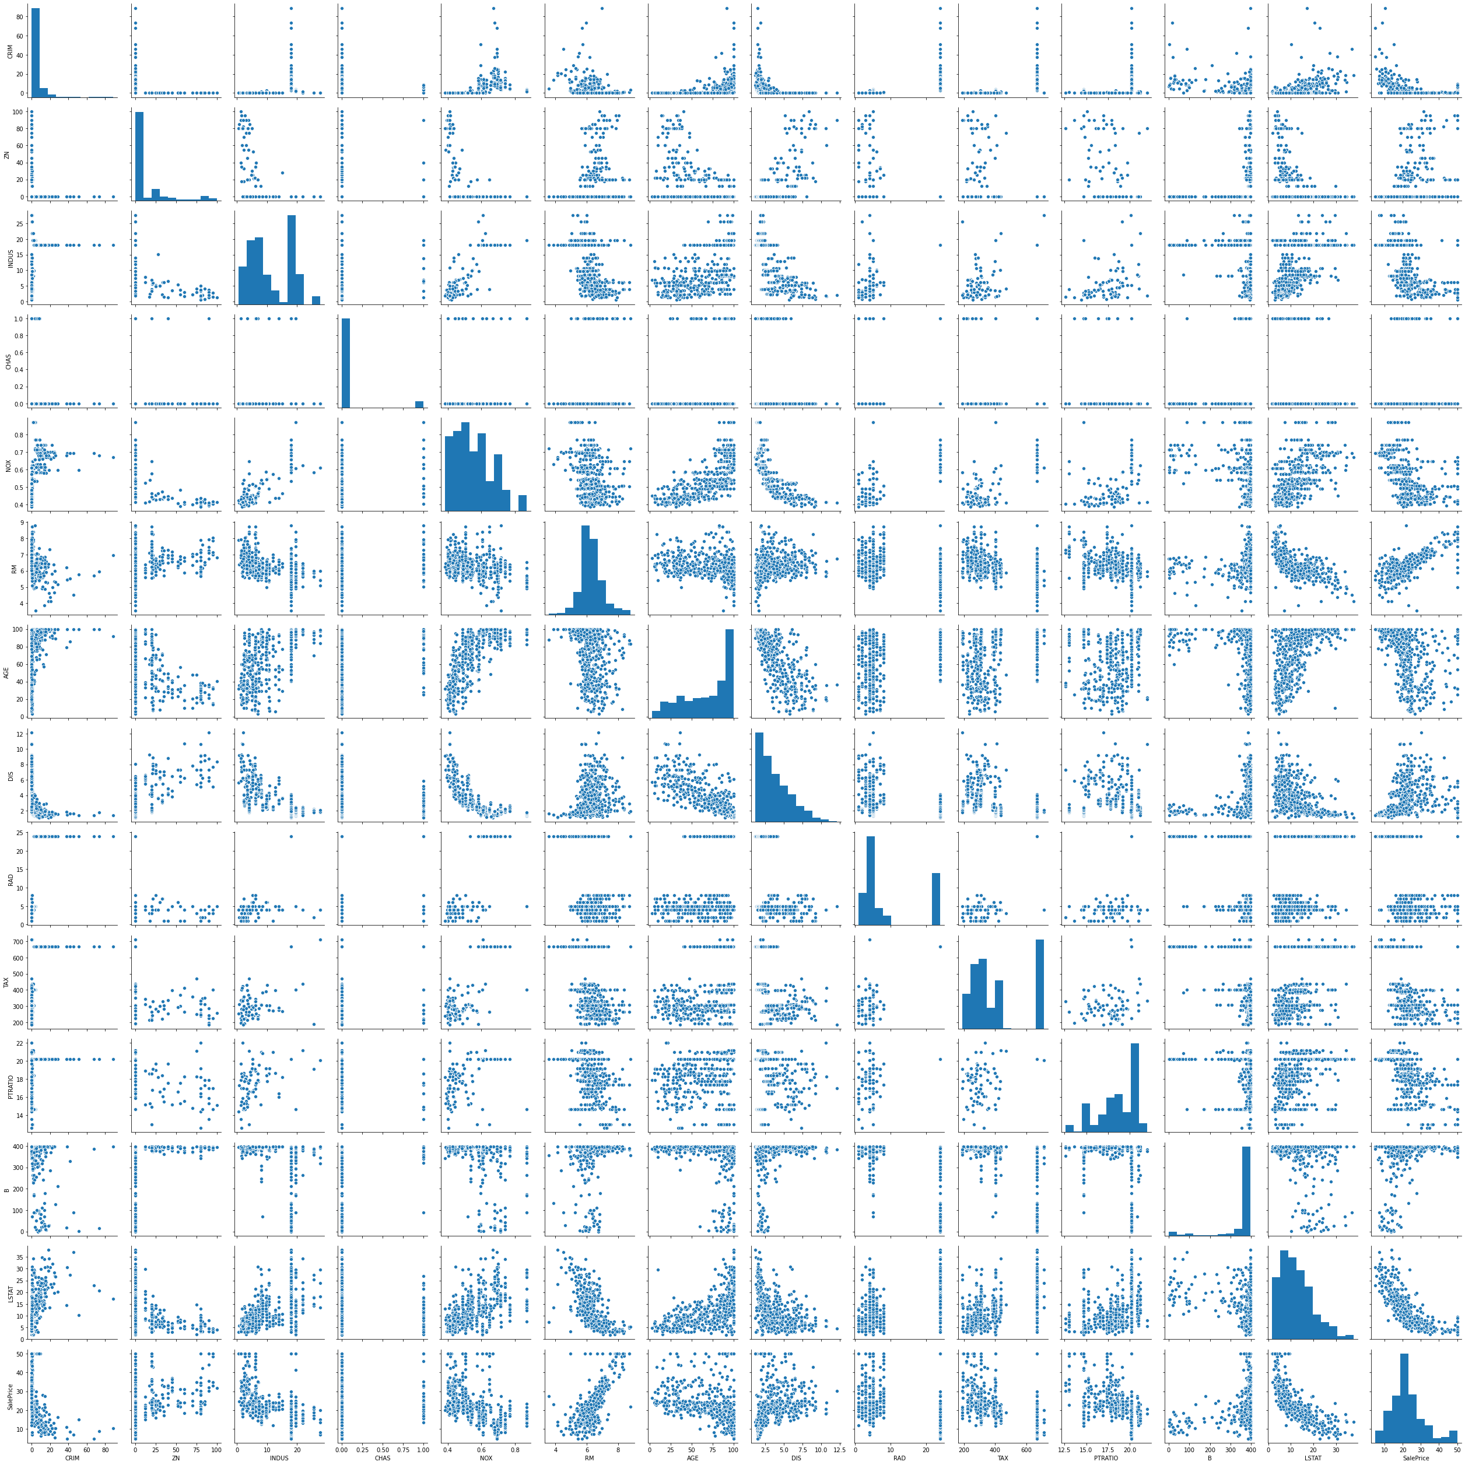
In [15]:
sns.distplot(data['SalePrice']);
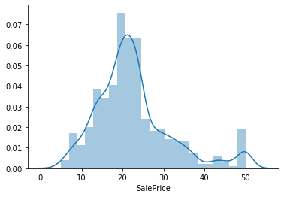
In [10]:
print("Skewness: %f" % data['SalePrice'].skew())
print("Kurtosis: %f" % data['SalePrice'].kurt())
Skewness: 1.108098
Kurtosis: 1.495197
In [11]:
fig, ax = plt.subplots()
ax.scatter(x = data['CRIM'], y = data['SalePrice'])
plt.ylabel('SalePrice', fontsize=13)
plt.xlabel('CRIM', fontsize=13)
plt.show()
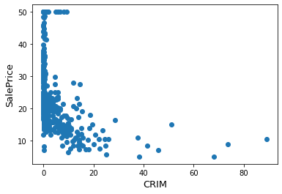
In [12]:
fig, ax = plt.subplots()
ax.scatter(x = data['AGE'], y = data['SalePrice'])
plt.ylabel('SalePrice', fontsize=13)
plt.xlabel('CRIM', fontsize=13)
plt.show()
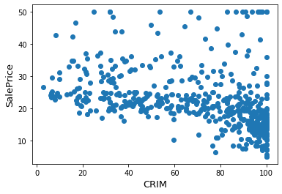
In [13]:
from scipy import stats
from scipy.stats import norm, skew #for some statistics

sns.distplot(data['SalePrice'] , fit=norm);

(mu, sigma) = norm.fit(data['SalePrice'])
print( '\n mu = {:.2f} and sigma = {:.2f}\n'.format(mu, sigma))

plt.legend(['Normal dist. ($\mu=$ {:.2f} and $\sigma=$ {:.2f} )'.format(mu, sigma)],
loc='best')
plt.ylabel('Frequency')
plt.title('SalePrice distribution')

#Get also the QQ-plot
fig = plt.figure()
res = stats.probplot(data['SalePrice'], plot=plt)
plt.show()
mu = 22.53 and sigma = 9.19

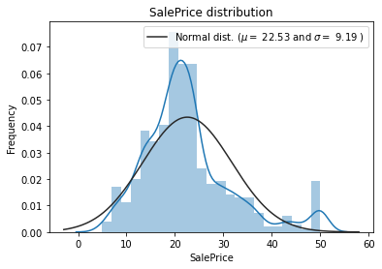
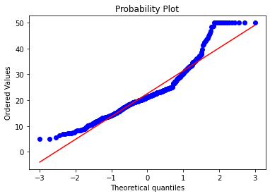
In [14]:
data["SalePrice"] = np.log1p(data["SalePrice"])

sns.distplot(data['SalePrice'] , fit=norm);

(mu, sigma) = norm.fit(data['SalePrice'])
print( '\n mu = {:.2f} and sigma = {:.2f}\n'.format(mu, sigma))

plt.legend(['Normal dist. ($\mu=$ {:.2f} and $\sigma=$ {:.2f} )'.format(mu, sigma)],
loc='best')
plt.ylabel('Frequency')
plt.title('SalePrice distribution')

fig = plt.figure()
res = stats.probplot(data['SalePrice'], plot=plt)
plt.show()
mu = 3.09 and sigma = 0.39

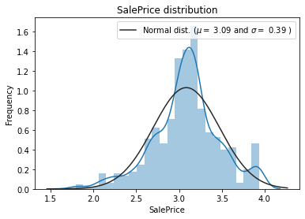
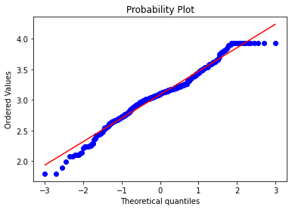

Data Correlation
In [15]:
plt.figure(figsize=(10,10))
cor = data.corr()
sns.heatmap(cor, annot=True, cmap=plt.cm.PuBu)
plt.show()
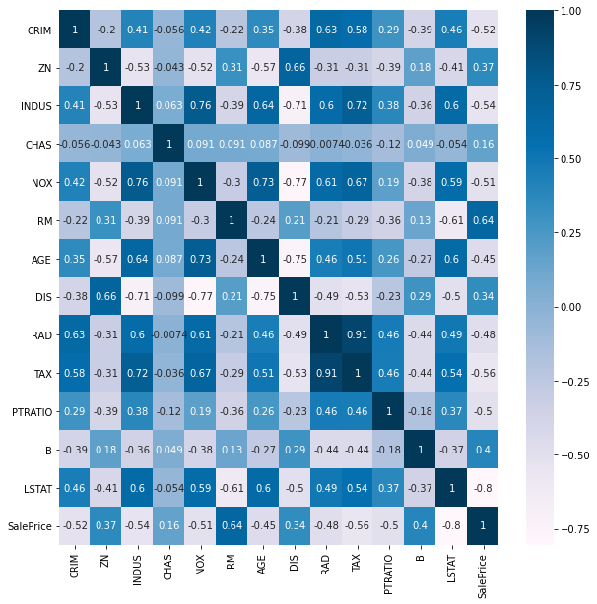
In [16]:
cor_target = abs(cor["SalePrice"]) # absolute value of the correlation

relevant_features = cor_target[cor_target>0.2] # highly correlated features

names = [index for index, value in relevant_features.iteritems()] # getting the names of the features

names.remove('SalePrice') # removing target feature

print(names) # printing the features
print(len(names))
['CRIM', 'ZN', 'INDUS', 'NOX', 'RM', 'AGE', 'DIS', 'RAD', 'TAX', 'PTRATIO', 'B', 'LSTAT']
12

Model Building
In [17]:
from sklearn.model_selection import train_test_split

X = data.drop("SalePrice", axis=1)
y = data["SalePrice"]
X_train, X_test, y_train, y_test = train_test_split(X,y,test_size=0.2,random_state=42)
In [18]:
print(X_train.shape)
print(X_test.shape)
print(y_train.shape)
print(y_test.shape)
(404, 13)
(102, 13)
(404,)
(102,)
In [19]:
from sklearn.linear_model import LinearRegression

lr = LinearRegression()
lr.fit(X_train, y_train)
Out[19]:
LinearRegression()
In [20]:
predictions = lr.predict(X_test)

print("Actual value of the house:- ", y_test[0])
print("Model Predicted Value:- ", predictions[0])
Actual value of the house:- 3.2188758248682006
Model Predicted Value:- 3.366894979996961
In [22]:
from sklearn.metrics import mean_squared_error

mse = mean_squared_error(y_test, predictions)
rmse = np.sqrt(mse)
print(rmse)
0.1879584328924155

Spam/Ham Detector System 📚
Natural Language Processing real world problem:-
In this notebook, I have prepared a Spam and Ham detector system that classified a text as a spam and ham.
In [1]:
import pandas as pd
import numpy as np

import seaborn as sns
import matplotlib.pyplot as plt
%matplotlib inline
In [2]:
# loading the data

data = pd.read_table("smsspamcollection/SMSSpamCollection",
sep="\t",
header=None,
names=["label", "messages"])
data.head()
Out[2]:
 | label | messages
0 | ham | Go until jurong point, crazy.. Available only ...
1 | ham | Ok lar... Joking wif u oni...
2 | spam | Free entry in 2 a wkly comp to win FA Cup fina...
3 | ham | U dun say so early hor... U c already then say...
4 | ham | Nah I don't think he goes to usf, he lives aro...
In [5]:
# exploring the data

def explore_data(df):
'''
Function for exploring the data
'''
print("Shape of the data:- ", df.shape)
print('======================================================')
print("Non of Null values:- ", df.isnull().sum().sum())
print('======================================================')
print("Information about the data:- ", df.info())
print('======================================================')
print("Describing the data:- ", df.describe())
print('======================================================')

explore_data(data)
Shape of the data:- (5572, 2)
======================================================
Non of Null values:- 0
======================================================
<class 'pandas.core.frame.DataFrame'>
RangeIndex: 5572 entries, 0 to 5571
Data columns (total 2 columns):
# Column Non-Null Count Dtype
--- ------ -------------- -----
0 label 5572 non-null object
1 messages 5572 non-null object
dtypes: object(2)
memory usage: 87.2+ KB
Information about the data:- None
======================================================
Describing the data:- label messages
count 5572 5572
unique 2 5169
top ham Sorry, I'll call later
freq 4825 30
======================================================

Exploratory data analysis
In [4]:
# seeing the distribution of classes, this will help us to identify which types

len_ham = len(data["label"][data.label == "ham"])
len_spam = len(data["label"][data.label == "spam"])

arr = np.array([len_ham , len_spam])
labels = ['ham', 'spam']
print("Total No. Of Ham Cases :- ", len_ham)
print("Total No. Of Spam Cases :- ", len_spam)

plt.pie(arr, labels=labels, explode = [0.2,0.0] , shadow=True)
plt.show()
Total No. Of Ham Cases :- 4825
Total No. Of Spam Cases :- 747
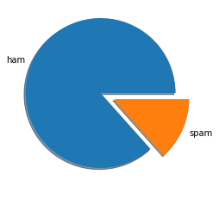

Text Preprocessing
In [6]:
def text_preprocess(x):
x = str(x).lower()
x = x.replace(",000,000", "m").replace(",000", "k").replace("′", "'").replace("’", "'")\
.replace("won't", "will not").replace("cannot", "can not").replace("can't", "can not")\
.replace("n't", " not").replace("what's", "what is").replace("it's", "it is")\
.replace("'ve", " have").replace("i'm", "i am").replace("'re", " are")\
.replace("he's", "he is").replace("she's", "she is").replace("'s", " own")\
.replace("%", " percent ").replace("₹", " rupee ").replace("$", " dollar ")\
.replace("€", " euro ").replace("'ll", " will")
return x

data["Preprocessed Text"] = data["messages"].apply(lambda x: text_preprocess(x))
data.head()
Out[6]:
 | label | messages | Preprocessed Text
0 | ham | Go until jurong point, crazy.. Available only ... | go until jurong point, crazy.. available only ...
1 | ham | Ok lar... Joking wif u oni... | ok lar... joking wif u oni...
2 | spam | Free entry in 2 a wkly comp to win FA Cup fina... | free entry in 2 a wkly comp to win fa cup fina...
3 | ham | U dun say so early hor... U c already then say... | u dun say so early hor... u c already then say...
4 | ham | Nah I don't think he goes to usf, he lives aro... | nah i do not think he goes to usf, he lives ar...
In [7]:
print(data['messages'][0])
print('================================================')
print(data['Preprocessed Text'][0])
Go until jurong point, crazy.. Available only in bugis n great world la e buffet... Cine there got amore wat...
================================================
go until jurong point, crazy.. available only in bugis n great world la e buffet... cine there got amore wat...

Feature Engineering
In [8]:
data["label"] = data.label.map({'ham':0, 'spam':1})

Data Development
In [23]:
from sklearn.model_selection import train_test_split

X_train, X_test, y_train, y_test = train_test_split(data['Preprocessed Text'],
data['label'],
random_state=1)

print('Number of rows in the total set: {}'.format(data.shape[0]))
print('Number of rows in the training set: {}'.format(X_train.shape[0]))
print('Number of rows in the test set: {}'.format(X_test.shape[0]))
Number of rows in the total set: 5572
Number of rows in the training set: 4179
Number of rows in the test set: 1393
In [24]:
from sklearn.feature_extraction.text import CountVectorizer
# Instantiate the CountVectorizer method
count_vector = CountVectorizer()

# Fit the training data and then return the matrix
training_data = count_vector.fit_transform(X_train)

# Transform testing data and return the matrix. Note we are not fitting the testing data into the CountVectorizer()
testing_data = count_vector.transform(X_test)

Model Development
In [25]:
from sklearn.naive_bayes import MultinomialNB
naive_bayes = MultinomialNB()
naive_bayes.fit(training_data, y_train)

# read more about Naive Bayes:- https://en.wikipedia.org/wiki/Naive_Bayes_classifier
Out[25]:
MultinomialNB()
In [26]:
predictions = naive_bayes.predict(testing_data)
predictions
Out[26]:
array([0, 0, 0, ..., 0, 1, 0], dtype=int64)
In [27]:
from sklearn.metrics import accuracy_score, precision_score, recall_score, f1_score
print('Accuracy score: ', format(accuracy_score(y_test, predictions)))
print('Precision score: ', format(precision_score(y_test, predictions)))
print('Recall score: ', format(recall_score(y_test, predictions)))
print('F1 score: ', format(f1_score(y_test, predictions)))
Accuracy score: 0.9877961234745154
Precision score: 0.9719101123595506
Recall score: 0.9351351351351351
F1 score: 0.953168044077135
In [28]:
doc = pd.Series("This is the 2nd time we have tried 2 contact u...")
test = count_vector.transform(doc)
In [29]:
naive_bayes.predict(test)
Out[29]:
array([0], dtype=int64)

