Python Tutorial for Beginners – Learn Python Programming
Welcome to the World of Python. Are you eager to know and learn Python – The Most Powerful and Popular Programming Langauge? Then start with this Python Tutorial now.
Here is a quick overview of what you are going to learn today in this Python Introduction-

- Python History
- Features of Python
- Applications of Python
- Architecture and Working of Python
- Python Constructs
Do not forget to check frequently asked interview questions from this topic at the end.

What is Python?

Python is a General Purpose object-oriented programming language, which means that it can model real-world entities. It is also dynamically-typed because it carries out type-checking at runtime.
It does so to make sure that the type of construct matches what we expect it to be.
The distinctive feature of Python is that it is an interpreted language.
The Python IDLE (Integrated Development Environment) executes instructions one line at a time. This also lets us use it as a calculator.

Why is it called Python?
Guido van Rossum named it after the comedy group Monty Python. That is why the metasyntactic variables (those we will often use to explain code syntax) used here are ‘spam’ and ‘eggs’ instead of ‘foo’ and ‘bar’.

History of Python
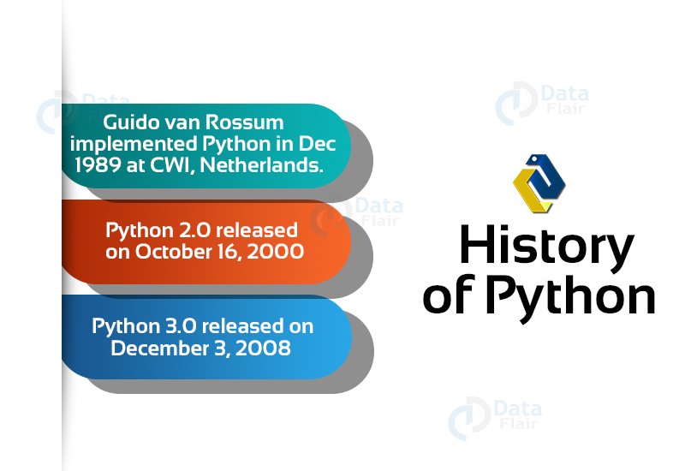
- Python was conceived in the late 1980s and was named after the BBC TV show Monty Python’s Flying Circus.
- Guido van Rossum started implementing Python at CWI in the Netherlands in December of 1989.
- This was a successor to the ABC programming language which was capable of exception handling and interfacing with the Amoeba operating system.
- On October 16 of 2000, Python 2.0 released with many new features.
- Then Python 3.0 released on December 3, 2008.

Why Learn Python?
Python is the “most powerful language you can still read”, Says Paul Dubois
Python is one of the richest Programming languages.
Going by the TIOBE Index, it is the Second Most Popular Programming Language in the world.
This makes a career in Python a great choice.

Python Features
Let us now see various features of Python that make it so powerful and popular:
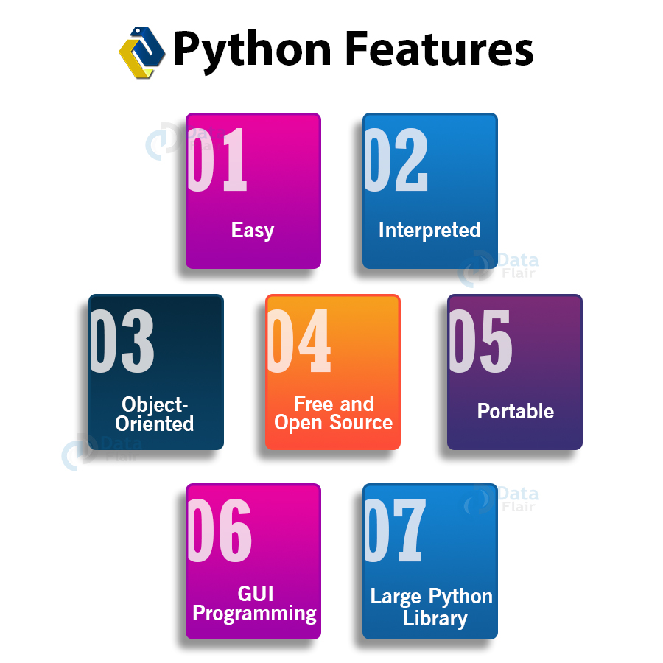
a. Easy
Python is very easy to learn and understand; any beginner can learn Python easily. When writing code in Python, you need fewer lines of code compared to languages like Java.
b. Interpreted
It is interpreted(executed) line by line. This makes it easy to test and debug.
c. Object-Oriented
The Python programming language supports classes and objects and hence it is object-oriented.
d. Free and Open Source
The language and its source code are available to the public for free; there is no need to buy a costly license.
e. Portable
Since Python is open-source, you can run it on Windows, Mac, Linux or any other platform. Your programs will work without any need to change it for every machine.
f. GUI Programming
You can use it to develop a GUI (Graphical User Interface). One way to do this is through Tkinter.
g. Large Python Library
Python provides you with a large standard library.
You can use it to implement a variety of functions without the need to reinvent the wheel every time. Just pick the code you need and continue.
In this Python tutorial, we have provided a short description. You must read them in detail at Python Programming Features

Applications of Python
Python is easy to pick-up even if you come from a non-programming background. You can look at the code and tell what’s going on.
Talking of Python applications, some of the cool things that you can do are –
- Build a website using Python
- Develop a game in Python
- Perform Computer Vision (Facilities like face-detection and color-detection)
- Implement Machine Learning (Give a computer the ability to learn)
- Enable Robotics with Python
- Perform Web Scraping (Harvest data from websites)
- Perform Data Analysis using Python
- Automate a web browser
- Perform Scripting in Python
- Perform Scientific Computing using Python
- Build Artificial Intelligence
Python isn’t limited to these applications. If you’ve ever used services from brands like YouTube, Dropbox, and Netflix, then you’ve been a consumer of Python.
The search-engine Google also made great use of this language in its initial stages.

Python Architecture and Working
Let’s now talk about Python architecture and its usual flow –
a. Parser
It uses the source code to generate an abstract syntax tree.
b. Compiler
It turns the abstract syntax tree into Python bytecode.
c. Interpreter
It executes the code line by line in a REPL (Read-Evaluate-Print-Loop) fashion.

Python Constructs

a. Functions in Python
A function in Python is a collection of statements grouped under a name. You can use it whenever you want to execute all those statements at a time.
You can call it wherever you want and as many times as you want in a program. A function may return a value.

b. Classes in Python
As we discussed earlier, Python is an object-oriented language. It supports classes and objects.
A class is an abstract data type. In other words, it is a blueprint for an object of a certain kind. It holds no values.
An object is a real-world entity and an instance of a class.

c. Modules in Python
Python module is a collection of related classes and functions.
We have modules for mathematical calculations, string manipulations, web programming, and many more.

d. Packages in Python
Python package is a collection of related modules. You can either import a package or create your own.

e. List in Python
You can think of a list as a collection of values. Declared in the CSV (Comma-Separated Values) format and delimit using square brackets:
life = [‘love’, ‘wisdom’, ‘anxiety’];
arity = [1,2,3];
Notice that we do not declare the type for the list either. A list may also contain elements of different types, and the indexing begins at 0:
person = [‘firstname’, 21];
print(person[1])
Output: 21
You can also slice lists; slicing is a way of retrieving some values from it. We will learn more about it in further lessons.

f. Tuple in Python
A tuple is like a list, but it is immutable (you cannot change its values).
pizza = (‘base’, ‘sauce’, ‘cheese’, ‘mushroom’);
pizza[3] = ‘jalapeno’
This raises a TypeError.

g. Dictionary in Python
A dictionary is a collection of key-value pairs. Declare it using curly braces, and commas to separate key-value pairs.
Also, separate values from keys using a colon (:).
student = {‘Name’: ‘Abc’, ‘Age’: 21}
print(student[‘Age’])
Output: 21

h. Comments and Docstrings in Python
Declare comments using an octothorpe (#). However, Python does not support multiline comments.
Docstrings are documentation strings that help explain the code.
#This is a comment
“““
This is a docstring
”””
Python has a lot of other constructs. These include control structures, functions, exceptions, etc.
Interested in learning python in detail? Just follow the sidebar and learn Python completely.

Python Interview Questions for Beginners
Below are some of the frequently asked Python Interview questions from this tutorial:
- How does Python get its name?
- What are the Features of Python that make it so popular?
- Define Modules in Python?
- What is the difference between List and Tuple in Python?
- Compare Python with Java
Summary
This was all about Python Tutorial where you learnt what is python, why python is so powerful, what are the applications of Python and basic architecture and constructs of python.

Advantages and Disadvantages of Python – How it is dominating Programming World
In this DataFlair’s tutorial, you will learn the advantages and disadvantages of Python. This will help you in knowing the benefits of learning the Python programming language.

Python Advantages and Disadvantages
Let’s first discuss what advantages Python provides to its users.

Advantages of Python
Let’s see how Python dominates over other languages.

1. Extensive Libraries
Python downloads with an extensive library and contains code for various purposes like regular expressions, documentation-generation, unit-testing, web browsers, threading, databases, CGI, email, image manipulation, and more.
So, we don’t have to write the complete code for that manually.

2. Extensible
Python can be extended to other languages. You can write some of your code in languages like C++ or C.
This comes in handy, especially in projects.

3. Embeddable
Complimentary to extensibility, Python is embeddable as well. You can put your Python code in your source code of a different language, like C++.
This lets us add scripting capabilities to our code in the other language.

4. Improved Productivity
The language’s simplicity and extensive libraries render programmers more productive than languages like Java and C++ do.
Also, the fact that you need to write less and get more things done.

5. IOT Opportunities
Since Python forms the basis of new platforms like Raspberry Pi, it finds the future bright for the Internet Of Things.
This is a way to connect the language with the real world.

6. Simple and Easy
When working with Java, you may have to create a class to print ‘Hello World’. But in Python, just a print statement will do.
It is also quite easy to learn, understand, and code.

7. Readable
Because it is not such a verbose language, reading Python is much like reading English. This is the reason why it is so easy to learn, understand, and code.
It also does not need curly braces to define blocks, and indentation is mandatory. This further aids the readability of the code.

8. Object-Oriented
This language supports both the procedural and object-oriented programming paradigms.
While functions help us with code reusability, classes and objects let us model the real world.
A class allows the encapsulation of data and functions into one.

9. Free and Open-Source
Python is freely available. But not only can you download Python for free, but you can also download its source code, make changes to it, and even distribute it.
It downloads with an extensive collection of libraries to help you with your tasks.

10. Portable
When you code your project in a language like C++, you may need to make some changes to it if you want to run it on another platform.
But it isn’t the same with Python. Here, you need to code only once, and you can run it anywhere.
This is called Write Once Run Anywhere (WORA). However, you need to be careful enough not to include any system-dependent features.

11. Interpreted
Lastly, we will say that it is an interpreted language. Since statements are executed one by one, debugging is easier than in compiled languages.
Any doubts till now in the advantages of Python? Mention in the comment section.
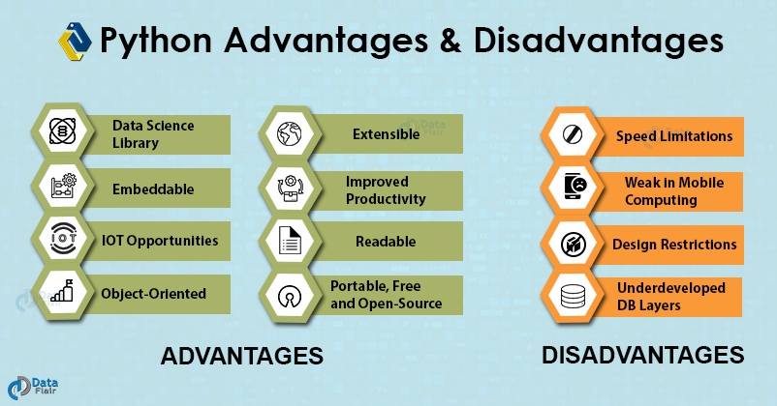

Advantages of Python Over Other Languages

1. Less Coding
Almost all of the tasks done in Python requires less coding when the same task is done in other languages.
Python also has awesome standard library support, so you don’t have to search for any third-party libraries to get your job done.
This is the reason that many people suggest learning Python to beginners.

2. Affordable
Python is free therefore individuals, small companies or big organizations can leverage the free available resources to build applications.
Python is popular and widely used so it gives you better community support.
The 2019 Github annual survey showed us that Python has overtaken Java in the most popular programming language category.

3. Python is for Everyone
Python code can run on any machine whether it is Linux, Mac or Windows.
Programmers need to learn different languages for different jobs but with Python, you can professionally build web apps, perform data analysis and machine learning, automate things, do web scraping and also build games and powerful visualizations.
It is an all-rounder programming language.

Disadvantages of Python
So far, we’ve seen why Python is a great choice for your project. But if you choose it, you should be aware of its consequences as well.
Let’s now see the limitations of Python over another language.

1. Speed Limitations
We have seen that Python code is executed line by line. But since Python is interpreted, it often results in slow execution.
This, however, isn’t a problem unless speed is a focal point for the project.

2. Weak in Mobile Computing and Browsers
While it serves as an excellent server-side language, Python is much rarely seen on the client-side.
Besides that, it is rarely ever used to implement smartphone-based applications. One such application is called Carbonnelle.
The reason it is not so famous despite the existence of Brython is that it isn’t that secure.

3. Design Restrictions
As you know, Python is dynamically-typed. This means that you don’t need to declare the type of variable while writing the code.
It uses duck-typing. But wait, what’s that? Well, it just means that if it looks like a duck, it must be a duck.
While this is easy on the programmers during coding, it can raise run-time errors.

4. Underdeveloped Database Access Layers
Compared to more widely used technologies like JDBC (Java DataBase Connectivity) and ODBC (Open DataBase Connectivity), Python’s database access layers are a bit underdeveloped.
Consequently, it is less often applied in huge enterprises.

5. Simple
No, we’re not kidding. Python’s simplicity can indeed be a problem. Take my example. I don’t do Java, I’m more of a Python person.
To me, its syntax is so simple that the verbosity of Java code seems unnecessary.
This was all about the Advantages and Disadvantages of Python Programming Language.

Summary
Concluding the tutorial on advantages and disadvantages of Python, I would say while there are some speed, security, and runtime issues, Python is a great language to pick up.
Its popularity speaks for itself. And this popularity is attributed to its being free, easy, interpreted, object-oriented, extensible, embeddable, portable, and readable.
Now!! as you are well aware with the advantages and disadvantages of Python, it’s time to know the real-time applications of Python.

Python Applications – Unleash the power of Python
Since the last few days, I was continuously thinking why Python is one of the most used programming languages on this planet? Then I started researching on it at different platforms, and can you guess what I found after my research?
Python is the most versatile language in the programming world, and it has applications in various domains. It helps us in taking care of our current programming task as well as lets us focus on the core functionality of Python programming languages.
Talking about this Python applications tutorial, it will help both beginners and intermediates in learning and polishing their coding skills.

Applications of Python
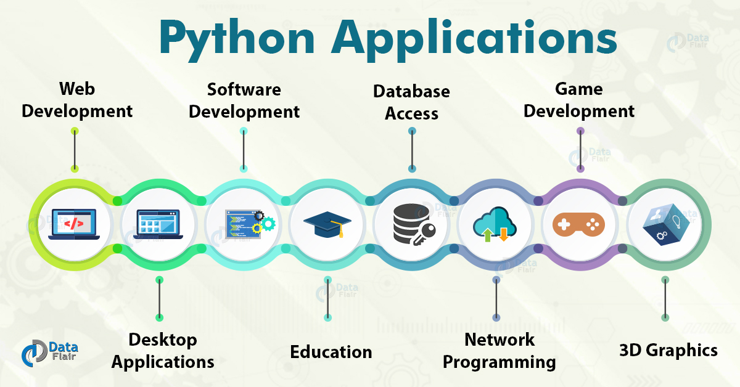These are some real-world Python applications:
- Web and Internet Development
- Desktop GUI Applications
- Science and Numeric
- Software Development
- Education
- Database Access
- Network Programming
- Games and 3D Graphics
Let’s discuss each of them in detail:

1. Web and Internet Development
Python lets you develop a web application without too much trouble. It has libraries for internet protocols like HTML and XML, JSON, e-mail processing, FTP, IMAP, and easy-to-use socket interface. Yet, the package index has more libraries:
- Requests – An HTTP client library
- BeautifulSoup – An HTML parser
- Feedparser – For parsing RSS/Atom feeds
- Paramiko – For implementing the SSH2 protocol
- Twisted Python – For asynchronous network programming
We also have a gamut of frameworks available. Some of these are- Django, Pyramid. We also get microframeworks like flask and bottle. We’ve discussed these in our write-up on an Introduction to Python Programming. We can also write CGI scripts, and we get advanced content management systems like Plone and Django CMS.

2. Desktop GUI Applications
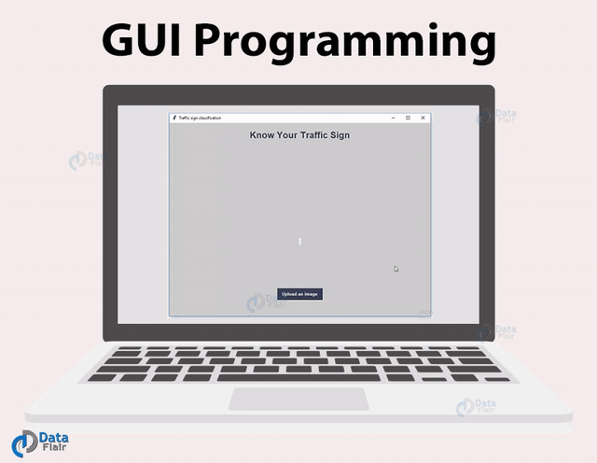
Most binary distributions of Python ship with Tk, a standard GUI library. It lets you draft a user interface for an application. Apart from that, some toolkits are available:
- wxWidgets
- Kivy – for writing multitouch applications
- Qt via pyqt or pyside
And then we have some platform-specific toolkits:
GTK+
- Microsoft Foundation Classes through the win32 extensions
- Delphi

3. Science and Numeric Applications
This is one of the widespread applications of Python programming. With its power, it comes as no surprise that Python finds its place in the scientific community. For this, we have:
- SciPy – A collection of packages for mathematics, science, and engineering.
- Pandas– A data-analysis and -modeling library
- IPython – A powerful shell for easy editing and recording of work sessions. It also supports visualizations and parallel computing.
- Also, NumPy enables us to deal with complex numerical calculations.

4. Software Development
Software developers make use of Python as a support language. They use it for build-control and management, testing, and for a lot of other things:
- SCons – for build-control
- Buildbot, Apache Gump – for automated and continuous compilation and testing
- Roundup, Trac – for project management and bug-tracking.
- The roster of Integrated Development Environments

5. Education
Thanks to its simplicity, brevity, and large community, Python makes for a great introductory programming language. Applications of Python programming in education has a huge scope as it is a great language to teach in schools or even learn on your own.

6. Business
Python is also a great choice to develop ERP and e-commerce systems:
- Tryton – A three-tier, high-level, general-purpose application platform.
- Odoo – A management software with a range of business applications. With that, it’s an all-rounder and forms a complete suite of enterprise-management applications in-effect.

7. Database Access
With Python, you have:
- Custom and ODBC interfaces to MySQL, Oracle, PostgreSQL, MS SQL Server, and others. These are freely available for download.
- Object databases like Durus and ZODB
- Standard Database API

8. Network Programming
With all those possibilities, how would Python slack in network programming? It does provide support for lower-level network programming:
- Twisted Python – A framework for asynchronous network programming. We mentioned it in section 2.
- An easy-to-use socket interface

9. Games and 3D Graphics
Safe to say, this one is the most interesting. When people hear someone say they’re learning Python, the first thing they get asked is – ‘So, did you make a game yet?’
PyGame, PyKyra are two frameworks for game development with Python. Apart from this, we also get a variety of 3D-rendering libraries.
If you’re one of those game-developers, you can check out PyWeek, a semi-annual game programming contest.

10. Artificial Intelligence and Machine Learning
The IT industry went far beyond science fiction ideas, and our future is moving towards Artificial Intelligence. People are keen to move to technologies where machines can mimic human behaviors, and machines are automating most of the human work. There is also a need to process and analyze huge volumes of data.
Statistically speaking that Python is the most popular language for Artificial intelligence and Machine Learning.
The several libraries and frameworks for Artificial intelligence are listed below.
- Tensorflow
- Scikit-learn
- NLTK
- Caffee
- PyTorch
- Keras
- Pandas
- Accord.NET

11. Prototyping
Programming in Python is easy when you compare it with other languages. It has easy syntax and it offers concise solutions for implementing all types of functionalities. This is the main reason why Python can be applied in prototyping stages of software development.
With many functionalities to offer, Python lets you develop a prototype of applications faster. Many organizations and firms use Python at the prototyping stage of a project.

Other Python Applications
These are some of the major Python Applications. Apart from what we just discussed, it still finds use in more places:
- Console-based Applications
- Audio or Video-based Applications
- Applications for Images
- Enterprise Applications
- 3D CAD Applications
- Computer Vision (Facilities like face-detection and color-detection)
- Machine Learning
- Robotics
- Web Scraping (Harvesting data from websites)
- Scripting
- Artificial Intelligence
- Data Analysis (The Hottest of Python Applications)

Summary
Now we know Python is everywhere and we have seen this in DataFlair’s Python Applications article. Moreover, we learned that the applications of Python lets us develop a web application without too much trouble; it helps to draft a user interface for an application.
And not so surprising that Python finds its place in the scientific community. We have also seen its application in education and business. We have learned how Python slack in network programming as well as we have thrown light on some more Python applications.
Time to see the reasons behind the limelight of Python in the healthcare sector.
If you liked our Python applications article, share it with your friends.

#simple program
# getting users name
print("Enter your name:")
name = input()
# Getting user's age
print("Enter your age:")
age = int(input())
#condition to check if user is eligible or not
if (age >= 18):
print(name, 'is eligible to vote.')
else:
print(name, 'is not eligible to vote\n')

# Back slash char
print("Hi\
How are you?")

# back slash number
a\
=\
10
print(a)

# triple quote string
print("""Hi\
How are you?""")

#function
def fun():
"""
This function prints out a greeting
"""
print("Hi")
print(fun())

#indentation
if 2 > 1:
print("2 is the bigger person");
print("But 1 is worthy too");

a = 15;print(a);

print('We need a chapter1');
print("We need a 'chapter1'");

#Python Identifiers
print("""\nPython Identifiers are:~\n* An identifier may only begin with A-Z, a-z, or an underscore(_).
* This may be followed by letters, digits, and underscores- zero or more.
* Python is case-sensitive. Name and name are two different identifiers.
* A reserved keyword may not be used as an identifier. """)

#Keywords
print("""\nPython Keywords are:~ \nassert, and, as, break, class, continue,
def, del, elif, else, except, exec, False, finally, for, from,
global, if, import, in, is, lambda, None, nonlocal, not, or,
pass, print, raise, return, True, try, while, with, yeild""");

#variables
x = 25
print(x)
x = 'Hello'
print(x)
x = 50; printer = "HP"
print("I just printed %s pages to the printer %s"% (x, printer))
print("I just printed {0} pages to the printer {1}".format (x, printer))
print("I just printed {x} pages to the printer {printer}".format (x = 25, printer = "Hp"))
print(f"I just printed {x} pages to the printer {printer}")
Result:~
linuxdeepa.my.lan@linuxdeepa:~/PycharmProjects/python_Hard_way/myPython> python3.6 s1_simple.py
Enter your name:
Deepa
Enter your age:
40
Deepa is eligible to vote.
Hi How are you?
10
Hi How are you?
Hi
2 is the bigger person
But 1 is worthy too
15
We need a chapter1
We need a 'chapter1'
Python Identifiers are:~
* An identifier may only begin with A-Z, a-z, or an underscore(_).
* This may be followed by letters, digits, and underscores- zero or more.
* Python is case-sensitive. Name and name are two different identifiers.
* A reserved keyword may not be used as an identifier.
Python Keywords are:~
assert, and, as, break, class, continue, def, del, elif, else, except, exec, False, finally, for, from, global, if, import, in, is, lambda, None, nonlocal, not, or,
pass, print, raise, return, True, try, while, with, yeild
25
Hello
I just printed 50 pages to the printer HP
I just printed 50 pages to the printer HP
I just printed 25 pages to the printer Hp
I just printed 50 pages to the printer HP
#mean and median
def mean_median(scores):
mean = sum(scores)/len(scores)
median = sorted(scores)[int(len(scores)/2)]
if median > mean : return True
return False
print(mean_median([3,4,3,2,9,7,11,12,13]))
print(mean_median([3,4,3,2,9,7,11,12,13,14,14]))
Result:~
linuxdeepa.my.lan@linuxdeepa:~/PycharmProjects/python_Hard_way/myPython> python3.6 s2_mean_media
n.py
False
True

#Area of Triangle
def triangle(base, height):
return(base * height *0.5)
print(triangle(3,4))
print(triangle(7,14))
print(triangle(10,10))
Result:~
linuxdeepa.my.lan@linuxdeepa:~/PycharmProjects/python_Hard_way/myPython> python3.6 s3_area_of_triangle.py
6.0
49.0
50.0

#Fibbanacci
def fib(length):
a, b, count = 0, 1, 0
while(count < length):
print(a, end = ', ');
count += 1;
a, b = b, a+b
print('...')
print(fib(-1))
print(fib(0))
print(fib(3))
print(fib(8))
Result:~
linuxdeepa.my.lan@linuxdeepa:~/PycharmProjects/python_Hard_way/myPython> python3.6 s4_fibanacci.py
...
None
...
None
0, 1, 1, ...
None
0, 1, 1, 2, 3, 5, 8, 13, ...
None
#Size of integer
def size(n):
count = 0
while(n > 1):
count += 1
n /= 10
return count
print(size(7))
print(size(1))
print(size(23))
print(size(423))
print(size(73546))
Result:~
linuxdeepa.my.lan@linuxdeepa:~/PycharmProjects/python_Hard_way/myPython> python3.6 s5_int_size.p
y
1
0
2
3
5
#Combat
def combat(n1, n2):
nums = (n1, n2)
while(n1 * n2 > 0):
diff = abs(n1 - n2)
if n1 > n2:
print(n1, "is greater than", n2)
n1 = n1 - diff - 1
else:print(n1, "is smaller than", n2);n2 = n2 - diff - 1
return nums[1] if n2 > n1 else nums[0]
print(combat(8, 6))
print(combat(8, 7))
Result:~
linuxdeepa.my.lan@linuxdeepa:~/PycharmProjects/python_Hard_way/myPython> python3.6 s6_combat.py
8 is greater than 6
5 is smaller than 6
5 is greater than 4
3 is smaller than 4
3 is greater than 2
1 is smaller than 2
8
8 is greater than 7
6 is smaller than 7
6 is greater than 5
4 is smaller than 5
4 is greater than 3
2 is smaller than 3
2 is greater than 1
7
Python Operator – Types of Operators in Python
In this Python Operator tutorial, we will discuss what is an operator in Python Programming Language.

# Perfect Square
import math
def next_perfect_square(num):
return (int(math.sqrt(num)+1)**2) if math.sqrt(num)%1 == 0 else "Not a perfect square itself"
print(next_perfect_square(0))
print(next_perfect_square(1))
print(next_perfect_square(3))
print(next_perfect_square(4))
Result:
1
4
Not a perfect square itself
9
# Remove vowels
def remove_vowels(string):
st=''
for letter in string:
if letter not in ['a', 'e', 'i', 'o', 'u']: st+=letter;
return st
print(remove_vowels('Deepa'))
print(remove_vowels('She was a pyramid'))
Result:
Dp
Sh ws pyrmd
#Sphere Volume
import math
def sphere_volume(radius):
return round(4/3*math.pi*radius**3,2)
print(sphere_volume(6))
print(sphere_volume(12.2))
Result:
904.78
7606.21
#Valid Password
def valid_password(password):
p = list(password)
if len(password)<6 or len(password)>12: return False
if not(any(j.isdigit() for j in p)): return False
if not(any(j in '$#@' for j in p)): return False
if not(any(j.isalpha() for j in p)): return False
return True
print(valid_password('abc'))
print(valid_password('ab6c'))
print(valid_password('ab6c!'))
print(valid_password('ab6c!#'))
Result:
False
False
False
True
We will learn different types of Python Operators: Arithmetic, Relational, Assignment, Logical, Membership, Identity, and Bitwise Operators with their syntax and examples.
So, let’s start the Python Operator Tutorial.
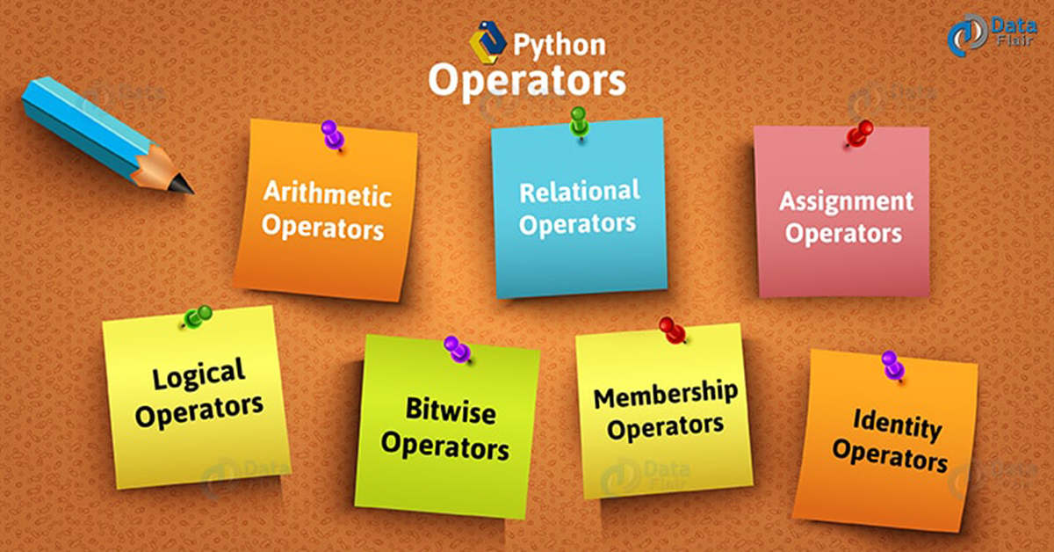

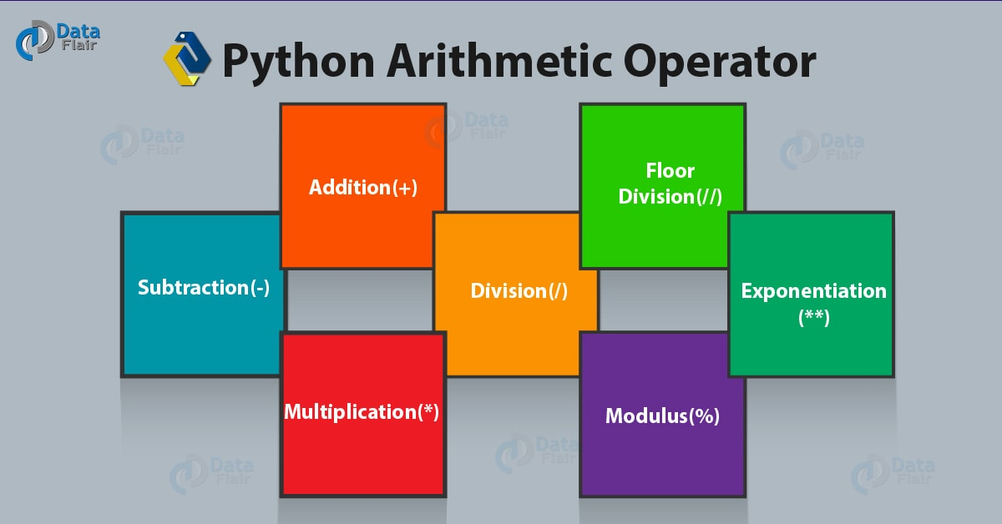

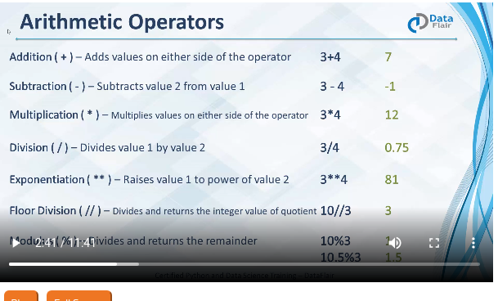
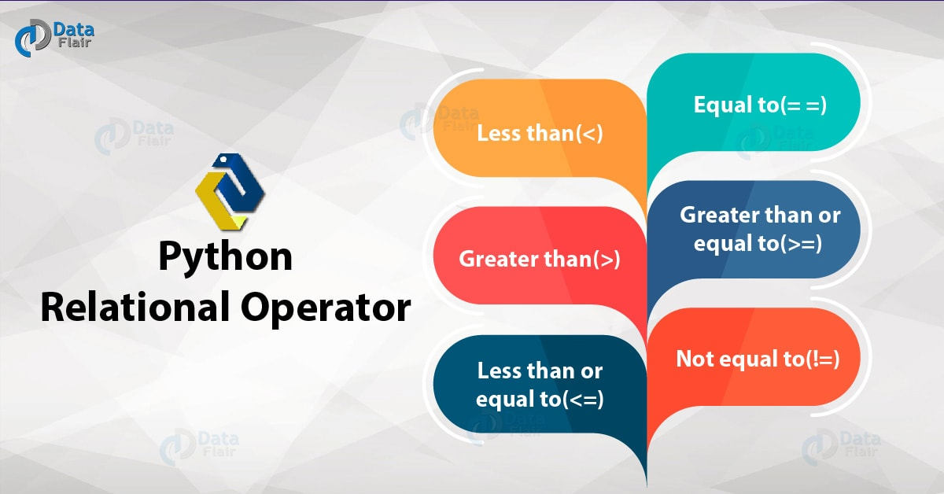

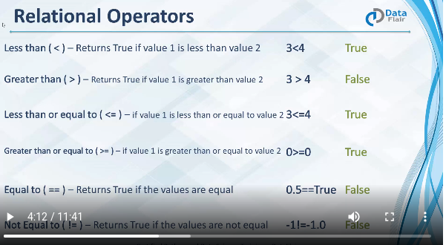

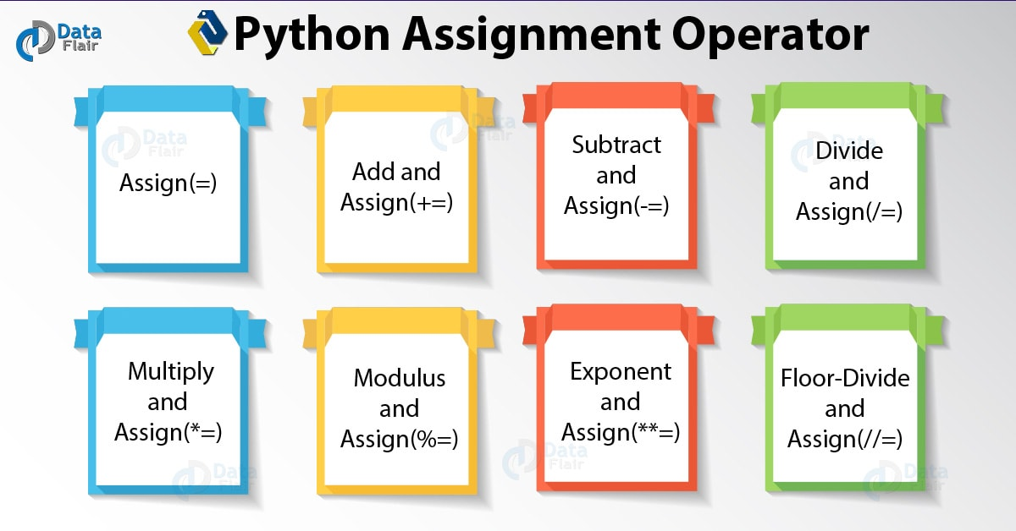

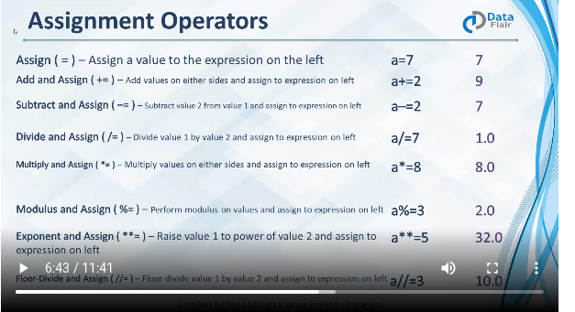

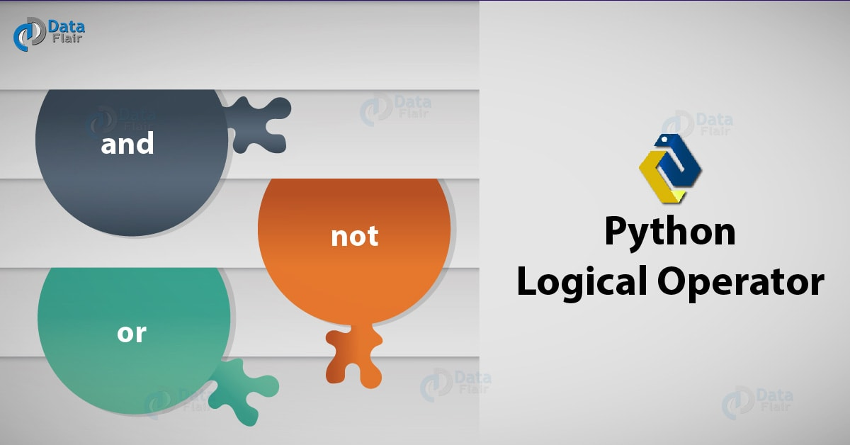

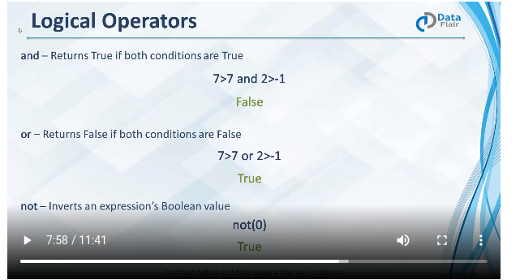

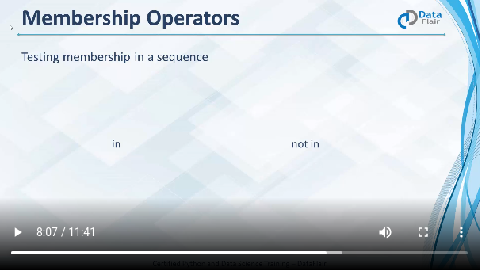

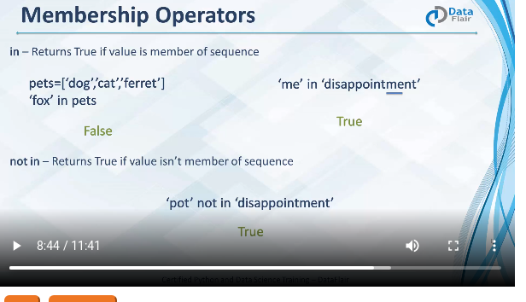

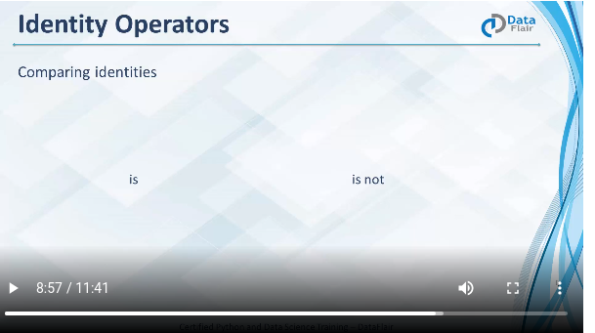

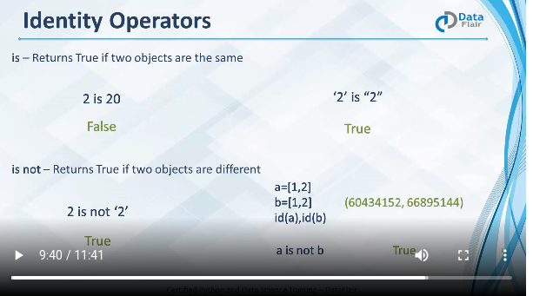

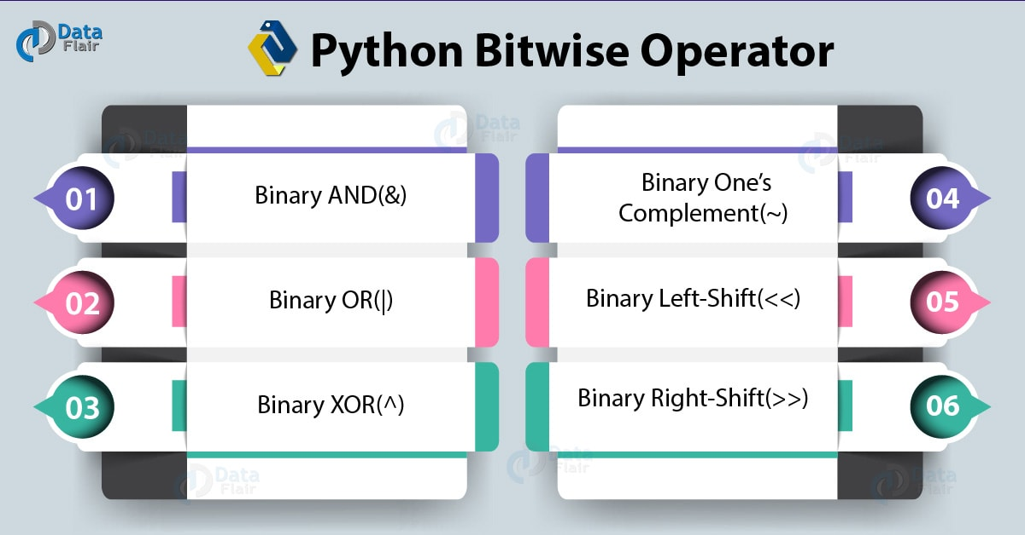
Bitwise Operators in Python

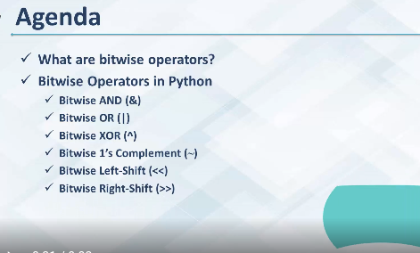

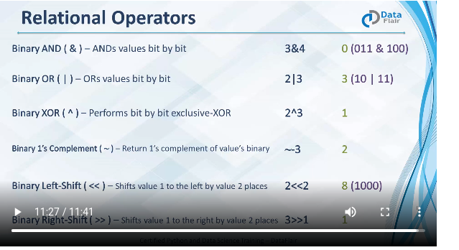

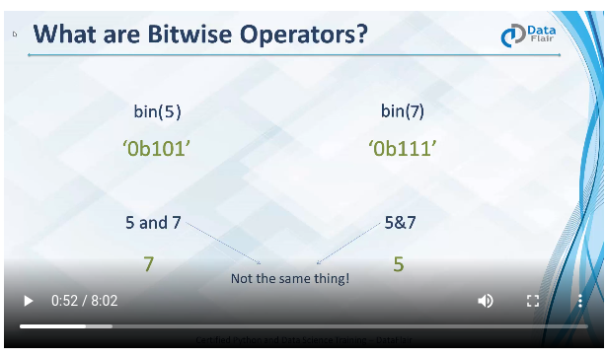

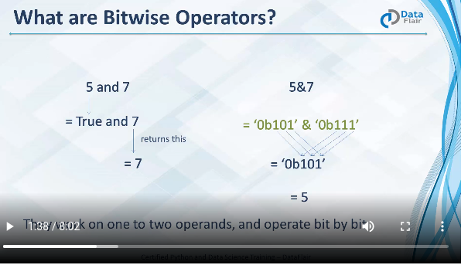

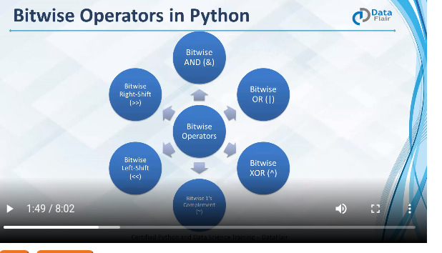

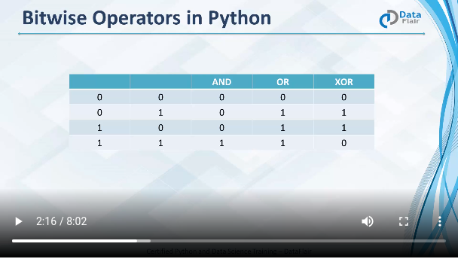

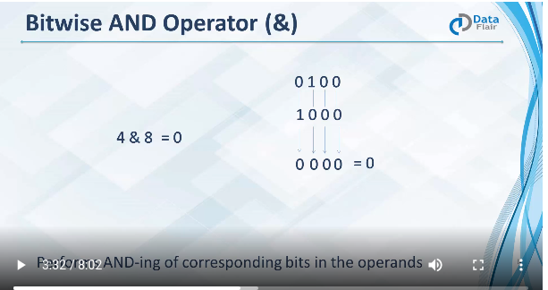

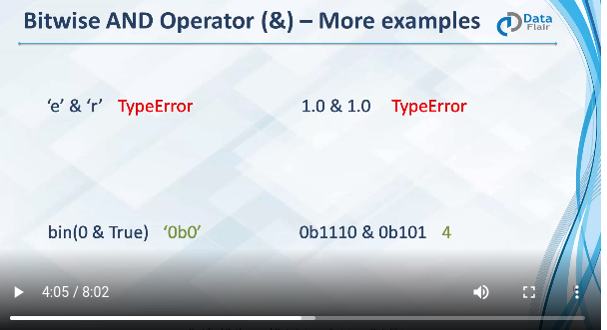

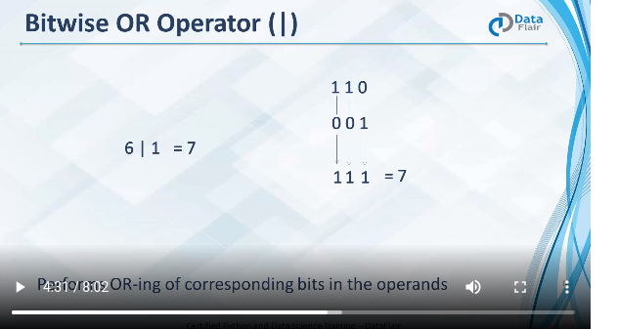

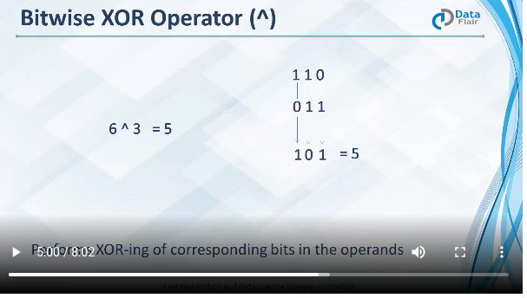

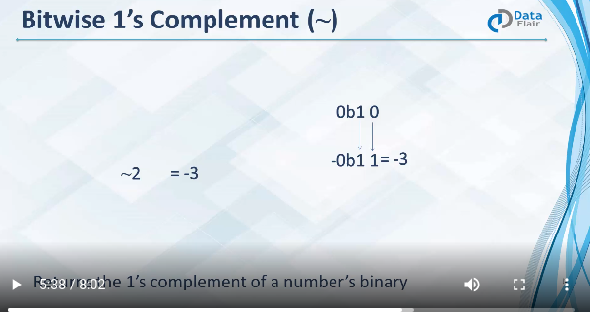

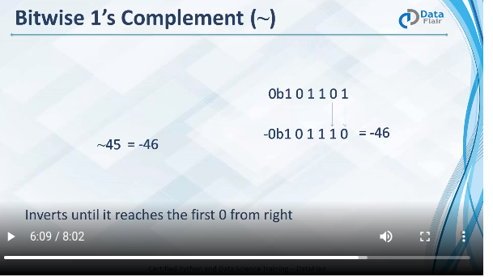
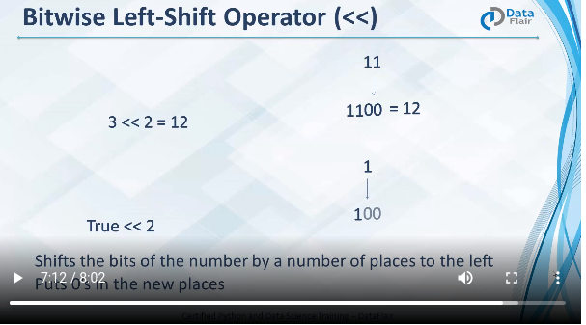

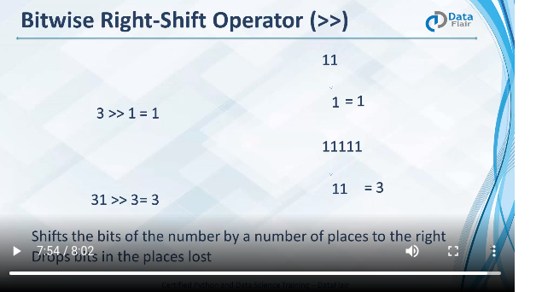
#Toggle Digits
def toggle(num, pos):
num^=(1<<pos)
return num
print(toggle(4,1))
print(toggle(4,2))
print(toggle(7,2))
Result:~
6
0
3
# Doubles
def doubles(n):
num = 3
for index in range(n):
num = eval(bin(num))<<1
print(num)
print(doubles(3))
print(doubles(5))
print(doubles(10))
Result:~
6
12
24
None
6
12
24
48
96
None
6
12
24
48
96
192
384
768
1536
3072
None
#Troubled Addition
def add(a, b):
return a-~b-1
print(add(3,7))
print(add(3,-7))
Result:~
10
-4

#Betwisw Swap
def betwise_swap(a, b):
a^=b #(a XOR b)
b^=a
a^=b
return a,b
print(betwise_swap(4, 21))
print(betwise_swap(41, 52))
Result:~
(21, 4)
(52, 41)
Comparision Operator:~
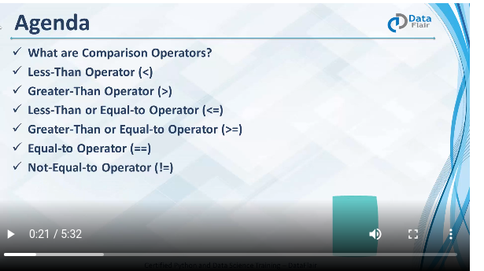

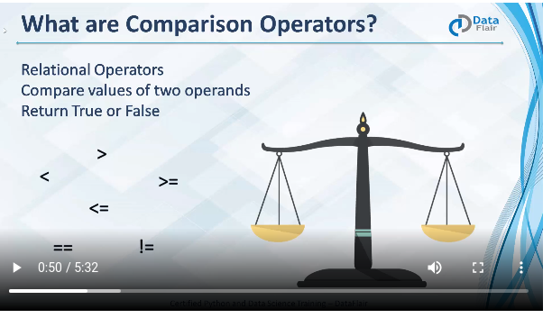

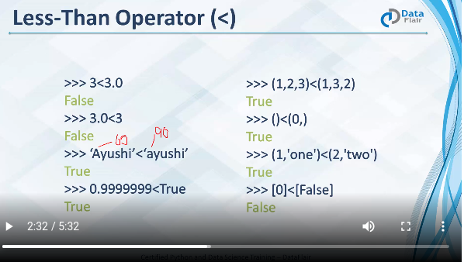
#Battle of numbers
def battle_of_numbers(numbers):
winner = numbers[0]
for num in numbers:
if num > winner: winner = num
return winner
print(battle_of_numbers([2,4,7,0,9,6]))
print(battle_of_numbers([1,5,8,3,0,6,7]))
print(battle_of_numbers([3,7,3,2,1]))
Result:~
9
8
7

#Anagrams
def anagrams(word1,word2):
return sorted(word1.lower()) == sorted(word2.lower())
print(anagrams('alert','alter'))
print(anagrams('alert','later'))
print(anagrams('alert','talor'))
print(anagrams('alert','alert'))
print(anagrams('alert','taler'))
Result:~
True
True
False
True
True

#the last digits
def last_digit(a,b,c):
return str(a*b)[-1] == str(c)[-1]
print(last_digit(13, 32, 226))
print(last_digit(55, 22, 729))
print(last_digit(755, 544, 0))
Result:~
True
False
True
#Tale of twins
def larger_twin(num):
return num >= int(str(num) [::-1])
print(larger_twin(73))
print(larger_twin(7))
print(larger_twin(132))
print(larger_twin(75))
print(larger_twin(5))
print(larger_twin(175))
Result:~
True
True
False
True
True
False
Operator Precedence


