
Coursera

Capstone Project Milestone Report

Data Science Specialization from Johns Hopkins University

Andrea Carpignani

19 February 2023

Initial Setup
To prepare the environment for this analysis let us first of all set up a directory where the project is going to be stored, and let us load the packages that we are going to use during this analysis.
setwd("~/Desktop/Coursera/Capstone Project/")
Let us also load all packages necessary:
library(RColorBrewer)
library(tidyr)
library(dplyr)
##
## Attaching package: 'dplyr'
## The following objects are masked from 'package:stats':
##
## filter, lag
## The following objects are masked from 'package:base':
##
## intersect, setdiff, setequal, union
library(ggplot2)
library(wordcloud)
library(stringr)
library(tm)
library(tidytext)

Load the Data
Let us now download the data from the original location at Coursera. Since the file is quite heavy, we shall only load the data if it is needed and let’s unzip the folder.
if(!file.exists("./Coursera-SwiftKey.zip")){
fileUrl <- "https://d396qusza40orc.cloudfront.net/dsscapstone/dataset/Coursera-SwiftKey.zip"
download.file(fileUrl, destfile = "Coursera-SwiftKey.zip", method = "curl")
unzip("Coursera-SwiftKey.zip")
rm(fileUrl)
}
It is also important to check what we have actually downloaded and unpacked.
list.files()
## [1] "all.R" "badwords.txt" "BiGram.txt"
## [4] "Capstone.R" "Coursera-SwiftKey.zip" "en_US.corpus.txt"
## [7] "en_US.sample.txt" "final" "milestone_cache"
## [10] "milestone_files" "milestone.html" "milestone.md"
## [13] "milestone.Rmd" "MonoGram.txt" "Project.R"
## [16] "rsconnect" "tidy-sample.txt" "TriGram.txt"
list.files("./final")
## [1] "de_DE" "en_US" "fi_FI" "ru_RU"
list.files("./final/en_US/")
## [1] "en_US.blogs.txt" "en_US.news.txt" "en_US.twitter.txt"

Load the Data into R
We can now load the files into R:
# Reading files
f1 <- file("./final/en_US/en_US.blogs.txt", open = "r")
blogs <- readLines(f1, encoding = "UTF-8", skipNul = TRUE)
close(f1)

f2 <- file("./final/en_US/en_US.news.txt", open = "r")
news <- readLines(f2, encoding = "UTF-8", skipNul = TRUE)
close(f2)

f3 <- file("./final/en_US/en_US.twitter.txt", open = "r")
twitter <- readLines(f3, encoding = "UTF-8", skipNul = TRUE)
close(f3)

rm(f1, f2, f3)

Initial Data Exploration
Prior to begin building the unified document corpus and cleaning the data, it is convenient to produce a brief summary of the three data sets we have loaded. In particular, since they are strings of texts, we shall be interested in the number of characters, the number of words and the number of words per line.
# Size of files
fileNames <- list(c("./final/en_US/en_US.blogs.txt",
"./final/en_US/en_US.news.txt",
"./final/en_US/en_US.twitter.txt"))
size <- round(sapply(fileNames, file.info)[[1]] / 1024^2, 0)

# Number of lines
lines <- sapply(list(blogs, news, twitter), length)

# Number of characters
characters <- sapply(list(nchar(blogs), nchar(news), nchar(twitter)), sum)

# Number of words
words <- sapply(list(blogs, news, twitter), function(x) sum(str_count(x, "\\w+")))

# Number of words per lines
wpl <- lapply(list(blogs, news, twitter), function(x) str_count(x, "\\w+"))
names(wpl) <- c("Blogs", "News", "Tweeter")
wplSummary <- t(sapply(wpl, function(x) round(c(min(x), mean(x), max(x)), 0)))
colnames(wplSummary) = c('WPL.Min', 'WPL.Mean', 'WPL.Max')

summarised.data <- data.frame(
File = c("en_US.blogs.txt", "en_US.news.txt", "en_US.twitter.txt"),
FileSize = size,
Lines = lines,
Characters = characters,
Words = words,
rbind(wplSummary))
The result is summarised in the following table:
 | File | FileSize | Lines | Characters | Words | WPL.Min | WPL.Mean | WPL.Max
Blogs | en_US.blogs.txt | 200 | 899288 | 206824505 | 38309620 | 1 | 43 | 6851
News | en_US.news.txt | 196 | 1010242 | 203223159 | 35624454 | 1 | 35 | 1928
Tweeter | en_US.twitter.txt | 159 | 2360148 | 162096241 | 31003544 | 1 | 13 | 47
This preliminary analysis shows that each text has a relatively small number of words per line, but the three files have many lines and they are overall big files (from 159MB to 200MB). In order to improve the processing time, we shall therefore take a random sample with 1% of the original size for each data set.
It is also interesting to notice that the maximum number of words per line in the twitter data set, 47 is much smaller than the number of words in the other two data sets, 1928 and 6851, which is expected since twitter limits the number of character per tweet.
Let us also plot a histogram of the number of words per line in the three data sets.
wpl.df <- stack(wpl)
names(wpl.df) <- c("WPL", "Source")

ggplot(data = wpl.df, aes(x = WPL,y = after_stat(density), colour = Source)) +
geom_histogram(binwidth = 5, fill = "white") +
coord_cartesian(xlim = c(0, 150)) +
facet_grid(Source ~ .) +
xlab("Words per line") +
ylab("Frequency Density")
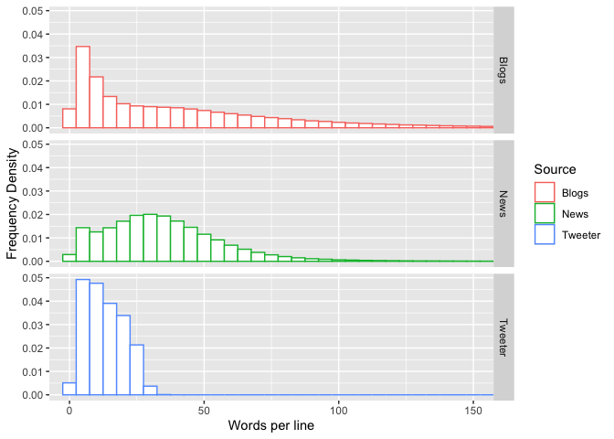
The relatively small number of words per line is also visible from the three histograms, which is restricted to the interval between 0 and 150 words per line, as the rest of the tail is negligible. This observation seems to support a general trend towards short and concise communications which may turn out to be useful later on.

Data Preparation

Introduction
Before performing the exploratory data analysis, we shall sample the three data sets to take only 1% of the data. This will improve the computational performance and the random sampling shall not, or should not, affect the analysis, because the uncertainty given by the sampling can be addressed with statistical methods. Also, all non-English characters shall be removed from the subset of data and then combined into a single data set.
Afterwards, we shall create a corpus from the sampled data set. We shall also focus on the following points to clean the data set:
- Remove url, twitter handles and email patterns
- Convert all words in lowercase
- Remove any punctuation marks
- Remove numbers
- Remove profanities
- Convert to plain text documents

Sampling and Cleaning Data
Let us first set the seed, in order to make the operation fully reproducible
set.seed(1010011)
With the function sample let us take a sample of all three data sets:
sampleSize <- 0.01
sampleBlogs <- sample(blogs, length(blogs) * sampleSize, replace = FALSE)
sampleNews <- sample(news, length(news) * sampleSize, replace = FALSE)
sampleTwitter <- sample(twitter, length(twitter) * sampleSize, replace = FALSE)
We shall also link these three samples into a single list, in order to make the coding simpler.
sampledList <- list(sampleBlogs, sampleNews, sampleTwitter)
names(sampledList) <- c("Blogs", "News", "Twitter")
Let us now remove all non-English characters from the sampled data. This is going to done converting the data from “latin1” to “ASCII”.
sampledList <- list(sampleBlogs,sampleNews, sampleTwitter)
sampledList <- lapply(sampledList, iconv, "latin1", "ASCII", sub = "")
names(sampledList) <- c("Blogs", "News", "Twitter")
Let us now combine the three sampled data sets into a single data set.
sampleData <- c(sampledList$Blogs, sampledList$News, sampledList$Twitter)
rm(sampledList)
Let us finally store in two variables sampleDataLines and sampleDataWords the total number of lines and the total number of words in the sampled data, respectively.
sampleDataLines <- length(sampleData)
sampleDataWords <- sum(str_count(sampleData, "\\w+"))
Let us also save a copy of this sampled data set into the hard drive:
con <- file("./en_US.sample.txt", open = "w")
writeLines(sampleData, con)
close(con); rm(con)
Finally, let us clean up the memory of all files:
rm(list = ls())

Building the Corpus
Before we can proceed to create the corpus and tidy up the data, let us load the sampled data:
f <- file("./en_US.sample.txt", open = "r")
sampleData <- readLines(f)
close(f); rm(f)
Let us first of all find a list of bad words and load it into R. To this end, upon research it turns out that google has created a full list of bad words that is freely downloadable. This list needs to be cleaned up.
# Downloading bad words from google
if(!file.exists("./badwords.txt")){
fileUrl <- "https://storage.googleapis.com/google-code-archive-downloads/v2/code.google.com/badwordslist/badwords.txt"
download.file(fileUrl, destfile = "badwords.txt", method = "curl")
rm(fileUrl)
}

# Reading bad words file
f <- file("./badwords.txt", open = "r")
profanities <- readLines(f)
close(f); rm(f)

# Cleaning up badwords
profanities <- profanities[-grep("(^[*])|([*]$)", profanities)]
We shall create the corpus with the aid of the package tm.
myCorpus <- VCorpus(VectorSource(sampleData))
In order to tidy up the corpus we need first to create a function which aims to clean up characters and strings that we wish to exclude from the analysis, such as URLs, email addresses, hashtags, but also punctuation, numbers and swear words. The function cleanup accomplishes this job.
cleanup <- function(corpus, profanity = NULL){
subs <- content_transformer(function(x, pattern) gsub(pattern, "", x))
# Removing URLs, Twitter handles, email patterns and hashtags
corpus <- tm_map(corpus, subs, "(f|ht)tp(s?)://(.*)[.][a-z]+")
corpus <- tm_map(corpus, subs, "@[^\\s]+")
corpus <- tm_map(corpus, subs, "\\b[A-Z a-z 0-9._ - ]*[@](.*?)[.]{1,3} \\b")
corpus <- tm_map(corpus, subs, "#(.*)")
corpus <- tm_map(corpus, subs, "\\b[a-z]{1}\\b")
# Transforming character in lower case, removing punctuation, numbers and extra spaces
corpus <- tm_map(corpus, tolower)
corpus <- tm_map(corpus, removePunctuation)
corpus <- tm_map(corpus, removeNumbers)
corpus <- tm_map(corpus, removeWords, stopwords("english"))
corpus <- tm_map(corpus, stripWhitespace)
corpus <- tm_map(corpus, PlainTextDocument)
# Removing profanities
if(!is.null(profanity)) corpus <- tm_map(corpus, removeWords, profanity)
return(corpus)
}
Let us now complete the work cleaning up the corpus and transforming it into a tidy data frame.
# Making a clean corpus
myCorpus <- cleanup(myCorpus, profanities)

# Transforming the corpus into a vector and a tidy data frame
cleanSample <- as.vector(tidy(myCorpus)$text)
tidyData <- data.frame(line = 1 : length(cleanSample), text = cleanSample)
This has already cost a lot of memory, so it is wise to now save the tidy data frame into an external file and clean up the memory.
f <- file("./tidy-sample.txt", open = "w")
saveRDS(tidyData, f, ascii = TRUE)
close(f); rm(f)

# Cleaning up messy memory
rm(list = ls())

Data Exploration
Once we have a tidy data frame, we can now begin the proper investigation. To this end, let us start by reading the data frame we have just saved:
f <- file("./tidy-sample.txt", open = "r")
tidyData <- readRDS(f)
close(f); rm(f)
We wish now to create three further data frames containing the mono-grams, bi-grams and tri-grams found in the corpus that we have sampled and cleansed. We shall do this with the aid of the package tidytext and in particular with the aid of the method unnest_tokens.
monoGrams <- tidyData %>%
unnest_tokens(word, text) %>%
count(word, sort = TRUE)

biGrams <- tidyData %>%
unnest_tokens(word, text, token = "ngrams", n = 2) %>%
count(word, sort = TRUE) %>%
filter(word != "<NA>")

triGrams <- tidyData %>%
unnest_tokens(word, text, token = "ngrams", n = 3) %>%
count(word, sort = TRUE) %>%
filter(word != "<NA>")
In order to create the prediction model, let us save these three data frames into three different files which shall be used in the prediction model.
# Saving mono-grams, bi-grams and tri-grams
f1 <- file("./MonoGram.txt", open = "w")
saveRDS(monoGrams, f1, ascii = TRUE)
close(f1)

f2 <- file("./BiGram.txt", open = "w")
saveRDS(monoGrams, f2, ascii = TRUE)
close(f2)

f3 <- file("./TriGram.txt", open = "w")
saveRDS(monoGrams, f3, ascii = TRUE)
close(f3)

rm(f1, f2, f3)
Now let us complete the exploration by plotting a graph of the most common mono-, bi- and tri-grams.

Mono-grams
ggplot(data = monoGrams[1:20,], aes(x = reorder(word, -n), y = n)) +
geom_bar(stat = "Identity") +
xlab("") + ylab("Frequency of Words") +
ggtitle("20 Most Common Words") +
geom_text(aes(label = n), vjust = -0.5, size = 3) +
geom_bar(stat = "identity", aes(colour = word), fill = "white") +
theme(legend.position = "none",
axis.text.x = element_text(hjust = 1.0, angle = 45),
plot.title = element_text(hjust = 0.5, face = "bold"))
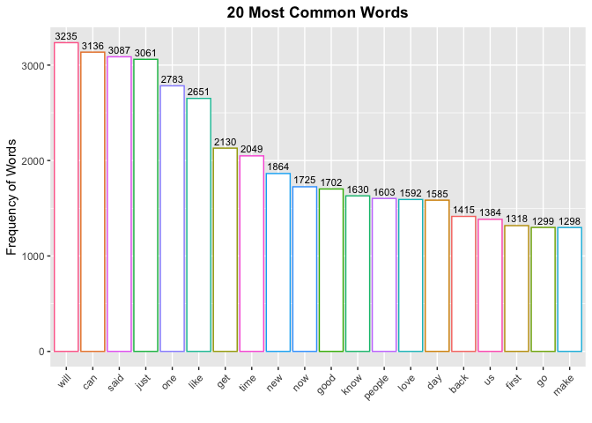
suppressWarnings(with(monoGrams, wordcloud(words = word, freq = n,
min.freq = 1, max.words = 100, random.order = FALSE,
rot.per = 0.35, colors = brewer.pal(9, "Purples"))))


Bi-grams
ggplot(data = biGrams[1:20,], aes(x = reorder(word, -n), y = n)) +
geom_bar(stat = "Identity") +
xlab("") + ylab("Frequency of Bigrams") +
ggtitle("20 Most Common Bigrams") +
geom_text(aes(label = n), vjust = -0.5, size = 3) +
geom_bar(stat = "identity", aes(colour = word), fill = "white") +
theme(legend.position = "none",
axis.text.x = element_text(hjust = 1.0, angle = 45),
plot.title = element_text(hjust = 0.5, face = "bold"))
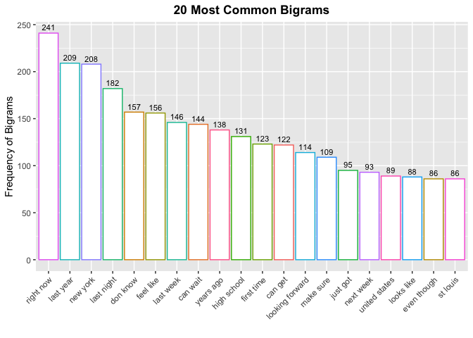
suppressWarnings(with(biGrams, wordcloud(words = word, freq = n,
min.freq = 1, max.words = 100, random.order = FALSE,
rot.per = 0.35, colors = brewer.pal(9, "Greens"))))


Tri-grams
ggplot(data = triGrams[1:20,], aes(x = reorder(word, -n), y = n)) +
geom_bar(stat = "Identity") +
xlab("") + ylab("Frequency of Trigrams") +
ggtitle("20 Most Common Trigrams") +
geom_text(aes(label = n), vjust = -0.5, size = 3) +
geom_bar(stat = "identity", aes(colour = word), fill = "white") +
theme(legend.position = "none",
axis.text.x = element_text(hjust = 1.0, angle = 45),
plot.title = element_text(hjust = 0.5, face = "bold"))
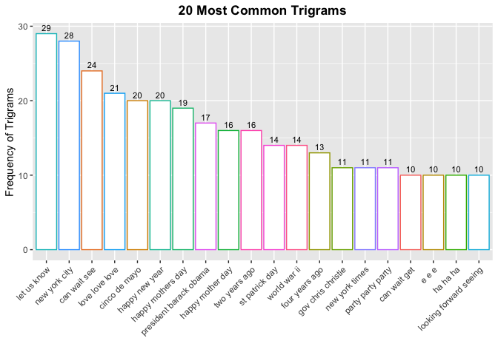
suppressWarnings(with(triGrams, wordcloud(words = word, freq = n,
min.freq = 1, max.words = 100, random.order = FALSE,
rot.per = 0.35, colors = brewer.pal(9, "Reds"))))
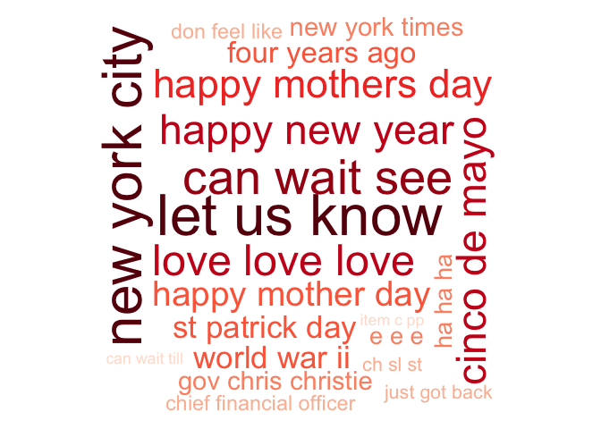

What’s Next
The next step is to create a Shiny app which performs a word prediction. Precisely, we shall construct a Shiny app that takes as input a phrase in a text box and outputs a prediction of the word that would come next.
The predictive algorithm that we shall develop uses n-gram models with a word frequency lookup similar to that performed in the exploratory data analysis section of this report. A strategy will bee built based on the knowledge gathered during the exploratory data analysis. For example, as n increased for each n-gram, the frequency decreased for each of its terms. So one possible strategy may be to construct the model to first look for the uni-grams that would follow from the entered text. Once a full term is entered followed by a space, find the most common bigram model and so on.

Developing Data Products 1

Andrea Carpignani

2023-02-17

The places of my life

Remark:
I am showing the code of the map for the benefit of the marker.

Please use the interactive map to go through the map and discover the important places of my life. Enjoy the tour.
library(leaflet)
df <- data.frame(name = c("Via Nievo", "Via XX Settembre", "Pontormo",
"DM Unipi", "Angus Drive", "Walton High",
"Bedford Town Hall"),
lat = c(43.72238325192714, 43.719234607336155,
43.71571261599621, 43.71966404407325,
52.00558407005514, 52.04695793845052,
52.136074493511614),
lng = c(10.956351064309342, 10.95310027322172,
10.933656425339382, 10.407605611847194,
-0.7509671726104704, -0.6743478609684557,
-0.4682699541806367))
popups <- c("I was born here", "I grew up here", "I studied here",
"I became a Mathematician here", "I live here",
"I work here", "I got married here")

df %>%
leaflet() %>%
addTiles() %>%
addMarkers(popup = popups, clusterOptions = markerClusterOptions())
## Assuming "lng" and "lat" are longitude and latitude, respectively
3
4
+−

Regression Models Peer Assessment

Andrea Carpignani

2023-02-12

Introduction
The following report examines the relationship between the consumption in miles per gallon mpg in the data set mtcars using linear regression. The following two queries are addressed and answered:
- “Is an automatic or manual transmission better for MPG”
- “Quantify the MPG difference between automatic and manual transmissions”
The data was extracted from the 1974 Motor Trend US magazine, and comprises fuel consumption and 10 aspects of automobile design and performance for 32 automobiles (1973-74 models). Source: Henderson and Velleman (1981), Building multiple regression models interactively. Biometrics, 37, 391-411.

Exploratory data analysis
Let us first load the data into R and perform a preliminary exploration.
data(mtcars)
head(mtcars)
## mpg cyl disp hp drat wt qsec vs am gear carb
## Mazda RX4 21.0 6 160 110 3.90 2.620 16.46 0 1 4 4
## Mazda RX4 Wag 21.0 6 160 110 3.90 2.875 17.02 0 1 4 4
## Datsun 710 22.8 4 108 93 3.85 2.320 18.61 1 1 4 1
## Hornet 4 Drive 21.4 6 258 110 3.08 3.215 19.44 1 0 3 1
## Hornet Sportabout 18.7 8 360 175 3.15 3.440 17.02 0 0 3 2
## Valiant 18.1 6 225 105 2.76 3.460 20.22 1 0 3 1
str(mtcars)
## 'data.frame': 32 obs. of 11 variables:
## $ mpg : num 21 21 22.8 21.4 18.7 18.1 14.3 24.4 22.8 19.2 ...
## $ cyl : num 6 6 4 6 8 6 8 4 4 6 ...
## $ disp: num 160 160 108 258 360 ...
## $ hp : num 110 110 93 110 175 105 245 62 95 123 ...
## $ drat: num 3.9 3.9 3.85 3.08 3.15 2.76 3.21 3.69 3.92 3.92 ...
## $ wt : num 2.62 2.88 2.32 3.21 3.44 ...
## $ qsec: num 16.5 17 18.6 19.4 17 ...
## $ vs : num 0 0 1 1 0 1 0 1 1 1 ...
## $ am : num 1 1 1 0 0 0 0 0 0 0 ...
## $ gear: num 4 4 4 3 3 3 3 4 4 4 ...
## $ carb: num 4 4 1 1 2 1 4 2 2 4 ...
Let us also load the help for this data set to see the actual meaning of the variables. Typing ?mtcars we can see the following:
Format
A data frame with 32 observations on 11 (numeric) variables.
[, 1] mpg Miles/(US) gallon
[, 2] cyl Number of cylinders
[, 3] disp Displacement (cu.in.)
[, 4] hp Gross horsepower
[, 5] drat Rear axle ratio
[, 6] wt Weight (1000 lbs)
[, 7] qsec 1/4 mile time
[, 8] vs Engine (0 = V-shaped, 1 = straight)
[, 9] am Transmission (0 = automatic, 1 = manual)
[,10] gear Number of forward gears
[,11] carb Number of carburetors
Since we are interested in the relationship between the consumption mpg and the transmission (automatic vs manual), am, let us transform the variable am into a factor and relabel the levels accordingly.
mtcars$am <- factor(mtcars$am)
levels(mtcars$am) <- c("automatic", "manual")
The number of items divided by these two levels is the following:
nrow(mtcars[mtcars$am == "automatic",])
## [1] 19
nrow(mtcars[mtcars$am == "manual",])
## [1] 13
Let us load the package ggplot2 to perform some data visualisation beforehand.
library(ggplot2)
Since we are interested in the formula mpg ~ am let us first draw a graph showing this relationship.
ggplot(data = mtcars, aes(x = am, y = mpg, colour = am)) +
xlab("Transmission") + ylab("Consumption (mpg)") +
labs(colour = "Transmission") +
ggtitle("Consumption by Transmission") +
geom_boxplot() +
theme(plot.title = element_text(hjust = 0.5, face = "bold"))
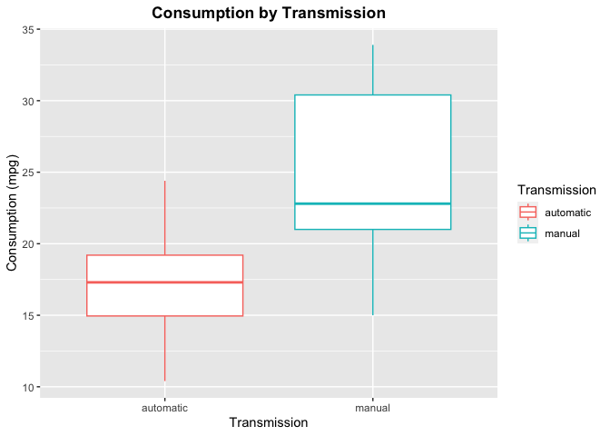
The graph suggests a significant difference in the consumption depending on the type of transmission, which needs to be analysed further.

Statistical Inferencee
First of all, let us prove that the difference in the mpg between automatic and manual transmission is significant. Since the number of data is relatively small, let us use the t-test.
test <- t.test(mpg ~ am, mtcars)
test
##
## Welch Two Sample t-test
##
## data: mpg by am
## t = -3.7671, df = 18.332, p-value = 0.001374
## alternative hypothesis: true difference in means between group automatic and group manual is not equal to 0
## 95 percent confidence interval:
## -11.280194 -3.209684
## sample estimates:
## mean in group automatic mean in group manual
## 17.14737 24.39231
The t-test shows a p-value of 0.0014 which yeileds that at a significance level of 0.05 we can reject the null hypothesis and infer that
- There is a significative difference betweeen the consumption of automatic cars and the consumption of manual cars.

Linear Models
Let us now try to fit a linear model for the variable mpg. We shall consider the following nested models:
lm_1 <- lm(mpg ~ am, mtcars)
lm_2 <- lm(mpg ~ am + wt, mtcars)
lm_3 <- lm(mpg ~ am + wt + hp, mtcars)
lm_4 <- lm(mpg ~ am + wt + hp + factor(cyl), mtcars)
lm_all <- lm(mpg ~ ., mtcars)
In the simplest model, with outcome mpg and only regressor am, we have
summary(lm_1)
##
## Call:
## lm(formula = mpg ~ am, data = mtcars)
##
## Residuals:
## Min 1Q Median 3Q Max
## -9.3923 -3.0923 -0.2974 3.2439 9.5077
##
## Coefficients:
## Estimate Std. Error t value Pr(>|t|)
## (Intercept) 17.147 1.125 15.247 1.13e-15 ***
## ammanual 7.245 1.764 4.106 0.000285 ***
## ---
## Signif. codes: 0 '***' 0.001 '**' 0.01 '*' 0.05 '.' 0.1 ' ' 1
##
## Residual standard error: 4.902 on 30 degrees of freedom
## Multiple R-squared: 0.3598, Adjusted R-squared: 0.3385
## F-statistic: 16.86 on 1 and 30 DF, p-value: 0.000285
which shows a, mpg increase of 7.245 for manual cars.
Let us run the ANOVA test to these nested models to see which variables are the most significative towards the variation of mpg.
anova(lm_1, lm_2, lm_3, lm_4, lm_all)
## Analysis of Variance Table
##
## Model 1: mpg ~ am
## Model 2: mpg ~ am + wt
## Model 3: mpg ~ am + wt + hp
## Model 4: mpg ~ am + wt + hp + factor(cyl)
## Model 5: mpg ~ cyl + disp + hp + drat + wt + qsec + vs + am + gear + carb
## Res.Df RSS Df Sum of Sq F Pr(>F)
## 1 30 720.90
## 2 29 278.32 1 442.58 63.0133 9.325e-08 ***
## 3 28 180.29 1 98.03 13.9571 0.001219 **
## 4 26 151.03 2 29.27 2.0834 0.149491
## 5 21 147.49 5 3.53 0.1006 0.990931
## ---
## Signif. codes: 0 '***' 0.001 '**' 0.01 '*' 0.05 '.' 0.1 ' ' 1
From the test it is appears that the best model is the third, mpg ~ am + wt + hp. In fact, though the model lm_all, with all variables considered as regressors, we would inflate the model’s variance, whereas the first mode, mpg ~ am, with a R2 coefficient of 0.36 would only explain around the 36% of the variation in mpg. Instead, as shown below,
summary(lm_3)
##
## Call:
## lm(formula = mpg ~ am + wt + hp, data = mtcars)
##
## Residuals:
## Min 1Q Median 3Q Max
## -3.4221 -1.7924 -0.3788 1.2249 5.5317
##
## Coefficients:
## Estimate Std. Error t value Pr(>|t|)
## (Intercept) 34.002875 2.642659 12.867 2.82e-13 ***
## ammanual 2.083710 1.376420 1.514 0.141268
## wt -2.878575 0.904971 -3.181 0.003574 **
## hp -0.037479 0.009605 -3.902 0.000546 ***
## ---
## Signif. codes: 0 '***' 0.001 '**' 0.01 '*' 0.05 '.' 0.1 ' ' 1
##
## Residual standard error: 2.538 on 28 degrees of freedom
## Multiple R-squared: 0.8399, Adjusted R-squared: 0.8227
## F-statistic: 48.96 on 3 and 28 DF, p-value: 2.908e-11
the model mpg ~ am + wt + hp has a R2 coefficient of 0.84 and therefore it explains around the 84% of the variation in mpg.

Conclusions
Is an automatic or manual transmission better for MPG?
It appears that manual transmission cars are better for MPG compared to automatic cars. However when modeled with confounding variables like HP and weight, the difference is not as significant as it seems in the beginning: a big part of the difference is explained by other variables.
Quantify the MPG difference between automatic and manual transmissions
Analysis shows that when only transmission was used in the model manual cars have an mpg increase of 7.245. However, when variables wt and hp are included, the manual car advantage drops to 2.084 with other variables contributing, sometimes more (e.g. weight) to the effect.

Appendix
Istogram of MPG in automatic and manual cars
ggplot(data = mtcars, aes(x = mpg, colour = am)) +
geom_histogram(fill = "white", bins = 10) +
labs(colour = "Trnasmission") +
facet_grid(. ~ am) +
ggtitle("Comparison between MPG in automatic and manual cars") +
xlab("Consumption (mpg)") +
ylab("Frequency") +
theme(plot.title = element_text(hjust = 0.5, face = "bold"))
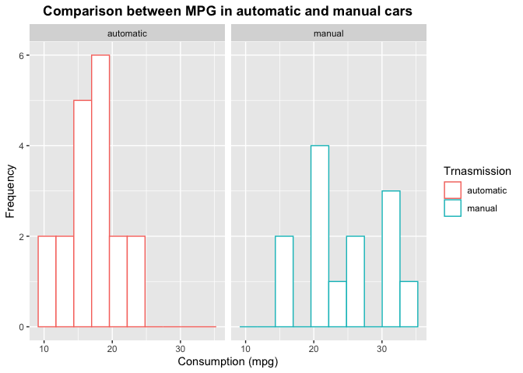
Plot of correlation for the variables considered.
library(GGally)
## Registered S3 method overwritten by 'GGally':
## method from
## +.gg ggplot2
ggpairs(data = mtcars, aes(colour = factor(am)), columns = c(1, 2, 4, 6, 9))
## `stat_bin()` using `bins = 30`. Pick better value with `binwidth`.
## `stat_bin()` using `bins = 30`. Pick better value with `binwidth`.
## `stat_bin()` using `bins = 30`. Pick better value with `binwidth`.
## `stat_bin()` using `bins = 30`. Pick better value with `binwidth`.
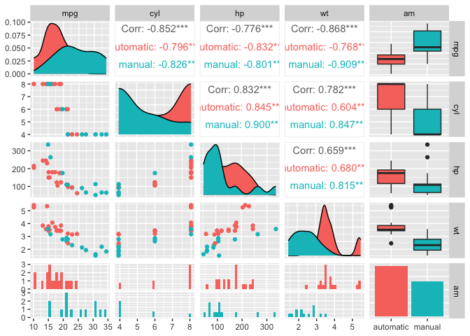

Coursera Regression Models Quiz 3

Andrea Carpignani

2023-02-12

Question 1
Consider the mtcars data set. Fit a model with mpg as the outcome that includes number of cylinders as a factor variable and weight as confounder. Give the adjusted estimate for the expected change in mpg comparing 8 cylinders to 4.
Answer. Let us first load the data set and have a look at it.
data(mtcars)
head(mtcars)
## mpg cyl disp hp drat wt qsec vs am gear carb
## Mazda RX4 21.0 6 160 110 3.90 2.620 16.46 0 1 4 4
## Mazda RX4 Wag 21.0 6 160 110 3.90 2.875 17.02 0 1 4 4
## Datsun 710 22.8 4 108 93 3.85 2.320 18.61 1 1 4 1
## Hornet 4 Drive 21.4 6 258 110 3.08 3.215 19.44 1 0 3 1
## Hornet Sportabout 18.7 8 360 175 3.15 3.440 17.02 0 0 3 2
## Valiant 18.1 6 225 105 2.76 3.460 20.22 1 0 3 1
factor(mtcars$cyl)
## [1] 6 6 4 6 8 6 8 4 4 6 6 8 8 8 8 8 8 4 4 4 4 8 8 8 8 4 4 4 8 6 8 4
## Levels: 4 6 8
Let us now fit a linear model and check the coefficients.
fit <- lm(mpg ~ wt + factor(cyl), data = mtcars)
summary(fit)$coefficients
## Estimate Std. Error t value Pr(>|t|)
## (Intercept) 33.990794 1.8877934 18.005569 6.257246e-17
## wt -3.205613 0.7538957 -4.252065 2.130435e-04
## factor(cyl)6 -4.255582 1.3860728 -3.070244 4.717834e-03
## factor(cyl)8 -6.070860 1.6522878 -3.674214 9.991893e-04
Hence, the adjusted estimate for the expected change in mpg comparing 8 cylinders to 4 is -6.071.

Question 2
Consider the mtcars data set. Fit a model with mpg as the outcome that includes number of cylinders as a factor variable and weight as a possible confounding variable. Compare the effect of 8 versus 4 cylinders on mpg for the adjusted and unadjusted by weight model. Here, adjusted means including the weight variable as a term in the regression model and unasjusted means the model without weight included. What can be said about the effect comparing 8 and 4 cylinders after looking at models with and without weight included?
** Answer.** The adjusted model is fit. Let us also work out the unadjusted model, which shall be called fit0.
fit0 <- lm(mpg ~factor(cyl), data = mtcars)
summary(fit)$coefficients
## Estimate Std. Error t value Pr(>|t|)
## (Intercept) 33.990794 1.8877934 18.005569 6.257246e-17
## wt -3.205613 0.7538957 -4.252065 2.130435e-04
## factor(cyl)6 -4.255582 1.3860728 -3.070244 4.717834e-03
## factor(cyl)8 -6.070860 1.6522878 -3.674214 9.991893e-04
summary(fit0)$coefficients
## Estimate Std. Error t value Pr(>|t|)
## (Intercept) 26.663636 0.9718008 27.437347 2.688358e-22
## factor(cyl)6 -6.920779 1.5583482 -4.441099 1.194696e-04
## factor(cyl)8 -11.563636 1.2986235 -8.904534 8.568209e-10
Taking a look at the coefficients, for the comparison of 8 cylinder to 4, we have -6.0708597 and -11.5636364, respectively. Hence
- Holding weight constant, cylinder appears to have less of an impact on mpg than i weight is disregarded.

Question 3
Consider the mtcars data set. Fit a model with mpg as the outcome that considers number of cylinders as a factor variable and weight as confounder. Now fit a second model with mpg as the outcome model that considers the interaction between number of cylinders (as a factor variable) and weight. Give the P-value for the likelihood ratio test comparing the two models and suggest a model using 0.05 as a type I error rate significance benchmark.
Answer. Again, the first model is fit, so let us only work out the second model.
fit1 <- lm(mpg ~ wt * factor(cyl), data = mtcars)
We can now use the ANOVA method to find the requested p-value.
anova(fit, fit1)
## Analysis of Variance Table
##
## Model 1: mpg ~ wt + factor(cyl)
## Model 2: mpg ~ wt * factor(cyl)
## Res.Df RSS Df Sum of Sq F Pr(>F)
## 1 28 183.06
## 2 26 155.89 2 27.17 2.2658 0.1239
This shows that the p-value is 0.123857 which is larger that the threshold 0.05. Thus,
- The P-value is larger than 0.05. So, according to our criterion, we would fail to reject, which suggests that the interaction terms may not be necessary.

Question 4
Consider the mtcars data set. Fit a model with mpg as the outcome that includes number of cylinders as a factor variable and weight inlcuded in the model as
lm(mpg ~ I(wt * 0.5) + factor(cyl), data = mtcars)
How is the wt coefficient interpreted?
Answer. Let us start by generating this new fit:
newfit <- lm(mpg ~ I(wt * 0.5) + factor(cyl), data = mtcars)
summary(fit)$coefficients[2,]
## Estimate Std. Error t value Pr(>|t|)
## -3.2056132562 0.7538956550 -4.2520649046 0.0002130435
summary(newfit)$coefficients[2,]
## Estimate Std. Error t value Pr(>|t|)
## -6.4112265124 1.5077913099 -4.2520649046 0.0002130435
Thus, looking at the numbers -3.2056133 and -6.4112265 for the original fit and the new fit, respectively, it turns out that
- The estimated expected change in MPG per one ton increase in weight for a specific number of cylinders (4, 6, 8).

Question 5
Consider the following data set
x <- c(0.586, 0.166, -0.042, -0.614, 11.72)
y <- c(0.549, -0.026, -0.127, -0.751, 1.344)
Give the hat diagonal for the most influential point.
Answer.
xyfit <- lm(y ~ x)
max(round(hatvalues(xyfit), 4))
## [1] 0.9946
So the answer is 0.9946.

Question 6
Consider the following data set
x <- c(0.586, 0.166, -0.042, -0.614, 11.72)
y <- c(0.549, -0.026, -0.127, -0.751, 1.344)
Give the slope dfbeta for the point with the highest hat value.
Answer.
signif(dfbetas(xyfit)[hatvalues(xyfit) == max(hatvalues(xyfit)),2], 3)
## [1] -134
So the answer is -134.

Question 7
Consider a regression relationship between Y and X with and without adjustment for a third variable Z. Which of the following is true about comparing the regression coefficient between Y and X with and without adjustment for Z.
Answer.
- It is possible for the coefficient to reverse sign after adjustment. For example, it can be strongly significant and positive before adjustment and strongly significant and negative after adjustment.

Statistical Inference Peer Assessment

Andrea Carpignani

2023-02-07

Part 1: Simulation of Exponential Distribution

Overview
The purpose of this section is to investigate the exponential distribution in R and to compare it with the Central Limit Theorem (CLT). The exponential distribution can be simulated in R with the command rexp(n, lambda) where n is the number of simulations and and lambda is the rate parameter. From the theory, it is known that the mean of an exponential random variable X is E(X)=1/λ and the variance is Var(X)=1/λ2. For the following simulation, we shall take λ=0.2 and we shall investigate the distribution of the average of 40 exponentials. In particular we shall:
- Show the sample mean and compare it to the theoretical mean of the distribution.
- Show how variable the sample is (via variance) and compare it to the theoretical variance of the distribution.
- Show that the distribution is approximately normal.

Preliminary actions
Before we start, let us load the libraries that we shall need throughout.
library(ggplot2)
library(dplyr)
##
## Attaching package: 'dplyr'
## The following objects are masked from 'package:stats':
##
## filter, lag
## The following objects are masked from 'package:base':
##
## intersect, setdiff, setequal, union

Simulation
First of all we need to simulate the data: the code below initialises the seed to 1, then creates a data frame with n=40 rows and nosim=1000 columns in which every row represents n=1000 simulations of an exponential random variable with λ=2.
set.seed(1)
nosim <- 1000
n <- 40
lambda <- 0.2

ExpSim <- data.frame(matrix(rexp(n * nosim, rate = lambda), nosim, n))

Sample mean against theoretical mean
Once the data frame is created, we can consider the data frame meanSim with the sample mean of each row from the data frame ExpSim. The sample mean is therefore sampleMean and the theoretical mean, 1/λ, is stored in the variable theoryMean. It follows a t-test to check whether these two means are compatible.
meanSim <- data.frame(means = apply(ExpSim, 1, mean))
sampleMean <- mean(meanSim$means)
theoryMean <- 1 / lambda
t.test(meanSim$means, mu = theoryMean)
##
## One Sample t-test
##
## data: meanSim$means
## t = -0.40134, df = 999, p-value = 0.6883
## alternative hypothesis: true mean is not equal to 5
## 95 percent confidence interval:
## 4.941254 5.038797
## sample estimates:
## mean of x
## 4.990025
Since the p-value of the test is 0.688, the null hypothesis cannot be rejected, i.e. the two sample mean and the theoretical mean are compatible. Let us also see this comparison in a graph. The dashed line in the graph represents the theoretical mean, λ=5.
ggplot(data = meanSim, aes(x = means)) +
geom_histogram(binwidth = 0.2, colour = "black", fill = "pink") +
geom_vline(xintercept = theoryMean, linewidth = 1, linetype = "dashed") +
ggtitle("The distribution of 1000 averages of 40 Exponential RVs") +
xlab("Value of the means") + ylab("Frequency") +
theme(plot.title = element_text(hjust = 0.5, face = "bold"))
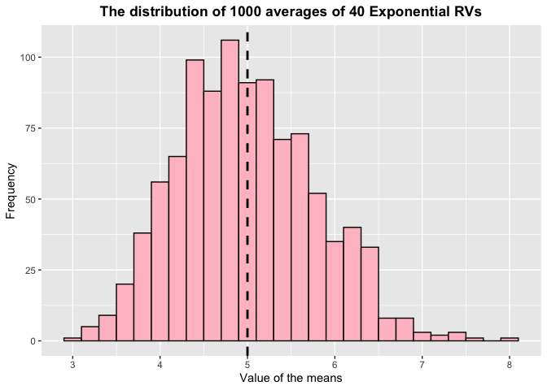

Sample variance against theoretical variance
A similar approach is taken for the variance: in this case we shall only store the two quantities into two variables and compare them ‘by eye’.
varSim <- data.frame(vars = apply(ExpSim, 1, var))
sampleVar <- sum(varSim$vars) / (length(varSim$vars) - 1)
theoryVar <- (1 / lambda) ^ 2
print(sampleVar)
## [1] 25.08292
print(theoryVar)
## [1] 25
At first glance, we notice how the theoretical value, 25, and the sample variance, 25.08, are indeed very close. Let us also see this in a graph. The dashed line in the graph represents the theoretical variance, λ2=25.
ggplot(data = varSim, aes(x = vars)) +
geom_histogram(binwidth = 3, colour = "black", fill = "lightskyblue") +
geom_vline(xintercept = theoryVar, linewidth = 1, linetype = "dashed") +
ggtitle("The distribution of 1000 variance of 40 Exponential RVs") +
xlab("Variance") + ylab("Frequency") +
theme(plot.title = element_text(hjust = 0.5, face = "bold"))
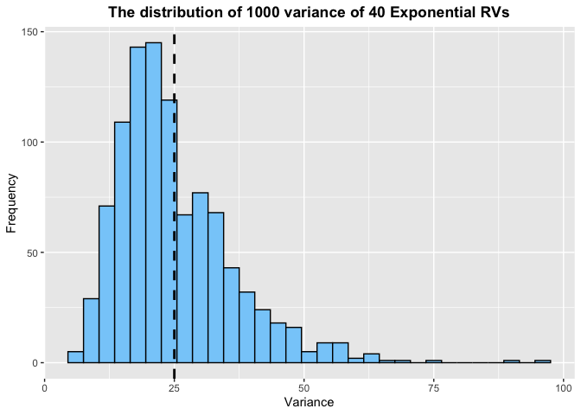

Distribution
As final part of the activity, we wish to show that the sample mean is normally distributed. We can plot the histogram of the sample means the n=40 groups of simulations, overlaying the normal distribution with mean 4.99 and standard deviation 0.786. In the graph, the vertical dashed line represents the mean of the distribution.
ggplot(data = data.frame(meanSim), aes(x = means)) +
geom_histogram(aes(y = after_stat(density)),
colour = "black", fill = "lavenderblush",
binwidth = 0.25) +
stat_function(fun = dnorm, args = list(mean = mean(meanSim$means),
sd = sd(meanSim$means)),
colour = "purple", linewidth = 1) +
geom_vline(xintercept = theoryMean, linewidth = 1, linetype = "dashed") +
xlab("Means") + ylab("Density") +
ggtitle("Comparison between Sample Mean of Data and Normal Distribution") +
theme(plot.title = element_text(hjust = 0.5, face = "bold"))
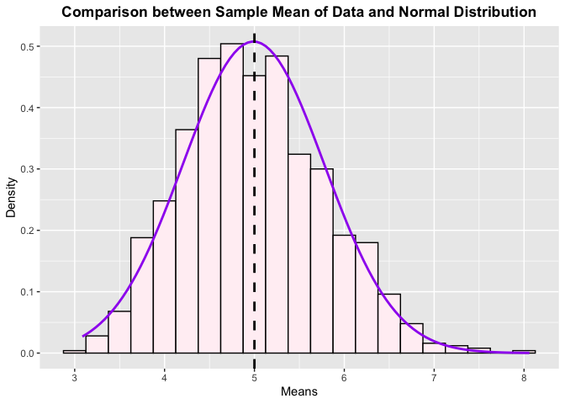

Part 2: Data Analysis of the Data Frame “ToothGrowth”

Overview
The second part of this work analyses the data frame ToothGrowth in R providing a basic data summary and comparing the tooth growth by supplement given and dosage.

Loading data and basic data exploration
Let us start by loading the data frame and check the variables involved.
data("ToothGrowth")
str(ToothGrowth)
## 'data.frame': 60 obs. of 3 variables:
## $ len : num 4.2 11.5 7.3 5.8 6.4 10 11.2 11.2 5.2 7 ...
## $ supp: Factor w/ 2 levels "OJ","VC": 2 2 2 2 2 2 2 2 2 2 ...
## $ dose: num 0.5 0.5 0.5 0.5 0.5 0.5 0.5 0.5 0.5 0.5 ...
Let us also check the head and the tail of the data frame:
head(ToothGrowth)
## len supp dose
## 1 4.2 VC 0.5
## 2 11.5 VC 0.5
## 3 7.3 VC 0.5
## 4 5.8 VC 0.5
## 5 6.4 VC 0.5
## 6 10.0 VC 0.5
tail(ToothGrowth)
## len supp dose
## 55 24.8 OJ 2
## 56 30.9 OJ 2
## 57 26.4 OJ 2
## 58 27.3 OJ 2
## 59 29.4 OJ 2
## 60 23.0 OJ 2
The summary of the data can be obtained simply taking:
summary(ToothGrowth)
## len supp dose
## Min. : 4.20 OJ:30 Min. :0.500
## 1st Qu.:13.07 VC:30 1st Qu.:0.500
## Median :19.25 Median :1.000
## Mean :18.81 Mean :1.167
## 3rd Qu.:25.27 3rd Qu.:2.000
## Max. :33.90 Max. :2.000

Investigation
In order to understand the relationship between the two different supplements and the tooth growth, let us start by analysing a boxplot of the tooth length by supplement.
ggplot(data = ToothGrowth) +
geom_boxplot(aes(x = supp, colour = supp, y = len)) +
xlab("Supplement") +
ylab("Tooth Length") +
ggtitle("Boxplot of Tooth Length by Supplement") +
theme(plot.title = element_text(hjust = 0.5, face = "bold"))
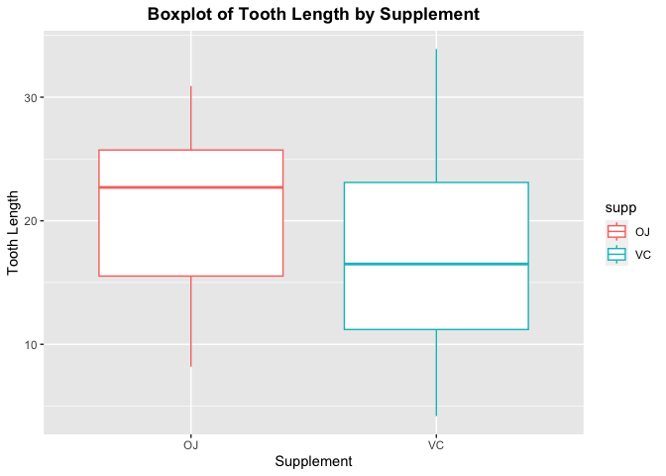
At a glance, it looks like the OJ supplement has a slightly better effect than VC. Let us also check the sample relationship by dosage:
ggplot(data = ToothGrowth) +
geom_boxplot(aes(x = supp, colour = supp, y = len)) +
facet_grid(. ~ dose) +
xlab("Supplement") +
ylab("Tooth Length") +
ggtitle("Boxplot of Tooth Length by Supplement and Dose") +
theme(plot.title = element_text(hjust = 0.5, face = "bold"))
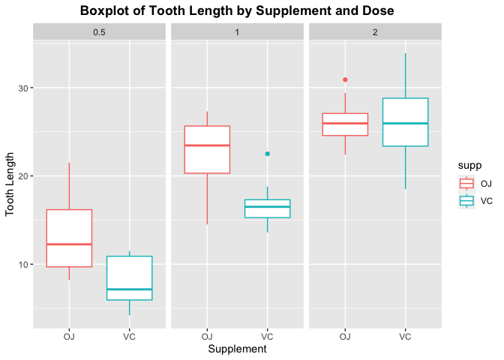
This second plot shows that for low and medium dosage (0.5 and 1), supplement OJ has bigger effect than VC on tooth length.

Statistical testing:
Let us prove this rigorously with the help of the t-test. To this end, we will need to filter the data set by dose This can be done effectively with the aid of the package dplyr.
lowDosage <- filter(ToothGrowth, dose == 0.5)
medDosage <- filter(ToothGrowth, dose == 1)
highDosage <- filter(ToothGrowth, dose == 2)
Let us now check the t-test for the whole data set and for the data sets filtered by dosage.
## t.test for overall group
totTest <- t.test(len ~ supp, paired = FALSE, var.equal = FALSE, data = ToothGrowth)

## t.test for small dosage
lowTest <- t.test(len ~ supp, paired = FALSE, var.equal = FALSE, data = lowDosage)

## t.test for med dosage
medTest <- t.test(len ~ supp, paired = FALSE, var.equal = FALSE, data = medDosage)

## t.test for high dosage
highTest <- t.test(len ~ supp, paired = FALSE, var.equal = FALSE, data = highDosage)
Let us store the p-values of the tests carried out into a variable pValues and with check whether the test allows to reject the null hypothesis H0: the two supplements have identical effect.
pValues <- c(totTest$p.value, lowTest$p.value, medTest$p.value, highTest$p.value)
round(pValues, 3)
## [1] 0.061 0.006 0.001 0.964
names(pValues) <- c("tot", "low", "med", "high")
pValues < 0.05
## tot low med high
## FALSE TRUE TRUE FALSE
As the code shows, the null hypothesis,
- For the overall study, with a p-value of 0.061, there is not enough evidence to reject the null hypothesis.
- For low and medium dose, there is actually enough evidence to reject the null hypothesis and infer that the effect of OJ is bigger than the effect of VC in the tooth length.
- For the high dose, there is not enough evidence to reject the null hypothesis.

Assumptions and Conclusions
- In the analysis, we have assumed that the overall population from which the sample was taken is at least approximately normally distributed, and that the population is also normally distributed with respect under each dose. We have also assumed that the sample is taken randomly and it represents the whole population.
- In conclusion, we have enough evidence to reject the null hypothesis for low and medium dose, and we may infer that, for low and medium dosage, the supplement OJ has a bigger effect on tooth growth. However, in general, the overall effect is not statistically significant, as shown by the result of the test on the overall sample, at least at 5% significance level.

Coursera Reproducible Research (PA 2)

Andrea Carpignani

2023-02-01

On the impact of severe weather in the US on health and economy

Synopsis
The study the follows investigates the relationship between severe weather in the US based on the official data from the National Oceanic and Atmospheric Administration (NOAA). The NOAA database shows the number of injuries and fatalities occurred during a meteorological event, as well as the estimated damage caused to properties and crop during the event. Further details on the database are available at https://www.ncdc.noaa.gov/stormevents/.

Data Processing

Download and load the data
The first step in this study is to collect the data and load them into R. The data is taken from the Coursera Reproducible Research Course website, downloaded and stored as a data frame into a variable storm.
fileUrl <- "https://d396qusza40orc.cloudfront.net/repdata%2Fdata%2FStormData.csv.bz2"
download.file(fileUrl, destfile = "repdata_data_StormData.csv.bz2", method = "curl")
storm <- read.csv("./repdata_data_StormData.csv.bz2")

Data inspection
Use colnames, str to have a first look at the variables.
colnames(storm)
## [1] "STATE__" "BGN_DATE" "BGN_TIME" "TIME_ZONE" "COUNTY"
## [6] "COUNTYNAME" "STATE" "EVTYPE" "BGN_RANGE" "BGN_AZI"
## [11] "BGN_LOCATI" "END_DATE" "END_TIME" "COUNTY_END" "COUNTYENDN"
## [16] "END_RANGE" "END_AZI" "END_LOCATI" "LENGTH" "WIDTH"
## [21] "F" "MAG" "FATALITIES" "INJURIES" "PROPDMG"
## [26] "PROPDMGEXP" "CROPDMG" "CROPDMGEXP" "WFO" "STATEOFFIC"
## [31] "ZONENAMES" "LATITUDE" "LONGITUDE" "LATITUDE_E" "LONGITUDE_"
## [36] "REMARKS" "REFNUM"
str(storm)
## 'data.frame': 902297 obs. of 37 variables:
## $ STATE__ : num 1 1 1 1 1 1 1 1 1 1 ...
## $ BGN_DATE : chr "4/18/1950 0:00:00" "4/18/1950 0:00:00" "2/20/1951 0:00:00" "6/8/1951 0:00:00" ...
## $ BGN_TIME : chr "0130" "0145" "1600" "0900" ...
## $ TIME_ZONE : chr "CST" "CST" "CST" "CST" ...
## $ COUNTY : num 97 3 57 89 43 77 9 123 125 57 ...
## $ COUNTYNAME: chr "MOBILE" "BALDWIN" "FAYETTE" "MADISON" ...
## $ STATE : chr "AL" "AL" "AL" "AL" ...
## $ EVTYPE : chr "TORNADO" "TORNADO" "TORNADO" "TORNADO" ...
## $ BGN_RANGE : num 0 0 0 0 0 0 0 0 0 0 ...
## $ BGN_AZI : chr "" "" "" "" ...
## $ BGN_LOCATI: chr "" "" "" "" ...
## $ END_DATE : chr "" "" "" "" ...
## $ END_TIME : chr "" "" "" "" ...
## $ COUNTY_END: num 0 0 0 0 0 0 0 0 0 0 ...
## $ COUNTYENDN: logi NA NA NA NA NA NA ...
## $ END_RANGE : num 0 0 0 0 0 0 0 0 0 0 ...
## $ END_AZI : chr "" "" "" "" ...
## $ END_LOCATI: chr "" "" "" "" ...
## $ LENGTH : num 14 2 0.1 0 0 1.5 1.5 0 3.3 2.3 ...
## $ WIDTH : num 100 150 123 100 150 177 33 33 100 100 ...
## $ F : int 3 2 2 2 2 2 2 1 3 3 ...
## $ MAG : num 0 0 0 0 0 0 0 0 0 0 ...
## $ FATALITIES: num 0 0 0 0 0 0 0 0 1 0 ...
## $ INJURIES : num 15 0 2 2 2 6 1 0 14 0 ...
## $ PROPDMG : num 25 2.5 25 2.5 2.5 2.5 2.5 2.5 25 25 ...
## $ PROPDMGEXP: chr "K" "K" "K" "K" ...
## $ CROPDMG : num 0 0 0 0 0 0 0 0 0 0 ...
## $ CROPDMGEXP: chr "" "" "" "" ...
## $ WFO : chr "" "" "" "" ...
## $ STATEOFFIC: chr "" "" "" "" ...
## $ ZONENAMES : chr "" "" "" "" ...
## $ LATITUDE : num 3040 3042 3340 3458 3412 ...
## $ LONGITUDE : num 8812 8755 8742 8626 8642 ...
## $ LATITUDE_E: num 3051 0 0 0 0 ...
## $ LONGITUDE_: num 8806 0 0 0 0 ...
## $ REMARKS : chr "" "" "" "" ...
## $ REFNUM : num 1 2 3 4 5 6 7 8 9 10 ...
It is convenient to consider the variable EVTYPE as factor. Also, in order to tidy up the entries of this variable, we shall convert all strings into upper-case. Furthermore, since the date is not in the right format, we have to fix the data type and, since the data set presents limited data before 1996, is shall be convenient to create an additional variable, BGN_YEAR to store the year where the event had happened.
# Converting EVTYPE in Uppercase and
# saving as factors
storm$EVTYPE <- toupper(storm$EVTYPE)
storm$EVTYPE <- factor(storm$EVTYPE)
# Converting the date into Date type
# and creating new variable BGN_YEAR
dates <- sapply(strsplit(storm$BGN_DATE, split = " "), function(x) x[[1]])
storm$BGN_DATE <- dates
storm$BGN_DATE <- as.Date(storm$BGN_DATE, "%m/%d/%Y")
storm$BGN_YEAR <- as.numeric(format(storm$BGN_DATE, "%Y"))
rm(dates)

Selection of the variables of interest
From the inspection it is clear that the variables of interest are
- EVTYPE, the type of meteorological event occurred
- INJURIES, counting the number of direct and indirect injuries due to the event
- FATALITIES, counting the number of direct and indirect fatalities due to the event
- PROPDMG, PROPDMGEXP, representing the quantity of monetary cost for property damage and the corresponding exponent
- CROPDMG, CROPDMGEXP, representing the quantity of monetary cost for crop damage and the corresponding exponent
- BGN_YEAR, the year where the meteorological event took place
To select and work with this specific subset it is convenient to load the library dplyr.
library(dplyr)
##
## Attaching package: 'dplyr'
## The following objects are masked from 'package:stats':
##
## filter, lag
## The following objects are masked from 'package:base':
##
## intersect, setdiff, setequal, union
In taking the selection, we have also changed the position of the variable BGN_YEAR at the front of the data set.
stormData <- select(storm, c(BGN_DATE, BGN_YEAR, EVTYPE,
FATALITIES, INJURIES,
PROPDMG, PROPDMGEXP,
CROPDMG, CROPDMGEXP))

# Only take events from 1996 (before data are incomplete)
stormData <- filter(stormData, BGN_YEAR >= 1996)

# Only take data with an impact
stormData <- filter(stormData, FATALITIES > 0 | INJURIES > 0 | PROPDMG > 0 | CROPDMG > 0)

Evaluating the economic damage for property and for crop
From the preliminary data inspection it turns out that the monetary cost of property and crop damage are stored in two pairs of variables containing the monetary cost and the power of this cost. This power, however, is stored in several different ways, as shown in the tables.
table(storm$PROPDMGEXP)
##
## - ? + 0 1 2 3 4 5 6
## 465934 1 8 5 216 25 13 4 4 28 4
## 7 8 B h H K m M
## 5 1 40 1 6 424665 7 11330
table(storm$CROPDMGEXP)
##
## ? 0 2 B k K m M
## 618413 7 19 1 9 21 281832 1 1994
Some letters appear both in upper-case and lower-case, some other times, instead of the magnitude (k, M, B) a number is used (0 to 9). There are also some irregular entries (-, +, ?) which need to be addressed: we shall consider these as 100=1. The following function has aims to fix these exponents in an organic way.
ExponentConvert <- function(x) {
if(x %in% 0:9) x <- 10 ^ as.numeric(x)
else if(tolower(x) == "h") x <- 10 ^ 2
else if(tolower(x) == "k") x <- 10 ^ 3
else if(tolower(x) == "m") x <- 10 ^ 6
else if(tolower(x) == "b") x <- 10 ^ 9
else x <- 1
return(x)
}
This function can be used to create two new variables, representing magnitude, as a power of 10.
# Adding power variables of economic damages
stormData$PROPDMGFACTOR <- sapply(stormData$PROPDMGEXP, ExponentConvert)
stormData$CROPDMGFACTOR <- sapply(stormData$CROPDMGEXP, ExponentConvert)
With these two new variables, we can now create the variables which represent the health impact and the economical cost of the meteorological event, which are labelled by HEALTHIMP and ECONCOST.
# Getting health impact and economic impact variables
stormData <- mutate(stormData, HEALTHIMP = FATALITIES + INJURIES)
stormData <- mutate(stormData, ECONCOST = PROPDMG * PROPDMGFACTOR + CROPDMG * CROPDMGFACTOR)

Selection of the data set of use
We can now remove from the data set the variables that we don’t need and focus only on the variable of interest.
stormData <- select(stormData, BGN_YEAR, EVTYPE, HEALTHIMP, ECONCOST)
This gives finally a tidy data set that can be analysed.
head(stormData)
## BGN_YEAR EVTYPE HEALTHIMP ECONCOST
## 1 1996 WINTER STORM 0 418000
## 2 1996 TORNADO 0 100000
## 3 1996 TSTM WIND 0 3000
## 4 1996 TSTM WIND 0 5000
## 5 1996 TSTM WIND 0 2000
## 6 1996 HIGH WIND 0 400000

Analysis of the processed data
Let us start by noticing that the variable EVTYPE has many different levels and some may be duplicates. For example:
evtypeUnique <- unique(stormData$EVTYPE)
evtypeUnique[grep("THUND", evtypeUnique)]
## [1] THUNDERSTORM THUNDERSTORM WIND (G40) THUNDERSTORM WIND
## [4] MARINE THUNDERSTORM WIND
## 898 Levels: HIGH SURF ADVISORY COASTAL FLOOD FLASH FLOOD ... WND
This also shows that there are actually 898 levels. Going through all these levels is pointlessly time consuming, so we shall take a faster route. To this end, let us start by taking a new data set consisting of the total health impact due to severe weather, taken adding up the variable HEALTHIMP grouped by EVTYPE and let’s check the subset of the 95% most extreme events.
healthImpact <- stormData %>% group_by(EVTYPE) %>% summarise(HEALTHIMP = sum(HEALTHIMP))
subset(healthImpact, HEALTHIMP > quantile(HEALTHIMP, prob = 0.95))
## # A tibble: 10 × 2
## EVTYPE HEALTHIMP
## <fct> <dbl>
## 1 EXCESSIVE HEAT 8188
## 2 FLASH FLOOD 2561
## 3 FLOOD 7172
## 4 HEAT 1459
## 5 HURRICANE/TYPHOON 1339
## 6 LIGHTNING 4792
## 7 THUNDERSTORM WIND 1530
## 8 TORNADO 22178
## 9 TSTM WIND 3870
## 10 WINTER STORM 1483
healthImpact <- as.data.frame(healthImpact)
As it is clear from the table shown, line 7 and line 9 both correspond to thunderstorm wind though sometimes this is recorded as TSTM. Let us also fix the record HURRICANTE/TYPHOON changing every possible hurricane to HURRICANE.
stormData[(stormData$EVTYPE == "TSTM WIND"), "EVTYPE"] <- "THUNDERSTORM WIND"
stormData[grep("HURRICANE", stormData$EVTYPE), "EVTYPE"] <- "HURRICANE"
Let’s do the same with the economic cost data set:
economicCost <- stormData %>% group_by(EVTYPE) %>% summarise(ECONCOST = sum(ECONCOST))
subset(as.data.frame(economicCost), ECONCOST > quantile(ECONCOST, prob = 0.95))
## EVTYPE ECONCOST
## 32 DROUGHT 14413667000
## 46 FLASH FLOOD 16557105610
## 48 FLOOD 148919611950
## 66 HAIL 17071172870
## 83 HIGH WIND 5881421660
## 86 HURRICANE 86467941810
## 139 STORM SURGE 43193541000
## 144 THUNDERSTORM WIND 8812957230
## 147 TORNADO 24900370720
## 150 TROPICAL STORM 8320186550
stormData[grep("STORM SURGE", stormData$EVTYPE), "EVTYPE"] <- "STORM SURGE"

Results
Once the problem of duplicates has been dealt with, we can finally recreate the data sets healthImpact and economicCost and plot a diagram to see order the events depending on their health impact and economic cost, repectively. Let us start by loading the package ggplot2.
library(ggplot2)

Health impact
# health Impact
healthImpact <- stormData %>%
group_by(EVTYPE) %>%
summarise(HEALTHIMP = sum(HEALTHIMP)) %>%
arrange(desc(HEALTHIMP))

ggplot(healthImpact[1:10,], aes(x = reorder(EVTYPE, -HEALTHIMP),
y = HEALTHIMP, colour = EVTYPE)) +
geom_bar(stat = "identity", fill = "white") +
ggtitle("Fatalities and Injuries in the US caused by severe weather") +
xlab("Event") + ylab("Number of fatalities and injuries") +
theme(axis.text.x = element_text(angle = 45, hjust = 1),
legend.position = "none",
plot.title = element_text(hjust = 0.5, face = "bold"))
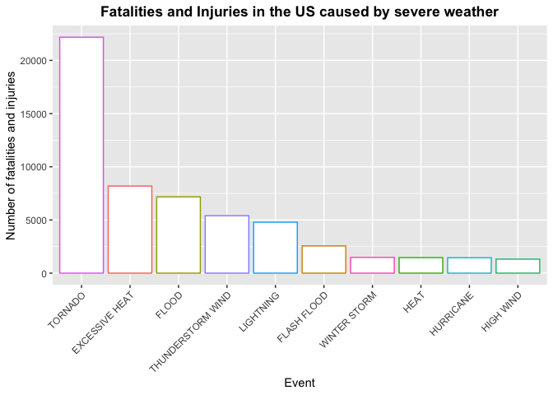
The diagram shows the first 10 most significative events in terms of health impact (injuries and fatalities). The graph shows that
- Tornado are the most significant meteorological event.

Economic cost
economicCost <- stormData %>%
group_by(EVTYPE) %>%
summarise(ECONCOST = sum(ECONCOST)) %>%
arrange(desc(ECONCOST))

ggplot(economicCost[1:10,], aes(x = reorder(EVTYPE, -ECONCOST),
y = ECONCOST / 1e6, colour = EVTYPE)) +
geom_bar(stat = "identity", fill = "white") +
ggtitle("Economic Cost in the US caused by severe weather") +
xlab("Event") + ylab("Economic cost in million USD") +
theme(axis.text.x = element_text(angle = 45, hjust = 1),
legend.position = "none",
plot.title = element_text(hjust = 0.5, face = "bold"))
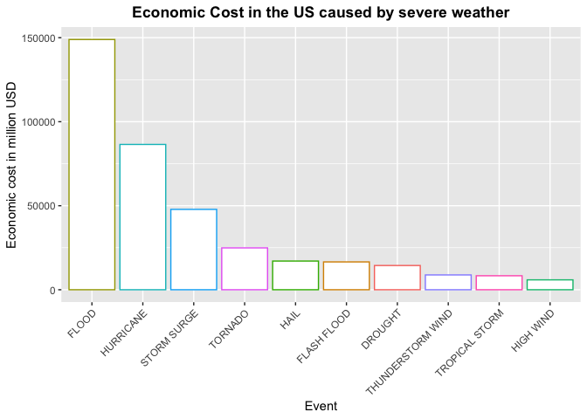
The diagram shows the first 10 most significative events in terms of economic cost. The graph shows that
- Flood are the most significant meteorological event, followed by Hurricane.

