**LIPSA KAR**

**JAVASCRIPT**

<html>

<head>

<meta charset="utf-8" />

<title></title>

</head>

<body>

<form name="textform" onsubmit="return validate()">

<input type="text" id="in" name="random" />

<input type="button" value="button" onclick="validate()" />

</form>

</body>

</html>

Function validate(){

var pannumber=document.(“in).value;

var reg=/^(

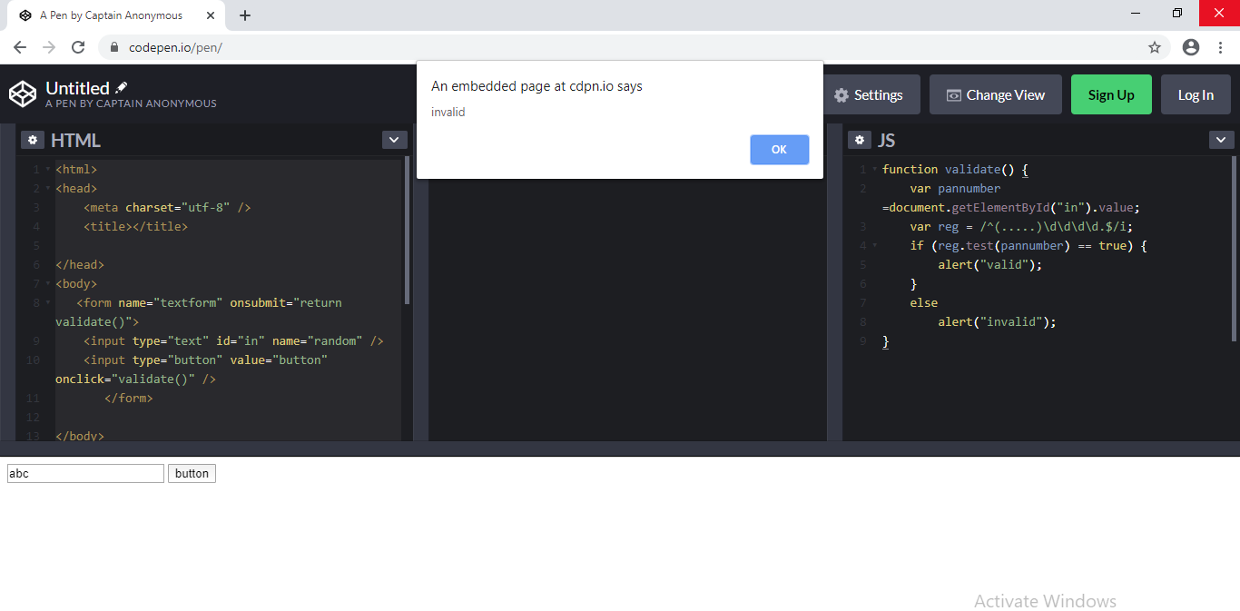

**SQL**

select * from countries

select * from regions

select * from product_categories

select * from employees

select * from productinfo

select * from warehouses

select * from locations

select count(country_id),region_name from regions d inner join countries e on d.region_id=e.region_id group by region_name

select location_id, address, country_name, region_name from countries c inner join regions r on c.region_id=r.region_id inner join locations l on l.country_id=c.country_id

select category_name, sum(standard_cost) from productinfo p inner join product_categories pc on p.category_id=pc.category_id group by category_name

select sum(standard_cost) as Totalcost, product_id from productinfo group by product_id having sum(standard_cost)>2500

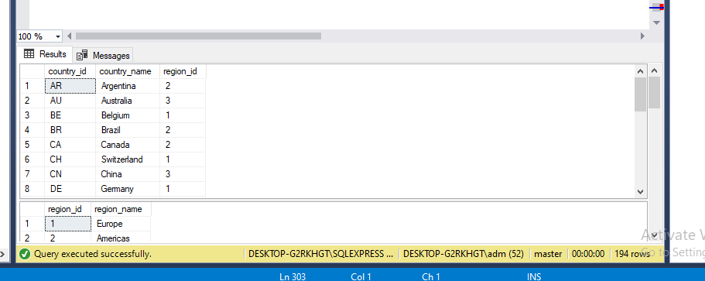

TABLE

<!DOCTYPE html>

<html>

<head>

<meta charset="utf-8" />

<title></title>

</head>

<body>

<table border="1">

<tr>

<th rowspan="2">DeptName</th>

<th colspan="3">Deptno</th>

</tr>

<tr>

<th>Male</th>

<th>Female</th>

<th>Total</th>

</tr>

<tr>

<td>Sales</td>

<td>19</td>

<td>74</td>

<td>93</td>

</tr>

<tr>

<td>Marketing</td>

<td>20</td>

<td>88</td>

<td>108</td>

</tr>

<tr>

<td>Finance</td>

<td>45</td>

<td>54</td>

<td>99</td>

</tr>

<tr>

<td>Account</td>

<td>52</td>

<td>61</td>

<td>113</td>

</tr>

</table>

</body>

</html>

