Q1.<!DOCTYPE html>

<html>

<head>

<meta charset="utf-8" />

<script src="JavaScript.js"></script>

<link href="StyleSheet1.css" rel="stylesheet" />

<title></title>

</head>

<body>

<input name="txtPANCard" type="text" id="txtPANCard" class="PAN" />

<span id="lblPANCard" class="error">Invalid PAN Number</span>

<hr />

<input type="button" id="btnSubmit" value="Submit" onclick="ValidatePAN()" />

</body>

</html>

body {

}

.PAN {

text-transform: uppercase;

}

.error {

color: Red;

visibility: hidden;

}

function ValidatePAN() {

var txtPANCard = document.getElementById("txtPANCard");

var lblPANCard = document.getElementById("lblPANCard")

var regex = /([A-Z]){5}([0-9]){4}([A-Z]){1}$/;

if (regex.test(txtPANCard.value.toUpperCase())) {

lblPANCard.style.visibility = "hidden";

return true;

} else {

lblPANCard.style.visibility = "visible";

return false;

}

}

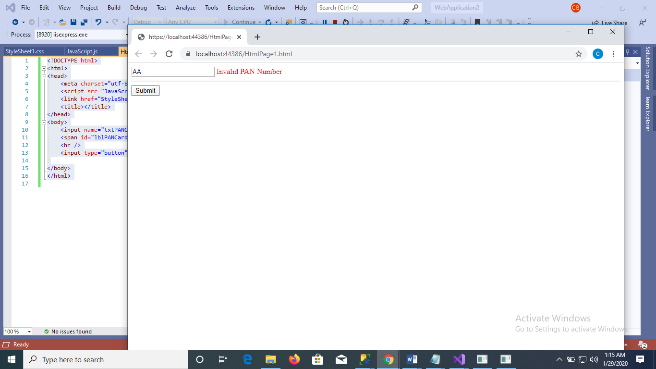



Q2.<!DOCTYPE html>

<html>

<head>

<meta charset="utf-8" />

<link rel="stylesheet" href="StyleSheet1.css">

<title></title>

</head>

<body>

<table>

<tr>

<th rowspan="2">

DeptName

</th>

<th colspan="3">

Deptno

</th>

</tr>

<tr>

<th>Male</th>

<th>Female</th>

<th>Total</th>

</tr>

<tr>

<td>Sales</td>

<td>19</td>

<td>74</td>

<td>93</td>

</tr>

<tr>

<td>Marketing</td>

<td>20</td>

<td>88</td>

<td>108</td>

</tr>

<tr>

<td>Finance</td>

<td>45</td>

<td>54</td>

<td>99</td>

</tr>

<tr>

<td>Accounts</td>

<td>52</td>

<td>61</td>

<td>113</td>

</tr>

</table>

</body>

</html>

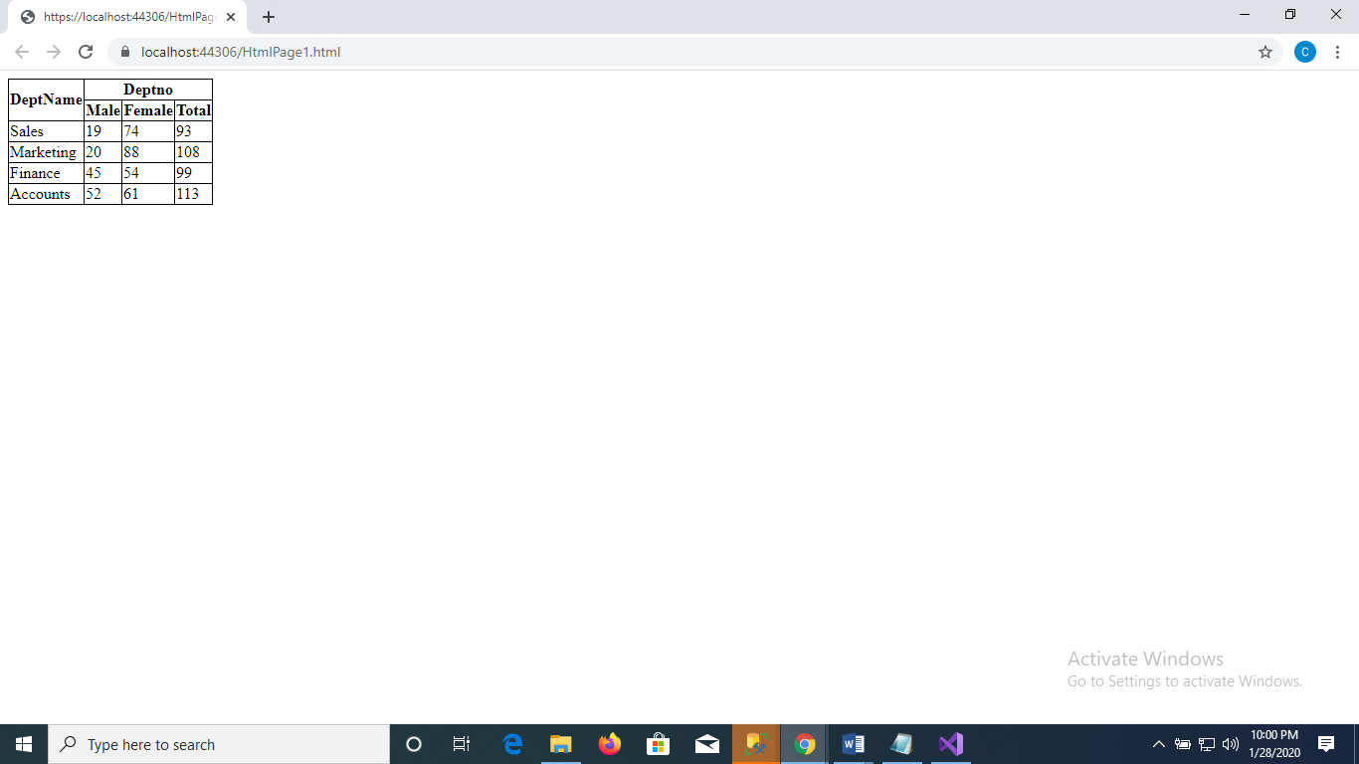

Q3.

(1) --Display the count of countries region_name

select count(country_id) as total_countries,region_name from countries inner join regions on countries.region_id=regions.region_id group by region_name;

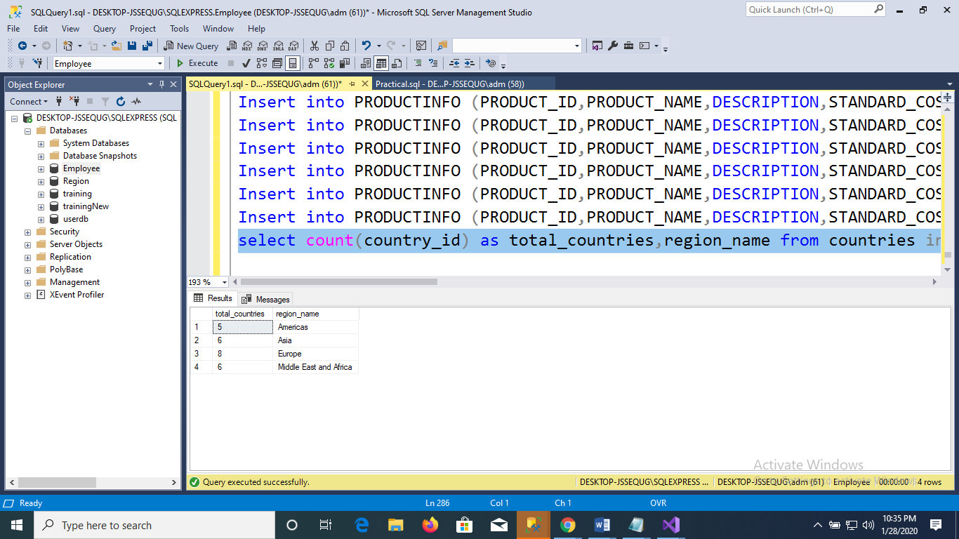

(2) --display location_id,Address,Country_name,Region_name

select location_id,address,country_name,region_name from locations inner join countries on locations.country_id=countries.country_id inner join regions on regions.region_id=countries.region_id;

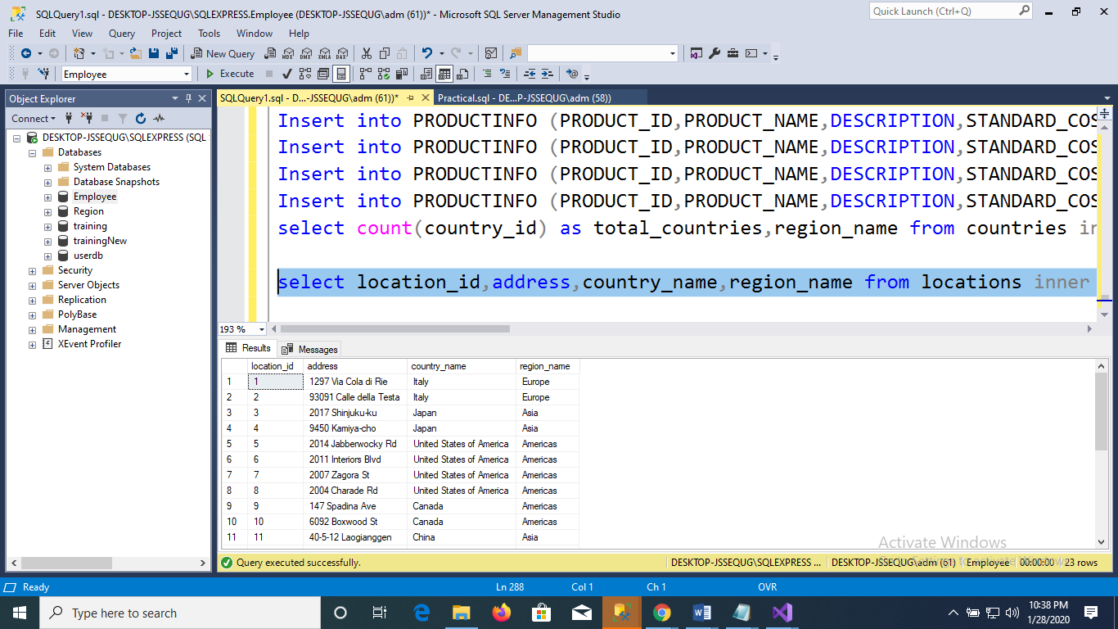

(3).-- Display category_name, Sum of Standardcost

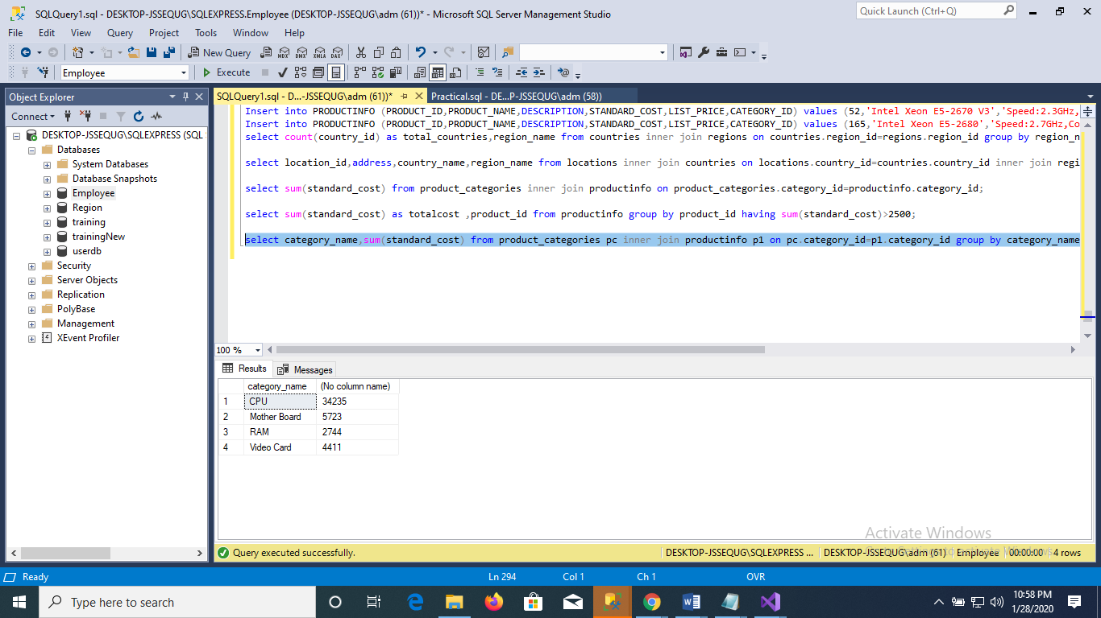

(4) --Find the sum of Standard_cost as Totalcost,product_ID wise whose sum(Standard_cost)>2500;

select sum(standard_cost) as total_cost,product_id from productinfo group by product_id having sum(standard_cost)>2500;

