1. Write a JavaScript program to check whether a string entered in a textbox contains valid PANCARD number or not Format: 5 Character,4 Numbers, 1 Character Ex:- AGSFE1245A

Javascript code

function ValidatePAN() {

console.log("odaiok", pan);

var PANNo = document.getElementById("pan").value;

if (PANNo.value != "") {

var ObjVal = PANNo;

var panPattern = /^([a-zA-Z]{5})(\d{4})([a-zA-Z]{1})$/;

var matchArray = ObjVal.match(panPattern);

if (matchArray == null) {

alert('Invalid PAN Card No.');

return false;

}

else {

alert("accepted");

}

return true;

}

}

Html code

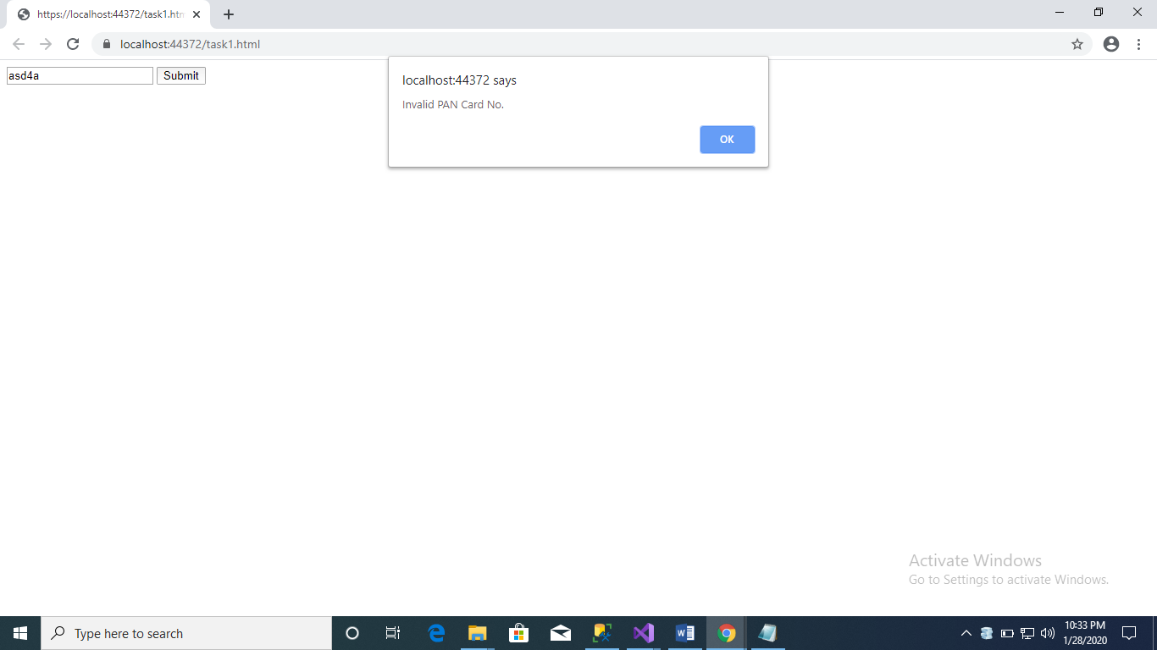

<!DOCTYPE html>

<html>

<head>

<meta charset="utf-8" />

<script src="script1.js"></script>

<title></title>

</head>

<body>

<input type="text" id="pan" />

<button onclick="ValidatePAN()">Submit</button>

</body>

</html>

Ass 2

Html

<!DOCTYPE html>

<html>

<head>

<meta charset="utf-8" />

<title></title>

<link href="StyleSheet1.css" rel="stylesheet" />

</head>

<body>

<table>

<tr>

<th rowspan="2">DeptName</th>

<th colspan="3">Deptno</th>

</tr>

<tr>

<th>Male</th>

<th>Female</th>

<th>Total</th>

</tr>

<tr>

<td>Sales</td>

<td>19</td>

<td>74</td>

<td>93</td>

</tr>

<tr>

<td>Marketing</td>

<td>20</td>

<td>88</td>

<td>108</td>

</tr>

<tr>

<td>Finance</td>

<td>45</td>

<td>54</td>

<td>99</td>

</tr>

<tr>

<td>Accounts</td>

<td>52</td>

<td>61</td>

<td>113</td>

</tr>

</table>

</body>

</html>

--css

table, th, td {

border: 1px solid black;

border-collapse:collapse

}

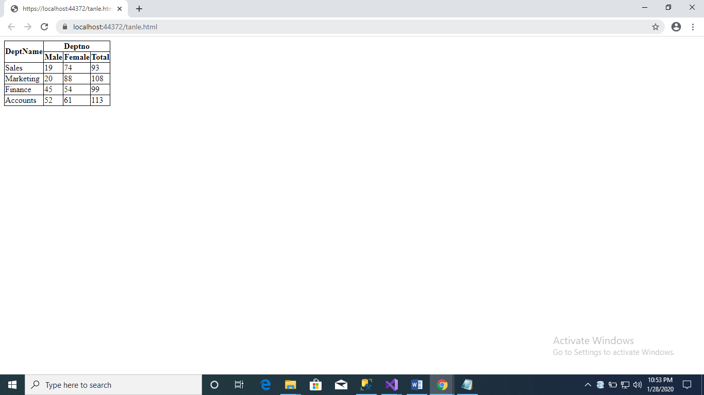

-------------------------------------query----------------------------------------

--display the count of countries region name

select region_name ,count(country_name) from countries c inner join regions r on c.region_id =r.region_id group by region_name

-----second

select location_id,address,country_name,region_name from locations,countries,regions

-------third

select category_name,sum(standard_cost) from productinfo p inner join product_categories pIN ON P.category_id =pIN.category_id group by category_name

-------------------fourth

select sum(standard_cost) as TotalCost,product_id from productinfo group by product_id having sum(standard_cost)>2500

-----------------------------------c#-------------------------------------

using System;

using System.Collections.Generic;

using System.Linq;

using System.Text;

using System.Threading.Tasks;

namespace student

{

public class Student

{

public int StudentNo { get; set; }

public string StudentName { get; set; }

public int Maths { get; set; }

public int Physics { get; set; }

public int Chemistry { get; set; }

public int Total { get; set; }

public int Average { get; set; }

public Student detaul()

{

Console.WriteLine("Enter name of student ");

StudentName = Console.ReadLine();

Console.WriteLine(" MAths number");

Maths = Convert.ToInt32(Console.ReadLine());

Console.WriteLine("physics number");

Physics = Convert.ToInt32(Console.ReadLine());

Console.WriteLine("Chemistry number");

Chemistry = Convert.ToInt32(Console.ReadLine());

Total = Maths + Physics + Chemistry;

Average =( (Maths + Physics + Chemistry)*100)/300;

return this;

}

public void Display(List<Student> stud)

{

foreach(Student no in stud)

{

Console.WriteLine("total:" +no.Total);

Console.WriteLine("average:"+ no.Average);

}

}

public void Scores (List<Student> stud)

{

foreach(Student numb in stud)

{

if (numb.Maths > numb.Chemistry)

{

if (numb.Physics > numb.Maths)

{

Console.WriteLine("Max score {0}", numb.Physics);

}

else

Console.WriteLine("Max score {0}", numb.Maths);

}

else if (numb.Chemistry > numb.Physics)

{

Console.WriteLine("Max score {0}", numb.Chemistry);

}

}

}

}

}

using System;

using System.Collections.Generic;

using System.Linq;

using System.Text;

using System.Threading.Tasks;

namespace student

{

public class Student

{

public int StudentNo { get; set; }

public string StudentName { get; set; }

public int Maths { get; set; }

public int Physics { get; set; }

public int Chemistry { get; set; }

public int Total { get; set; }

public int Average { get; set; }

public Student detaul()

{

Console.WriteLine("Enter name of student ");

StudentName = Console.ReadLine();

Console.WriteLine(" MAths number");

Maths = Convert.ToInt32(Console.ReadLine());

Console.WriteLine("physics number");

Physics = Convert.ToInt32(Console.ReadLine());

Console.WriteLine("Chemistry number");

Chemistry = Convert.ToInt32(Console.ReadLine());

Total = Maths + Physics + Chemistry;

Average =( (Maths + Physics + Chemistry)*100)/300;

return this;

}

public void Display(List<Student> stud)

{

foreach(Student no in stud)

{

Console.WriteLine("total:" +no.Total);

Console.WriteLine("average:"+ no.Average);

}

}

public void Scores(List<Student> stud)

{

foreach(Student numb in stud)

{

if (numb.Maths > numb.Chemistry)

{

if (numb.Physics > numb.Maths)

{

Console.WriteLine("Max score {0}", numb.Physics);

}

else

Console.WriteLine("Max score {0}", numb.Maths);

}

else if (numb.Chemistry > numb.Physics)

{

Console.WriteLine("Max score {0}", numb.Chemistry);

}

}

}

}

}

---------------------------------------------------------------------------------------------------------------------------