**TERM : FALL 2022**

| **Course & Section Code:** | **COMP214** |
| --- | --- |
| **Course Name:** | **Advanced Database Concept** |
|  |  |
| **Q&A / Virtual Office Hour:** | **Sundays** |
| **Instructor Name & Email:** | Ersan Cam  [ecam@my.centennialcollege.ca](mailto:ecam@my.centennialcollege.ca) |

Assigment#2

**Due Date : October 30th**

Instructions for delivery of this Labs file back to instructor.

**Step 1:** Download this word copy of Lab document.

**Step2:** Work on your question in SQL Developer.

**Step3:** Once you solve the problem copy paste the code under each question and Highlight with RED color

**Step4:** Also go to your Sql Developer and capture screen entire screen with command you execute and result at the bottom. Use Snipping tool in windows to capture screen shot. Below picture shows how to open free windows based snipping screen capture tool

Step5: Drop your finalized & saved word document to respective Lab dropbox assignment folder.

**Please note that Instructor has keep the right to call out any students randomly to ask demonstration their solution, and walk thru their work and justify their answers in one on one breakout room.**

**The tool to capture screen shot.**

**Demo Question.**

How to execute Sequence.Nextval command?

Demo Answer:

Copy paste of actual command: SELECT std_seq.NEXTVAL FROM DUAL;

Demo Screen shot:

Copy paste screen shot of same command

**1. Create convertion program from meter to kilometer or vice versa**

In this task, you use nested IF statements. This script converts the value of a distance from one

system to another. If the distance is supplied in mt, it is converted to km, and vice versa.gj,

DECLARE

v_distanceNum NUMBER(8) := '&v_distanceNum';

v_distanceUnit varchar2(8) := UPPER('&v_distanceUnit');

v_convrsnDistance NUMBER(8,5);

BEGIN

DBMS_OUTPUT.PUT_LINE('Please enter the distance :' );

DBMS_OUTPUT.PUT_LINE('Please enter the unit- m or Km :' );

IF v_distanceUnit = ('M')THEN

v_convrsnDistance:=v_distanceNum/1000;

DBMS_OUTPUT.PUT_LINE('The distance in Kilometers is' || ' ' || v_convrsnDistance || 'km' );

ELSIF v_distanceUnit = ('KM')THEN

v_convrsnDistance:=v_distanceNum*1000;

DBMS_OUTPUT.PUT_LINE('The distance in meters is' || ' ' || v_convrsnDistance || 'm' );

END IF;

END;

**2.Create convertion program from Foot(ft) to cm or vice versa**

In this task, you use nested IF statements. This script converts the value of a measurement from one system to another. If the distance is supplied in ft, it is converted to cm, and vice versa.

DECLARE

v_lengthNum NUMBER(8,5) := '&v_lengthNum';

v_lengthUnit varchar2(8) := UPPER('&v_lengthUnit');

v_convrsnLength NUMBER(8,5);

BEGIN

DBMS_OUTPUT.PUT_LINE('Please enter the distance :' );

DBMS_OUTPUT.PUT_LINE('Please enter the unit- ft or cm :' );

IF v_lengthUnit = ('CM')THEN

v_convrsnLength:=v_lengthNum/30.48;

DBMS_OUTPUT.PUT_LINE('The distance in feet is' || ' ' || v_convrsnLength || 'Feet' );

ELSIF v_lengthUnit = UPPER('FT')THEN

v_convrsnLength:=v_lengthNum*30.48;

DBMS_OUTPUT.PUT_LINE('The distance in centimetres is' || ' ' || v_convrsnLength || 'cm' );

END IF;

END;

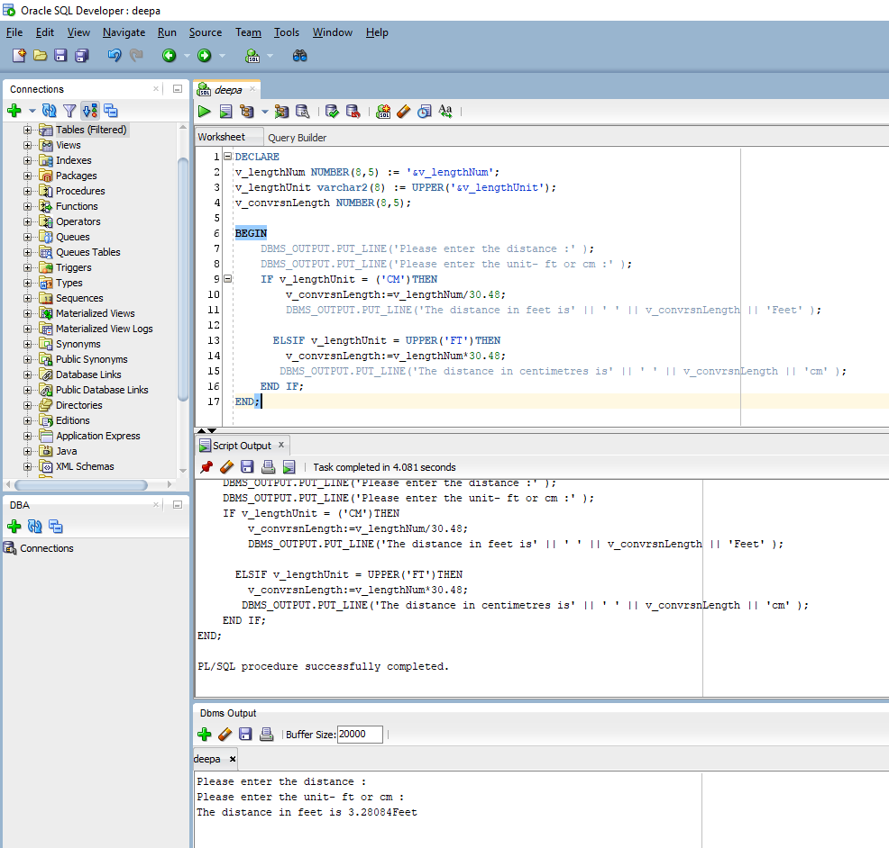

**3.** Before you work on Quesiton 3 , please create a table because you will be inserting numbers in this Messages table

CREATE TABLE messages

( RESULTS NUMBER

)

Run below query to see if there is any data :

SELECT * FROM MESSAGES

Run below query to see if there is any data :

SELECT * FROM MESSAGES

DECLARE

v_num NUMBER(8) :=0;

BEGIN

FOR v_num IN 1..10 LOOP

IF v_num NOT IN (6,8) THEN

INSERT INTO messages(RESULTS)

VALUES (v_num);

END IF;

END LOOP;

END;

SELECT * from messages;

**4) In this task you will ask the end user how many side shape has and based on the entry you will print name of the shape**

For example ;

if user answers 3 for number of side then you need to print Triangle

if user answers 4 for number of side then you need to print Rectangle

if user answers 5 for number of side then you need to print Pentagon

if user answers 6 for number of side then you need to print Hexagon

if user answers 8 for number of side then you need to print Octagon

Anything else other than these numbers print No shape available

DECLARE

v_sides NUMBER(8) := '&v_sides';

BEGIN

DBMS_OUTPUT.PUT_LINE('Please enter a number:');

IF v_sides = 3 THEN

DBMS_OUTPUT.PUT_LINE('You have entered three sides.The shape is a Triangle' );

ELSIF v_sides = 4 THEN

DBMS_OUTPUT.PUT_LINE('You have entered four sides.The shape is a Square' );

ELSIF v_sides = 5 THEN

DBMS_OUTPUT.PUT_LINE('You have entered five sides. The shape is a Pentagon' );

ELSIF v_sides = 6 THEN

DBMS_OUTPUT.PUT_LINE('You have entered six sides. The shape is a Hexagon' );

ELSIF v_sides = 7 THEN

DBMS_OUTPUT.PUT_LINE('You have entered seven sides. The shape is a Heptagon' );

ELSIF v_sides = 8 THEN

DBMS_OUTPUT.PUT_LINE('You have entered eight sides. The shape is a Octagon' );

ELSE

DBMS_OUTPUT.PUT_LINE(' The sides entered is out of range. No Shape available');

END IF;

END;

**5.** **Ask the user their name and how many times they want to output their name (using a for loop).**

Hint:

*DECLARE*

*v_name varchar(50) := '&name';*

*v_hmtimes number :=&numb;*

*BEGIN*

*FOR i IN 1.XXXXX LOOP*

*END LOOP;*

*END;*

DECLARE

v_name varchar(20) := '&name';

v_hmtimes number(8) := '&numb';

BEGIN

DBMS_OUTPUT.PUT_LINE('Please enter your name:');

DBMS_OUTPUT.PUT_LINE('Please enter the number of times you want to output your name');

FOR i IN 1..v_hmtimes LOOP

DBMS_OUTPUT.PUT_LINE(v_name);

END LOOP;

END;

