

**CPQ & Fusion Modeling Integration**

**Business Requirements**

Author: Chris Peterson

Feb. 2020

Contents

1 Overview 3

2 Problem Statement 4

3 Solution Overview 5

4 High Level User Experience 6

5 Scope 7

5.1 In Scope 7

5.2 Stretch Scope 7

5.3 Out of Scope 7

6 Anticipated Questions 8

7 User Stories (Stack Ranked) 9

8 Reporting Requirements 12

9 Primary Integration Pathways & Building Blocks 13

10 Conceptualization & Existing Examples 14

# Overview

Our goal is to help drive sales, increase velocity and field efficiency by streamlining Sizing, Design and Quoting workflows across NetApp’s product portfolio.

This phase and these requirements are focused on integrating the most popular features from Fusion’s modeling capabilities and incorporating those features directly into CPQ. Users of CPQ will be able to request technical details related to their configurations, and eliminate the need to use Fusion separately for the majority of use cases.

This initial step of integrating Fusion Technical Modeling capabilities with CPQ is only one of many, to help us reach this vision:

* Provide a unified and seamless experience for Sizing and Configuring using the new CPQ platform.
* Transition from being product focused to solution focused recommendations, supporting NetApp’s Data Fabric vision.

Solutions may consist of multiple products across NetApp’s portfolio best satisfying the Customer’s needs.

* Simplify, evolve and incorporate the most used features and capabilities of our Sizing and Modeling services into the CPQ user experience.

# Problem Statement

Multiple, disjointed tools result in designs that are not quotable, increase repetitive steps and potential for error.

In the design phase, Solution Engineers do not have the full configuration abilities and pricing information necessary to quickly determine the best solution.

During the quoting phase, Sales Reps do not have enough technical information to understand and present the full solution.

# Solution Overview

Today, users manually design their configurations in Fusion to better understand and share the technical details of the solution. These technical details are often incorporated with sales proposals to help the Customer understand the full value of what NetApp is providing.

Integrating the most used features and capabilities of Fusion’s manual design workflow directly into CPQ will save Account Teams time and reduce the potential for errors.

Fusion’s manual design workflow accounts for most use cases (78%), and its technical modeling capabilities and features align with and complement the CPQ Configurator.

# High Level User Experience

* User – Enters CPQ – Configurator
* User – Configures an ONTAP solution for Pricing & Quoting
* User – Clicks on “Technical Details” button
  + CPQ API – Sends Configuration to Fusion
  + Fusion API – Sends Technical Detail Response to CPQ
* User - Is presented the following technical details in CPQ
  + Capacity Details
  + Environmental Details
  + Storage Layouts
* User – Is given the option to produce Technical Reports from CPQ

# Scope

## In Scope

* Supports CPQ ONTAP CTO & Express Packs
* Fusion API receives CPQ Configuration
* Fusion API responds with Technical Details
* CPQ presents technical details to the User
* Fusion provides Reporting Services
* CPQ provides the ability to produce technical reports
* Fusion models the CPQ Config as a Project for User Advanced Use Cases

## Stretch Scope

* CPQ HCI Configurator Integration
* CPQ MetroCluster Configurator Integration
* Performance Modeling with Default Workload Characteristics (SPM ONTAP Reverse Sizer)

## Out of Scope

Post Phase 1 Scope will be determined based on success, feasibility and demand

* Fusion - ONTAP Tech Refresh Workflows
* Fusion - ONTAP Size & Recommend Workflows
* Fusion – ONTAP Legacy System Modeling

# Anticipated Questions

**Is Fusion going away?**

* Fusion will remain available, until critical features are evolved, simplified and integrated with CPQ
* Critical feature includes components of:
  + Size & Recommend – Ability to take Customer workload needs, and size and recommend ONTAP solutions
  + Tech Refresh – Ability to import Install Base details, and recommend replacement solutions
  + Modify/Expand – Ability to import install Base details, and allow modifications to the configuration
  + Parity Gaps with CPQ – Use cases not covered by CPQ, may be covered by Fusion until parity is reached
  + Legacy System Modeling – Ability for users to model configurations that are no longer available for sale

**Will the CPQ configurator be as efficient as Fusion for iterating over multiple configs?**

* CPQ is much more agile and responsive than the legacy QuoteEdge system
* CPQ may not provide the user the flexibility to design multiple clusters in a single instance, which is a use case we see commonly modeled in Fusion
* CPQ will allow users to design a Cluster in a single instance and save that template
* In some ways, CPQ will be more efficient
  + The user will be able to include other components of the Cluster that Fusion does not support (Switches, Cards, Cables, Etc…)
  + CPQ will ensure that what is designed is Quotable
  + CPQ will allow the user to see pricing details, when the configuration is saved and moves back into the QuoteEdge Pricing

**Based on this integration plan, what known Manual Design feature gaps will exist, which may drive users to Fusion?**

|  |  |  |
| --- | --- | --- |
| **Fusion Manual Design Feature** | **Fusion Adoption** | **Notes** |
| Customized storage layouts (RAID, Aggrs, etc…) | 27% | •       This is one of the most complicated user experiences to replicate, and is out of scope for phase 3 (*see Addressing the Gaps*) |
| Accepts detailed workloads for Performance Analysis (Reverse Sizing) | 12% | * Redefine the requirements for Reverse sizing to better meet the needs of the business * This will be a stretch goal for Phase 3 |
| Accepts basic workloads for Storage Efficiency Analysis | 5% | •       The need for this feature is diminished based on NetApp’s new Storage Efficiency guidelines |
| Generate a Rack Diagram Report | 4% | •       If leveraging Fusion reporting services is possible, this feature may be possible |

**What can the user do, when they would like to use Fusion features unavailable in CPQ?**

* When the CPQ solution requests Technical Details from the Fusion API, the Fusion API will model that request as a project under the user SSO ID.
* If that user wishes, they can open Fusion and the project for more advanced use cases

# User Stories (Stack Ranked)

|  |  |  |
| --- | --- | --- |
| User Stories | MVP | Team(s)  Owners |
| As a CPQ User, I would like to see critical technical details (Capacity, Environmental, Storage Layouts, Performance) similar to what Fusion delivers, to ensure the full configuration is correct.  Acceptance Criteria:   * Upon configuring core product stack requirements, allow user to manually request technical details * Render technical details for the user * User should be able to do this without completing all required inputs for the Configuration (i.e. Support, Training, Switches, Etc…) | yes | **Team(s):**  CPQ  Fusion  EPIC  **LOE Lead:**  Mark K |
| As a CPQ User, in the event of a problem retrieving Technical Details, I do not want my ability to Configure, Price & Quote a solution to be inhibited, because moving the sales opportunity forward without delay is mission critical.  Acceptance Criteria:   * In the event the Technical Details API is unavailable or results in an error,   do not block the user from completing their Configure, Price & Quoting   * Handle the errors gracefully and provide a user-friendly message to the user | yes | **Team(s):**  CPQ  **LOE Lead:**  Jyotsna |
| As a CPQ User, without an opportunity, I need to build a configuration in CPQ and start working on a prospect’s solution, as early as possible  Acceptance Criteria:   * Allow the user to create and save a configuration in CPQ without an Opportunity or Quote * Provide a user-friendly URL, for users to navigate to | yes | **Team(s):**  CPQ  **LOE Lead:**  Jyotsna |
| As a CPQ User, I need the ability to create a technical proposal to include with my quotes without engaging another person, or entering the sales configuration in a separate tool, which will save time and reduce errors  Acceptance Criteria:   * From CPQ, Allow the user to generate Technical Assessment Report or Rack Diagrams * Rack Diagram - May be a requirement conflict with cable logic CPQ is implementing | yes | **Team(s):**  Fusion  CPQ  **LOE Lead:**  Mark K |
| As a CPQ User, I would like to understand the Discounted or Before Discounting cost of the configuration before an opportunity is created to ensure it meets my Customer’s budgetary constraints, because I often start working on designing solutions in advance of Deal Registration and Opportunity Creation  Acceptance Criteria:   * In CPQ, show list price “Before Discounting Price” of the Configuration * Stretch goal - Show entitled discounting | yes | **Team(s):**  CPQ  **LOE Lead:**  Jyotsna |
| As an Advanced User, in situations when CPQ does not allow me to perform advanced modeling activities on a configuration, I need the ability to efficiently perform modeling in Fusion without reentering the configuration built inside CPQ  Acceptance Criteria:   * Create a Fusion project associated to the requesting CPQ user * The Fusion project should be named and tagged in such a way that it relates closely to the CPQ/Quote configuration * The CPQ user should be able to access the project inside Fusion and make any necessary modifications * Multiple requests from the same CPQ configuration without changes to the CPQ configuration, should not create or overwrite previously created projects * Multiple requests from the same CPQ configuration with changes to the CPQ configuration, should create new project IDs and add a “Rev.” # to the Project Name (i.e. CPQ ID: 1234 - {NAME} – Rev. 2)   UX Discussion Points:   * What should be returned if a Fusion user modifies a previously Technically sized project? * Can Fusion make Technically Sized project’s Physical Configs – Read Only * Can Fusion allow the non-Physical Configs to be modified (i.e. Aggregates, Workloads, Etc…) | yes | **Team(s):**  Fusion  **LOE Lead:**  Mark K |
| As a CPQ User, I would like an alert to changes in the CPQ configuration that are no longer aligned with what was previously technically sized, so I can request updated technical details to ensure alignment.  Acceptance Criteria:   * If the CPQ user requests Technical Details, and then alters the Core Configuration   + Invalidate the previously rendered Technical Details   + Alert the user they will need to be requested again | yes | **Team(s):**  CPQ  **LOE Lead:**  Jyotsna |
| As a Legacy Fusion User, I would like the technical details presented to me from CPQ in a fashion that is familiar and intuitive, so I don’t have a difficult time adjusting to and learning an entirely new experience  Acceptance Criteria:   * Provide a similar look/feel of Fusion, so CPQ users are not confused * Provide Aggregated Cluster details and Individual HA Pair details similar to Fusion (see conceptualization) | yes | **Team(s):**  CPQ  **LOE Lead:**  Jyotsna |
| As a Fusion Modeling Service, configurations shared by CPQ should be easily transformed into a modeled solution for technical sizing, so there is minimal chance for error and failures  Acceptance Criteria:   * Requests to the Fusion Modeling service should used common data keys and product structures, so they can be easily transformed | yes | **Team(s):**  CPQ  Fusion  EPIC  **LOE Lead:**  Mark K |
| As a CPQ API, technical details shared in the Fusion response should be easily transformed and presented to users, so there is minimal chance for error and failures  Acceptance Criteria:   * Responses from the Fusion Modeling service should use common data keys and product structures, so they can be easily transformed | yes | **Team(s):**  CPQ  Fusion  EPIC  **LOE Lead:**  Mark K |
| As a CPQ User, I would like to be made aware of what hardware is not accounted for in the environmental details, so it is clear in the Technical Proposals (i.e. Switches, Cabinets, Etc…)  Acceptance Criteria:   * Notifications in both the UI and Report indicating what hardware is not accounted for in the Environmental details | yes | **Team(s):**  CPQ  Fusion  **LOE Lead:**  Joint |
| As a Solution Architect, I need the ability to share a saved CPQ template id with a Quoting Specialist for use in quotes, as I may design the solution, but I do not build the quotes.  Acceptance Criteria:   * Allow CPQ users the ability to share saved configuration template IDs with other users * Other users should be able to build quotes using that template IDs to their own quotes | yes | **Team(s):**  CPQ  **LOE Lead:**  Jyotsna |
| As a Sales Team, I would like to see estimated performance profiles based on common workload profiles, so I can show performance estimates similar to our competitors.  Acceptance Criteria:   * Basic performance measurements (IOPS, Throughput & Avg Utilization) * Based on three common performance profiles * Does not require the user to enter workload details * Include performance details in Fusion API Response * CPQ render performance details along with other Technical Details | stretch | **Team(s):**  Sizer  CPQ  **LOE Lead:**  Syam |
| As a CPQ User, in addition to standard ONTAP AFF/FAS solutions, I would like similar capabilities for HCI, so I don't have to use multiple tools.  Acceptance Criteria:   * Match workflow/user stories proposed for AFF/FAS | stretch | **Team(s):**  CPQ  Fusion  EPIC  **LOE Lead:**  Joint |
| As a CPQ User, in addition to standard ONTAP AFF/FAS solutions, I would like similar capabilities for All SAN Array, so I don't have to use multiple tools.  Acceptance Criteria:   * Match workflow/user stories proposed for AFF/FAS | stretch | **Team(s):**  CPQ  Fusion  EPIC  **LOE Lead:**  Joint |
| As a CPQ User, in addition to standard ONTAP AFF/FAS solutions, I would like similar capabilities for MetroCluster, so I don't have to use multiple tools.  Acceptance Criteria:  Match workflow/user stories proposed for AFF/FAS | stretch | **Team(s):**  CPQ  Fusion  EPIC  **LOE Lead:**  Joint |
| As a CPQ User, I would like other non-core stack hardware accounted for in the Environmental details (Switches, Racks, Etc…).  Acceptance Criteria:   * In addition to core stack hardware, pass other hardware that impact environmental details to Fusion Modeling API * Fusion modeling API return environmental details for additional hardware along with core stack | no | **Team(s):**  CPQ  Fusion  **LOE Lead:**  Fusion |
| As a Sales Rep, I would like to produce technical reports from the quote generation area, so I do not have to return to the Configurator  Acceptance Criteria:   * Allow QuoteEdge users the ability to generate the Technical Proposals | no | **Team(s):**  ConfigEdge  **LOE Lead:**  Jyotsna |

|  |  |  |
| --- | --- | --- |
| As a CPQ User, I need the ability to share a saved CPQ template with a colleague for use in other quotes, as this will save time and reduce the chance for errors  Acceptance Criteria:   * Allow CPQ users the ability to share saved configurations with other users * Other users should be able to manipulate or add saved templates to their own quotes * Other users should be able to request technical details on the shared templates | no |  |

# Reporting Requirements

|  |
| --- |
| Metrics |
| For reporting purposes, the ability to link:   * CPQ Configuration ID * Fusion Project ID * Quote ID (optional) * Opportunity ID (optional) * ~~Sales Order ID (optional)~~ |
| How often users request Technical Details   * For CPQ Projects that Qualify, how many do or do not use Technical Details |
| How often users generate Technical Reports and which ones |
| How often an API failure occurs and the failure reason |
| How often a technically validated, configuration is priced, quoted and booked |
| How often are users modifying Fusion CPQ Projects & Why |
| Service health reporting |

# Primary Integration Pathways & Building Blocks

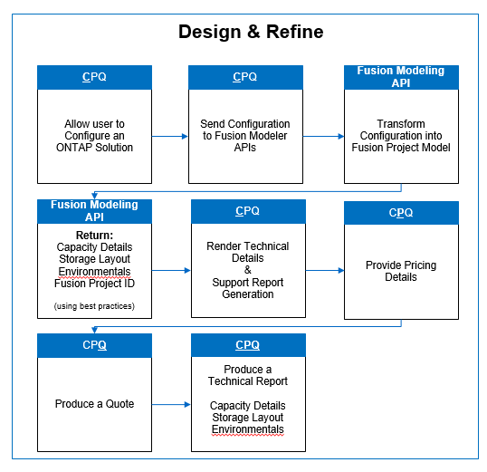

# Conceptualization & Existing Examples

CPQ Concept: Ability to request Technical Details

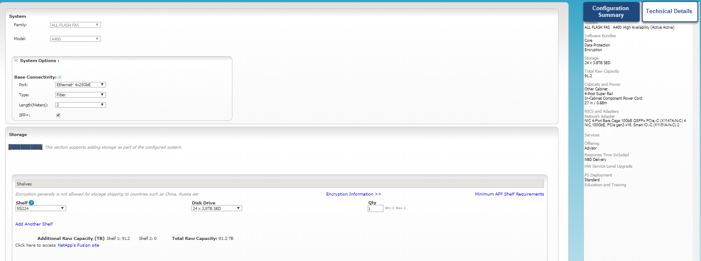

CPQ Concept: Ability to render those Technical Details & Produce a Report

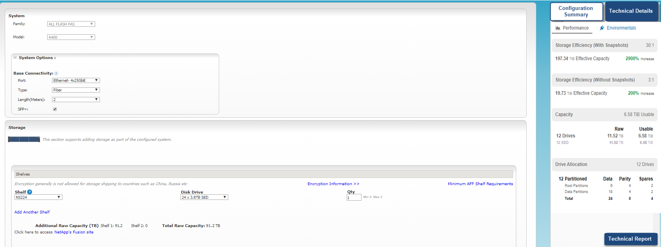

Aggregated Cluster Level Details and Individual HA Pair Details

|  |  |  |
| --- | --- | --- |
| Cluster Level | A300 HA Pair | A220 HA Pair |
|  |  |  |