LAB- running basic commands

STEP 1 – Running basic docker commands

To pull a docker image use docker pull ubuntu

To run the container, run docker run ubuntu

You should observe ubuntu container start and also stops immediately

Now run docker ps to see all the running containers. You should not see any running containers. To see all the containers Running and Not Running, execute docker ps –a

Now we want to run a nginx container. Execute docker run nginx. Nginx container will start in foreground. You should see all the logs. If you want to get command prompt, press CTRL+C.

Is the container stopped once u press CTRL+C ?

Run docker ps and observe that this nginx container is still up.

Now stop the nginx container using docker stop <<containerid>> . To get container id, run docker ps and observe.

Run docker ps and see that nginx container is not listed. If u want to see all conainers (running and not running) use docker ps –a

If u want to run the stopped container again, docker start <<containerid>>

If u want to remove a container completely, use docker rm <<containerid>>

use docker rm –f <<containerid>> to forcefully remove container even if it is running

if we run ubuntu container using docker run ubuntu, it will terminate immediately.

After starting container, if we want to run a command like sleep 20, use “docker run ubuntu sleep 20”

execute docker run –it ubuntu bash to get the bash shell prompt in the container.

Once u get the bash shell of the container, u can execute and commands inside the container.

I want to see the ubuntu release version in the container. So, execute cat /etc/*release*

You should observe the ubuntu version in the output

To come out of bash shell, type exit

If you want to give a name to the container, use a command like below:

docker run --name mynginx –d nginx

Can you tell what is the meaning of –d option in the above command?

To remove an image, we can use docker rmi <<imagename>

Now try to remove ubuntu image forcefully. (Hint : use –f option to remove forcefully)

If we want to run a command on existing container, use
docker exec <<containerid>> command

Try the following docker exec –it <<containerid>> bash

STEP 3 – Create your first Image

We want a custom nginx image which contains tools like ping, ip so that we can see the ip of container and ping one container from another.

Open nginx-dockerfile-v1 inside 01-ubuntu-with-ping-ip folder and observe that it contains following lines:

from nginx

RUN apt-get update && apt-get install iputils-ping -y && apt-get install iproute2 -y

COPY ./staticfiles-v1/hello.html /usr/share/nginx/html/hello.html

Now cd to 01-ubuntu-with-ping-ip folder

Run the following command to build image

docker build -t mynginx . -f nginx-dockerfile-v1

Now you should be able to see your images listed if u execute docker images

Now we want to run a container of this image and find its ip.

Execute following commads to start 2 containers of mynginx:

docker run –d --name nginx1 mynginx

docker run –d --name nginx2 mynginx

Now attach to bash shell of nginx1 using
docker exec –it nginx1 bash

Once u are in bash shell execute ip addr show and see the ip.

Do the same with nginx2 and get its ip.

Now from bash terminal of nginx2, try to ping ip of nginx1 and observe that ping should be successful because all the docker containers created in this host will be part of a NAT Network

Now delete nginx2 container using docker rm –f nginx2

Create another nginx2 container now with link option as shown below:

docker run –d --name nginx2 –link nginx1:nginx1 mynginx

Now execute the following to get the bash terminal of nginx2

docker exec –it nginx2 bash

Now execute cat /etc/hosts at bash terminal and observe that ip of nginx1 is mapped with name nginx1

So, you will be able to ping nginx1 from nginx2 using name with below command:

ping nginx1

STEP 3 – Using Port Mapping, inspecting container and getting logs

As we are using Docker toolbox, you containers are running inside VirtualBox in a Linux VM.

How to get ip of the machine?
Execute following command:

docker-machine ip

Nginx will be listening for requests at port 80 inside the container. We need to configure port forwarding to forward requests from host to containers

Use the below command docker run –p 8080:80 -d --name mynginx nginx

Now you will be able to see index page of nginx by hitting http://192.168.99.100:8080

Here 192.168.99.100 is assumed to be ip of linux vm in which our containers are running

Now i want to see all the details of my container. So, use the following command:

docker inspect <<containerid/name>>

Now start a mysql container.

See the documentation at https://hub.docker.com/_/mysql

Accoring to documentation, this mysql image is configured to store data at /var/lib/mysql inside the container.

If we want to mount a directory on host machine to this /var/lib/mysql inside container, use the –v option as shown below:

docker run --name siva-mysql -e MYSQL_ROOT_PASSWORD=root –d –p 3306:3306 –v mysqlvolume:/var/lib/mysql mysql

Observe how we are passing environment variables to containers

Above command will automatically create a volume with name mysqlvolume on the host machine and mount it to /var/lib/mysql of the container

Now, execute following command to list all the volumes

docker volume ls

To inspect a volume, use the below command:

docker volume inspect mysqlvolume
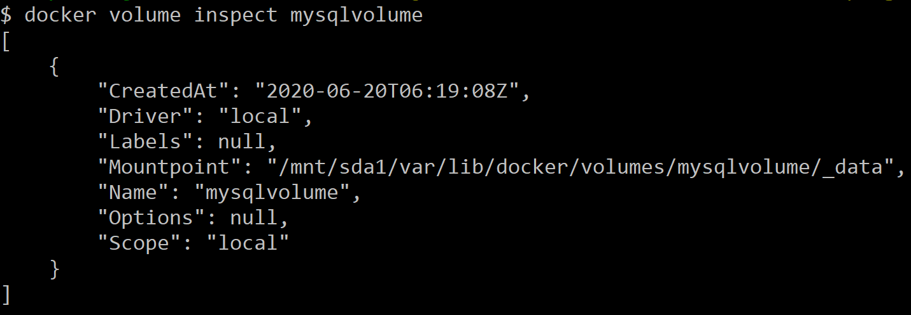

We can ssh in to the linux machine where our containers are running using below command:

docker-machine ssh

Once you do ssh into linux vm,

execute sudo ls /var/lib/docker/volumes and view that there is a folder with name mysqlvolume

To see logs of a container use

docker logs <<containerid/name>>

