Figure 1: Workflow of the proposed sentiment analysis medicine recommendation system

Figure 2: Architecture of sentiment lexicon enhanced aspect-aware attention enclosed multi-task learning transformer

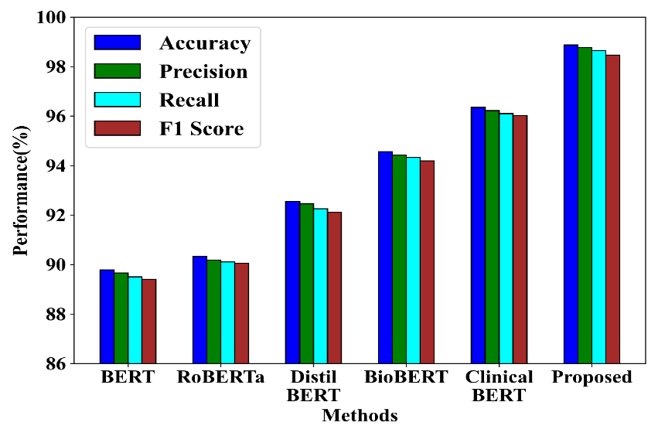
Figure 3: Sentiment analysis performance validation of proposed approach with existing models

