AWS European Sovereign Cloud

Initial Landing Zone OU Structure Deployment
GitHub Branching Strategy

Trunk-Based Development with Protected Release Branches and Controlled Backport Promotion
Document Version | 2
Status | Client Review Draft
Reference Scenario | Initial Landing Zone OU Structure Deployment
Deployment Environments | Staging AWS Organization and Production AWS Organization
Prepared For | Client Cloud Platform, Security and Architecture Teams

Purpose: Define the complete branch lifecycle from feature development through release, Staging validation, Production deployment, pre-Production remediation, and Production hotfix execution using temporary backport branches so that protected release branches never receive direct commits.

1. Purpose and Context
This document describes the proposed GitHub branching and deployment model for the first deployment of the AWS Landing Zone OU structure. The model removes the long-lived develop branch and adopts trunk-based development with short-lived feature branches, protected release branches, temporary backport branches, and a controlled hotfix path.
The objective is to provide a simple and auditable flow in which main remains the central integration branch, release branches represent protected deployable and supportable production baselines, and any approved correction is first integrated into main and then promoted to an active release through a temporary backport/* branch and reviewed pull request. This prevents direct commits to release/* while preserving a complete audit trail.

2. Executive Summary (Proposed Branching and Deployment Approach)
This section provides a summary of the proposed branching and deployment approach for the AWS European Sovereign Cloud Landing Zone implementation.
The proposed branching model keeps main as the single integration branch and removes the long-lived develop branch. This approach reduces branch divergence, simplifies hotfix management, and aligns release promotion with modern trunk-based development practices. Short-lived feature/* and hotfix/* branches are created from main and merged back only after CI and required reviews. When a Landing Zone deployment phase is ready, a protected release/* branch is created from an approved and validated main commit and is used for both Staging and Production deployment. The release/* branch remains protected from direct commits; any subsequent approved correction is introduced through a temporary backport/* branch and PR into the active release branch.
The release is first deployed to the Staging AWS Organization using staging.yaml. Staging creates and validates the complete OU hierarchy and one test workload account under each Prod and Non-Prod OU in Hybrid, Online and Corp. Once OU structure, SCP, account, IAM, KMS, logging, security, compliance and idempotency checks pass, the release proceeds through Architecture, Security, Platform and CAB approvals.
If issues are identified during Staging validation before the release has been deployed to Production, changes must not be committed or cherry-picked directly to the active release/* branch. The fix is implemented through a feature/fix branch and merged into main following the standard PR, review, and CI validation process. A temporary backport/* branch is then created from the active release branch (for example, backport/lz-v1.0.0-staging-fix). Only the approved fix commit from main is cherry-picked into the backport branch. A pull request is raised from backport/* to the active release/* branch, where CI checks, review, and approval must pass before merge. The approved merge to release/* triggers redeployment to Staging for revalidation. This stabilization cycle may be repeated until Staging validation passes. No new release version is created for issues identified before Production; release/lz-v1.0.0 remains the release candidate and, after successful Production validation, is tagged lz-v1.0.0.
Production is then deployed from the same protected release branch and commit SHA using production.yaml. Environment-specific account data, organization identifiers, account IDs, role ARNs, and logging or KMS references may differ; however, the CDK code, release branch, commit SHA, deployment pipeline, and governance controls remain unchanged.
If a post-production correction (hotfix) is required after a release has been deployed to Production, the hotfix is implemented through hotfix/* and merged into main. A temporary backport/* branch is created from the active release branch, only the specifically approved hotfix commit(s) from main are cherry-picked into it, and a reviewed PR is raised to the protected release/* branch. The merged release is validated in Staging, approved through the emergency/expedited change process, and manually deployed to Production. This results in a new patch version, for example lz-v1.0.1.
Only the specific approved fix/hotfix commit is carried through the temporary backport/* branch. Unrelated commits from main are not included, and release/* never receives a direct cherry-pick or direct commit.
This ensures that main remains the source of truth while preventing unrelated changes already present in main from being included in the current Production release.

3. Initial Landing Zone Deployment Scope
The initial deployment reference includes the following Landing Zone capabilities:
- Definition and deployment of the approved AWS Organizations OU hierarchy.
- Creation of mandatory shared accounts such as Security/Audit/Tooling, Log Archive, Network, and Shared Services where approved.
- Creation of one test workload account under each Prod and Non-Prod OU beneath Hybrid, Online, and Corp for initial validation.
- Attachment of approved Service Control Policies to the correct OU levels.
- Deployment of baseline IAM roles and permissions, including deployment and break-glass access patterns.
- Configuration of KMS, centralized logging, security baseline, compliance controls, and validation checks.
- Validation of repeatable and idempotent deployment behaviour before Production promotion.

4. Branching Model Overview
Purpose: Define the complete branch lifecycle from feature development through release, Staging validation, Production deployment, pre-Production remediation, and controlled Production hotfix execution.
The proposed model uses five branch types. Each branch has a distinct purpose, protection model, and deployment responsibility.
Branch Type | Created From | Primary Purpose | Deployment Behaviour | Lifecycle
main | N/A | Central integration branch and source of all future development | CI validation only; no direct Production deployment | Permanent and protected
feature/* | main | Short-lived implementation of OU, SCP, account, logging, KMS or security changes | CI checks and PR validation only | Deleted after merge
release/* | Approved and validated commit from main | Stabilization, Staging validation and Production deployment | Initial creation of release/* automatically triggers Staging deployment. After creation, only an approved PR merge from backport/* may update release/* and trigger Staging redeployment. Production deployment occurs only after successful Staging validation and required approvals. No direct commits or direct cherry-picks. | Retained while active/supported and retired after the support period expires
backport/* | active protected release/* branch | Temporary promotion branch used to carry only approved fix/hotfix commit(s) from main into the active release baseline | No AWS deployment. Approved commit(s) are cherry-picked from main into backport/*, then promoted to release/* only through PR + CI + review + approval. The approved PR merge to release/* triggers Staging redeployment. | Deleted after successful merge to the active release/* branch.
hotfix/* | main | Urgent correction to the version currently running in Production | No direct deployment. The hotfix is merged to main first; the approved hotfix commit is then carried through backport/* -> approved PR -> release/*. The approved release/* update triggers automatic Staging deployment; Production follows only after validation and required approvals. | Deleted after merge to main. The temporary backport/* branch is separately deleted after merge to release/*.

Purpose of the Backport Branch
The temporary backport/* branch exists to preserve release branch protection while enabling the controlled promotion of approved fixes from main into an active release/* branch. By creating the backport branch from the active release branch and cherry-picking only the approved fix or hotfix commit(s), the release baseline remains stable and protected. This approach ensures that only the approved change set is introduced into the release branch without including unrelated changes that may already exist in main. The backport branch also enables pull request review, CI validation, approval workflows, and complete audit traceability before the change is merged into the protected release branch.

5. Complete Branch Flow (Updated)

main (protected Integration Branch)
|
+-- feature/ou-structure or feature/fix-*
+-- feature/scp-baseline
+-- feature/logging
+-- feature/kms
+-- feature/security-baseline
|
+-- CI checks + PR reviews
|
v
main
|
+-- Post-merge CI / Integration Validation
|
+-- Create protected release branch from Approved and validated main commit
v
release/lz-v1.0.0 (Protected Release Branch – NO DIRECT COMMITS)
|
+-- Release branch creation event triggers GitHub Actions Staging Deployment
|
+-- Deploy using staging-deploy.yml to Staging AWS Organization
|
+-- Uses staging.yaml
|
+-- Deploy to Staging AWS Organization
|
v
STAGING VALIDATION
|
+-----------------------------+
| |
| NO ISSUES | ISSUES IDENTIFIED
| |
v v
Architecture / Security / Create feature/fix branch from main
Platform / CAB Approval |
| +-- feature/fix-staging-issue
| |
| +-- Implement Fix
| |
| +-- CI Checks
| |
| +-- PR and Merge to main
| |
| +-- Review + Approval
| |
| v
| main
| |
| +-- Merge Approved fix
| |
| +-- Post-merge CI validation
| |
| +-- Identify Approved Fix commit(s)
| |
| v
release/lz-v1.0.0
| |
| |
| v
| backport/lz-v1.0.0-staging-fix
| |
| +-- Cherry-pick ONLY the approved fix commit(s) from main into backport/*
| |
| +-- CI Checks
| |
| +-- PR backport/lz-v1.0.0-staging-fix -> release/lz-v1.0.0
| |
| +-- Review + Approval
| |
| v
| Approved PR Merge
| |
| v
| release/lz-v1.0.0
| |
| +-- Approved PR Merge to release/* triggers GitHub Actions Staging Deployment
| |
| +-- staging-deploy.yml
| |
| +-- Uses staging.yaml
| |
| v
| STAGING AWS ORGANIZATION
| |
| v
| RE-VALIDATE STAGING
| |
| +-------+-------+
| | |
| ISSUE PASS
| | |
| | v
| | Architecture /
| | Security /
| | Platform / CAB
| | Approval
| |
| +-- Repeat remediation
| through main +
| new backport/*
|
+----------------------------------+
|
v
+-------------------------> PRODUCTION PROMOTION & APPROVAL
|
+-- Authorized approver
|
v
Manual workflow_dispatch
|
+-- production-deploy.yml
|
+-- Source branch: release/lz-v1.0.0
|
+-- Uses production.yaml
|
+-- OIDC authentication
|
v
Production AWS Organization
|
v
Production Validation
|
v
Git Tag: lz-v1.0.0

Figure 1 – Complete GitHub Branching Strategy: Protected Release and Backport Promotion Flow
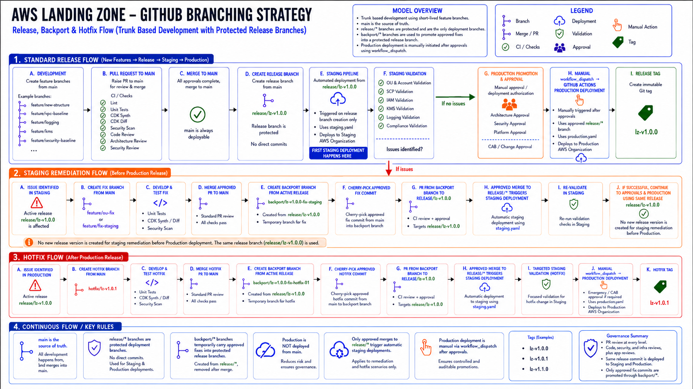
Complete branch lifecycle: feature development, release promotion, staging remediation through backport branches, and post-production hotfix backport to the active release branch

6. Standard Release Flow for a Landing Zone Deployment Phase
1. Create a feature branch from main:
Create a feature branch from main for the Landing Zone capability being implemented. Examples include feature/ou-structure, feature/accounts, feature/logging, feature/security-baseline, or feature/kms.
The branch should contain only the scope associated with the planned deployment phase.
2. Develop and commit the changes:
Implement the required AWS CDK TypeScript code, infrastructure configuration, deployment parameters, validation tests, and supporting documentation required for the selected Landing Zone capability.
Depending on the deployment phase, this may include OU hierarchy definitions, account provisioning logic, SCP attachments, IAM Identity Center configuration, centralized logging, KMS configuration, security controls, or other Landing Zone components.
3. Raise a pull request to main:
The pull request triggers mandatory validation checks including CDK synth, CDK diff, linting, unit tests, cfn-lint, Checkov, secrets scanning, architecture review, code review, and security review.
4. Merge the feature branch to main:
The feature branch is merged only after all required reviews, and automated validation checks have successfully completed. Direct commits to the main branch are prohibited.
4A. Validate the integrated code in main:
- Following a successful merge, an automated CI pipeline is executed against the main branch.
- This validation confirms that the integrated codebase remains stable, secure, and deployable after combining multiple approved changes. Infrastructure validation, automated testing, security scanning, and quality checks must complete successfully before the change can be considered for release.
- A merge to main triggers CI validation only. It does not trigger deployment to either the Staging or Production AWS Organization.
5. Create the protected release branch:
When a Landing Zone release is ready for deployment, create a protected release branch from the approved and successfully validated commit in main.
Examples include:
- release/lz-v1.0.0
- release/lz-v1.1.0
- release/lz-v1.2.0
The release branch represents the versioned and deployable snapshot of the complete Landing Zone baseline approved for deployment to the Staging and Production AWS Organizations.
🔵 Important Branch Governance
The release/* branch is the only branch authorized to perform Landing Zone deployments.
Changes merged to main are not deployed directly.
There is no PR from release/* back to main. The release branch is created from main and remains protected from direct commits. Any approved correction to an active release must follow the controlled backport promotion process defined in Sections 8 and 8A.

6. Deploy the Release Branch to Staging
For the first Staging deployment of a release, creation of the protected release/* branch triggers the GitHub Actions staging-deploy.yml workflow. For a subsequent Staging remediation or Production hotfix, an approved PR merge from a temporary backport/* branch into the active release/* branch triggers the same staging-deploy.yml workflow. In both cases, the workflow deploys from release/* using staging.yaml. Direct commits and direct cherry-picks to release/* are prohibited.
The workflow:
- Checks out the approved release/* branch.
- Uses the release branch commit as the deployment source.
- Loads the Staging configuration from staging.yaml.
- Authenticates to the Staging AWS Organization using the approved deployment role through OIDC.
- Executes the AWS CDK deployment.
- Performs automated post-deployment validation.
The pipeline automatically deploys the release branch to the Staging AWS Organization. No additional approval is required for Staging deployment.
Following successful Staging deployment and validation, the release becomes eligible for the required Architecture, Security, Platform, and CAB/change-management approvals before Production deployment.
Deployment evidence, workflow identifiers, commit SHA values, and execution logs are retained for governance, audit, and change-management purposes.
Release Deployment Trigger: Initial release/* branch creation triggers the first Staging deployment. After the release branch exists, only an approved pull-request merge from a controlled backport/* branch may update the active release/* branch; that approved merge triggers Staging redeployment and revalidation. The backport/* branch itself never deploys to AWS.
Updates to an active release branch must follow the controlled backport promotion process defined in Sections 8 and 8A.
Changes merged into main trigger integration CI validation only and must not result in deployment to either the Staging or Production AWS Organization. All deployments to Staging are performed from the active release/* branch.

7. Validate the Landing Zone in Staging:
Execute the validation activities applicable to the deployment phase. Validation may include OU structure verification, account provisioning checks, SCP validation, IAM Identity Center validation, KMS verification, centralized logging validation, security baseline validation, compliance controls verification, and idempotency testing.
If the staging validation passes, the release proceeds through the required approval process, including Architecture Approval, Security Approval, Platform Approval, and CAB/Change Management Approval. Once all the necessary approvals have been obtained, the release is authorized for deployment to the Production environment.
If issues are identified during Staging validation before the release has been deployed to Production, changes must not be committed or cherry-picked directly to the active release/* branch. The fix is implemented through a feature/fix branch and merged into main following the standard PR, review, and CI validation process. A temporary backport/* branch is then created from the active release branch (for example, backport/lz-v1.0.0-staging-fix). Only the approved fix commit from main is cherry-picked into the backport branch. A pull request is raised from backport/* to the active release/* branch, where CI checks, review, and approval must pass before merge. The approved merge to release/* triggers redeployment to Staging for revalidation. This stabilization cycle may be repeated until Staging validation passes. No new release version is created for issues identified before Production; release/lz-v1.0.0 remains the release candidate and, after successful Production validation, is tagged lz-v1.0.0.
Once Staging validation passes, the active release/* branch proceeds to Architecture, Security, Platform and CAB/Change Management approvals and then to the controlled Production deployment. The exact approved release commit that passed Staging is used for Production deployment.
The active release branch therefore contains the exact set of changes that has passed the required integration and release validation before Production promotion.
8. Obtain Production Approvals:
Following successful Staging validation, the release is submitted for the required Production approvals.
Required approvals may include:
- Architecture Approval
- Security Approval
- Platform Approval
- CAB / Change Management Approval

9. Manually Promote the Approved Release to Production:
Production deployment is initiated using the GitHub Actions workflow_dispatch mechanism after the required approvals have been obtained.
The Production deployment workflow:
- Source branch: the approved active release/* branch.
- Uses the corresponding approved release commit SHA.
- Loads the Production configuration from production.yaml.
- Authenticates to the Production AWS Organization using the approved deployment role through OIDC.
- Executes the AWS CDK deployment.
- Performs automated post-deployment validation.
The same approved release branch and validated release commit that passed Staging validation are deployed to Production.
Environment-specific configuration such as account IDs, organization identifiers, role ARNs, logging resources, and KMS references may differ between environments; however, the CDK source code and release commit remain unchanged.
No direct deployment from main is permitted.
No direct deployment from a feature branch is permitted.
Production deployment is performed only from the approved release/* branch through the authorized GitHub Actions workflow_dispatch workflow.

10. Perform Production validation and tag the release:
Following Production deployment, execute the Production validation activities applicable to the deployed Landing Zone capability. Following successful production validation, create an immutable Git tag (for example lz-ou-structure-v1.0.0) and retain all associated deployment evidence, approvals, and audit records.

7. Staging and Production Deployment Configuration
Staging and Production are deployed from the same approved release branch and commit SHA, but each environment uses an approved configuration file. Environment-specific account data, organization identifiers, account IDs, role ARNs, and logging or KMS references may differ; however, the CDK code, release branch, commit SHA, deployment pipeline, and governance controls remain unchanged. This allows environment-specific configuration differences while ensuring that the same validated release baseline is promoted from Staging to Production.

Aspect | Staging AWS Organization | Production AWS Organization
Configuration file | staging.yaml | production.yaml
Workload accounts | One test account under every Prod and Non-Prod OU in Hybrid, Online and Corp | Approved Production workload accounts; initial reference may also use one controlled account under each Prod and Non-Prod OU
Purpose | Validate deployment logic, OU placement, SCPs, IAM, KMS, logging, security and compliance | Establish the governed Production Landing Zone
Environment values | Staging Organization ID, account emails, account IDs, role ARNs and logging/KMS references | Production Organization ID, approved account data, role ARNs and production logging/KMS references
What remains identical | Release branch, commit SHA, CDK code, dependencies, pipeline version and governance checks | Release branch, commit SHA, CDK code, dependencies, pipeline version and governance checks

8. Hotfix (Post-Production Correction) Flow
A hotfix is required when an urgent issue is identified after the corresponding release has already been successfully deployed to Production. For example, an issue identified after lz-v1.0.0 has been released to Production is handled as a hotfix and results in a new patch release such as lz-v1.0.1.
The hotfix branch is created from main. The fix is implemented, tested and reviewed through the standard pull request and CI validation process and is merged into main only after the required approvals and checks have successfully completed.
Only the specific approved hotfix commit(s) required to resolve the Production issue are promoted from main through a temporary backport/* branch. The backport branch is created from the active release/* branch, the approved hotfix commit is cherry-picked into backport/*, and a PR with CI and approval is raised to release/*. After the approved backport PR is merged, the update to the protected release/* branch triggers the GitHub Actions staging-deploy.yml workflow, which deploys the release branch to the Staging AWS Organization using staging.yaml. The latest state of main is not merged into the active release branch, and no direct cherry-pick to release/* is permitted.
main
|
+-- create hotfix/ou-fix
| |
| +-- Implement fix
| +-- CI Tests
| +-- PR + review
| |
| v
+------> main
|
+-- Merge approved hotfix
+-- Post-merge CI / Integration Validation
|
+-- Identify approved hotfix commit(s)
|
v
release/lz-v1.0.0
|
| Create temporary backport branch
v
backport/lz-v1.0.0-hotfix
|
+-- Cherry-pick ONLY approved
| hotfix commit(s) from main
|
+-- CI checks
|
+-- PR:
| backport/lz-v1.0.0-hotfix
| ->
| release/lz-v1.0.0
|
+-- Review + Approval
|
v
Approved PR Merge
|
v
release/lz-v1.0.0
(Protected Release Branch)
|
+-- Approved merge to release/*
| triggers GitHub Actions
| Staging Deployment
|
+-- staging-deploy.yml
|
+-- Uses staging.yaml
|
v
STAGING AWS ORGANIZATION
|
v
TARGETED / REGRESSION
HOTFIX VALIDATION
|
+---------------------------+
| |
FAIL PASS
| |
| v
| Emergency / Expedited
| CAB / Change Approval
| |
| v
| Manual workflow_dispatch
| |
| +-- production-deploy.yml
| +-- Source branch: release/lz-v1.0.0
| +-- Uses production.yaml
| +-- OIDC authentication
| |
| v
| PRODUCTION AWS ORGANIZATION
| |
| v
| Production Validation
| |
| v
| Create Patch Tag
| lz-v1.0.1
|
+--- If hotfix validation fails:
correct through main and repeat
the controlled backport flow
During the hotfix lifecycle, normal feature development may continue independently in main. Unreleased features and enhancements already integrated into main are not promoted to the active release branch unless separately approved and promoted through the controlled backport/* PR process.
- The hotfix branch is created from main.
- The hotfix is merged into main through the standard pull request, review, and CI validation process.
- Only the specific approved hotfix commit(s) are cherry-picked from main into a temporary backport/* branch created from the active release/* branch. The backport/* branch is then merged into release/* only through an approved PR with CI, review, and approval. The latest state of main is not merged into the release branch.
- The corrected release is validated in Staging before Production unless an explicitly approved emergency exception is authorized by the client's change-management process.
- Production deployment is manually initiated through GitHub Actions workflow_dispatch after the required emergency or expedited CAB/change-management approval.
- Following successful Production deployment and validation, an immutable patch tag such as lz-v1.0.1 identifies the exact Production commit deployed.

8A. Post-Production Correction Promotion Controls
After a hotfix has been approved and merged into main, a temporary backport/* branch is created from the active release/* branch. Only the specific approved hotfix commit(s) required to resolve the Production issue are cherry-picked from main into that backport branch. The backport branch must then pass CI, review, and approval through a pull request to the protected release/* branch.
The active release branch must not receive unrelated feature or enhancement changes from main and must not receive direct commits or direct cherry-picks. Only approved PR merges from controlled backport/* branches may update an active release after its creation.
No changes are propagated from the release branch back to main as part of the hotfix process because the fix is merged to main first. The backport/* branch exists only to safely promote the approved main commit into the protected active release branch.

The active release branch should not routinely receive feature or enhancement changes. Only explicitly approved release corrections or Production hotfixes may be promoted through a temporary backport/* branch and reviewed PR.

9. Release Branch Retirement
After the Production deployment has been completed and the agreed support period has expired, the release branch is marked as closed and no further feature development is permitted on that branch.

Future deployment phases must be created from approved and validated commits in main through the creation of a new release branch representing the next deployment scope, while historical release branches are retained for audit, traceability and recovery purposes.

Any additional Production fixes required during the support window must follow the documented hotfix process: the fix is first merged into main, then the approved commit is cherry-picked into a temporary backport/* branch created from the active release branch, and an approved PR from backport/* updates the protected release/* branch.

10. Release Evidence and Audit Traceability
The model relies on GitHub, GitHub Actions and the approved ITSM process to provide end-to-end traceability. A separate S3 evidence repository is not required unless the client has a specific long-term retention or regulatory requirement.
- Change request or CAB ticket reference.
- Feature, backport, release and hotfix pull requests with reviewer approvals.
- Source commit SHA, backport branch, protected release branch, and approved PR merge SHA.
- CDK synth and CDK diff results.
- Linting, unit test, cfn-lint, Checkov, secrets scan and security scan results.
- GitHub Actions run ID and deployment status.
- CloudFormation, CloudTrail, Config and centralized logging records.
- Production release tag and hotfix patch tag.

Figure 2 – Initial Landing Zone OU Structure Deployment: End-to-End Branching and Deployment Flow
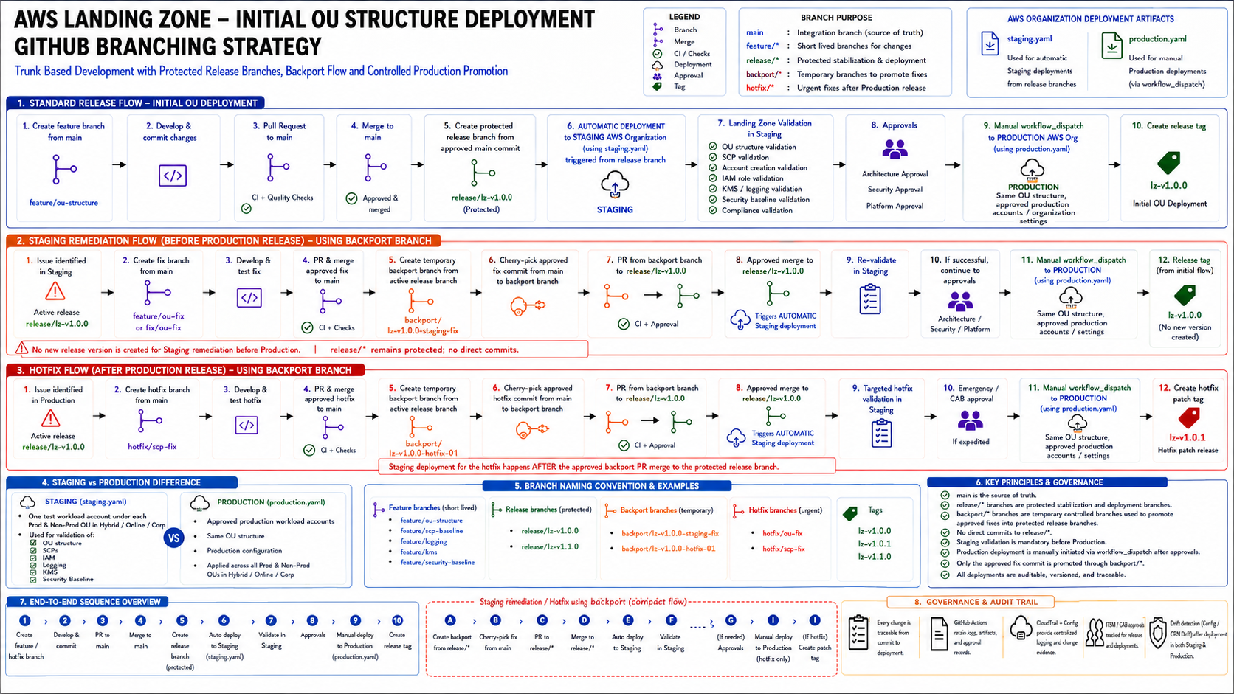
Initial OU deployment mapped to protected release promotion, Staging validation, backport-based remediation, Production promotion, post-Production correction (hotfix) handling, and governance.

11. Branch Protection and Governance Rules
Control | Requirement
main protection | No direct commits. Pull request, CI checks and required reviews are mandatory.
feature branch lifecycle | Created from main, kept short-lived, merged through PR and deleted after merge.
release branch protection | Direct commits and direct cherry-picks are prohibited. Normal feature/enhancement changes are merged to main. Any correction to an active release is promoted only through a temporary backport/* branch created from that release, followed by PR, CI, review, and approval into release/*.
Release Branch Protection Controls | The release/* branch must enforce:  - No direct pushes or commits  - Pull requests required for all changes  - Successful CI status checks before merge  - Required reviewer approvals  - CODEOWNERS approval where configured and applicable  - Restricted merge permissions to designated maintainers and release managers
Release Branch Deployment Authority | Only designated release managers or approved deployment administrators may create release branches and initiate  Production deployments.
Backport Promotion Authority | Only designated repository maintainers or release managers may create temporary backport/* branches and cherry-pick approved commit(s) from main. All promotions into an active release branch must be performed through a pull request from backport/* to release/* and must satisfy branch protection, CI validation, review, and approval requirements.
hotfix branch origin | hotfix/* is created from main and merged through the standard PR/review/CI process. The approved hotfix commit is then cherry-picked into a temporary backport/* branch created from the active release branch. A reviewed PR from backport/* to release/* is mandatory; unrelated main changes are excluded.
Staging-first deployment | Every normal release and Production hotfix is validated in Staging before Production unless an explicitly approved emergency exception exists.
Production approval | Architecture, Security, Platform and CAB/change approval are required according to the change classification.
No manual drift | Manual changes are prohibited except approved break-glass actions, which must be reconciled back into code.
Tagging | Production releases and hotfixes are versioned using immutable Git tags  that follow Semantic Versioning (SemVer), for example lz-v1.0.0,  lz-v1.1.0, lz-v1.1.1, and lz-v2.0.0.
backport branch lifecycle | Temporary backport/* branch is created from the active release/* branch. Only explicitly approved fix/hotfix commit(s) from main are cherry-picked into it. CI and review run on the PR from backport/* to release/*. The backport branch never deploys directly; the approved PR merge to release/* triggers Staging deployment. The backport branch is deleted after successful merge.

12. Naming Convention
main
feature/ou-structure
feature/scp-baseline
feature/logging
feature/kms
feature/security-baseline
hotfix/ou-placement-fix
hotfix/scp-baseline-fix

backport/lz-v1.0.0-staging-fix
backport/lz-v1.0.0-hotfix

Examples of Release Branches
release/lz-v1.0.0
release/lz-v1.1.0
release/lz-v1.1.1
release/lz-v2.0.0
Examples of Production Release Tags
lz-v1.0.0 # Initial Production release
lz-v1.1.0 # New backward-compatible capability release
lz-v1.1.1 # Hotfix or patch release
lz-v2.0.0 # Breaking change release

12A. Release Versioning Strategy
Release branches and Production release tags must follow Semantic Versioning (SemVer).
PATCH (1.1.1)
Backward-compatible fixes and hotfixes only. No breaking changes are permitted.
MINOR (1.1.0)
Backward-compatible enhancements and new Landing Zone capabilities may be introduced.
MAJOR (2.0.0)
Breaking changes are permitted and may require migration, redesign, or additional release planning activities.
This versioning approach provides a consistent and auditable method for identifying Landing Zone releases, distinguishing between hotfixes, non-breaking enhancements, and releases that introduce breaking changes.

Patch releases continue to use the active release branch associated with the original production release. Version progression for fixes and post-production corrections is represented through immutable Git tags rather than by creating a new release branch for each patch version. For example, release/lz-v1.0.0 may subsequently produce production tags lz-v1.0.1, lz-v1.0.2, and lz-v1.0.3 through the approved hotfix promotion process.

13. Conclusion
This model provides a clear separation between ongoing development, release stabilization, Staging validation, Production deployment, pre-Production remediation, and post-production corrections (hotfixes). main remains the integration source of truth; release/* remains the protected deployment source; and backport/* provides the controlled, reviewable promotion path for approved fixes into an active release. No direct commits or direct cherry-picks are made to release/*, and only explicitly approved commits are introduced through backport PRs, ensuring traceability while preventing unrelated changes in main from entering the supported Production baseline.

