AWS ESC Landing Zone Bootstrap
and GitHub Actions Deployment Flow
Recommendation: Retain aws-sc-foundation as the authoritative owner of CDK bootstrap, GitHub OIDC trust establishment, and deployment readiness. aws-sc-landing-zone should consume those capabilities, validate readiness, and perform landing-zone deployments without duplicating bootstrap resources, trust configuration, or CDK deployment infrastructure.

AWS partition / Region | aws-eusc / eusc-de-east-1
Foundation repository | aws-sc-foundation
Landing-zone repository | aws-sc-landing-zone
Branch promotion | feature/* → develop → main

1. Purpose and Executive Summary
This document explains the complete bootstrap and deployment workflow for the AWS European Sovereign Cloud (ESC) Landing Zone. It responds to the question of whether the current manually triggered bootstrap process in aws-sc-foundation should be replaced or handled differently, and it defines how aws-sc-landing-zone will consume the foundation capabilities through GitHub Actions.
Conclusion: The current foundation-owned bootstrap model is appropriate for the initial trusted setup. The recommended improvement is not to duplicate or replace it, but to harden it through idempotency, OIDC-only maintenance after initial setup, complete cleanup of temporary credentials, and explicit readiness validation in the landing-zone pipeline.
- aws-sc-foundation remains the bootstrap owner for both Staging and Production AWS ESC Organizations.
- aws-sc-landing-zone does not create duplicate OIDC providers, custom deployment roles, or CDK bootstrap roles.
- GitHub Actions authenticates through GitHub OIDC and assumes the foundation-managed deployment role. That deployment role then assumes the required CDK bootstrap roles (deploy, lookup, file publishing, and image publishing) used by the CDK deployment process.
- The foundation reusable composite credentials action configures the ESC STS endpoint by default.
- Common multi-account baselines are deployed through approved organization-wide StackSets; direct CDK deployment is used only where account-specific resources require it.

Decision Requested:
Confirm that aws-sc-foundation remains the authoritative owner of CDK bootstrap, OIDC trust establishment, and deployment readiness for AWS ESC environments, and that aws-sc-landing-zone consumes these capabilities rather than implementing a separate bootstrap mechanism.

Why this approach:
Maintaining bootstrap ownership within aws-sc-foundation provides a single source of truth for trust establishment, deployment roles, CDK bootstrap resources, and OIDC configuration. Implementing a second bootstrap process within aws-sc-landing-zone would introduce duplicate ownership, increase operational complexity, and create a risk of configuration drift between repositories.

2. Repository Responsibility Model
aws-sc-foundation - Bootstrap Owner | aws-sc-landing-zone - Deployment Repository
• Manually triggered CDK bootstrap workflows | • Foundation/CDK readiness validation
• GitHub OIDC provider | • Environment configuration loading
• Custom GitHub deployment role | • OU hierarchy creation
• OIDC trust relationships restricted to approved GitHub organization/repositories, with deployment permissions | • SCP creation and attachment
• Reusable composite actions (credentials, check-out, setup and common tooling) | • Account provisioning, registration, and placement
• Reusable workflows and composite actions | • Approved organization-wide StackSets
• ESC STS endpoint configuration | • Account baseline and specialized stacks
• OIDC deployment smoke validation | • Post-deployment validation and compliance checks

3. Foundation Bootstrap Process
The existing aws-sc-foundation implementation already follows the required initial bootstrap sequence:
01-bootstrap-cdk: Uses controlled temporary initialization credentials to run CDK bootstrap in the target account and Region. This creates the CDKToolkit stack, CDK deployment roles, lookup role, file/image publishing roles, asset bucket, and other bootstrap resources.
02-identity-provider: Deploys the GitHub OIDC provider and custom GitHub deployment role for the approved repositories.
03-disable-access-keys: Disables—and preferably deletes—the temporary initialization access keys after successful OIDC setup.
04-oidc-deploy-smoke: Assumes the custom deployment role through OIDC, performs a test CDK deployment, and destroys the smoke stack to prove that the role and CDK trust chain work correctly.

3.1 Recommended Enhancements to the Existing Process
- Retain the manual trigger and approval gate because bootstrap changes affect trust, IAM permissions, and deployment authority.
- Make each bootstrap workflow idempotent and safe to rerun for CDK version upgrades, trust-policy changes, new accounts, or bootstrap remediation.
- Use temporary access keys only for the initial trust establishment. All later bootstrap maintenance should use OIDC where technically possible.
- Delete temporary IAM access keys and remove the related GitHub secrets after the OIDC smoke test succeeds.
- Apply the same bootstrap and smoke-validation process consistently to both Staging and Production management accounts.
- Pin the CDK CLI/bootstrap version so that bootstrap-template changes are controlled and reviewed.

4. Authentication and Role-Assumption Flow
GitHub Actions does not directly assume a CDK-generated role. The correct flow is:
GitHub Actions
↓ OIDC
Custom Deployment Role (provided by aws-sc-foundation)
↓ sts:AssumeRole
CDK Bootstrap Roles (lookup, deploy, file publishing, image publishing)
↓
CDK lookup, asset publishing and stack deployment

ESC credentials handling: aws-sc-landing-zone consumes the foundation reusable composite credentials action. The composite action wraps aws-actions/configure-aws-credentials and applies the ESC STS endpoint by default: sts.eusc-de-east-1.amazonaws.eu
OIDC trust scope: The custom deployment role trust policy is restricted to the approved GitHub organization and repositories. Branch-level restrictions and protected GitHub Environment approvals are enforced through GitHub branch protection, pull-request governance, workflow permissions and environment controls rather than through the AWS IAM trust policy.

5. GitOps Branch and Configuration Mapping
Source branch | Configuration | Target environment | Deployment control
feature/* | N/A | No deployment | CI, static checks, code and security review
develop | config/environments/develop.yaml | Staging AWS Organization | Approved merge to develop; readiness and post-deployment validation
main | config/environments/production.yaml | Production AWS Organization | PR approvals, environment protection, production approval, validation and compliance checks

6. Landing Zone Deployment Sequence
After foundation readiness validation passes, aws-sc-landing-zone executes the following ordered sequence in the relevant Organizations management account:
- Foundation and CDK readiness validation: confirm the custom deployment role, CDK bootstrap roles, asset resources, trust relationships, permissions, target account, and Region readiness.
- OU Structure Stack: create the approved L1 and L2 OU hierarchy.
- SCP Policy Stack: create the approved Service Control Policies.
- SCP Attachment Stack: attach SCPs to Root, OUs, and approved accounts.
- Account Provisioning Stack: create, register, or move accounts into target OUs.
- Approved Organization-wide StackSets: deploy approved common resources and prerequisites to targeted OUs/accounts.
- Account Baseline StackSets: deploy common IAM, logging, security, tagging, and monitoring baselines.
- Shared-Service and Specialized Account Stacks: deploy resources unique to Security, Log Archive, Network, Shared Services, and workload accounts.
- Post-deployment Validation and Compliance Checks: validate deployments, StackSet instances, account placement, tagging, logging, and compliance controls.

7. Future Account Onboarding
The repeatable onboarding flow for accounts created under Hybrid/Online and Corp OUs is:
New account created
↓
Account placed in approved target OU
↓
Approved organization-wide StackSets deploy common prerequisites and baselines
↓
Account readiness is validated
↓
Approved baseline and account-specific deployments are performed
↓
Post-deployment validation and compliance checks
Deployment rule: Use service-managed StackSets by default for common OU-wide controls. A member account requires a full CDK bootstrap only when a direct standard CDK deployment is made into that account or when account-local asset publishing is required.

7.1 Member Account Bootstrap Decision and Flow

Normal path —> common baseline through StackSets
When a Hybrid/Online or Corp member account receives only common landing-zone controls through service-managed CloudFormation StackSets, the member account does not require a separate CDK bootstrap solely for those StackSet deployments. CDK creates or updates the StackSet in the Organizations management account, and CloudFormation StackSets creates the stack instance in the member account through Organizations trusted access.
The flow is: new account created → account placed in the approved OU → approved organization-wide and account-baseline StackSets deployed → baseline validation completed.

Direct-deployment path —> member account requires CDK bootstrap
A member account must be bootstrapped by aws-sc-foundation when aws-sc-landing-zone or another approved repository performs a direct standard CDK deployment into that account and Region. Examples include account-specific network resources, dedicated KMS keys, specialized security tooling, workload-specific infrastructure, or stacks that publish file or container assets.
For this path, aws-sc-foundation performs the controlled bootstrap sequence for the member account: run CDK bootstrap in eusc-de-east-1 → deploy the GitHub OIDC provider and custom deployment role → configure the trust and permission path to the CDK bootstrap roles → run the OIDC smoke deployment → delete or disable the temporary initialization credentials after validation.
After the smoke test succeeds, aws-sc-landing-zone validates readiness and performs the approved account-specific deployment through OIDC. The authentication chain remains GitHub Actions → custom deployment role → required CDK bootstrap roles → CDK deployment.

8. Ownership boundary
aws-sc-foundation owns deployment readiness: CDKToolkit resources, custom OIDC deployment role, CDK bootstrap roles, asset-publishing resources, trust relationships, and smoke validation. aws-sc-landing-zone owns OU/SCP governance, account placement, baseline StackSets, specialized landing-zone stacks, and post-deployment validation.
Decision rule: use StackSets for common OU-wide baselines by default. Bootstrap a member account only when a direct CDK deployment into that account is required.

9. Conceptual GitHub Actions Flow
The exact reusable workflow and input names must match the implemented aws-sc-foundation interfaces. The following illustrates the intended consumption model.

9.1 Staging Deployment
name: Deploy Landing Zone - Staging
on:
push:
branches: [develop]
workflow_dispatch:
permissions:
id-token: write
contents: read
jobs:
deploy-staging:
uses: ccoe-aws/reusable-workflows/.github/workflows/deploy-cdk.yml@main
with:
account-id: '<STAGING_MANAGEMENT_ACCOUNT_ID>'
region: 'eusc-de-east-1'
environment: 'develop'
config-file: 'config/environments/develop.yaml'
secrets: inherit

9.2 Production Deployment
name: Deploy Landing Zone - Production
on:
push:
branches: [main]
workflow_dispatch:
permissions:
id-token: write
contents: read
jobs:
deploy-production:
uses: ccoe-aws/reusable-workflows/.github/workflows/deploy-cdk.yml@main
with:
account-id: '<PRODUCTION_MANAGEMENT_ACCOUNT_ID>'
region: 'eusc-de-east-1'
environment: 'production'
config-file: 'config/environments/production.yaml'
secrets: inherit

10. Recommended Response to “Do You Have Any Other Thoughts?”
We reviewed the existing aws-sc-foundation bootstrap workflow and believe it is an appropriate and practical approach for the initial setup of the Staging and Production AWS ESC Organizations. The current sequence correctly resolves the initial dependency by using controlled temporary credentials to create the CDK bootstrap resources and GitHub OIDC trust, followed by an OIDC smoke deployment and removal of the temporary credentials.
We do not recommend introducing a separate bootstrap implementation in aws-sc-landing-zone, as doing so would duplicate ownership of OIDC trust establishment, CDK bootstrap resources, deployment roles, and permission management. Our recommendation is to retain aws-sc-foundation as the bootstrap owner and strengthen the existing process through idempotent workflows, controlled CDK versioning, complete deletion of temporary credentials after validation, consistent execution for Staging and Production, and a pre-deployment readiness check in aws-sc-landing-zone.
Once OIDC is established, all ongoing landing-zone deployments and future bootstrap maintenance should use the custom OIDC deployment role and the required CDK bootstrap roles rather than long-lived access keys.

This approach preserves a clear ownership boundary between foundation platform capabilities and landing-zone governance while minimizing operational risk and configuration drift.

11. Decisions and Confirmations Required
Key Decisions
- Bootstrap Ownership
  - Can we confirm that aws-sc-foundation remains the authoritative owner of initial CDK bootstrap and future bootstrap upgrades for both Staging and Production AWS ESC management accounts?
- Landing-Zone Deployment Model
  - Should aws-sc-landing-zone consume the reusable deploy-cdk workflow directly, or should it own the deployment workflow and consume foundation composite actions within that workflow?
- Member-Account Deployment Model
  - Can we confirm that:
    - Common baselines and prerequisites will be deployed through service-managed StackSets without requiring a separate member-account CDK bootstrap, and
    - Member accounts will only be bootstrapped when a direct CDK deployment into that account is required?
Implementation Confirmations
- Does the custom deployment role already include the permissions required for:
  - AWS Organizations
  - SCP management
  - IAM
  - CloudFormation StackSets
  - iam:PassRole
- Are the OIDC trust conditions restricted by:
  - Repository
  - Branch
  - Protected GitHub Environment

12. Assumptions and Decision Points
Item | Current working assumption | Required confirmation
Bootstrap ownership | aws-sc-foundation | Confirm retained ownership
OIDC entry role | Custom deployment role | Confirm role name, trust and permissions
CDK role use | Custom role assumes CDK roles | Confirm trust chain in Staging and Production
Common member-account baselines | Service-managed StackSets | Internal validation of ESC support and OU auto-deployment required
Direct member-account deployment | Bootstrap only where direct CDK is required | Confirm target-account model
Configuration naming | develop.yaml / production.yaml | Confirm naming convention

Appendix A - Landing Zone Bootstrap and Deployment Flow
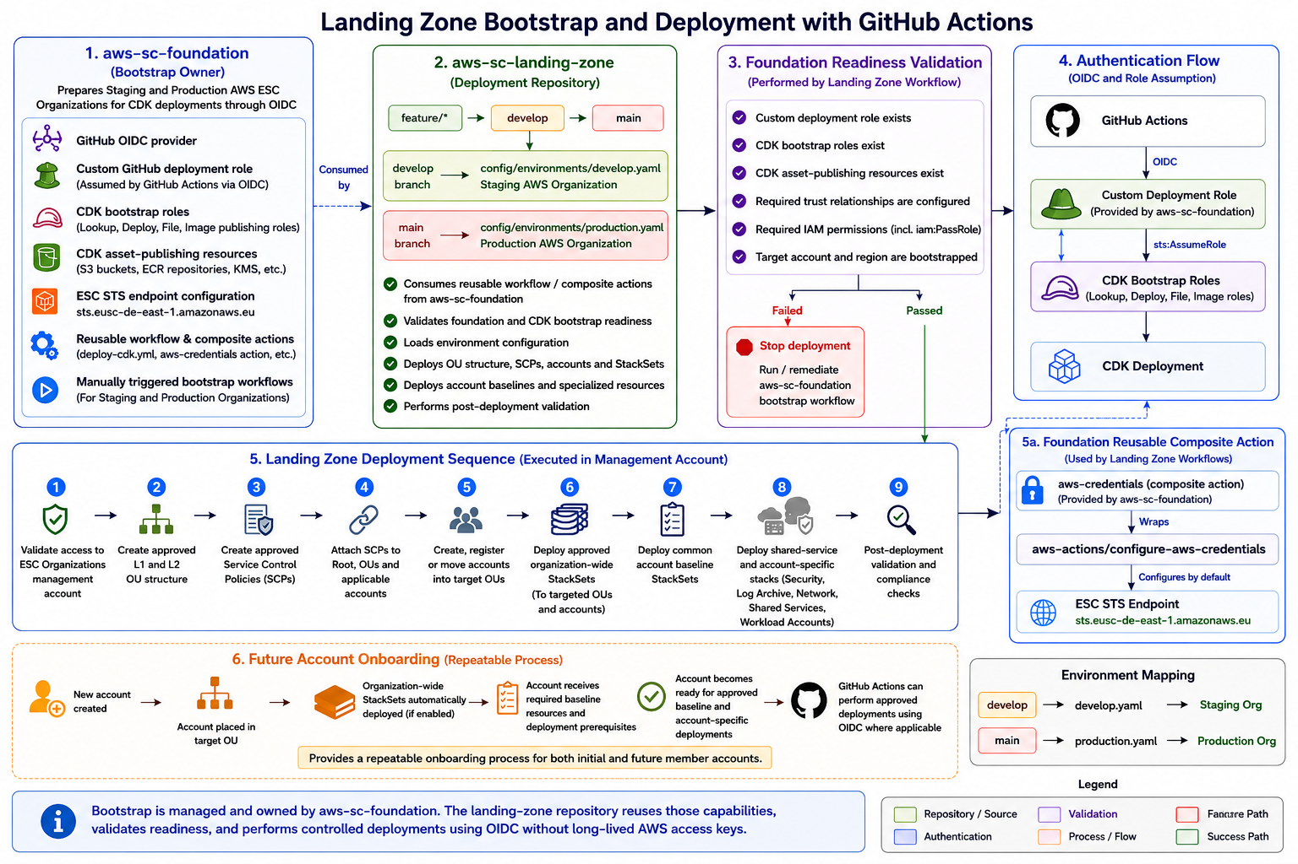

Appendix B - aws-sc-landing-zone Repository Structure
