AWS European Sovereign Cloud
GitOps CI/CD Pipeline, Branching Strategy & PR Governance Model
Landing Zone IaC Deployment Governance - Design Phase Deliverable
Region: eusc-de-east-1 | Partition: aws-eusc | Brandenburg, Germany
Document ID | US-1542070 | ESC-GITOPS-DESIGN-v1.0
Phase | Design Phase - GitOps CI/CD Pipeline, Branching Strategy & PR Governance Catalogue (No implementation code)
Version | 1.0 - June 2026
Platform | AWS ESC | Partition: aws-eusc | Region: eusc-de-east-1 | Tooling: AWS CDK (TypeScript) + GitHub Actions
Classification | Confidential - For Internal If Insurance Use Only
Companion Docs | ESC SCP Design Catalogue (US-1542064), ESC Security Baseline (US-1542065), ESC KMS & Encryption Strategy (US-1542066), ESC Centralized Logging Strategy (US-1542069) - cross-referenced
Frameworks Alignment (Design Reference) | BSI C5:2020 | NIS2 Art.21 | ISO 27001:2022 A.14 | NIST SP 800-53 (Informative)
Status | Draft - Pending Stakeholder Review and Approval (WI-1543685)

Table of Contents

Introduction 3
Purpose 3
Scope 3
1. GitOps Design Overview 4
1.1 Work Package Completion Matrix 4
2. GitOps Operating Model (WI-1543673) 6
2.1 ESC-Specific GitOps Facts and AWS Organization Structure 6
2.2 AWS Organization Structure 8
2.3 GitOps Principles 8
3. Repository Branching & Promotion Strategy (WI-1543674) 9
3.1 Repository Structure 9
3.2 Branch Model 10
3.2 Promotion Flow 11
4. PR Review & Approval Standards (WI-1543675) 15
4.1 PR Requirements 15
4.2 Automated CI Pipeline Checks (Required to Pass Before Human Review) 16
4.3 Human Reviewer Requirements 16
4.4 ESC-Specific Security Reviewer Checklist 17
4.5 Landing Zone Validation – Staging and Production 17
4.6 Drift Detection and Reconciliation Approach 18
5. Deployment Approval & Governance Controls (WI-1543677) 19
5.1 Deployment Windows 19
5.2 Production Change Approval and Governance Process 19
6. Rollback Approach (WI-1543683) 20
6.1 Rollback Principles 20
6.2 Rollback Procedures by Change Type 20
6.3 Rollback Decision Tree 21
7. Governance Validation Matrix 21
8. Stakeholder Review & Approval (WI-1543685) 23
8.1 Review Process 23
8.2 Key Review Points for Client 23
8.3 Approval Sign-Off 24

Introduction
This document defines the GitOps CI/CD Pipeline, Branching Strategy, and Pull Request (PR) Governance Model for Infrastructure as Code (IaC) deployments in the AWS European Sovereign Cloud (ESC) Landing Zone for If Insurance. It governs how all Landing Zone infrastructure changes - SCPs, KMS keys, logging configuration, and security baseline controls are proposed, reviewed, approved, and deployed.
The model is organised in two phases. Phase 1 (Landing Zone Bootstrap) provisions and validates the complete Landing Zone first in the Staging AWS Organization, then in the Production AWS Organization after Staging validation and independent Production approval. Phase 2 (Infrastructure Change Deployment) governs all subsequent infrastructure changes using the same Staging → Production model. Both phases share an identical branch workflow: feature/* → develop (triggers automatic CDK deploy to Staging AWS Organization) → Staging Validation → develop→main (independenct production approval) → Production AWS Organization.
The develop branch is the Integration and Staging deployment branch. Every merge to develop triggers an automatic CDK deployment to the Staging AWS Organization. There is no separate staging branch between develop and main.
The Staging AWS Organization mirrors the Production OU hierarchy and governance model (Security OU, Infrastructure / Shared Services OU, Workloads OU with Online, Hybrid and Corp sub-OUs),but contains only ONE representative test workload account per workload OU rather than the full Production workload account set. This is sufficient to validate SCP enforcement, KMS key access, logging delivery, Security Baseline controls and Compliance posture before Production promotion.

Purpose
This document has been prepared by the Cloud Engineering team of Hexaware to provide If Insurance's Cloud Governance Board, Information Security, and Compliance functions with a complete and reviewable GitOps governance model prior to implementation.
The key objectives of this document are to:
- Establish a single, auditable path for every infrastructure change from code commit to production deployment in the ESC Landing Zone
- Ensure every merge to develop triggers an automatic CDK deploy to the Staging AWS Organization - errors are caught immediately, not accumulated across multiple features.
- Define the branching and promotion strategy that enforces environment segregation and prevents untested changes from reaching production
- Use a Staging AWS Organization that mirrors the Production OU structure but contains only one test workload account per workload OU (Online / Hybrid / Corp), sufficient to validate SCP, KMS, Logging, Security Baseline and Compliance changes.
- Use the same CDK codebase for Staging and Production deployments, with environment selection via config/staging.yaml and config/production.yaml
- Define the PR review and approval standards that ensure every change is peer-reviewed, security-verified, and correctly scoped to the aws-eusc partition before deployment
- Define the deployment approval and governance controls that link infrastructure changes to the companion SCP/KMS/Logging/Security Baseline design decisions
- Define a documented rollback approach that allows any deployment to be safely and quickly reversed
- Require Staging validation results as evidence before Production promotion. Production approval must be provided by at least one authorized approver who is not the person creating or initiating the release; an ITSM/CAB record is included where required by the applicable change classification.

Scope
This document is limited to the design phase of the GitOps operating model for the ESC Landing Zone. It defines what governance processes and standards will be implemented and does not include implementation-level details.
In scope:
- GitOps operating model for IaC deployment using AWS CDK (TypeScript) and GitHub Actions
- Repository branching and promotion flow for Phase 1 (Landing Zone Bootstrap) and Phase 2 (Infrastructure Change Deployment)
- Pull request review and approval standards including the ESC-specific reviewer checklist
- Deployment approval and governance controls. including separation of duties and applicable ITSM/change-management processes for Production
- Staging and Production validation activities
- Rollback procedure for infrastructure deployments
Out of Scope:
- AWS CDK construct-level implementation code - this will be covered in the implementation phase
- Application-layer CI/CD pipelines - this document governs Landing Zone IaC only, not workload application code
- Detailed GitHub Actions workflow YAML - implementation phase deliverable
- SIEM/Sentinel integration configuration - see companion Logging document

1. GitOps Design Overview
This section defines the complete GitOps CI/CD Pipeline, Branching Strategy, and PR Governance Model for the ESC Landing Zone. This is a design-phase deliverable that describes what will be implemented, not how.
This document governs how every control defined in the companion SCP, KMS, Logging, and Security Baseline documents is deployed. No control defined in those documents takes effect until a change passes the PR review, Staging validation, and all required approvals.

1.1 Work Package Completion Matrix
Work Item | Type | Title | Addressed In | Status
1542070 | User Story | Define GitOps CI/CD Pipeline, Branching Strategy, and PR Governance Model for IaC Deployments | Sections 2–8 (full model) | Complete
1543673 | Task | Define GitOps operating model for Infrastructure as Code deployment | Section 2 - GitOps Operating Model | Complete
1543674 | Task | Define repository branching and promotion strategy | Section 3 - Branching & Promotion Strategy | Complete
1543675 | Task | Define pull request review and approval standards | Section 4 - PR Review & Approval Standards | Complete
1543677 | Task | Define deployment approval and governance controls | Section 5 - Deployment Approval & Governance | Complete
1543683 | Task | Define rollback approach for infrastructure deployments | Section 6 - Rollback Approach | Complete
1543684 | Task | Document GitOps standards and governance model | This document (Sections 1–8) | Complete
1543685 | Task | Conduct stakeholder review and obtain approval | Section 8 - Stakeholder Review & Sign-off | Pending

2. GitOps Operating Model (WI-1543673)

2.1 ESC-Specific GitOps Facts and AWS Organization Structure
The ESC partition uses different STS and service endpoints from commercial AWS. GitHub Actions OIDC integration must be configured explicitly for the ESC partition - using the ESC STS endpoint (sts.eusc-de-east-1.amazonaws.eu) and ESC ARN prefix (arn:aws-eusc:). CDK must be bootstrapped in both the Staging and Production AWS Organizations before first deployment.
Attribute | Value | Design Implication
IaC Tooling | AWS CDK (TypeScript) | Supported in ESC since August 2025. Region configured per stack. ARN prefix must be arn:aws-eusc: throughout.
CI/CD Platform | GitHub Actions | OIDC-based authentication to ESC - no stored long-lived AWS credentials in GitHub Secrets. ESC OIDC provider uses arn:aws-eusc: ARN prefix.
AWS Authentication | OIDC (OpenID Connect) - keyless | GitHub Actions authenticates to AWS European Sovereign Cloud through OIDC and assumes a custom deployment role created and managed through the aws-sc-foundation setup. The custom deployment role subsequently assumes the required CDK bootstrap roles for lookup, asset publishing and CloudFormation deployment. Authentication uses temporary credentials obtained through the AWS ESC STS endpoint. No long-lived AWS_ACCESS_KEY_ID or AWS_SECRET_ACCESS_KEY values are stored in GitHub Secrets for ongoing deployments.
ESC STS Endpoint | sts.eusc-de-east-1.amazonaws.eu | The aws-sc-landing-zone workflows do not invoke aws-actions/configure-aws-credentials directly. Instead, they use the reusable composite AWS credentials action maintained in the ccoe-aws/reusable-workflows repository. The composite action wraps aws-actions/configure-aws-credentials and configures the AWS European Sovereign Cloud STS endpoint as the default. This ensures that consuming workflows use:  sts.eusc-de-east-1.amazonaws.eu rather than the commercial AWS STS endpoint.
Configuration Strategy | Same CDK codebase, different config files | develop branch uses config/staging.yaml → deploys to Staging AWS Organization. main branch uses config/production.yaml → deploys to Production AWS Organization.
Staging AWS Organization | Validation environment - ONE test workload account per workload OU | Mirrors the Production OU hierarchy and governance structure (Security OU, Infrastructure/Shared Services OU, and Workloads OU with Online, Hybrid, and Corp sub-OUs), but contains a reduced set of representative workload accounts for validation. The Staging AWS Organization includes one test workload account per workload OU rather than the full Production account population, enabling SCP, KMS, Logging, and Security Baseline changes to be validated prior to Production deployment.
Production AWS Organization | Live environment - full workload accounts | Full production OU structure with all approved workload accounts (Non-Prod and Prod) under each workload OU. Changes only promoted here after Staging validation and all approvals.
develop branch deployment | Every merge to develop triggers automatic CDK deploy to Staging AWS Organization | No separate manual trigger required. The CD pipeline fires on every merge to develop, deploying using config/staging.yaml. This ensures every change is validated in Staging immediately - errors are caught at the point of merge, not accumulated.
CDK Bootstrap Managed through aws-sc-foundation | Required per Target account and Region receiving direct CDK deployments | CDK bootstrap for the Staging and Production AWS ESC environments is performed through manually triggered workflows in the aws-sc-foundation repository. These workflows establish the required CDK bootstrap roles, asset-publishing resources, custom OIDC deployment role, trust relationships and ESC-specific configuration for eusc-de-east-1. The aws-sc-landing-zone repository does not recreate or manage these bootstrap resources. It validates that the target environment is deployment-ready before running the Landing Zone stacks and stops with a clear remediation message if the required foundation resources are unavailable.
Deployment determinism and drift awareness | Both phases are deterministic and drift-aware | Re-running the same approved CDK configuration should produce the same intended state. cdk diff is used for template-level change review; CloudFormation stack and StackSet drift detection is used only for supported resources, wihile AWS Config, service API checks and targeted validation scripts covering unsupported or partially supported resources.

2.2 AWS Organization Structure
The table below defines the OU and account structure of both the Staging and Production AWS Organizations, as confirmed with If Insurance.
OU / Account | Staging AWS Organization | Production AWS Organization
Root | Present | Present
Security OU | Present - same as Production | Present
Infrastructure / Shared Services OU | Present - same as Production | Present
Workloads OU | Present - same as Production | Present
Online OU (under Workloads OU) | ONE test workload account only | Multiple workload accounts (Non-Prod & Prod)
Hybrid OU (under Workloads OU) | ONE test workload account only | Multiple workload accounts (Non-Prod & Prod)
Corp OU (under Workloads OU) | ONE test workload account only | Multiple workload accounts (Non-Prod & Prod)
Purpose | Validate Landing Zone changes (SCPs, KMS, Logging, Security Baseline, Compliance, IAM) against representative test accounts before Production promotion. | Full production environment - validated changes promoted here after all approvals.
CDK configuration | config/staging.yaml | config/production.yaml
Note: The Staging AWS Organization mirrors the Production OU hierarchy and governance model, but contains a limited number of representative workload accounts for validation purposes.

2.3 GitOps Principles
The following principles govern every IaC change in the ESC Landing Zone:
- Git is the source of truth for IaC-managed resources – All Landing Zone resources provisioned and managed through IaC must be changed through the approved GitOps workflow. Direct manual changes to these resources are not permitted, except through an approved break-glass or remediation process. Service lifecycle activities and externally governed changes, such as Control Tower events, account state changes, Identity Center groups and permission assignments and account invitations, may be handled through approved ServiceNow processes or authoritative system integrations.
- tManual changes are discouraged and monitored – Changes to IaC-managed resources should be made through the approved GitOps workflow. Manual console changes are detected through drift monitoring and audit logging. Root and break-glass access may still be used for emergency changes in Landing Zone accounts; any such change must follow the approved emergency process, be documented, and be reconciled back into the IaC repository.
- Every change is a pull request - no direct commits to protected branches (main or develop)
- Every merge to develop triggers automatic Staging deployment, errors are caught immediately at the point of merge, not accumulated.
- Staging before Production - all Staging validations must pass before a PR to main is raised.
- Same code, different config - develop uses config/staging.yaml; main uses config/production.yaml.
- GitHub Actions authenticates to ESC primarily through OIDC using short-lived credentials. The only exception is the initial bootstrap process, where AWS access keys are required to create the GitHub OIDC provider, deployment roles and trust relationships. Once OIDC has been established and validated, the bootstrap credentials can be disabled and all subsequent deployments can use OIDC exclusively.
- Deployments are deterministic and drift-aware - Re-running the same approved CDK configuration should produce the same intended infrastructure state. cdk synth and cdk diff are run for every change to identify template-level differences. CloudFormation stack and StackSet drift detection is used for supported resource types, while AWS Config, service-specific API checks and targeted validation scripts are used for resources with partial or no drift support. Material unexplained variance must be reviewed and reconciled either back to the approved IaC state or into the repository through an approved pull request.
- Every deployment leaves an audit trail - The GitHub pull request records the change rationale, scope, linked work item, reviewer approval, CDK diff and any applicable ITSM/change reference. GitHub Actions records the pipeline execution and deployment result, while CloudTrail records the AWS API and CloudFormation activity in eusc-de-east-1. The workflow carries the PR number, commit SHA, Git Tag and change reference as deployment metadata so the AWS activity can be traced back to the approved change. Evidence is retained in accordance with the companion Logging document.
- Releases are versioned using Git Tags. Every merge to main creates a Git Tag.
- ESC partition correctness is automatically enforced - pipeline lint checks fail immediately if any arn:aws: prefix is detected (must be arn:aws-eusc:) or if any non-ESC region is referenced.

3. Repository Branching & Promotion Strategy (WI-1543674)

3.1 Repository Structure
All Landing Zone IaC code is maintained in a single GitHub repository. The repository contains CDK TypeScript code for both deployment phases - Phase 1 (Control Tower OU structure) and Phase 2 (SCPs, KMS, Logging, Security Baseline, etc.).
- Phase 1 – Landing Zone Bootstrap: Control Tower/Landing Zone initialization, OU structure, shared foundational accounts, baseline governance controls, logging, KMS, and security baseline.
- Phase 2 – Infrastructure Change Deployment: Ongoing Landing Zone and governance updates, including SCP changes, KMS policy updates, logging updates, IAM / Identity Center changes, security baseline enhancements, and compliance controls.
The same CDK codebase is used for both Staging and Production deployments. Environment-specific behaviour is controlled through configuration files under the config/ folder.
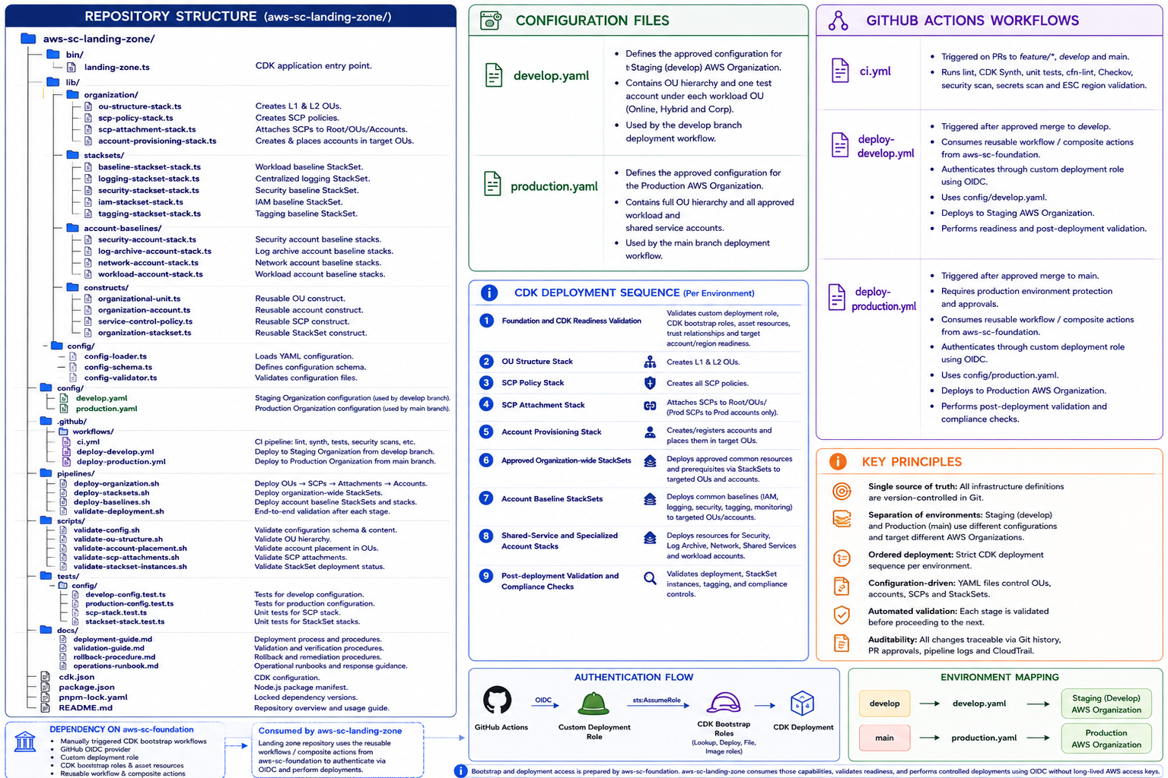
This repository structure is indicative and shows how the GitOps model separates CDK application code, reusable constructs, environment-specific configuration, automated tests, pipeline definitions, and operational documentation. The same CDK codebase is used for both Staging and Production environments. The develop branch uses config/staging.yaml and deploys automatically to the Staging AWS Organization, while the main branch uses config/production.yaml and deploys to the Production AWS Organization after Staging validation and independent release approval.
The tests/ folder ensures that CDK stacks and reusable constructs are validated before deployment. These tests help detect incorrect resource definitions, SCP structures, KMS configurations, OU definitions, tagging issues, and ESC-specific configuration issues during the CI stage.
The config/ folder enables the same CDK implementation to be safely deployed to different AWS Organizations without duplicating infrastructure code. This keeps the solution consistent while allowing the Staging AWS Organization to remain lightweight and representative, and the Production AWS Organization to contain the full approved workload account structure.

3.2 Branch Model
Branch names (main, develop, feature/*) are identical in Phase 1 and Phase 2. What differs is the CI check set on the PR to develop, and the configuration file used for deployment.

Branch | Role and Protection | Approval required to merge | What happens after merge
main | Protected Production branch. No direct commits. Represents the approved code and configuration deployed to the Production AWS Organization. | Phase 1 and Phase 2: approval by at least one authorized reviewer who is not the person creating or initiating the release. The release creator cannot approve their own Production promotion. Relevant stakeholders are consulted before implementation based on scope and risk. An ITSM/CAB reference is included only where required by the applicable change-management process. | An approved merge to main triggers the Production deployment using config/production.yaml, creates a Git Tag and runs Production validation. Phase 1 deploys and validates the approved Landing Zone. Phase 2 deploys and validates the approved infrastructure change across the Production OU structure.
develop | Protected Integration & Staging branch. No direct commits. Acts as both the code integration gate and the Staging deployment trigger. Phase 1 label: Bootstrap Integration. Phase 2 label: Integration / Staging. | Phase 1 and Phase 2: internal Cloud Platform peer review by an authorized reviewer, with all required CI checks passing. Architecture, Security or Platform consultation is completed before development where the change scope or risk requires it. | Every merge to develop triggers automatic CDK deploy to the Staging AWS Organization using config/staging.yaml. Staging validation runs against the one test workload account per workload OU. All validations must pass before PR to main is raised.
feature/* | Developer working branch. Not protected. Created from develop in both phases. | None required to commit. CI pipeline runs on every push: CDK Synth, CDK Diff, cfn-lint, Checkov Scan, Unit Tests, Security Scan, Secrets Scan. | No deployment. PR raised to develop when ready. Nothing is deployed until the PR is approved and merged to develop
hotfix/* | Emergency break-glass – Phase 2 Only. All CI checks still enforced | Approval by an authorized approver independent of the release creator. Emergency escalation and retrospective change review follow the approved incident/change process. | Emergency deployment to Production. Back-merge to develop within 24 hours and complete the required retrospective change review.

3.2 Promotion Flow
Phase 1 - Landing Zone Bootstrap (Bootstrap Deployment and Future Landing Zone Enhancements).
Every merge to develop triggers automatic CDK deploy to the Staging AWS Organization. Landing Zone Validation must pass in Staging before PR to main is raised.
Step | From → To | Trigger | Gate / Action
1 | develop → feature/* | Engineer creates feature branch from develop for each Landing Zone component. | No approval - free development.
2 | Commits on feature/* | Engineer commits Landing Zone IaC changes. | GitHub Actions CI: CDK Synth, CDK Diff, cfn-lint, Checkov Scan, Unit Tests, Security Scan, Secrets Scan. All must pass.
3 | feature/* → develop | PR raised to develop. | Internal Cloud Platform peer review by an authorized reviewer. All required automated CI checks must pass. Relevant specialist consultation is completed before implementation where required by scope or risk.
4 | Merge to develop | PR approved and merged. | Automatic CDK deploy triggered to the Staging AWS Organization using config/staging.yaml.
5 | Staging AWS Organization | CDK deploys complete Landing Zone to Staging. | CDK bootstrap readiness is verified and the complete Landing Zone is deployed to the Staging AWS Organization using config/staging.yaml. This includes AWS Control Tower, OU Structure, Shared Accounts, SCP Baselines, IAM Identity Center, Logging (Centralized), KMS, and Security Baseline components.
6 | Staging AWS Organization | Landing Zone Validation (Staging). | Bootstrap Validation + CDK Bootstrap Readiness + Account & OU Validation + SCP Validation + KMS Validation + Logging Validation + Security Baseline Validation + Compliance Validation. Validated against ONE test workload account per workload OU (Online / Hybrid / Corp). All validations must pass.
7 | develop → main | PR raised after Staging validation passes. | Staging validation evidence is required. Approval must be provided by at least one authorized reviewer who is not the person creating or initiating the release. An ITSM/CAB reference is included only where required by the applicable change classification.
8 | Merge to main | PR approved and merged. | Git Tag created. Scheduled deployment window confirmed.
9 | main → Production AWS Organization | Automatic CDK deploy triggered using config/production.yaml. | AWS Control Tower, OU Structure, all Shared / Audit / Log Archive accounts, SCP Baselines, IAM Identity Center, Logging, KMS, Security Baseline deployed to Production AWS Organization.
10 | Production AWS Organization | Landing Zone Validation (Production). | Bootstrap Validation + Account & OU Validation + SCP Validation + KMS Validation + Logging Validation + Security Baseline Validation + Compliance Validation + CloudTrail Verification. Landing Zone Provisioned.

Phase 2 - Infrastructure Change Deployment (After Landing Zone Creation).
Every merge to develop triggers automatic CDK deploy to the Staging AWS Organization. Staging Validation must pass before PR to main is raised. Merge to main deploys to the full Production OU structure and creates a Git Tag.
Step | From → To | Trigger | Gate / Action
1 | develop → feature/* | Engineer creates feature branch from develop for the infrastructure change. | No approval - free development.
2 | Commits on feature/* | Engineer commits infrastructure (Landing Zone) IaC changes. | GitHub Actions CI: CDK Synth, CDK Diff, cfn-lint, Checkov Scan, Unit Tests, Security Scan, Secrets Scan. All must pass.
3 | feature/* → develop | PR raised to develop. | Internal Cloud Platform peer review by an authorized reviewer. All required automated CI checks must pass. Relevant specialist consultation is completed before implementation where required by scope or risk.
4 | Merge to develop | PR approved and merged. | Automatic CDK deploy triggered to the Staging AWS Organization using config/staging.yaml.
5 | Staging AWS Organization | CDK deploys infrastructure changes to Staging. | Changes applied to the Staging AWS Organization - validated against ONE test workload account per workload OU (Online Test, Hybrid Test, Corp Test Workload Accounts). Validates SCPs, IAM, KMS, Logging, Security Baseline, Compliance.
6 | Staging AWS Organization | Staging Validation. | Infrastructure Validation + SCP Validation + IAM Identity Center Validation + Logging Validation + KMS Validation + Security Baseline Validation + Compliance Validation + targeted drift validation. CloudFormation/StackSet drift checks are run for supported resources, with supplementary service/API checks for unsupported or partially supported resources. All material findings must be resolved or approved.
7 | develop → main | PR raised after Staging validation passes. | Staging validation evidence is required. Approval must be provided by at least one authorized reviewer who is not the person creating or initiating the release. An ITSM/CAB reference is included only where required by the applicable change classification.
8 | Merge to main | PR approved and merged. | Git Tag created. Scheduled deployment window confirmed.
9 | main → Production AWS Organization | Automatic CDK deploy triggered using config/production.yaml. | Changes applied to the full Production AWS Organization OU structure: Apply SCPs, Apply IAM / KMS Policies, Apply Logging / Monitoring, Apply Security Baseline, Apply Compliance Controls. Targets all approved workload accounts across Online, Hybrid and Corp OUs.
10 | Production AWS Organization | Production Validation. | Post-deployment validation + Security Validation + Compliance Validation + CloudTrail Verification + targeted drift and variance checks. Supported resources are assessed through CloudFormation/StackSet drift detection; unsupported areas use AWS Config and service-specific validation. Deployment completes only when material findings are resolved or formally accepted.

Figure 1 (Phase 1 - Landing Zone Bootstrap Workflow) and Figure 2 (Phase 2 - Infrastructure Change Deployment Workflow) are on the following pages.

ESC-Specific Note: All CDK deployments target the ESC partition exclusively. The pipeline configuration explicitly sets AWS_DEFAULT_REGION=eusc-de-east-1 and validates that no commercial AWS region or arn:aws: prefix appears in synthesized CloudFormation templates before deployment proceeds.

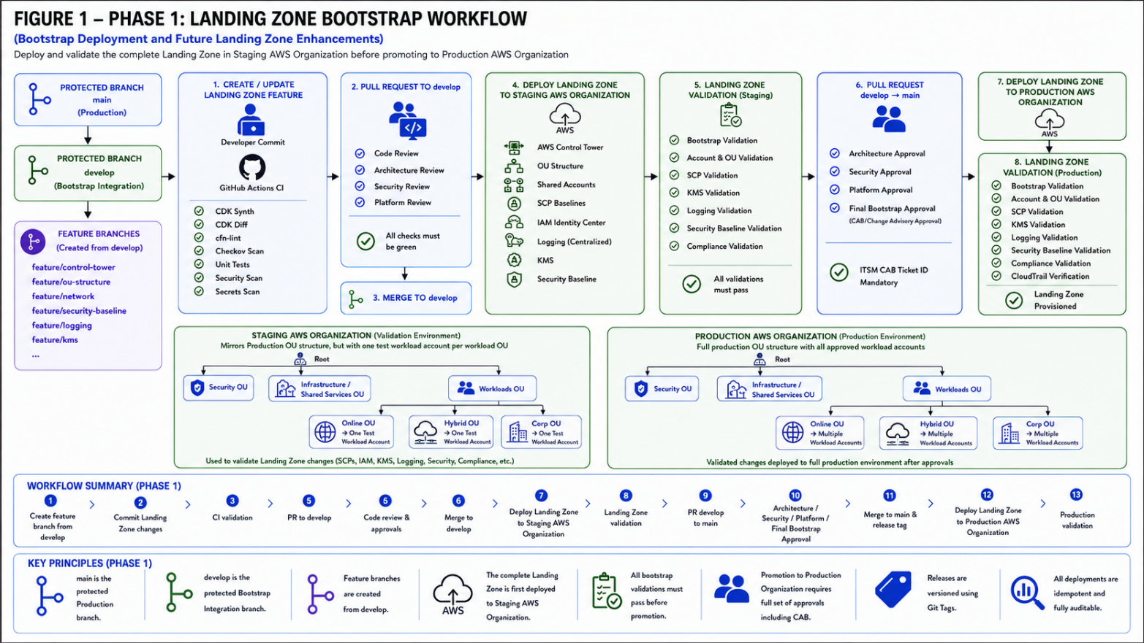
Figure 1 - Phase 1: Landing Zone Bootstrap Workflow (Bootstrap Deployment and Future Landing Zone Enhancements). feature/*→develop: Code Review + Architecture + Security + Platform Review; merge to develop triggers automatic CDK deploy to Staging AWS Organization (config/staging.yaml); Landing Zone Validation (Staging) - ONE test workload account per OU; develop→main: Architecture + Security + Platform + Final Bootstrap Approval (CAB); main→Production AWS Organization (config/production.yaml); Landing Zone Validation (Production).

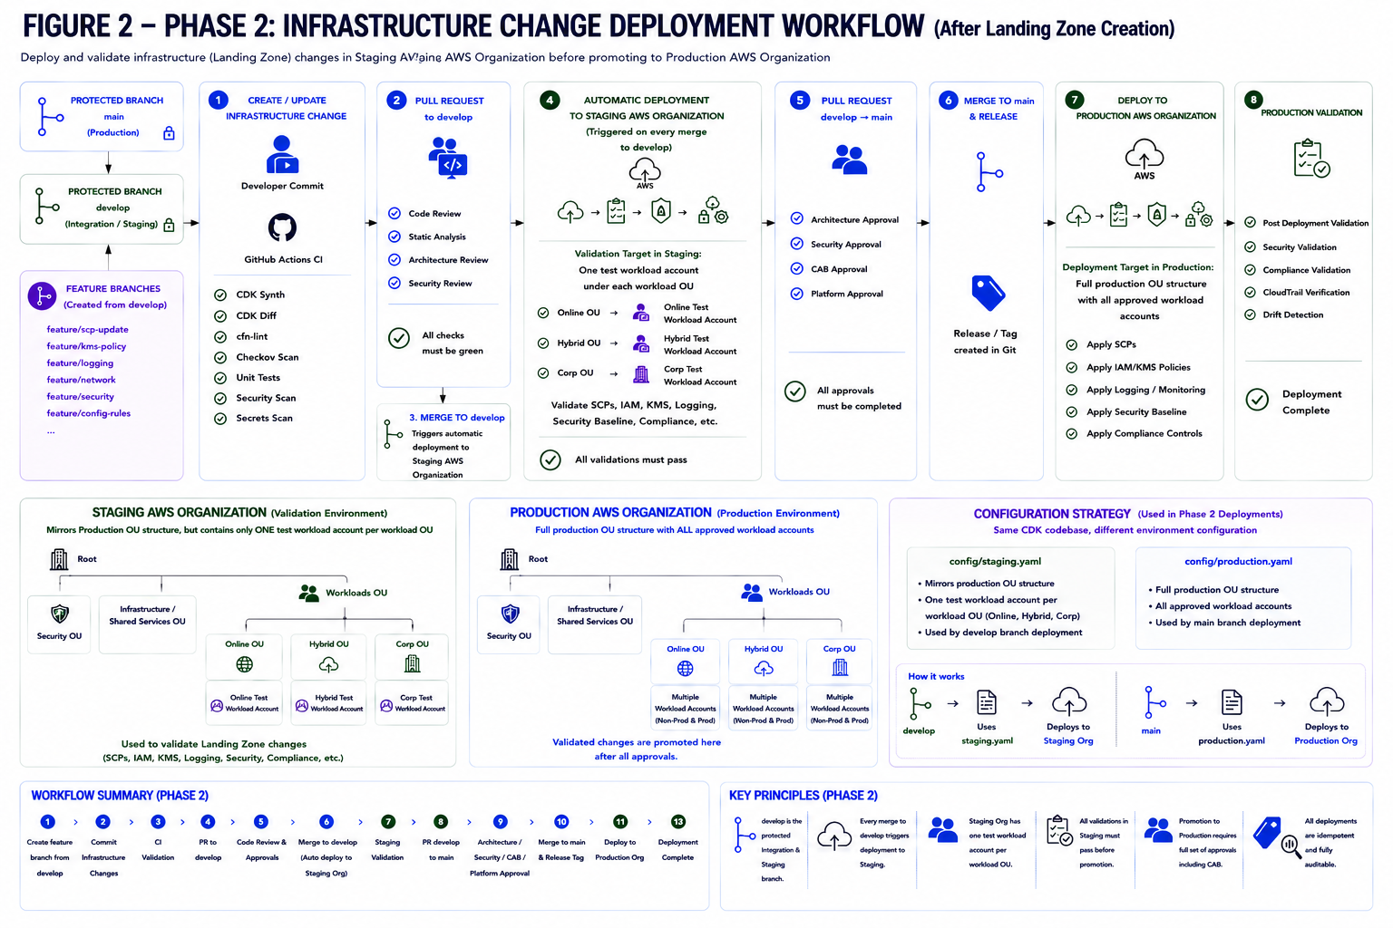
Figure 2 - Phase 2: Infrastructure Change Deployment Workflow. feature/*→develop: internal Cloud Platform peer review and required automated checks; merge to develop triggers automatic deployment to the Staging AWS Organization (config/staging.yaml); Staging validation must pass; develop→main: approval by at least one authorized approver independent of the release creator, with an ITSM/change reference where applicable; main→Production AWS Organization (config/production.yaml); Production validation and Git Tag creation

4. PR Review & Approval Standards (WI-1543675)

4.1 PR Requirements
Every pull request in the Landing Zone repository must satisfy all of the following before it can be merged.
- PR title follows the convention: [SCP|KMS|LOG|SEC|GITOPS]-ESC-{brief description} (e.g. SCP-ESC: Add ec2:CreateVpc to INF-001 denied actions)
- PR description references the Azure Boards work item(s) the change addresses
- PR description includes a CDK diff summary (generated automatically by the pipeline and posted as a comment)
- All automated CI checks are green before merge is permitted (see Section 4.2)
- Required human reviewers have approved and no unresolved review comments remain (see Section 4.3)
- For develop→main PRs: Staging validation evidence must be attached or linked. The PR must include the release/change rationale and any applicable ITSM change reference. The deployment workflow records the PR number, commit SHA, Git Tag and change reference so the pipeline and AWS activity can be traced back to the approved change.

4.2 Automated CI Pipeline Checks (Required to Pass Before Human Review)
Check | What it validates | Fails if
CDK Synth | CDK application synthesizes to CloudFormation without errors. | Any CDK synthesis or TypeScript compilation failure.
CDK Diff | Computes CloudFormation diff and posts as PR comment for reviewer inspection. | Informational - reviewers must read the diff before approving.
cfn-lint | Structural linting of synthesized CloudFormation templates. | Any cfn-lint error or warning above defined severity.
Checkov Scan | Static security scanning of all IaC templates. | Any Checkov policy violation above defined severity.
Unit Tests | CDK unit tests confirming expected resource properties. | Any test failure or coverage below defined threshold.
Security Scan | Scans CDK constructs for known security misconfigurations. | Any misconfiguration above defined severity.
Secrets Scan | Scans commits for hardcoded credentials, secrets, tokens, and access keys. | Any hardcoded credential, secret, token, or access key
ESC ARN Prefix Check | Scans synthesized templates for incorrect ARN prefixes. | Any arn:aws: prefix - must be arn:aws-eusc:.
ESC Region Check | All region references are eusc-de-east-1. | Any non-ESC region in templates or CDK code.

4.3 Human Reviewer Requirements
Target PR | Phase | Approvals | Reviewer requirements
feature/* → develop | Phase 1 (Bootstrap) | Authorized Cloud Platform peer reviewer | Internal Cloud Platform peer review. All CI checks must pass. Relevant Architecture, Security or Platform consultation is completed before implementation where the change scope or risk requires it. Merge triggers automatic deployment to Staging.
develop → main | Phase 1 (Bootstrap) | Independent authorized Production approver | At least one authorized approver who is not the release creator. Staging validation evidence is required. An ITSM/CAB reference is included only where required by the applicable change process. Merge triggers Production deployment.
feature/* → develop | Phase 2 (Infrastructure Change) | Authorized Cloud Platform peer reviewer | Internal Cloud Platform peer review and all required automated checks. Specialist consultation is completed before implementation where required. Merge triggers automatic deployment to Staging using config/staging.yaml.
develop → main | Phase 2 (Infrastructure Change) | Independent authorized Production approver | At least one authorized approver who is not the release creator. Staging validation evidence is required. An ITSM/CAB reference is included only where required by change classification. Merge deploys to Production and creates a Git Tag.
hotfix/* → main | Emergency (Phase 2 only) | Independent authorized emergency approver | An authorized approver independent of the release creator. All CI checks remain enforced. Back-merge to develop and retrospective change review are completed within 24 hours.

4.4 ESC-Specific Security Reviewer Checklist
The IF Insurance Security Team reviewer must confirm each of the following in their PR review comment before approving any PR to develop or main:
- All ARNs use the arn:aws-eusc: prefix (no arn:aws: prefix detected)
- All region references are eusc-de-east-1 (no commercial AWS region referenced)
- SCP/RCP changes are consistent with the companion SCP Design Catalogue (US-1542064)
- KMS key changes are consistent with the companion KMS & Encryption Strategy (US-1542066)
- No plaintext secrets, access keys, or hardcoded account IDs in the diff
- CDK diff has been read and the change matches the stated PR description
- Security impact of the change has been assessed and is acceptable

4.5 Landing Zone Validation – Staging and Production
Landing Zone Validation is a mandatory gate in both phases. All validations must pass in the Staging AWS Organization before a PR to main is permitted. The same validation set is run in the Production AWS Organization after deployment.
Validation activity | Staging AWS Organization | Production AWS Organization
Bootstrap / Infrastructure Validation | Confirms CDK deploy completed and CDK bootstrap resources are present and usable in the Staging AWS Organization. All CloudFormation stacks are in CREATE_COMPLETE or UPDATE_COMPLETE. | Confirms full Production Landing Zone deployed successfully and CDK bootstrap resources are present and usable in the Production AWS Organization.
Account & OU Validation | Confirms OU structure matches approved design. ONE test workload account present and ACTIVE under each of Online, Hybrid and Corp OUs. | Confirms all approved workload accounts (Non-Prod & Prod) are created and ACTIVE under each OU.
SCP Validation | Validates SCP attachment and enforcement against the test workload accounts in each OU. | Validates SCP attachment and enforcement across the full Production workload account set.
IAM Identity Center Validation | Confirms permission sets are configured and assignable to the test accounts. | Confirms permission sets and assignments are applied correctly across all accounts.
KMS Validation | Confirms KMS keys, key policies and cross-account access are configured correctly. | Confirms KMS encryption is functioning correctly across all Production workload accounts.
Logging Validation | Confirms CloudTrail and AWS Config are enabled and log delivery to the Staging Log Archive account is functioning. | Confirms centralized logging to the Production Log Archive account is functioning across all accounts.
Security Baseline Validation | Confirms Security Hub, GuardDuty and AWS Config are enabled and aggregated in Staging. | Confirms Security Hub, GuardDuty and AWS Config are active and aggregated across all Production accounts.
Compliance Validation | Confirms the deployed state matches the approved design using CloudFormation/StackSet drift detection where supported, supplemented by AWS Config and targeted service validation. | Confirms the Production state matches the approved design using supported drift checks, AWS Config and targeted service/API validation. Material unexplained variance is raised for remediation or approval.
CloudTrail Verification | Phase 2 Staging: N/A (included in Logging Validation). | Confirms all deployment actions are captured in CloudTrail in eusc-de-east-1 (both phases).

4.6 Drift Detection and Reconciliation Approach
Drift management uses layered controls because CloudFormation drift detection does not support every AWS or third-party resource type and may provide only partial coverage for some resources. A full Organization-wide drift scan is therefore not treated as a mandatory blocking step before every deployment.
1. Pre-deployment template comparison - The pipeline runs cdk synth and cdk diff for every pull request and deployment. This compares the synthesized IaC template with the currently deployed CloudFormation template and shows the proposed code-driven changes. It does not, by itself, confirm whether live resources were modified outside CloudFormation.
2. Direct stack drift checks - For directly deployed CDK stacks, CloudFormation drift detection is run for the affected stacks where the contained resource types support drift. Targeted checks may run before deployment when risk warrants it and after deployment to confirm the resulting state.
3. StackSet drift checks - For shared baselines deployed through StackSets, drift detection is run against the affected StackSets and stack instances where supported. Targeted checks are performed for changed StackSets, while broader Organization-wide scans are scheduled or initiated on demand because they can be long-running across many accounts.
4. Unsupported or partially supported resources - AWS Config rules, service-specific API queries and validation scripts are used to verify controls that CloudFormation drift detection cannot fully assess. These checks include, as applicable, Organizations and OU structure, account placement and state, SCP attachments, IAM trust and policy configuration, KMS policies, logging, security services, tagging and compliance settings.
5. Audit and detection - CloudTrail and pipeline logs are used to identify out-of-band activity and to correlate manual, break-glass or service-lifecycle changes with the observed configuration variance.
6. Deployment gate and reconciliation - Material unexplained drift or variance blocks deployment or requires an explicit approval decision. The finding is classified as an approved operational change, emergency change, unauthorized drift or unsupported-resource variance. If Git remains authoritative, the resource is remediated to the approved IaC state. If the runtime change is approved as the intended state, the IaC/configuration is updated through a pull request. Validation is rerun and evidence is retained.

5. Deployment Approval & Governance Controls (WI-1543677)

5.1 Deployment Windows
Environment | Deployment window | Rationale
Staging AWS Organization (triggered on merge to develop - both phases) | Business hours - Mon to Fri, 08:00–18:00 CET | Support team available to respond immediately. Errors caught at merge are fixed in the feature branch before accumulating. No weekend Staging deployments.
Production AWS Organization (triggered on merge to main - both phases) | Scheduled change window - typically Tuesday and Thursday, 10:00–12:00 CET | Minimises blast radius. Cloud Platform and Security teams available for immediate rollback.
Emergency hotfix (Phase 2 only) | Any time - CISO approval required | Emergency exception only. Retrospective CAB within 24 hours mandatory.

5.2 Production Change Approval and Governance Process
Every Production promotion requires Staging validation evidence and approval from at least one authorized reviewer who is not the person creating or initiating the release. Architecture, Security, Platform and other stakeholders are consulted during change preparation where required by scope and risk. An ITSM/CAB record is required only when mandated by the applicable change-management classification.
# | Stage | Action | Outcome
1 | Change preparation and classification | The Cloud Platform team documents the PR link, CDK diff, Staging validation results, rollback plan and requested deployment window. Relevant Architecture, Security, Compliance or Platform stakeholders are consulted before implementation where required by scope and risk. The change is classified to determine whether an ITSM/CAB record is required. | Change evidence prepared and classification confirmed
2 | Independent Production approval | At least one authorized reviewer who is not the person creating or initiating the release reviews the PR, Staging evidence and rollback plan. The release creator cannot approve their own Production promotion. | Approved or rejected with a documented reason
3 | Change record linked, where required | Where mandated by the applicable change classification, the ITSM/CAB reference is linked in the PR before merge to main. Standard changes that do not require a formal CAB record follow the approved team-level release process. | Required traceability evidence is present
4 | Scheduled Deployment | The approved GitHub Actions deployment runs during the agreed window using config/production.yaml. Deployment metadata includes the PR number, commit SHA, Git Tag and applicable change reference. | GitHub Actions and CloudTrail activity can be traced back to the approved PR and release record
5 | Production Validation | Post-deployment validation + Security Validation + Compliance Validation + CloudTrail Verification + targeted drift/variance validation. CloudFormation and StackSet drift detection is used where supported, with supplementary controls for unsupported resources. Any material unexplained finding triggers rollback or an approved remediation decision under Section 6. | Deployment confirmed or rollback triggered

6. Rollback Approach (WI-1543683)

6.1 Rollback Principles
- Every Production deployment must have a documented rollback plan before release approval. The rollback plan is included in the PR and, where required by the change classification, in the associated ITSM change record.
- All rollbacks follow the standard Staging → Production workflow — the reverted change is validated in the Staging AWS Organization before being promoted to Production, except in a declared emergency.
- Rollback is always a forward Git operation - new commit reverts the change; no force-pushing to protected branches.
- Target: rollback initiated within 30 minutes of decision for the Production AWS Organization.
- No rollback may worsen the security posture of the Landing Zone - if a rollback would temporarily remove a guardrail (e.g. an SCP protecting the Log Archive), If Insurance Security team must explicitly approve any plan that temporarily removes a guardrail.

6.2 Rollback Procedures by Change Type
Change Type | Rollback Method | ESC-Specific Consideration
SCP / RCP change | Create a new rollback commit that reverses the SCP/RCP change → PR to develop → automatic deploy to Staging → validate → PR to main → deploy to Production. | The rollback remains a forward Git operation. SCP/RCP changes take effect when deployed; validation in Staging confirms the intended guardrail scope before Production promotion.
KMS key policy change | Create a new Rollback commit that reverses the KMS policy change → raise a PR to develop → deploy and validate in Staging → promote the rollback commit to main → deploy to Production. | The rollback is a forward Git operation and does not rewrite history. Validate the restored key policy, grants and application-level encrypt/decrypt access after deployment. kms:DescribeKey confirms key metadata and status but does not by itself prove that decryption access has been restored.
CloudFormation stack change (new resource) | cdk destroy new stack or revert and redeploy via standard Staging → Production workflow | Destroy must not remove resources with deletion protection enabled (e.g. Log Archive S3 bucket). CDK diff must be reviewed before destroy is executed.
CloudFormation stack change (config update) | Revert Git commit → standard Staging → Production workflow. | CloudTrail captures forward and reverse deployment in eusc-de-east-1.
OU / Account structure change | Revert Git commit → standard Staging → Production workflow. Full Landing Zone Validation must pass in Staging before Production rollback. | OU changes affect SCP scope. Validate thoroughly in Staging, including all three test workload OUs.
GitHub Actions pipeline / config | Revert workflow file via PR → merge to develop. | Confirm reverted pipeline still uses sts.eusc-de-east-1.amazonaws.eu and arn:aws-eusc:.

6.3 Rollback Decision Tree
The following criteria determine when rollback is triggered vs. when the team waits for forward resolution:
- Immediate rollback: any SCP guardrail inadvertently weakened or removed; any KMS key rendered inaccessible causing data unavailability; any deployment that causes a Security Hub CSPM CRITICAL finding
- Rollback within 4 hours: any deployment that causes unexpected service degradation in a Production OU; or any material, unexplained post-deployment drift or configuration variance that was not represented in the approved CDK diff and cannot be safely remediated forward.
- Forward resolution preferred: non-critical findings; cosmetic/naming issues; configuration drift in Non-Prod or Sandbox that does not impact security posture

7. Governance Validation Matrix
This matrix validates that the GitOps model addresses every Landing Zone IaC governance requirement and relevant framework control. This is a design-phase validation, actual pipeline execution testing will be performed during the implementation phase.

Governance Requirement | Addressed By | Framework Reference | Design Coverage
Every merge to develop triggers deploy to Staging - errors caught immediately | Section 3.2 - automatic CDK deploy to Staging AWS Organization on every merge to develop | BSI C5 / NIST CM-3 | Complete
Staging org mirrors Production OU structure with ONE test workload account per OU | Section 2.1 - org structure table; Section 3.1 - config/staging.yaml | ISO 27001 A.14 / NIST CM-3 | Complete
Every IaC change is reviewed before deployment | Section 4 - PR review and approval standards | BSI C5 / NIST CM-3 | Complete
All LZ changes validated in Staging before Production | Section 3.2 - Staging validation gate in both phases; all validations must pass | ISO 27001 A.14 / NIST CM-3 | Complete
Every IaC change receives authorized internal team review | Section 4.3 - internal Cloud Platform peer review for Staging; independent authorized approver for Production | NIS2 Art.21 / NIST CM-3 | Complete
No stored long-lived credentials in the pipeline | Section 2 - OIDC keyless authentication per AWS Organization | BSI C5 / NIST IA-5 | Complete
ESC partition correctness enforced automatically | Section 4.2 – ESC ARN prefix and region checks in every CI run | GDPR Art.44 / NIST SC-7 | Complete
Production changes require independent approval and applicable change traceability | Section 5.2 - independent approver, Staging evidence and ITSM/CAB reference where required by change classification | ISO 27001 A.14 / NIST CM-3 | Complete
Every deployment has a traceable PR-to-AWS audit trail | Sections 2.3, 4.1 and 5.2 - PR rationale/approval, commit SHA, Git Tag, change reference, GitHub Actions logs and CloudTrail activity | BSI C5 / NIST AU-2 | Complete
No manual console changes in managed | Section 2.2 - GitOps principles; SCPs enforce pipeline-role-only access | BSI C5 / NIST CM-5 | Complete
Deployments are deterministic and drift-aware | Sections 2.1 and 2.3 - CDK template comparison, supported CloudFormation/StackSet drift detection, and supplementary AWS Config/service validation | BSI C5 / NIST CM-3 | Complete
Releases versioned using Git Tags | Section 3.2 - Git Tag created on every merge to main | BSI C5 / NIST AU-2 | Complete
Rollback plan documented for every production change | Section 5.2 (RFC includes rollback plan) + Section 6 | BSI C5 / NIST CP-10 | Complete
Secrets never committed to the repository | Section 4.2 - Secrets scan in automated pipeline checks | BSI C5 / NIST IA-5 | Complete

8. Stakeholder Review & Approval (WI-1543685)

8.1 Review Process
- This document is distributed to all stakeholders for a 5-business-day review window, consistent with the process used for the companion SCP, KMS, Logging, and Security Baseline documents.
- A review meeting is held on Day 6 to resolve open design comments and complete sign-off before implementation begins.
- Design sign-off must be completed before development begins. Material unresolved design concerns from relevant Security, Compliance or Cloud Governance stakeholders block implementation sign-off. During implementation, IaC pull requests and Staging/Production deployments are approved by authorized Cloud Platform team members; external stakeholders are consulted only where the scope or risk of the change requires it..

8.2 Key Review Points for Client
Design decision | Detail
develop is the Integration and Staging deployment branch | The develop branch serves two purposes: (1) it is the code integration gate where PR reviews are completed, and (2) every merge to develop triggers an automatic CDK deployment to the Staging AWS Organization. There is no separate staging branch between develop and main. This was confirmed with the IF team - the develop branch IS the staging deployment branch.
Every merge to develop triggers automatic Staging deployment | On every merge to develop, the GitHub Actions CD pipeline fires automatically using config/staging.yaml. This ensures every change is deployed to Staging immediately at the point of merge, not accumulated. An error in one feature will be caught as soon as it is merged to develop - not discovered later when a different engineer promotes to Staging.
Staging AWS Organization structure - confirmed by client | The Staging AWS Organization mirrors the Production OU hierarchy and governance model, including the Security OU, Infrastructure / Shared Services OU, and Workloads OU (with Online, Hybrid, and Corp sub-OUs). To maintain a lean validation environment, it contains one representative test workload account per workload OU rather than the full Production account set. This approach, confirmed by If Insurance, is sufficient to validate SCP enforcement, IAM controls, KMS access, logging, security baseline controls, and compliance requirements before changes are promoted to Production.
Same CDK codebase, different configuration | The same CDK codebase is used for both Staging and Production deployments. The environment is selected via the configuration file: config/staging.yaml for develop branch deployments (one test workload account per OU) and config/production.yaml for main branch deployments (full workload accounts). This ensures the code path is identical - only the target accounts differ.
CAB RFC requires Staging validation evidence | The RFC submitted to the CAB before any production deployment must include the Staging validation results as evidence that the change has been validated. The CAB reviews the Staging validation report alongside the CDK diff and rollback plan before approving Production deployment.
Git Tag on every merge to main | Every merge to the main branch in both phases creates a Git Tag. This provides a versioned, auditable record of every change promoted to the Production AWS Organization.
Rollback always via Staging first | All rollbacks follow the same Staging → Production workflow: the reverted change is deployed to the Staging AWS Organization and validated before being promoted to Production. The only exception is a declared emergency (hotfix path), which requires CISO approval and a mandatory retrospective CAB within 24 hours.
Roles and responsibilities | Joint Delivery Model: Hexaware and If Insurance jointly design, develop, implement, review, test and validate the CDK-based AWS ESC Landing Zone for the Staging environment. Both organizations actively contribute to cloud architecture, CDK TypeScript development, GitHub Actions implementation, testing, documentation and deployment activities. If Insurance also provides the existing aws-sc-foundation capabilities, centrally maintained reusable actions and AWS ESC environment access. Hexaware and If Insurance collaborate throughout the complete delivery lifecycle, with implementation responsibilities shared between both teams. Pull requests and deployment promotions are reviewed and approved by authorized If Insurance reviewers in accordance with the agreed GitOps governance and separation-of-duties controls.

8.3 Approval Sign-Off
Role | Name | Date | Signature
Cloud Platform Architect
CISO / Security Lead
Cloud Governance Board Representative
Compliance Officer

