Question 1:

package Ca1;

import org.openqa.selenium.By;

import org.openqa.selenium.JavascriptExecutor;

import org.openqa.selenium.WebDriver;

import org.openqa.selenium.WebElement;

import org.openqa.selenium.chrome.ChromeDriver;

import org.openqa.selenium.chrome.ChromeOptions;

import org.testng.Assert;

import org.testng.annotations.Test;

import io.github.bonigarcia.wdm.WebDriverManager;

public class que1 {

*@Test*

public void f() throws InterruptedException {

WebDriverManager.*chromedriver*().setup();

ChromeOptions co=new ChromeOptions();

co.addArguments("--remote-allow-origin=*");

WebDriver driver=new ChromeDriver(co);

driver.get("https://www.amazon.in/");

driver.manage().window().maximize() ;

String title=driver.getTitle();

System.***out***.print(title);

String exptit="Online Shopping site in India: Shop Online for Mobiles, Books, Watches, Shoes and More - Amazon.in";

Assert.*assertEquals*(title,exptit);

driver.findElement(By.*xpath*("//*[@id=\"nav-link-accountList-nav-line-1\"]")).click();

driver.findElement(By.*xpath*("//*[@id=\"ap_email\"]")).click();

driver.findElement(By.*xpath*("//*[@id=\"ap_email\"]")).sendKeys("8754988838");

driver.findElement(By.*xpath*("//*[@id=\"continue\"]")).click();

driver.findElement(By.*xpath*("//*[@id=\"ap_password\"]")).click();

driver.findElement(By.*xpath*("//*[@id=\"ap_password\"]")).sendKeys("mano&1234");

driver.findElement(By.*xpath*("//*[@id=\"signInSubmit\"]")).click();

// driver.findElement(By.xpath("//*[@id=\"ap_password\"]")).click();

// driver.findElement(By.xpath("//*[@id=\"ap_password\"]")).sendKeys("mano&1234");

Thread.*sleep*(10000);

driver.findElement(By.*xpath*("//*[@id=\"twotabsearchtextbox\"]")).click();

driver.findElement(By.*xpath*("//*[@id=\"twotabsearchtextbox\"]")).sendKeys("smartphones");

driver.findElement(By.*xpath*("//*[@id=\"nav-search-submit-button\"]")).click();

driver.findElement(By.*xpath*("//*[@id=\"search\"]/div[1]/div[1]/div/span[1]/div[1]/div[5]/div/div/div/div/div/div[2]/div/div/div[1]/h2/a/span")).click();

Thread.*sleep*(3000);

JavascriptExecutor js=(JavascriptExecutor)driver;

js.executeScript("window.scrollBy(0,500)","");

Thread.*sleep*(10000);

driver.findElement(By.*xpath*("//*[@id=\"add-to-cart-button\"]")).click();

driver.findElement(By.*xpath*("//*[@id=\"attach-sidesheet-view-cart-button\"]/span/input")).click();

driver.findElement(By.*xpath*("//*[@id=\"nav-cart\"]")).click();

driver.findElement(By.*xpath*("//*[@id=\"a-autoid-0-announce\"]")).click();

driver.findElement(By.*xpath*("//*[@id=\"quantity_4\"]")).click();

driver.findElement(By.*xpath*("//*[@id=\"sc-buy-box-ptc-button\"]/span/input")).click();

}

}

Output:

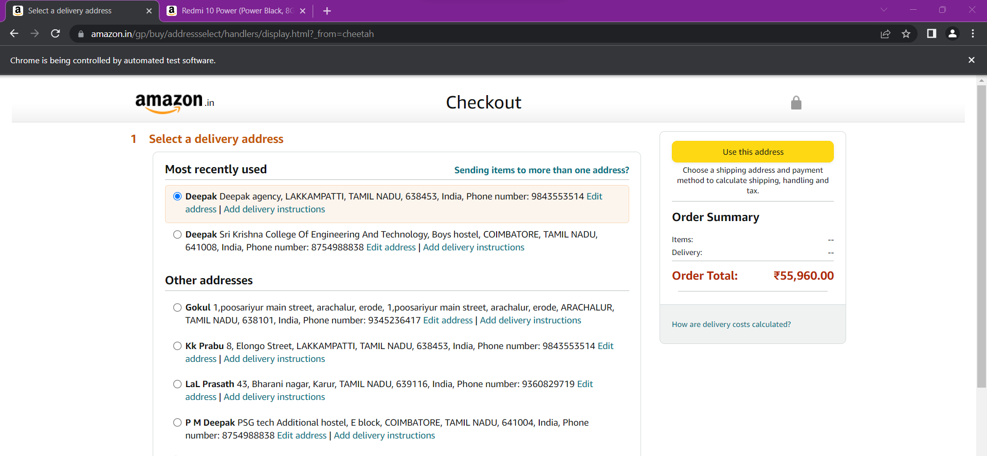

Question 2:

package Ca1;

//import java.util.ArrayList;

import org.openqa.selenium.By;

import org.openqa.selenium.WebDriver;

import org.openqa.selenium.WebElement;

import org.openqa.selenium.chrome.ChromeDriver;

import org.openqa.selenium.chrome.ChromeOptions;

import io.github.bonigarcia.wdm.WebDriverManager;

public class que2 {

public static void main(String[] args) throws InterruptedException {

// **TODO** Auto-generated method stub

ChromeOptions co=new ChromeOptions();

co.addArguments ("--remote-allow-origins=*");

WebDriverManager.*chromedriver*().setup ();

WebDriver driver=new ChromeDriver(co);

driver.get ("https://www.amazon.in/");

driver.manage().window().maximize() ;

String currentTitle=driver.getTitle();

System.***out***.println(currentTitle);

String expectedTitle="Online Shopping site in India: Shop Online for Mobiles, Books, Watches, Shoes and More - Amazon.in";

if(currentTitle.equals(expectedTitle)) {

System.***out***.println("Title Matched");

}

else {

System.***out***.println("Title not Matched");

}

WebElement txtBoxl=driver.findElement(By.*xpath*("//*[@id=\"twotabsearchtextbox\"]"));

txtBoxl.sendKeys("macbook");

driver.findElement(By.*xpath*("//*[@id=\"nav-search-submit-button\"]")).click();

driver.findElement(By.*xpath*("//*[@id=\"p_36/7252032031\"]/span/a/span")).click();

Thread.*sleep*(3000);

driver.findElement(By.*xpath*("//*[@id=\"p_n_pattern_browse-bin/1464446031\"]/span/a/span")).click();

//displaying 5 products

String txt1=driver.findElement(By.*xpath*("//*[@id=\"search\"]/div[1]/div[1]/div/span[1]/div[1]/div[3]/div/div/div/div/div/div/div/div[2]/div/div/div[1]/h2/a/span")).getText();

System.***out***.println(txt1);

String txt2=driver.findElement(By.*xpath*("//*[@id=\"search\"]/div[1]/div[1]/div/span[1]/div[1]/div[4]/div/div/div/div/div/div/div/div[2]/div/div/div[1]/h2/a/span")).getText();

System.***out***.println(txt2);

String txt3=driver.findElement(By.*xpath*("//*[@id=\"search\"]/div[1]/div[1]/div/span[1]/div[1]/div[5]/div/div/div/div/div/div[2]/div/div/div[1]/h2/a/span")).getText();

System.***out***.println(txt3);

String txt4=driver.findElement(By.*xpath*("//*[@id=\"search\"]/div[1]/div[1]/div/span[1]/div[1]/div[6]/div/div/div/div/div/div[2]/div/div/div[1]/h2/a/span")).getText();

System.***out***.println(txt4);

String txt5=driver.findElement(By.*xpath*("//*[@id=\"search\"]/div[1]/div[1]/div/span[1]/div[1]/div[7]/div/div/div/div/div/div[2]/div/div/div[1]/h2/a/span")).getText();

System.***out***.println(txt5);

Thread.*sleep*(3000);

}

}

Output:

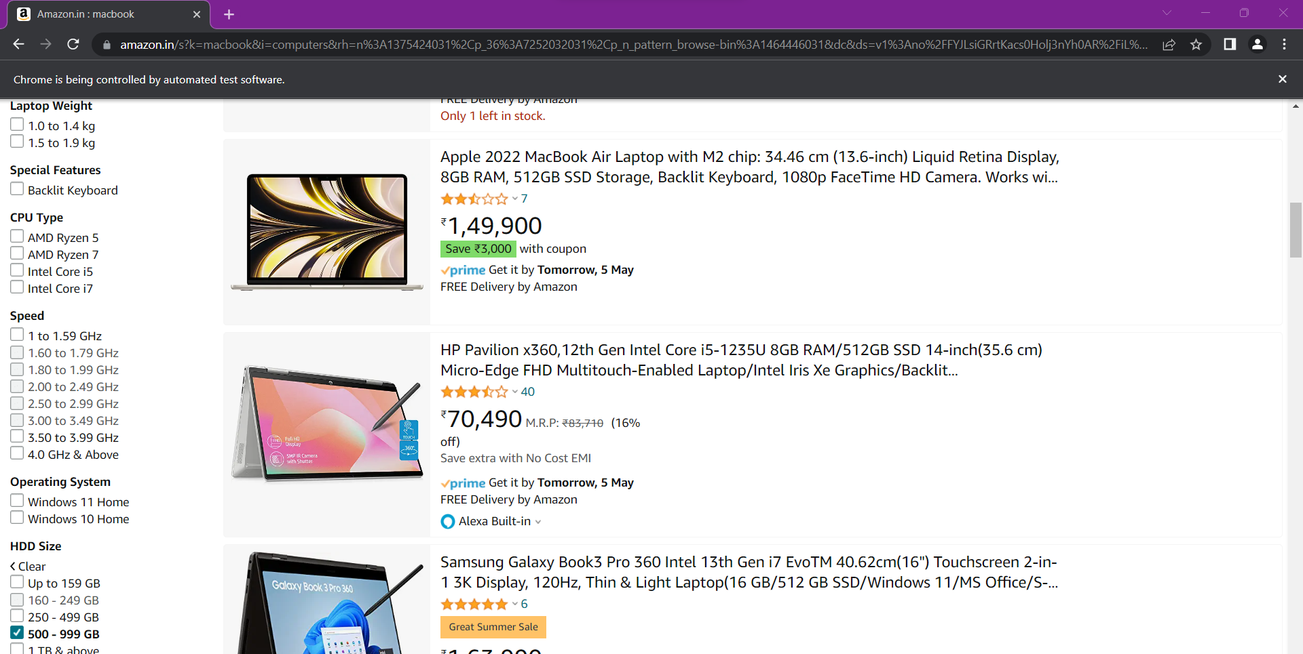

Question 3:

package Ca1;

import org.openqa.selenium.By;

import org.openqa.selenium.WebDriver;

import org.openqa.selenium.WebElement;

import org.openqa.selenium.chrome.ChromeDriver;

import org.openqa.selenium.chrome.ChromeOptions;

import org.openqa.selenium.interactions.Actions;

import io.github.bonigarcia.wdm.WebDriverManager;

public class que3 {

public static void main(String[] args) throws InterruptedException {

WebDriverManager.*chromedriver*().setup();

WebDriver driver;

ChromeOptions co=new ChromeOptions();

co.addArguments("--remote-allow-origins=*");

driver=new ChromeDriver(co);

driver.navigate().to("https://www.amazon.in/");

Actions actions = new Actions(driver);

WebElement element = driver.findElement(By.*xpath*("//*[@id=\"nav-link-accountList\"]/span"));

actions.moveToElement(element).perform();

Thread.*sleep*(3000);

WebElement link = driver.findElement(By.*xpath*("//*[@id=\"nav-al-your-account\"]/a[1]/span"));

link.click();

Thread.*sleep*(3000);

WebElement yourorder=driver.findElement(By.*xpath*("//*[@id=\"a-page\"]/div[2]/div/div[2]/div[1]/a/div/div"));

yourorder.click();

Thread.*sleep*(3000);

WebElement searchbox=driver.findElement(By.*xpath*("//*[@id=\"ap_email\"]"));

searchbox.sendKeys("8754988838");

WebElement yesbutton=driver.findElement(By.*xpath*("//*[@id=\"continue\"]"));

yesbutton.click();

Thread.*sleep*(3000);

WebElement passw=driver.findElement(By.*xpath*("//*[@id=\"ap_password\"]"));

passw.sendKeys("mano&1234");

WebElement signin=driver.findElement(By.*xpath*("//*[@id=\"signInSubmit\"]"));

signin.click();

}

Output;

