SIS issues for alanka

- Bulk upload sheet:
I downloaded the Export sheet and edited that for adding new products. I just changed the Name, SKU and prices of the product and REUPLOAD the File. I got saved.
In the export sheet the variants color and size details were not displayed
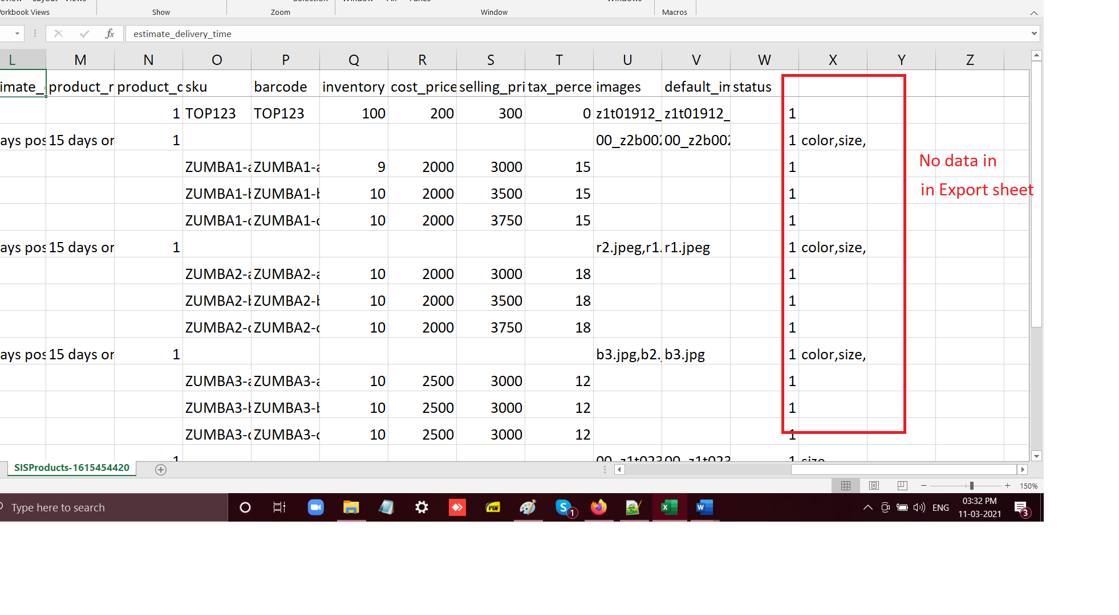
The final product in Zwear Distrubution Seller looks like this In the detail page the variant there was no color size etc details
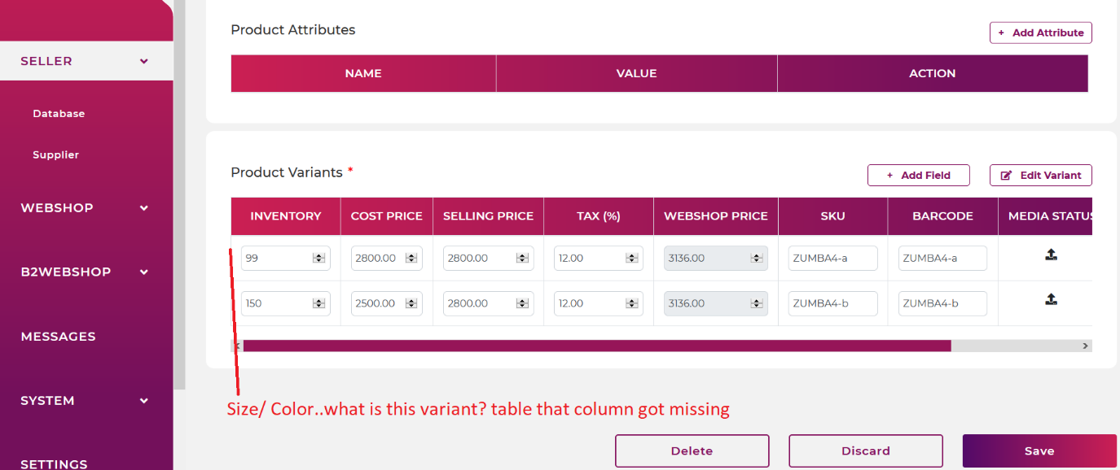
When Clicked on edit variant button this blank popup shows
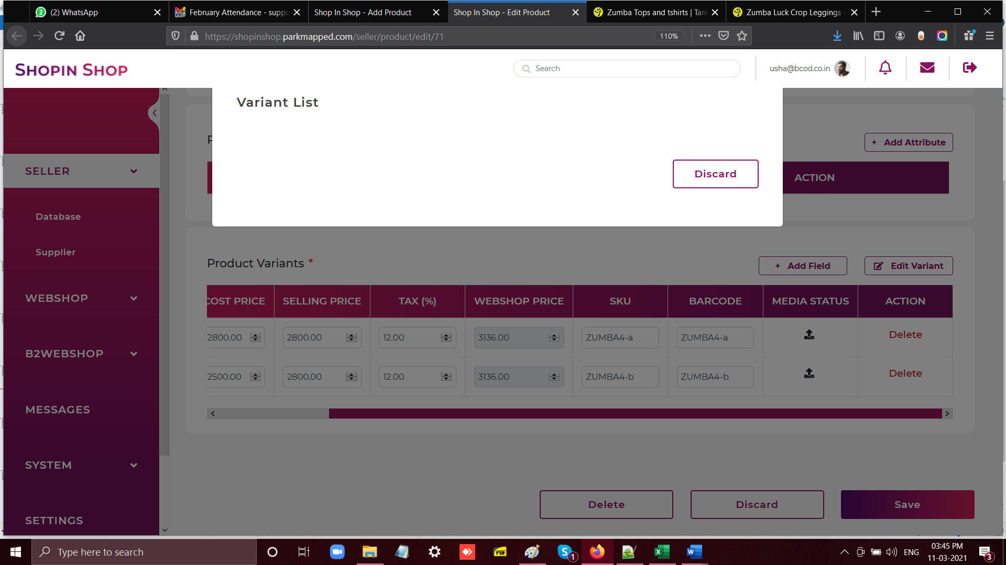
B2Webshop(Zwear)
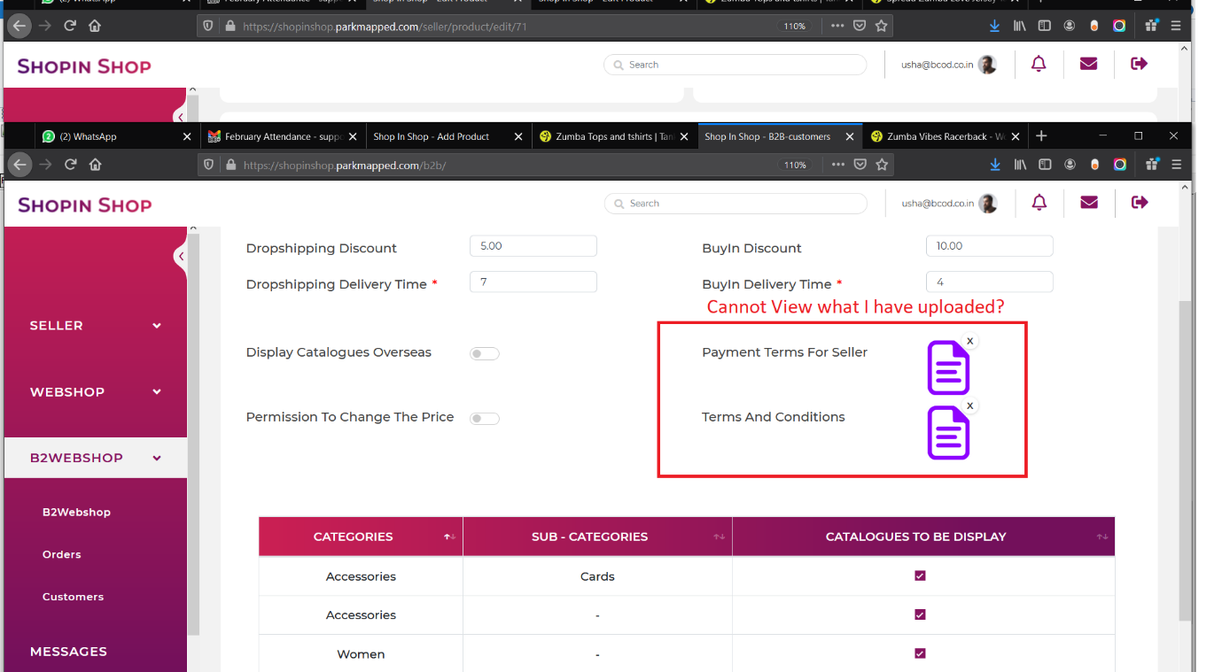

In Seller(zumbashop(anu@bcod.co.in)this looks like this
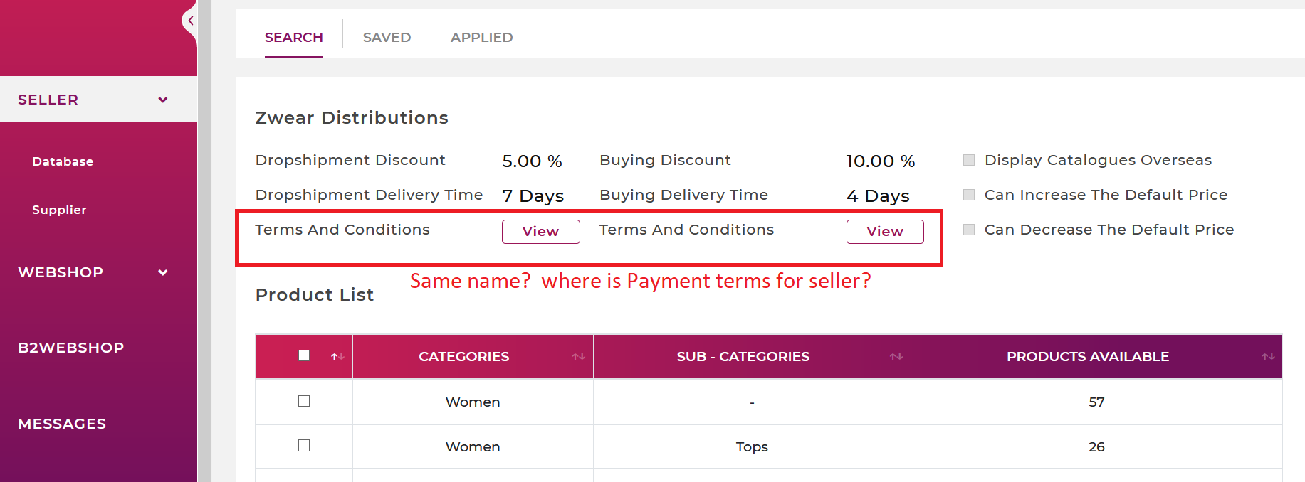
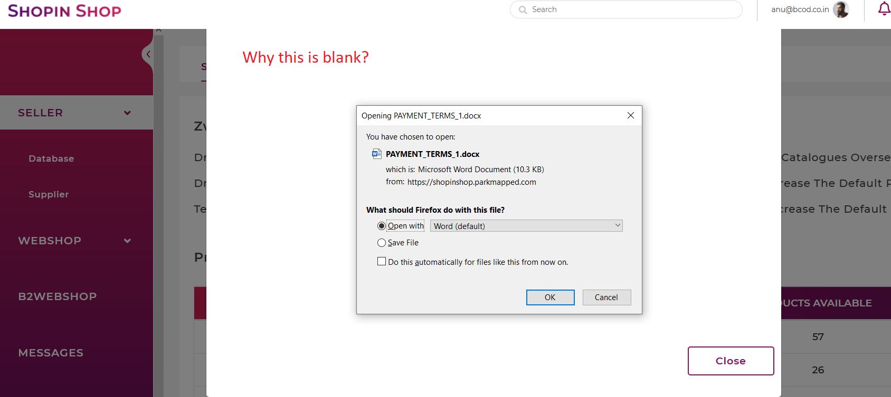

Whn I cancel the grey popup looks like this
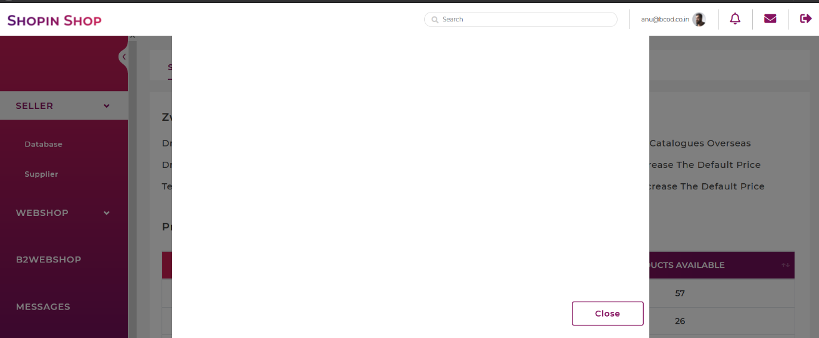

Zumbashop:
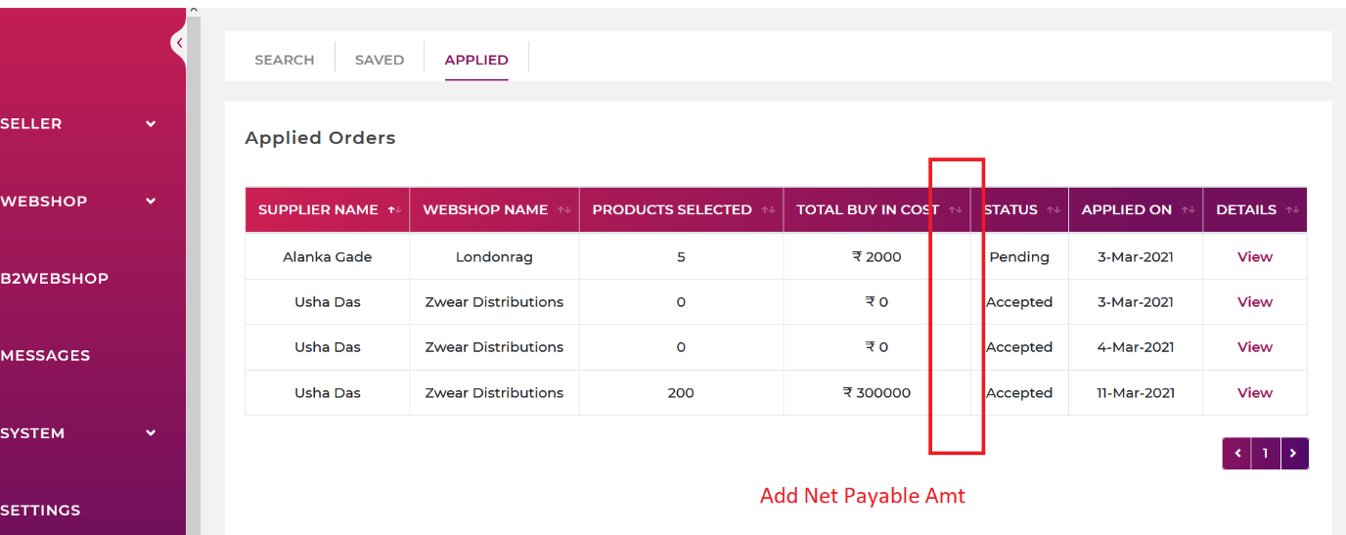
In Zumbashop warehouse the new prd I have added its inventory is showing 0 where as this product have 200 qty which is imported
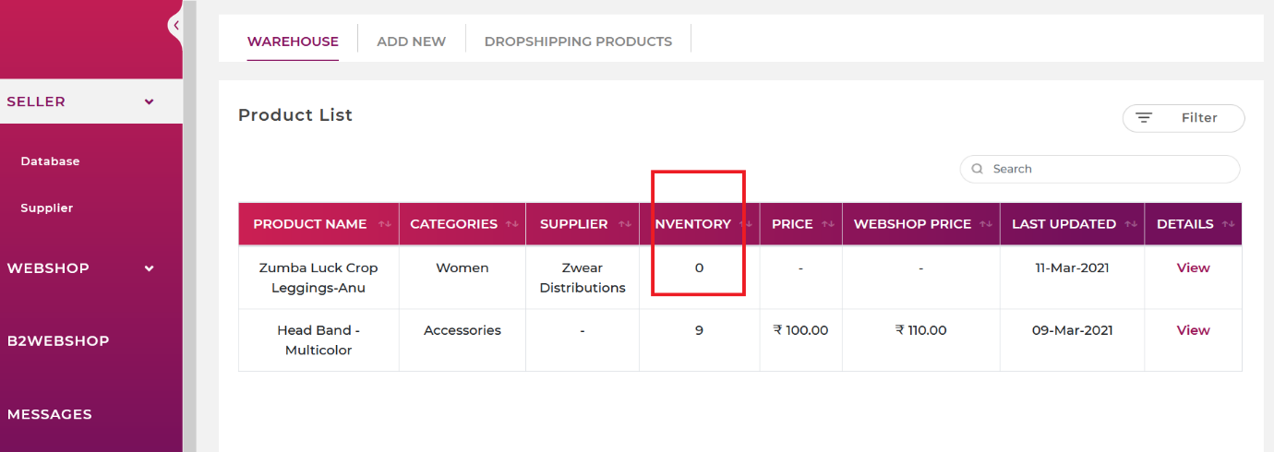
VIEW PAGE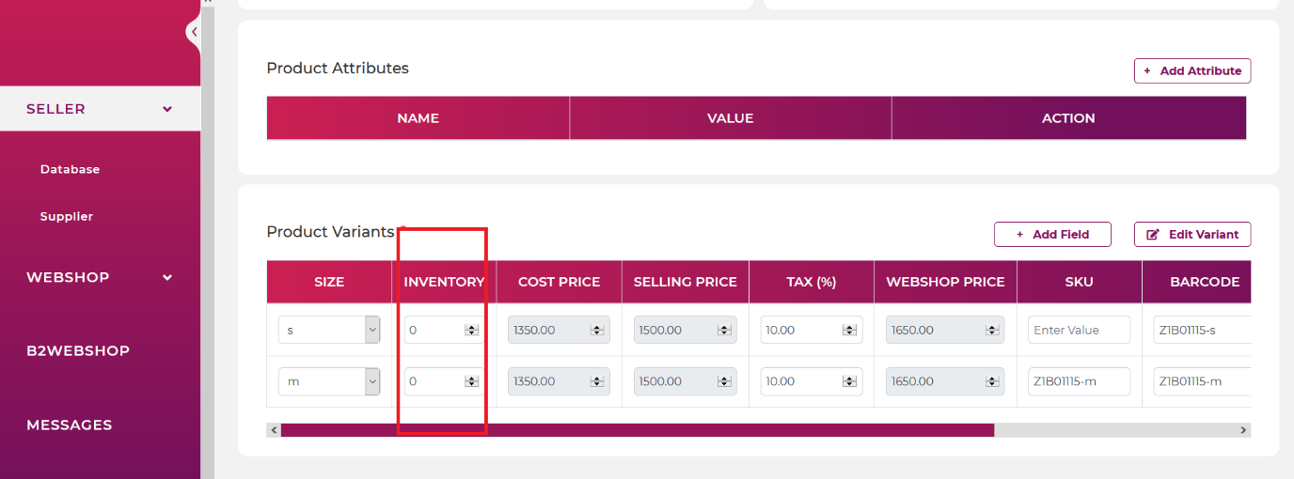

Product editing
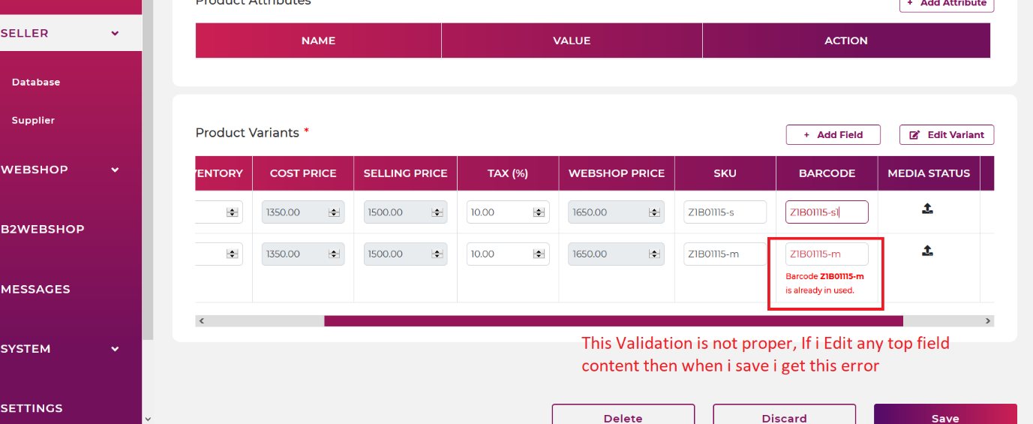

In PRODUCT DETAIL PAGE ADD THE FOLLOWING
- Add Weight Field: Text field it will be in KG keep it optional
- Keep BARCODE make it as optional
- Add Meta Description, Mega Title, Meta keywords. Keep it optional

IN ORDER AND RETURNS need to add MANUAL BARCODE SCANNING for each item(for each item we need to add scan button at the end and on click popup to enter the qty.)
Need to add TRACKING URL along with TRACKING ID for B2B and Webshop Orders.
In Warehouse Listing when u add Single codes it shows error. We need to buypass this with Slash.

We placed an Dropship order with 1 item with 1 tracking box. When we entered the tracking code the order status did not become the TRACKING COMPLETE neither in WEBSHOP(parallelkart) nor in B2B orders(Zwear)

