- For Monthly, Quarterly, Half yearly and Yearly - Need the business rules related to timing and as well entry of half yearly/quarterly/yearly with Month. – Its there in the create report document shared, any specific question?

- If the reporting type is 'Milestone' - then how this will work. – Ask for start date and end date at the beginning of the project, before contracting. This start- end date should be used for contract and for then Milestone. If its milestone based, allow the dates to be edited again for each milestone

- Multiple contributor selection. – Didn’t understand the question

- Pdf format of the report. – are we referring to design?

- For program projects how the reporting system will work. Because there will be no Project end date field. – Contributor will be funding a program also for a said period. Add start-end date before funding. Ref. point 2. response

- Funding Status: - If any fund is received and if we can edit the fields how we will update that entry as there is no button to update.

  - Need to provide button to update and maintain a log to see date of update for both contributor and the other funder outside trucsr
  - Show a pop out to update details
  - Show options received, committed to be updated for each funded by entity. And then do net balance

Pop-out- when you click on the name of Funded by

Godrej and boyce

committed edit
SD-ED

Entries Received Utilized
<date> <time>

Auto calculate balance

Utilized
Receieved

- And if we are adding new entry Case 1 – If contributor has committed to give 100000 but has only received 50000 and after 2-3 months he again gives the balance amount of 500000. Then how we will manage this?

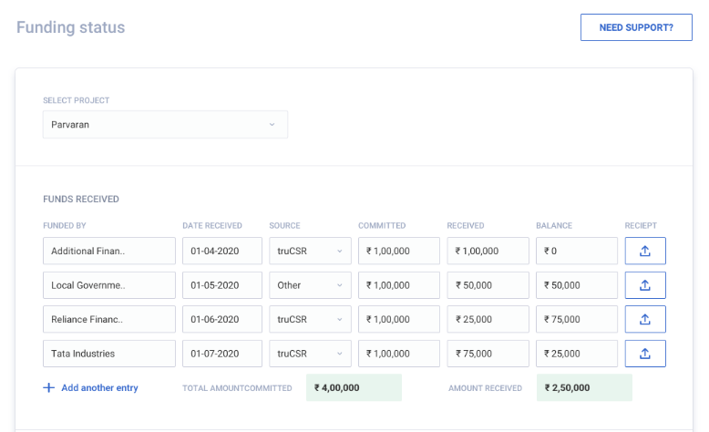

- If any project duration is of 3 months. Start date is 1 Sep 2020 and end date is 31 Dec 2020. If the project received is first funding on 20 Sep 2020 so monthly reporting will be start from 20th Oct 2020, 20th Nov 2020 and 20th Dec 2020. But here the end date is 31st Dec so what about that 10 days report? What will be the business rule here? This issue will come for quarterly, half yearly and yearly also.
  - The report will be generated on 20th only, however, user can at his discretion report later also after overdue
  - Allow to edit start date and end date before the start of the project

- When this milestone summary will come? If milestone is not added while creating project, allow user to add milestone as option in create report- monthly, quarterly etc.
- If milestone is not selected in the beginning of the project, amount allotted can be optional, it can also run on Start date – end date

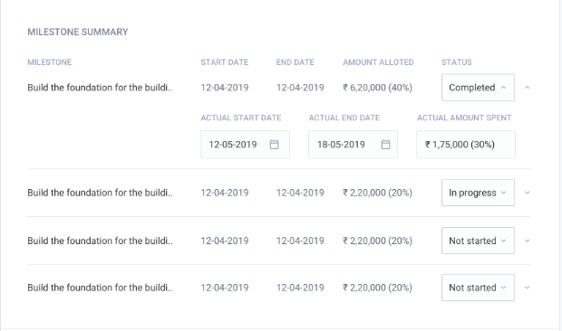

- On click on cancel button the form will reset or redirect to report listing page? Redirect to listing page and the report will be saved in draft report
- In funding status If we will add new entry by clicking on Add another entry how we will save the details into DB as there is no action button is given for the same. Allow to save via an icon to save
- In create report the beneficiaries we will enter should added in the already added beneficiaries? And after entering beneficiaries the above beneficiary should get auto updated? Didn’t understand the question.
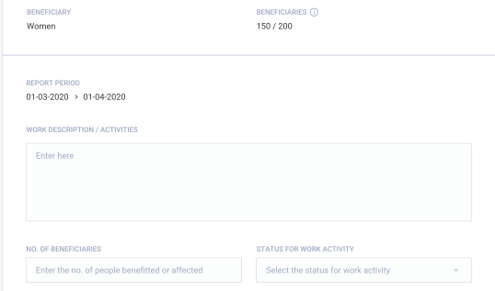

- Need clarification for this. Only monthly basis or yearly half year and quarterly also? And When this milestone graph will come? Milestone will appear for all the time cycles. The actual milestone can come if the milestone details are filled properly (scheduled). The other blue bar with actual status will appear when the details start date and end date of milestone is filled. If it is not marked as complete show a small text there as in-progress.
- 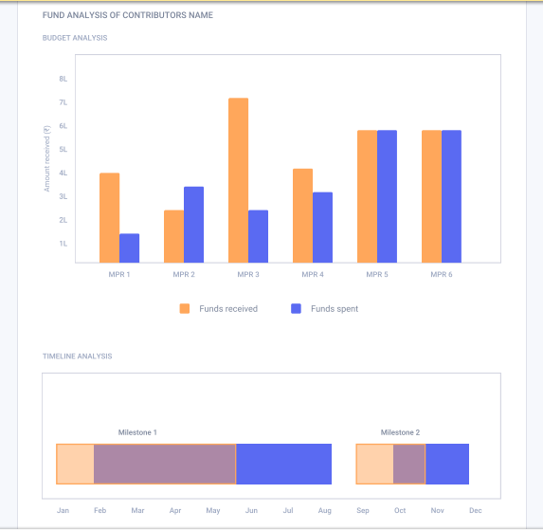

Admin
- If report is created for multiple contributors then in admin only one report will show?Or for multiple contributors report?
  - If the funding has occurred through truCSr then show multiple reports available to front end as well as admin
  - For each Contributor maintain separately, both in backend and front end
    - name
    - Funding status
    - Reports

- And when own report is created then that report will show individually in the admin? Who can able to see these reports? All users?
  - When own report is created name it as “Custom report”
  - RM and SM both can access it

