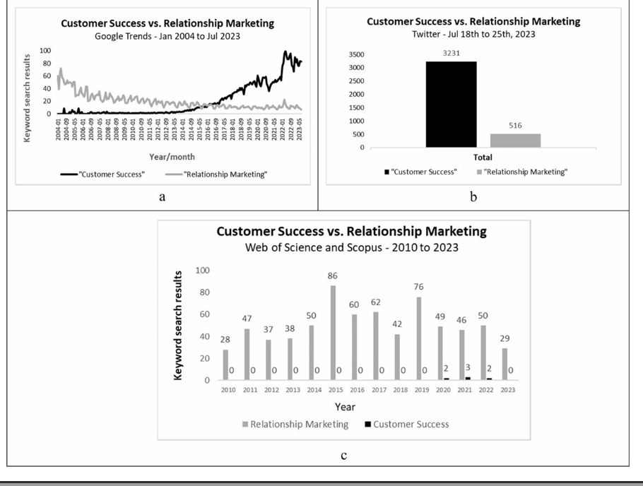
The following figure is about customer success and relationship marketing. It highlights how modern marketing increasingly values long-term relationships over single transactions.

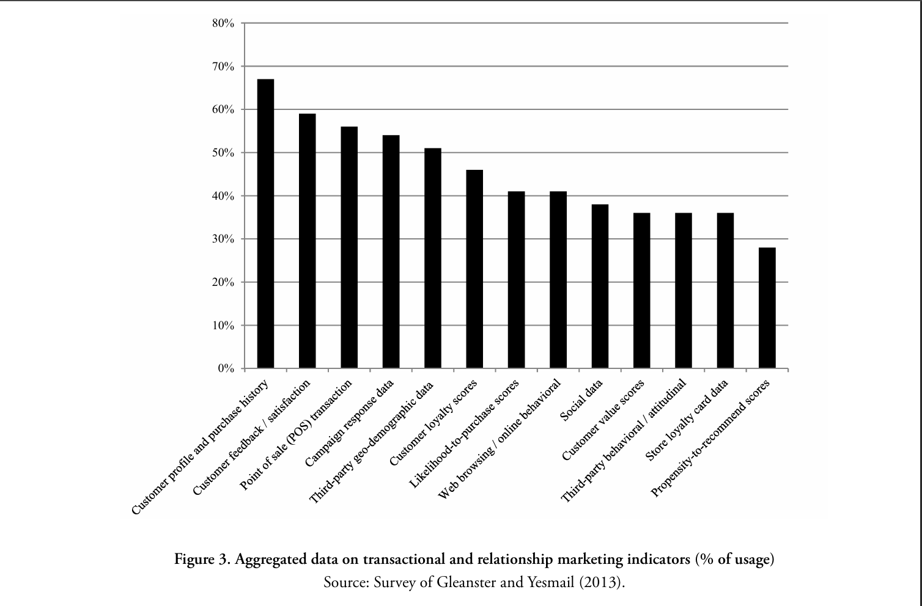
This figure presents finding from a 2013 survey conducted by Gleanster and Yeasmail, which analyzed customer engagement practices across 100 senior marketers from industries such as retail, finance, and healthcare.

