27th CRSI National Symposium in Chemistry
and
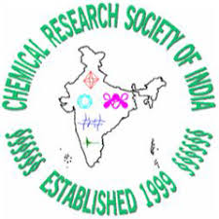
15th CRSI-RSC Joint Symposium
 | February 11-14, 2021
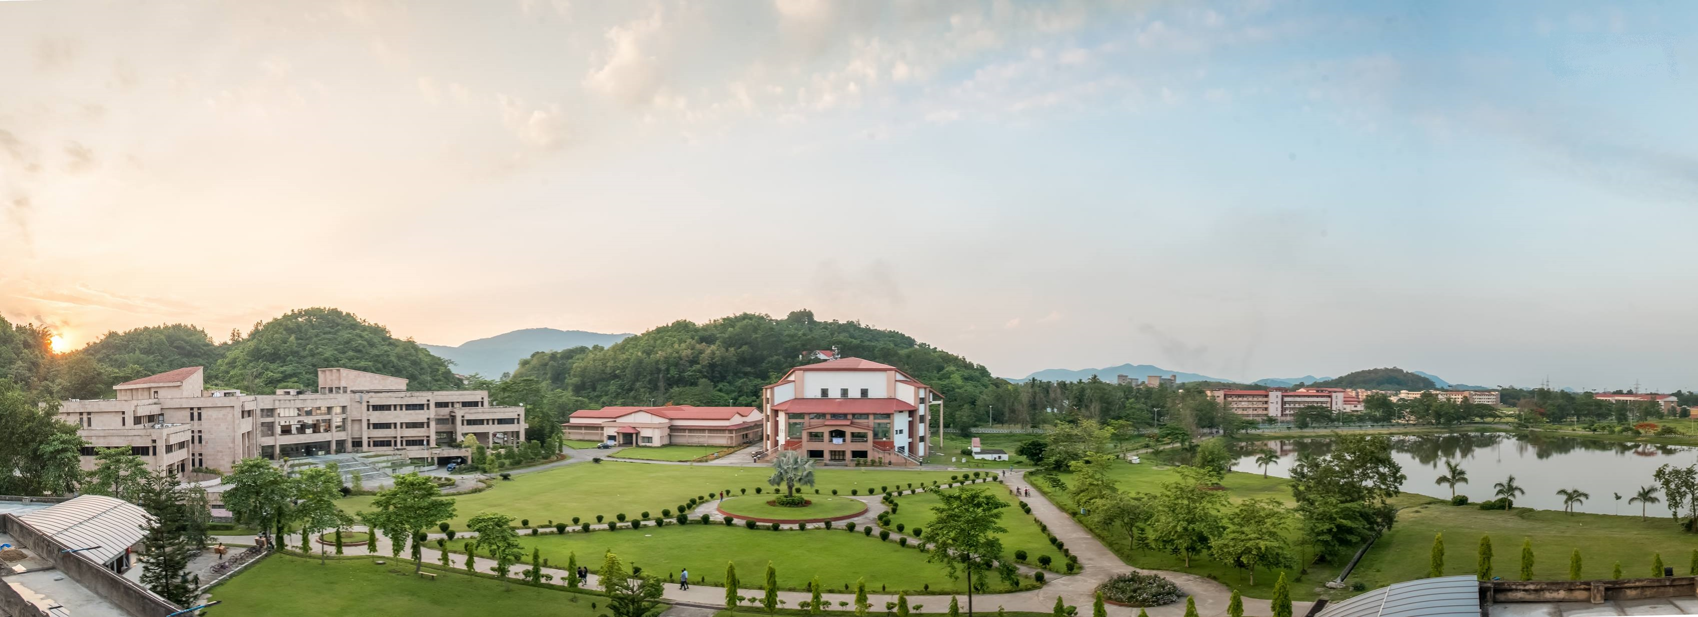

Organised by
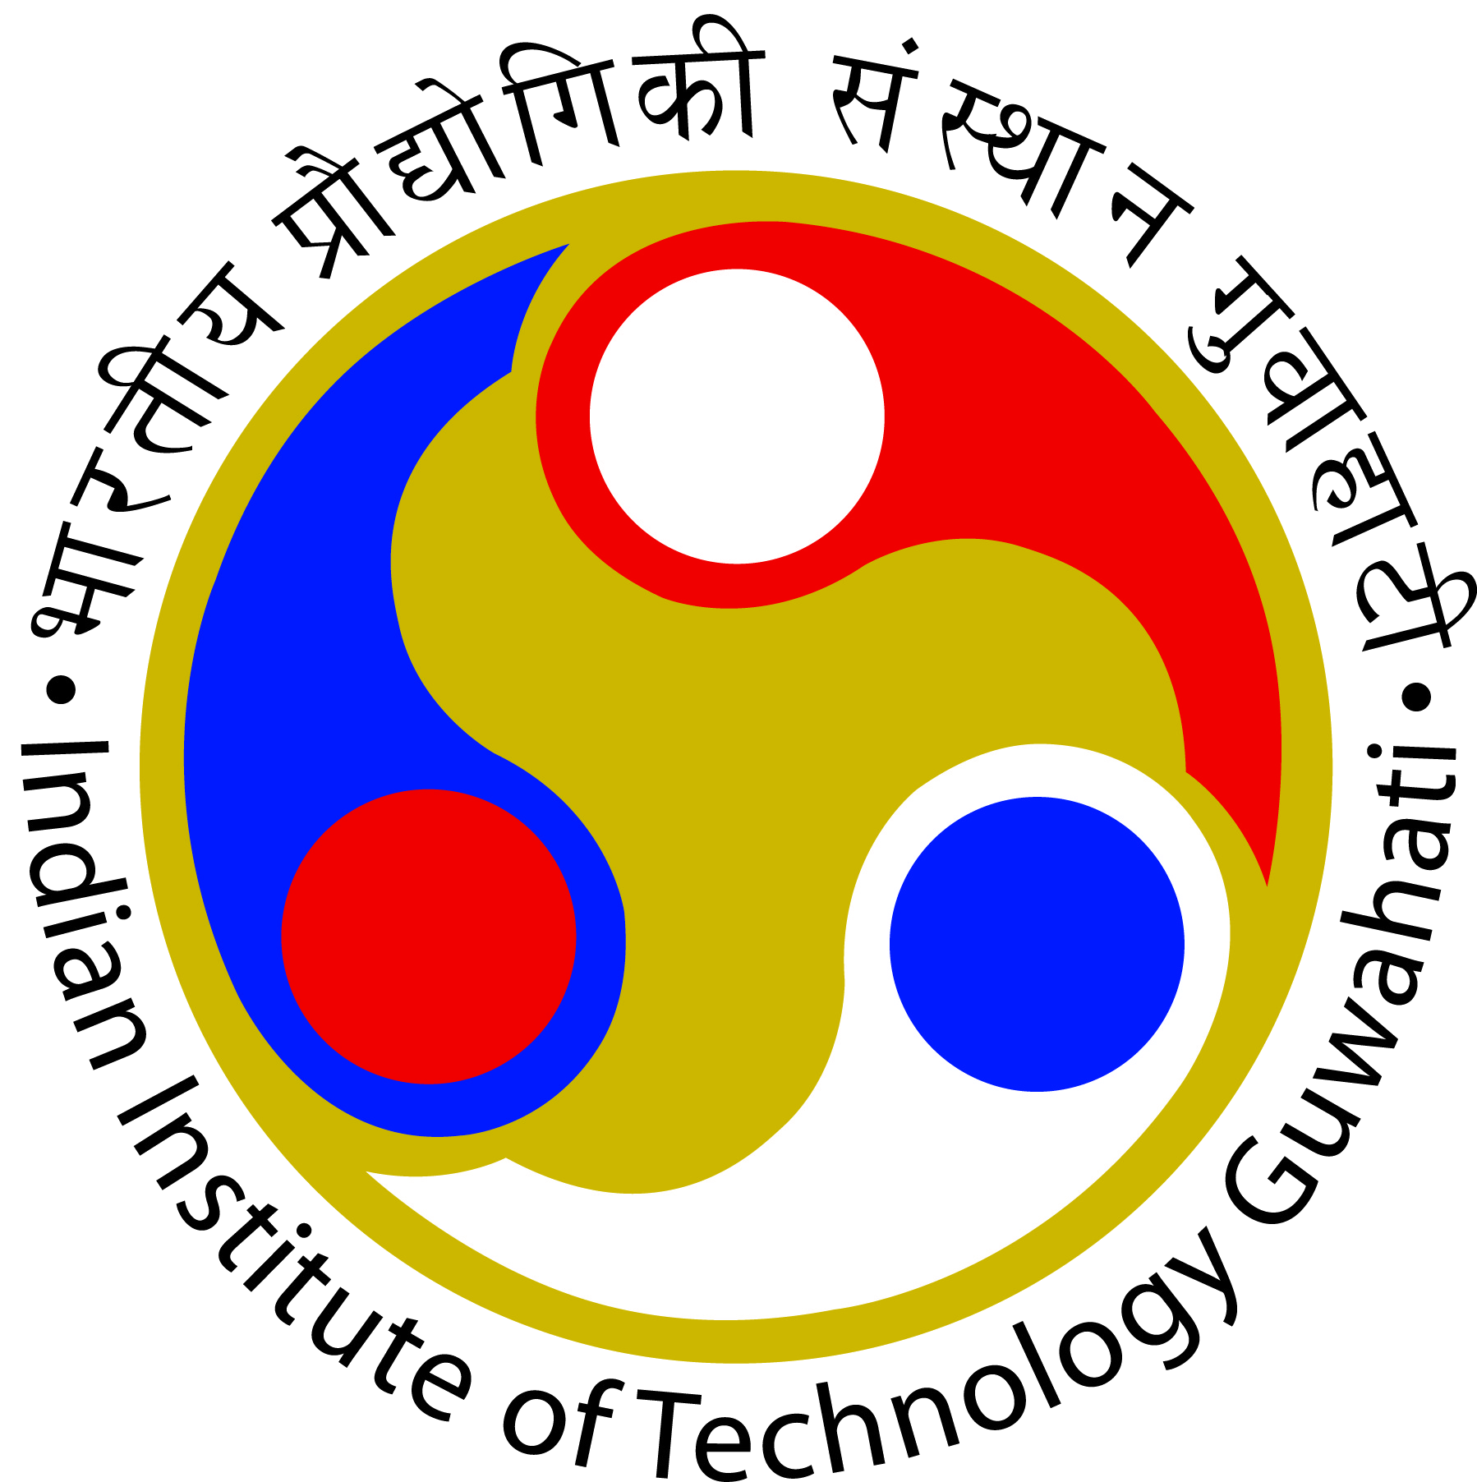

Indian Institute of Technology Guwahati

About CRSI
The Chemical Research Society of India (CRSI) was established in 1999 as part of the 50th anniversary celebrations of the country’s independence. Currently, CRSI represents more than 2300 lifetime members, who participate in the study, practice, teaching and promotion of Chemistry. The main objectives of the CRSI are to recognize, promote and foster talent in Chemistry and Chemical Sciences and to improve the quality of Chemical Education at all levels. The CRSI organizes conferences, seminars, workshops, symposia and other related programs to facilitate and promote research in all branches of Chemistry.

Governing body of CRSI
President | Vinod K. Singh
Immediate Past President | N. Sathyamurthy
Founder President | C. N. R. Rao
Vice-Presidents | V. Chandrasekhar, TIFR Hyderabad  Amitava Das, IISER Kolkata  Ashok K. Ganguli, IIT Delhi  K. P. Kaliappan, IIT Bombay  G. Mugesh, IISc Bangalore
Secretary General | N. Jayaraman, IISc Bangalore
Secretaries | T. Govindaraju, JNCASR Bangalore  Neelima Gupta, University of Rajasthan
Treasurer | V. Subramanian, CSIR-CLRI, Chennai
Jt. Secretaries | Prodeep Phukan, Gauhati University  G. Sekar, IIT Madras  Kallol K. Ghosh, Raipur  D. S. Reddy, NCL, Pune
Jt. Treasurer | P. Thilagar, IISc Bangalore

Council Members
Rakeshwar Bandichhor, Dr.Reddys Laboratories | Swagata Dasgupta, IIT Kharagpur
Ramesh C. Deka, Tezpur University | Pradyut Ghosh, IACS Kolkata
Ruchi Anand, IIT Bombay | S. Muthusamy, Bharathidasan University,Trichy
T. Punniyamurthy, IIT Guwahati | P. Sujatha Devi, CGCRI, Kolkata
C. H. Suresh, NIIST Trivandrum | Raksh Vir Jasra, Reliance
Parthasarathi Das, IIT Dhanbad | Rajeev Gupta, Delhi University
M. N. Roy, North Bengal University | Swati De, University of Kalyani
R. Mayilmurugan, Madurai Kamaraj University | Susanta Mahapatra, University of Hyderabad
Geetha Hundal, GNDU | Joyanta Choudhury, IISER Bhopal
Parbati Biswas, Delhi University | H. N. Gopi, IISER Pune
Swadhin Mandal, IISER Kolkata | G. Narahari Sastry, CSIR-NEIST, Jorhat
K. Pitchumani, MSU, Tirunelveli | Farukh Arjamand, Aligarh Muslim University
About RSC
The Royal Society of Chemistry (RSC) is a learned society in the United Kingdom with the goal of “advancing the chemical sciences”. It was formed in 1980 from the amalgamation of the Chemical Society, the Royal Institute of Chemistry, the Faraday Society, and the Society for Analytical Chemistry with a new Royal Charter and the dual role of learned society and professional body.

About the Symposia
The 27th CRSI National Symposium in Chemistry (NS - 27) and 15th CRSI-RSC Joint Symposium is scheduled to be held in Indian Institute of Technology (IIT) Guwahati from February 11 to February 14, 2021 with the support of the Chemical Research Society of India (CRSI) and Royal Society of Chemistry (RSC). The organizing committee at IIT Guwahati takes the pleasure of inviting you to attend this symposium. The symposium includes medal lectures, poster presentations and special lectures by eminent chemists and scientists working in the allied areas of chemistry from India and abroad. The National Symposium in Chemistry (NSC) and Royal Society of Chemistry (RSC) provide a platform for scientists, teachers and students to discuss the recent developments in chemical sciences across the sub-disciplines. In addition, NSC & RSC creates opportunities to exchange ideas and to build long lasting collaborations in the frontier areas of chemistry and its allied disciplines. We look forward to welcoming you at IIT Guwahati.

Registration
The participants are required to complete online registration and pay the registration fee via the online portal . The registration fee is non-refundable and it includes full participation, conference kit, lunch/dinner/refreshments. | Registration fee to be paid on or before ........, 2020. After this date, the following registration fee will be applicable:
  Important Date
  27th CRSI NSC
  February 12-14, 2021
  15th CRSI-RSC Joint Symposium
  February 11, 2021
  Announcement of selected abstracts
  January......., 2021
  Abstract Submission
  Last Date: Xxx ##, 20##
  Registration & Fee Payment
  Last Date: Xxx ##, 20##
  Registration Fee
  Student | Rs. 3000.00
  Faculty/Scientist | Rs. 5000.00
  Industrial delegate | Rs. 7000.00
  Accompanying Person | Rs. 5000.00
  Registration Fee
  Student | Rs. 4000.00
  Faculty/Scientist | Rs. 6000.00
  Industrial delegate | Rs. 9000.00
  Accompanying Person | Rs. 6000.00

Abstract
Last date of abstract submission is ## June, 2021. Interested participants may submit an abstract of their original research work for poster presentation. Abstract template, the process of abstract submission, and poster size can be obtained from the conference website.

Accommodation
Participants will be accommodated in the Institute Guest House and Student's Hostels (separate for boys and girls) of IIT Guwahati within the campus. Guwahati city has plenty of budget hotels including four-star hotels. Participants who wish to continue their stay after the conference may book the hotels in the city in advance.
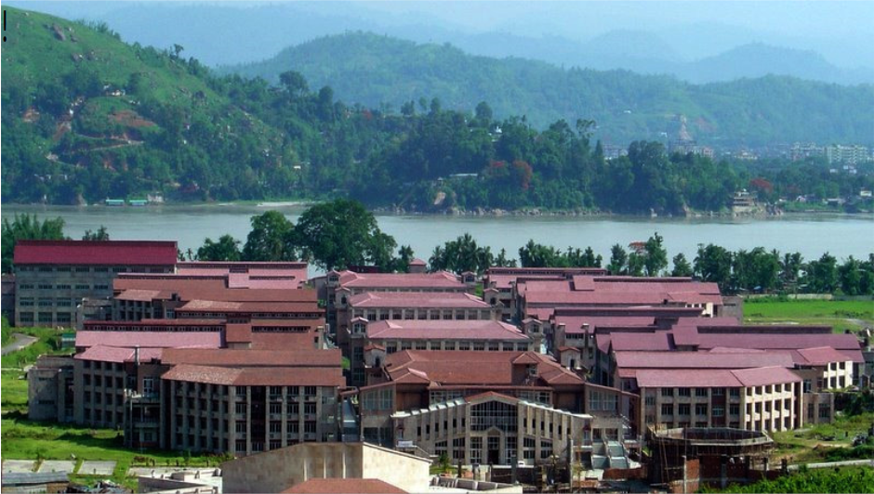
ABOUT IIT Guwahati
Indian Institute of Technology Guwahati is the sixth member of the IIT fraternity and was established in 1994. The Department of Chemistry, one of the oldest in the institute, started functioning since 1995. The campus is located on 285 hectares plot of land on the north bank of the river Brahmaputra around 20 km from the heart of the city. With the majestic Brahmaputra on one side, and with hills and vast open spaces on other sides, the campus provides an ideal setting for learning. Guwahati city is gateway to beautiful north eastern region of the country and linked with all major cities by rail, road and air. The temperature in Guwahati in the month of May varies from 28ºC to 32ºC. Buses, auto-rickshaws and taxis are available from Guwahati City to the IIT Guwahati Campus. Institute buses are available at frequent intervals from Pan Bazaar (about ½ kms away from Guwahati Railway Station).
More details for visitors to reach IIT Guwahati can be found at http://www.iitg.ac.in/home/pagesin/103

Organizing Committee
Patron | Prof. Dr. T. G. Sitharam
Chairman
Convener | Prof. T Punniyamurthy
Co-Conveners | Dr. Uttam Manna and Dr Akshai Kumar A. S
Contact
Prof. Prof. T Punniyamurthy
Conveners, 27th CRSI NSC and 15th CRSI-RSC Joint Symposium, 2021 Department of Chemistry Indian Institute of Technology Guwahati Guwahati - 781039, India Email : tpunni@iitg.ac.in Phone : +91 361 2582309 FAX : 0361 2690762

