Setting up Eclipse for C/C++

IDEs are tools to make code development a lot easier, specially if your project has multiple files, classes, and functions. However, setting up the IDE can sometimes be as painful as developing complex codes without an IDE. This post will present a short tutorial about how to install and configure Eclipse for C/C++ on Windows 7 in a (hopefully) fairly painless manner. This tutorial is sequenced as follows:

- Installation
  - Downloading the Java Runtime Environment.
  - Downloading the GCC compiler.
  - Downloading Eclipse.
- First steps with Eclipse
  - Setting up a template (optional)
  - Creating a new project
  - Including libraries in your project
INSTALLATION
Downloading the Java Runtime Environment
To check if you have the Java Runtime Environment installed, go to java.com with either Internet Explorer or Firefox (Chrome will block the plugin) and click on “Do I have Java?”. Accept running all the pluggins and, If the website tells you you do not have java, you will have to download and install it from the link displayed on the website.
Downloading the GCC compiler
After the check is done, you will have to download the GCC compiler, which can be done from http://www.equation.com. On the side menu, there will be a link to Programming Tools, which after expanded shows a link to Fortran, C, C++. Click on this link and download the right GCC version for your system (32/64 bit), as shown in the following screenshot.
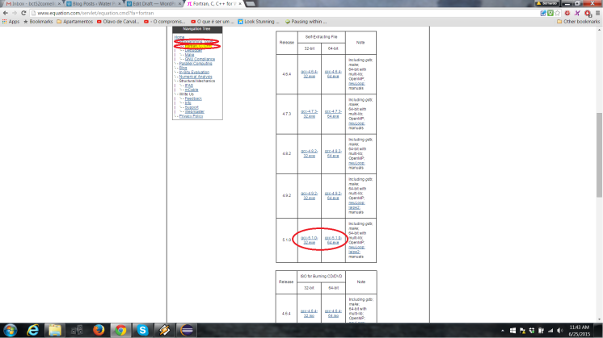
After downloading it, double click on the executable, accept the licence, and type “c:\MinGW” as the installation directory. This is important because this is the first folder where Eclipse will look for the compiler in your computer. Proceed with the installation.
Downloading Eclipse
Now it is time to download an install eclipse. Go to the Eclipse download website and download Eclipse IDE for C/C++ Developers. Be sure to select the right option for your computer (Windows, 32bit/64bit), otherwise eclipse may not install and even if it does it will not run after installed. If unsure about which version you should download, this information can be found at Control Panel -> System by looking at System type.
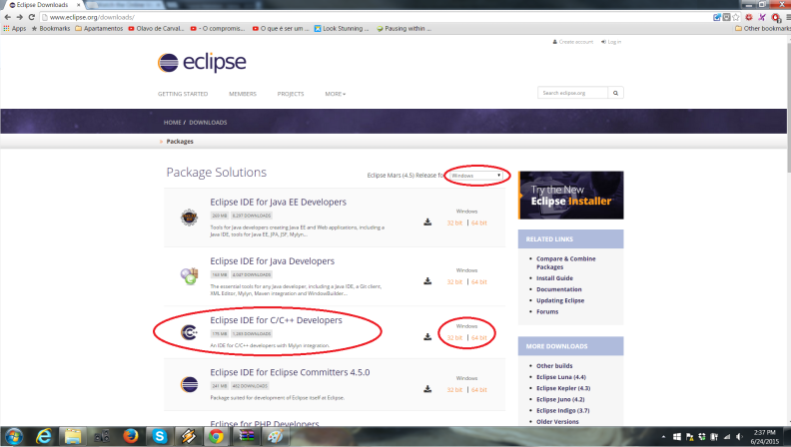
After downloading it, extract the file contents to “C:\Program Files\eclipse” (“Program Files (x86) if installing the 32 bits version) so that everything is organized. Note that for this you will need to start WinRAR or any other file compression program with administrative privileges. This can be done by right clicking the name of the program on the start menu and clicking on Run as Administrator.
Now, go to C:\Program Files\eclipse and double click on eclipse.exe to open eclipse. In case you get an error message saying, among other things:
Java was started but returned exit code=13
...
...
-os win32
-ws win32
...
then delete the whole eclipse folder, go back to the eclipse download page, download eclipse 32 bit, and extract it as previously described. You should not see the same error again when trying to run eclipse.exe.
Now that Eclipse is up and running, it is time to use it.
FIRST STEPS WITH ECLIPSE
The first thing eclipse will do is ask you to choose a workspace folder. This is the folder where all your code projects will be stored. It should not matter too much which folder you choose, so using the default is probably a good idea.
Setting up templates (optional)
It is helpful to create a code template in order to avoid retyping the same standard piece of code every time you create a new file or project. Many scientific codes have similar imports (such as math.h and stdio.h) and all of them must have a main method (as any C++ code). If we create a code template with a few common imports and the int main function, we can just tell Eclipse when creating a new project to add these to a new .cpp file.
In order to create the mentioned template, go to Window -> Preferences. There, under C/C++ -> Code Style on the left panel, click on Code Templates. Under Configure generated code and comments, expand Files -> C++ Source File, and then click on New. Choose a meaningful name for your template (I chose “Cpp with main”) and type a short description. After that, copy and paste the template below under “Pattern”.
1  2  3  4  5  6  7  8  9  10  11  12  13  14  15  16  17  18  19  20  21 | /*  File: ${file_name}  Author: ${user}  Date: ${date}  */  #include <iostream>  #include <string>  #include <math.h>  #include <stdio.h>  #include <string.h>  using namespace std;  int main()  {  // Your code here.  return 0;  }

Note ${file_name}, ${data}, and ${user} are variables, which means that they will be replaced by your file’s actual data. To see a list of the other variables that can be inserted in your template, click on Insert Variable…. Click Ok and Ok again and your template will be ready to be used!
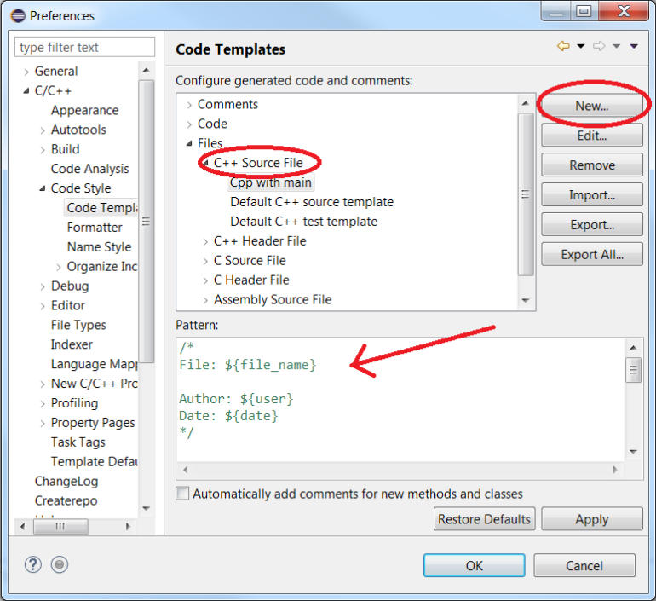
Creating a new project
Click on File -> New -> C++ Project. Under Project type choose Empty Project, then under Toolchains choose MinGW GCC, and, finally, type “project1” as your project name an click on Finish.
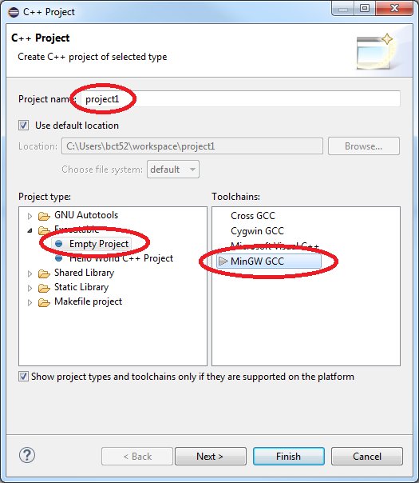
After your project is created, click on File -> New -> Source File. Type “say_something.cpp” (no quotes and do not forget the .cpp after the file name) as the name of your source file and choose the template you created as the template. The window should then look like this:
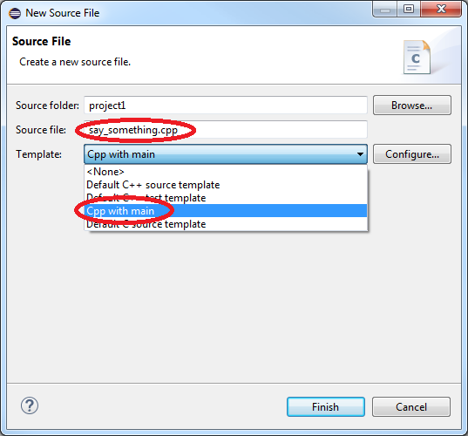
Click on Finish. If you used the template, replace the comment “// Your code here.” by “cout << “Yay, it worked!” << endl;”. Your code should look like the snippet below. If you have not created the template, just type the following code to your file.
1  2  3  4  5  6  7  8  9  10  11  12  13  14  15  16  17  18  19  20  21 | /*  File: say_something.cpp  Author: bct52  Date: Jun 26, 2015  */  #include <iostream>  #include <string>  #include <math.h>  #include <stdio.>  #include <string.h>  using namespace std;  int main()  {  cout << "Yay, it worked!" << endl;  return 0;  }

Now, build the code by clicking on the small hammer above the code window and, after the project is built, click on the run button (green circle with white play sign in the center). If everything went well, your window should look like the screenshot below, which means your code compiled and is runs as expected.
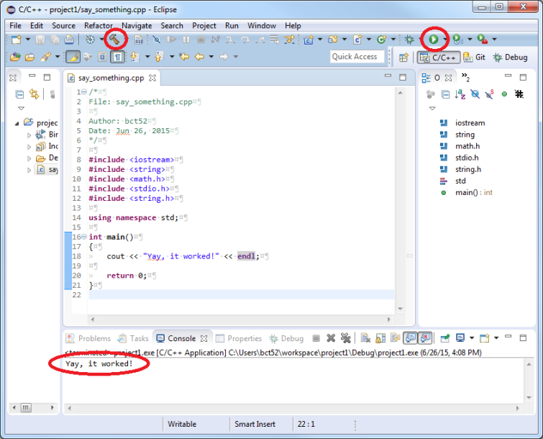
Including libraries in your project
When developing code, often times other people have had to develop pieces of code to perform some of the intermediate steps we want our code to perform. These pieces of code are often publicly available in the form of libraries. Therefore, instead of reinventing the wheel, it may be better to simply use a library.
Some libraries are comprised of one or a few files only, and can be included in a project simply by dragging the file into the Eclipse project. Others, however, are more complex and should be installed in the computer and then called from the code. The procedure for the latter case will be described here, as it is the most general case . The process of installation and usage of the Boost library with MinGW (GCC) will be used here as a case study.
The first step is downloading the library. Download the Boost library from here and extract it anywhere in your computer, say in C:\Users\my_username\Downloads (it really doesn’t matter where because these files will not be used after installation is complete).
Now it is time to install it. For this:
  - Hold the Windows keyboard button and press R, type “cmd”, and press enter.
  - On the command prompt, type “cd C:\Users\bct52\Downloads\boost_1_58_0” (or the directory where you extracted boost to) and press enter.
  - There should be a file called bootstrap.bat in this folder. If that is the case, run the command:
1 | bootstrap.bat mingw

  - In order to compile Boost to be used with MinGW, compile Boost with the gcc toolset. You will have to choose an installation directory for Boost, which WILL NOT be the same directory where you extracted the files earlier. In my case, I used C:\boost. For this, run the command:
1 | b2 install --prefix=C:\boost toolset=gcc

Now go read a book or work on something else because this will take a while.
Now, if the installation worked with just warnings, it is time to run a code example from Boost’s website that, or course, uses the Boost library. Create a new project called “reveillon” and add a source file to it called “days_between_new_years.cpp” following the steps from the “Creating a new project” section. there is no need to use the template this time.
You should now have a blank source file in front of you. If not, delete any text/comments/codes in the file so that the file is blank. Now, copy and paste the following code, from Boost’s example, into your file.
1  2  3  4  5  6  7  8  9  10  11  12  13  14  15  16  17  18  19  20  21  22  23  24  25  26  27  28 | /* Provides a simple example of using a date_generator, and simple  * mathematical operatorations, to calculate the days since  * New Years day of this year, and days until next New Years day.  *  * Expected results:  * Adding together both durations will produce 366 (365 in a leap year).  */  #include <iostream>  #include "boost/date_time/gregorian/gregorian.hpp"  int  main()  {  using namespace boost::gregorian;  date today = day_clock::local_day();  partial_date new_years_day(1,Jan);  //Subtract two dates to get a duration  days days_since_year_start = today - new_years_day.get_date(today.year());  std::cout << "Days since Jan 1: " << days_since_year_start.days()  << std::endl;  days days_until_year_start = new_years_day.get_date(today.year()+1) - today;  std::cout << "Days until next Jan 1: " << days_until_year_start.days()  << std::endl;  return 0;  };

Note that line 9 (“#include “boost/date_time/gregorian/gregorian.hpp””) is what tells your code what exactly is being used from Boost in your code. Line 15 (“using namespace boost::gregorian;”) saves you from having to type boost::gregorian every time you want to use one of its functions.
However, the project will still not compile in Eclipse because Eclipse still does not know where to look for the Boost library. This will require a couple of simple steps:
- Right click on the project (reveillon), under the Project Explorer side window, then click on Properties. Under C/C++ Build->Settings, click on Includes under GCC C++ Compiler. On the right there should be two blank boxes, the top one called Include paths (-I) and the other called Include files (-include). Under Include paths (top one), add the path “C:\boost\include\boost-1_58” (note that this path must reflect the path where you installed Boost as well as which version of Boost you have). This is where the compiler will look for the header file specified in the code with the #include statement.
- The compiled library files themselves must be included through the linker. This step is necessary only if you are using a compiled library. For this, on the same window, click on Libraries under MinGW C++ Linker. Add the path to the Boost libraries folder to the Library search path (-L) (bottom box). this path will be “C:\boost\lib” (again, if you installed Boost in a different folder your path will be slightly different). Now the actual compiled library must be added to the Libraries (-i) (top box). First, we need to figure out the name of the compiled library file used in the code. In this case, it is the file “libboost_date_time-mgw51-mt-d-1_58.a”. Therefore, add boost_date_time-mgw51-mt-d-1_58 (no lib prefix, no .a postfix, and be sure to match the name of your file) to Libraries (-i). Click Ok and Ok again.
Now compile the code by clicking on the hammer button and run the rode by clicking on the play button. Below is a screenshot reflecting both steps above as well as the expected output after running the program.
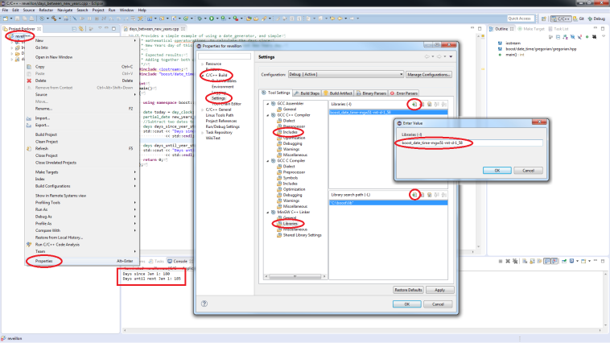
That’s it. After your model is in a good shape and it is time to run it with Borg (or other optimization algorithm), just change your “int main()” to a function with your model’s name and the right Borg’s arguments, add the standard Borg main, and change the makefile accordingly. Details on how to do all this for Borg will be explained in a future post.

Advertisements

